9:30 a.m. EASTER 4, Year C May 8, 2022

***Welcome to Old North.*** *We are pleased you chose to worship with us today!*

The Reverend Susan E. Kerr Mr. Alan Newman

Minister and Pastor Organist and Music Director

**OUR APPROACH TO GOD**

PRELUDE and CHIMES   “Spring Song”                                 Felix Mendelssohn

                   “Belgian Mother’s Song”        arr. Charles Courboin

ANNOUNCEMENTS and VOTUM

**ANTHEM** “These Are the Things”                     Anon. Women’s Choir

**RESPONSIVE CALL TO WORSHIP** *Psalm 23, NIV*

L: The Lord is my shepherd, I shall not be in want.

**ALL: He makes me lie down in green pastures,**L: he leads me beside quiet waters,

**ALL: he restores my soul.**   L: He guides me in paths of righteousness for his name's sake.

**ALL: Even though I walk through the valley of the shadow of death,I will fear no evil,**

**for You are with me; Your rod and Your staff, they comfort me.**

L: You prepare a table before me in the presence of my enemies.   
**ALL: You anoint my head with oil; my cup overflows.**

L: Surely goodness and love will follow me all the days of my life,   
**ALL: and I will dwell in the house of the Lord forever.**

**UNISON GATHERING PRAYER**\*

By the power of Your Spirit O God,

we rise and embrace this day.

Spirit, touch our places of brokenness and we will be healed,

our eyes will open to new possibilities.

We come to worship the One who makes us whole,

the One in whose name we serve,

the One who gives our work meaning.

Praise be to God. Amen!

SALUTATION AND **SHARING of the Peace** *(Remain seated.)*

L: Peace be with you! **ALL:** **AND ALSO WITH YOU!**

**HYMN #311 “GOD HAS SPOKEN BY HIS PROPHETS”**

CHILDREN’S MESSAGE

**UNISON PRAYER OF CONFESSION**\*

God, I come to You, chosen and precious in Your sight.

I bring to You all that I am, including those things in my life that I carry like stones that weigh me down: the burdens that hurt, the sins that break and bruise the world, and I lay them down here -- all that prevents me from knowing the abundant life You offer.

(*time of silent reflection)*

**KYRIE ELEISON (sung) #444**“Into My Heart”

*Into my heart, into my heart, come into my heart, Lord Jesus;*

*Come in today, come in to stay, come into my heart, Lord Jesus.*

**ASSURANCE OF**  **FORGIVENESS** *from 1 Peter 2:2-10*

Jesus hears our confessions and takes them in love, redeems and transforms them, forming you into a holy house, a sacred community, rebuilt in grace, and dedicated to God. **People: THANKS BE TO JESUS! AMEN.**

**THE LAW OF GOD**

* **GLORIA PATRI #805**

*Glory be to the Father and to the Son and to the Holy Ghost! As it was in the*

*beginning, is now and ever shall be, world without end; Amen, Amen.*

**THE WORD OF GOD**

PRAYER FOR ILLUMINATION

READING OF THE SCRIPTURES Acts 9:36-43 John 10:22-42

**SERMON HYMN #****549 “NEAR THE CROSS”** *(remain seated)*

SERMON  “The Quality of Love” The Rev. Susan Kerr

**OUR RESPONSE TO GOD**

**THE WORSHIP OF GIVING:** OUR OFFERINGS TO GOD

* **DOXOLOGY #809** (The Worshiping Church hymnal)

*“Praise God from whom all blessings flow. Praise God all creatures here below.*

*Praise God above, ye heavenly host: Praise Father, Son and Holy Ghost. Amen.”*

* PRAYER OF DEDICATION OF OUR GIFTS AND TITHES

PRAYERS OF THE PEOPLE AND **THE LORD’S PRAYER**

*Our Father, who art in heaven, Hallowed be thy name*

*Thy kingdom come. Thy will be done on earth as it is in heaven.*

*Give us this day our daily bread, and forgive us our debts,*

*as we forgive our debtors,*

*and lead us not into temptation, but deliver us from evil.*

*For thine is the kingdom, and the power, and the glory, forever. Amen.*

**HYMN #781, vss 1,4,5 “THIS IS THE THREEFOLD TRUTH”**

* PASTORAL BENEDICTION

POSTLUDE  “For All the Saints”                           Gerhard Krapf

* Congregation Standing as able. **BOLD** indicates congregation’s participation.

*Indicates materials used from “Seasons of the Spirit”©.

**THE CONSISTORY OF OLD NORTH**

Elders: Karen DiBella (2022) Scott Benell (2023) Carol Sushko (2023, 2nd term)

Deacons: Brianna Polbos (2021) John Passarotti (2022) Richard Schmude (2023)

Minister: Rev. Susan Kerr (Parsonage) 201-338-8237; [revskerr@gmail.com](mailto:revskerr@gmail.com)



**Old North Reformed Church**

120 Washington Avenue, Dumont, New Jersey 07628

201-385-2243 [oldnorthdumont@gmail.com](mailto:oldnorthdumont@gmail.com)

<https://oldnorth.church>

***Welcome to worship at Old North Reformed Church!***

*If you would like to be added to our mailing list, please leave your contact*

*information in the guest book before leaving today.*

**Flowers**: The flowers on the chancel are given to the Glory of God by Sandy Schwarz in loving memory of her Mom, Eleanor Schwarz.

**We encourage you to keep this copy of the liturgy and take it home to**

**share** **with a member of your family, or with a friend.**

Our next Consistory meeting is on May 19th.

Old North’s community building use includes: AA, Anchor Wrestling, Body Fit & Aerobics, Boy Scouts, Girl Scouts, Broadway Bound Dance, Yoga, as well as our own Thrift Shoppe and Chance at Life Cat Rescue and more.

If you know of anyone that might be interested in using space at Old North,

please have them contact the office to request a Building Use Application.

**Prayer Chain:** If you would appreciate adding the power of prayer in times of celebration, healing, or transitions in life, please call Pat Hooey, 201-843-4456.

Your prayer requests are uplifted by the prayer team, and confidentiality is honored.



**Church Family Prayer List:**

**●Adrianne ●Barbara ●Katie ●Margaret ●Michael ●Nancy**

Support for those with chronic conditions and their care-givers;

uplifting those undergoing medical procedures and thanksgiving for those who are recovering;

comfort for those in mourning; strength for those fighting cancer; all who are

seeking spiritual and emotional well-being, and for those with addictions. Pray for Peace.



If you are able to host, please sign up in the Auditorium or

contact the office for a date to that is open.

**Join Pastor Susan on Wednesdays for 11 a.m. Lectionary Bible Study.**

**We meet in the Church House Lounge. All are welcome!**

Bring your own Bible or use one of ours.

*It is expected that participants are fully vaccinated.*

**Congratulations to all of our Church Family who are celebrating a special event!**

**Happy Birthday!**

5/1 Steven Cordova - 5/1 Nate Schmude - 5/4 Irene Yanick - 5/5 Erin Benell

5/5 John Woerner - 5/6 Helen Berthold - 5/9 Andrew Messina

5/14 Ethel Reitsema - 5/22 Thomas Edone - 5/24 Alexandra & Andrew Huth

5/25 Donair Karkkainen - 5/26 Marianne Schmude

**Happy Anniversary! -** 5/19 Rich and Marianne Schmude

**NOTES FROM THE THRIFT SHOPPE:**

1. Please label Sunday deliveries with a note on the bag so they are not mistaken

for garbage.

1. We are unable to accept ANYstuffed animals.
2. Our updated donation list is on our Thrift Shoppe Facebook page.
3. We are happy to accept clothing donations for the **current season only**!

**OUR NEXT SALE IS MAY 14th 9 a.m. - 2 p.m. - Volunteers are always appreciated!**

**TRUNK TO TRUNK FOOD DRIVE** **- May 21st**

**9:00 a.m. - 12:00 p.m.**

Collections are distributed to the Dumont Food Pantry. Contact Scott Benell to volunteer.

**PANTRY NEEDS:**

Perishable and non-perishable items, fresh produce, any type of cooking oil, coffee, milk, eggs, butter, sugar, pancake mix, syrup, meat, chicken, bacon, frozen vegetables, canned carrots, fruit, mayonnaise, mustard, ketchup, peanut butter, jelly, tuna, pasta sauce, mac and cheese, red, pink, pinto and black beans (canned or bags), bags of white rice, jars of gravy, cheese, crackers, Honey Nut Cheerios, Rice Krispies, Frosted Flakes, nuts, (GLUTEN FREE cereal, mac and cheese, pancake mix, flour) bread crumbs, Boost or Ensure, size 4,5,& 6 diapers, Personal hygiene product’s, household cleaning products, paper towels, and toilet paper.

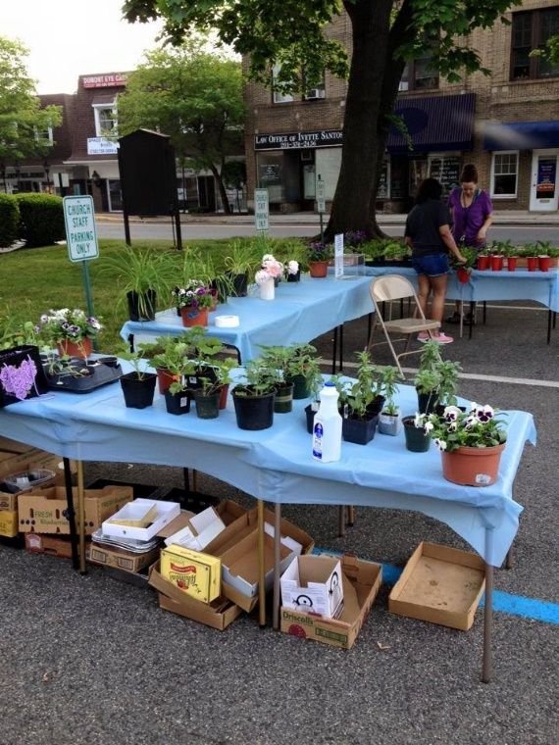**Plant Swap & Sale**

THANK YOU TO OUR VOLUNTEERS FOR MAKING

THIS ANOTHER SUCCESSFUL EVENT AT OLD NORTH!

**CELEBRATION CHOIR FOR EASTER**

There will be a short rehearsal after the church’s service this morning in the Choir Loft.

**GRIMES - SPRING FUND:** Application Letters are now being accepted for the Grimes - Spring Fund grants.  The fund was established at ONRC to provide financial assistance to those going to college.  Your letter must include a description of your course of study and your involvement in church.  Applications may be sent to the church, emailed or placed in the Consistory mailbox located in the library, and must be received before **JUNE 5TH**.