9:30 a.m. EASTER 6, Year C May 22, 2022

***Welcome to Old North.*** *We are pleased you chose to worship with us today!*

The Reverend Susan E. Kerr Mr. Alan Newman

Minister and Pastor Organist and Music Director

*Today we are pleased to welcome the Rev. Leah Ennis into the pulpit.*

**OUR APPROACH TO GOD**

PRELUDE and CHIMES   “Fanfare”                                 Francis Jackson

                   “Traumerei”                      Robert Schumann

                   “Psalm 149”                        Emma Lou Dieme

ANNOUNCEMENTS and VOTUM

**CONGREGATIONAL INTROIT (sung) #788**  **“THERE’S A QUIET UNDERSTANDING”**

**RESPONSIVE CALL TO WORSHIP**Psalm 67

L: May God be gracious to us and bless us and make his face to shine upon us,  
**All:** **that Your way may be known upon earth, Your saving power among all nations.**L:Let the peoples praise You, O God;

**All: let all the peoples praise You.  
L:** Let the nations be glad and sing for joy,

**All: for You judge the peoples with equity and guide the nations upon earth.**   
L: Let the peoples praise You, O God

**All: let all the peoples praise You.**L:The earth has yielded its increase; God, our God, has blessed us.  
**All: May God continue to bless us; let all the ends of the earth revere God.**

**UNISON GATHERING PRAYER\*** *based on John 14:23-29*

Parenting God, You promised that those who love Jesus and live His words of love will be loved by You, and that our homes will be Your home.

You have given to us the Holy Spirit to teach us how to do just that.

Continue to teach us what we need to know. Remind us of all You have said to us, that we may feel Your peace this day, live freely untroubled by the cares of the world, and let go of all our fears. Help us to believe, and to live Your love! Amen.

SALUTATION AND **SHARING of the Peace** *(Remain seated.)*

L: Peace be with you! **ALL:** **AND ALSO WITH YOU!**

* **HYMN # 62 “Immortal, Invisible, God Only Wise”**

CHILDREN’S MESSAGE

**UNISON PRAYER OF CONFESSION** *based on today’s scripture*

**Even as we hear the echoes of Your voice, O God,**

**we know there are many who sit on the edges of life**

**– even the life of the church.**

**They wait in hope**

**but the plates on the tables of love seem to be empty.**

**Often we don’t think to visit those**

**who live across rivers of cultural differences,**

**with lifestyles and habits that seem strange.**

**Sometimes we don’t recognize other places of prayer,**

**because we are not expecting to see them,**

**especially if the voices there are of those**

**who do not hold power and influence.**

**Forgive us when we are not**

**Your faithful disciples, Jesus Christ.**

**Call us back to Your way of life.** (*time of silent reflection)*

**KYRIE ELEISON (sung) #444**“Into My Heart”

*Into my heart, into my heart, come into my heart, Lord Jesus;*

*Come in today, come in to stay, come into my heart, Lord Jesus.*

**ASSURANCE OF**  **FORGIVENESS** *from 1 Peter 2:2-10*

Jesus hears our confessions and takes them in love, redeems and transforms them, forming you into a holy house, a sacred community, rebuilt in grace, and dedicated to God. **People: THANKS BE TO JESUS! AMEN.**

**THE LAW OF GOD**

* **GLORIA PATRI #805**

*Glory be to the Father and to the Son and to the Holy Ghost! As it was in the*

*beginning, is now and ever shall be, world without end; Amen, Amen.*

**THE WORD OF GOD**

PRAYER FOR ILLUMINATION

READING OF THE SCRIPTURES John 14:23-29

**SERMON HYMN** **#304** **“Come Down, O Love Divine!** *(remain seated)*

SERMON  “The Courage of Easter People” The Rev. Leah Ennis

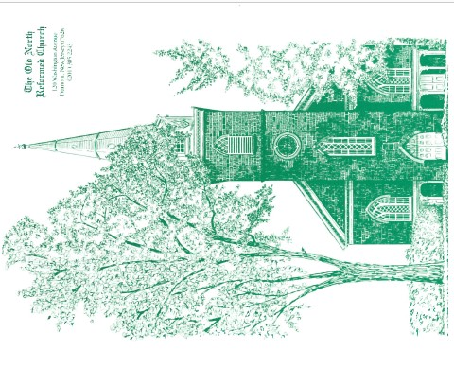 **OUR RESPONSE TO GOD**

**THE WORSHIP OF GIVING:** OUR OFFERINGS TO GOD

* **DOXOLOGY #809** (The Worshiping Church hymnal)

*“Praise God from whom all blessings flow. Praise God all creatures here below.*

*Praise God above, ye heavenly host: Praise Father, Son and Holy Ghost. Amen.”*

* PRAYER OF DEDICATION OF OUR GIFTS AND TITHES

PRAYERS OF THE PEOPLE AND **THE LORD’S PRAYER**

*Our Father, who art in heaven, Hallowed be thy name*

*Thy kingdom come. Thy will be done on earth as it is in heaven.*

*Give us this day our daily bread, and forgive us our debts,*

*as we forgive our debtors,*

*and lead us not into temptation, but deliver us from evil.*

*For thine is the kingdom, and the power, and the glory, forever. Amen.*

* **HYMN # 289 “Holy Spirit, Ever Dwelling”**

* PASTORAL BENEDICTION

POSTLUDE  “Postlude in D”            C. Armstrong Gibbs

The Reverend Leah Ennis graduated (and was ordained) in 2013. She has held both chaplain and pastoral roles. Currently Leah works as a Teacher's Assistant through Bergen County Special Services and as a project manager at Hudson River Care and Counseling Center working with spiritual and religious abuse survivors. Leah is mom to Zechariah

(3.5 years). They reside with their cats in New Milford, New Jersey.

* Congregation Standing as able. **BOLD** indicates congregation’s participation.

*Indicates materials used from “Seasons of the Spirit”©.

**THE CONSISTORY OF OLD NORTH**

Elders: Karen DiBella (2022) Scott Benell (2023) Carol Sushko (2023, 2nd term)

Deacons: Brianna Polbos (2024) John Passarotti (2022) Richard Schmude (2023)

Minister: Rev. Susan Kerr (Parsonage) 201-338-8237; [revskerr@gmail.com](mailto:revskerr@gmail.com)