**9:30 a.m. PENTECOST Year A May 31, 2020**

The Reverend Susan E. Kerr Mr. Alan Newman

Minister and Pastor Organist and Music Director

* **Bold words indicate unison participation.**

*\*Indicates worship material from Seasons of the Spirit©.*

**Note: The worship service is available on YouTube (subscribe to Old North Reformed Church Dumont NJ), and on Facebook.**

**OUR APPROACH TO GOD**

PRELUDE “**Spirit of the Living Lord”    Robert Thygerson**

WELCOME AND ANNOUNCEMENTS

**CONGREGATIONAL INTROIT #496 “GIVE THANKS WITH A GRATEFUL HEART”**

<https://www.youtube.com/watch?v=5waffTnMH6g>

CALL TO WORSHIP Psalm 104:24-35

Leader: How many are your works, O LORD!   
**ALL: In wisdom you made them all;**

**the earth is full of your creatures.**

Leader: There is the sea, vast and spacious,   
       teeming with creatures beyond number—   
**ALL: living things both large and small.**

Leader: There the ships go to and fro,   
       and the leviathan, which you formed to frolic there.

**ALL: These all look to you   
       to give them their food at the proper time.**

Leader: When you give it to them,   
       they gather it up;   
**ALL: when you open your hand,   
       they are satisfied with good things.**

Leader:  When you hide your face, they are terrified;   
**ALL: when you take away their breath,   
       they die and return to the dust.**

Leader:  When you send your Spirit, they are created,   
**ALL: and you renew the face of the earth.**

Leader:  May the glory of the LORD endure forever;   
**ALL: may the LORD rejoice in his works-**

Leader:  he who looks at the earth, and it trembles,   
**ALL: who touches the mountains, and they smoke.**

Leader: I will sing to the LORD all my life;   
**ALL: I will sing praise to my God as long as I live.**

Leader:  May my meditation be pleasing to him,   
       as I rejoice in the LORD.

**ALL: But may sinners vanish from the earth   
       and the wicked be no more.   
       Praise the LORD, O my soul.   
       Praise the LORD.**

### UNISON GATHERING PRAYER

Gather us, O God, Body, Spirit, Soul, Mind;

Gather us, O God,

One in union now with You.

SALUTATION AND **SHARING the Peace**

Leader: Peace be with you; **ALL:** **AND ALSO WITH YOU.**

* **HYMN #694**  v.1-3  **“GLORIOUS THINGS OF THEE ARE SPOKEN”**

<https://www.youtube.com/watch?v=RTpaIi6Uhi4>

CHILDREN’S MESSAGE

Invitation, **UNISON PRAYER of Confession**\*

Spirit of God, Your power blows in our world,

across the Earth, and into our lives.

Forgive us when we do not receive Your Spirit with gratitude.

Spirit of God, You bring light to our world,

You energize the Earth, and inspire us with goodness.

Forgive us when we snuff out Your presence with our

gracelessness.  *(pause for reflection and self-examination)*

KYRIE ELEISON (sung) #444 “Into My Heart”

<https://www.youtube.com/watch?v=8tWzfX66lCg>

Into my heart, into my heart, come into my heart, Lord Jesus;

Come in today, come in to stay, come into my heart, Lord Jesus.

ASSURANCE OF FORGIVENESS

Jesus said, “Peace be with you,” and then breathed out his spirit. “If you forgive the sins of any, they are forgiven them.”

Receive the Spirit of God and may the flame of forgiveness

blow freely within you. **ALL: Thanks be to God; Amen.**

THE LAW OF GOD; THE TEACHING OF CHRIST John 13:34

* GLORIA PATRI (spoken)

***Glory be to the Father and to the Son and to the Holy Ghost!***

***As it was in the beginning, is now and ever shall be,***

***world without end; Amen, Amen.***

**THE WORD OF GOD**

PRAYER FOR ILLUMINATION

SCRIPTURE READINGS Acts 2:1-21 John 7:37-39

**SERMON HYMN #304 “COME DOWN, O LOVE DIVINE”**

https://www.youtube.com/watch?v=zXO4rqBQOAU

SERMON  “Everyone?!” Pastor Susan

**OUR RESPONSE TO GOD**

THE WORSHIP OF GIVING: OUR OFFERINGS TO GOD

*We are thankful to and grateful for all who continue to provide your offerings in support of Old North and her ministries by dropping off or mailing your envelopes.*

*Offerings may also be given via our website by PayPal or credit card, at https://oldnorth.church*

* Dedication of our Gifts and Tithes

PRAYERS OF THE PEOPLE AND THE LORD’S PRAYER

*Our Father, who art in heaven, Hallowed be thy name.*

*Thy kingdom come. Thy will be done on earth as it is in heaven. Give us this day our daily bread, and forgive us our debts, as we forgive our debtors, and lead us not into temptation, but deliver us from evil. For thine is the kingdom, and the power, and the glory, forever. Amen.*

* **HYMN “GO FORTH FOR GOD”**

<https://www.youtube.com/watch?v=ao8rgsk5i7k>

BENEDICTION

**POSTLUDE  “Chaconne”                 Louis Couperin**

THE CONSISTORY OF OLD NORTH

Elders: Gay Gravina (2022), Carol Sushko (2020),

Leslie Maro (2020), Karen DiBella (2022)

Deacons: Betsy Erhard (2021), Brianna Polbos (2021),

Ralph Condis (2022), John Passarotti (2022)

Minister: Rev. Susan Kerr (Parsonage) 201-338-8237; [revskerr@gmail.com](mailto:revskerr@gmail.com)

Please visit our website at <https://oldnorth.church>

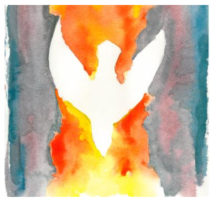

Old North Reformed Church

120 Washington Avenue, Dumont, New Jersey 07628

201-385-2243 [oldnorthdumont@gmail.com](mailto:oldnorthdumont@gmail.com)

Website - https://oldnorth.church

*Crossword Puzzle*

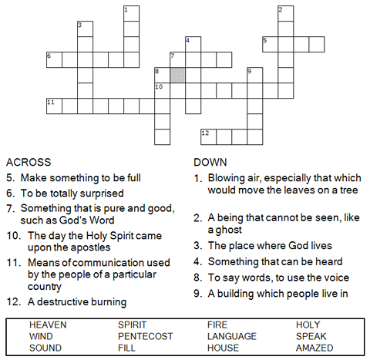



Copyright © Sermons4Kids, Inc.

May be reproduced for Ministry Use

Children’s Worship Bulletin

Filled with the Holy Spirit

Acts 2:1-21

*Word Search Puzzle*

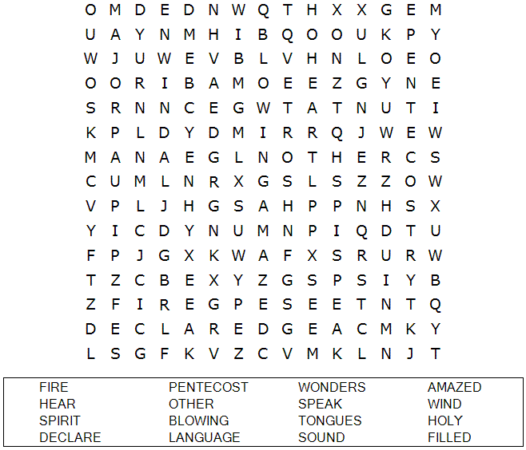

**OLD NORTH REFORMED CHURCH**

<https://oldnorth.church>

*Multiple Choice Quiz*

Choose the word that best matches the definition.  
Check your answers in Acts 2:1-21 (NIV)

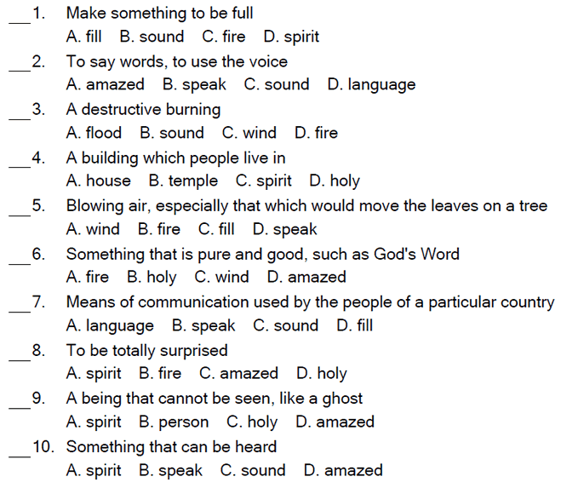

All of them were filled with the Holy Spirit and began to speak in other tongues as the Spirit enabled them.

Acts 2:4 (NIV)

*Word Jumble*

Unscramble each word and then place the numbered letters  
in the numbered boxes at the bottom to reveal the answer.

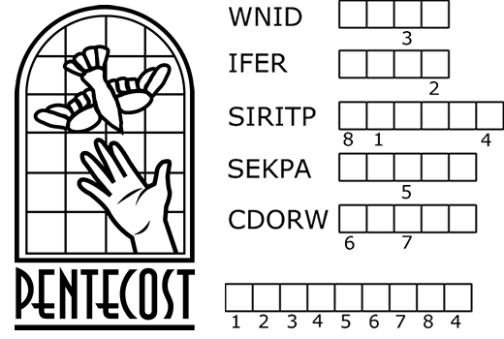

|  |
| --- |
| **PUZZLE CLUES** |
| 1. A sound like the blowing of a violent _______ came from heaven. |
| 2. They saw what seemed to be tongues of ______. |
| 3. All of them were filled with the Holy _______. |
| 4. They began to ______ in other tongues as the Spirit enabled them. |
| 5. Peter stood up and spoke to the ______ of people. |
| Answer: All of these events took place on the day of _____________. |
| Check your answers in Acts 2:1-14 (NIV) |