9:30 a.m. Pentecost Sunday+3, Year C June 26, 2022

***Welcome to Old North.*** *We are pleased you chose to worship with us today!*

The Reverend Susan E. Kerr Mr. Alan Newman

Minister and Pastor Organist and Music Director

*We welcome as guest minister this morning the Rev. Melchior Van Hattem.  “Mel” is a retired RCA pastor in our Classis who continues to specialize in Parent Enrichment Ministry, Young Adult Ministry, and Congregational Development.*

**OUR APPROACH TO GOD**

PRELUDE and CHIMES “When I Survey the Wondrous Cross”    Albin Whitworth

                    “O Lamb of God, I Come”                   Eduard  Broughton

                    “Adagio  in E Major”                                  Frank Bridge

ANNOUNCEMENTS and VOTUM

**CONGREGATIONAL INTROIT #383, vs.1 “FOR BEAUTY OF MEADOWS”**

**UNISON CALL TO WORSHIP** (based on Ephesians 4)

      We are here to commune in spirit with Christ,

      so we can lead a life worthy of the calling we have received,

      so we can sense better how to enrich life with one another in love,

      so we build wholesome bonds of admiration, friendship and encouragement.

      Let us worship our saving, enriching, and revitalizing Lord.

**UNISON GATHERING PRAYER:\***

We come to this place to be fed by God’s word, to be nurtured by God’s grace, and to be strengthened by the power of God’s Spirit.

Speak to us in this time of worship, O God, that we might recognize the abundance of your goodness, and find in your presence the things that sustain us. Amen.

SALUTATION AND **SHARING of the Peace** *(Remain seated.)*

L: Peace be with you! **ALL:** **AND ALSO WITH YOU!**

* **HYMN #492 “I WILL SING OF MY REDEEMER”**

INVITATION AND **UNISON PRAYER OF CONFESSION**

    Lord, we need your help to get away from media that increases attitudes of suspicion,

criminality, hatred, anger, frustration, and animosity… and violence as a solution.

We want your help in promoting and choosing programs that build renewal and

redeeming attitudes within us so we can live a more Christ-like life.

 So we are here to get more awareness of how we can be those persons who:

-    See opportunities to cultivate good hopes in people.

-    Don’t miss out on opportunities to express comfort and healing for hearts and

souls, and ways they can step into a fulfilling future.

-    Don’t miss out on being interpreters about society to our loved ones who help

them sort out what to discard and what to pursue to live the fulfilling life you, God,

see for them and us.

-    Don’t miss out on opportunities to be developers of people’s potential so they can

enjoy the fullness of God’s good vision and will for their lives.

So we bring before you our relationships and dialogues, our opportunities for hugs,

our secret hopes, that you may renew and increase our thoughts and actions for spirit-

enriched holistic living.  Amen. (*time of silent reflection)*

**KYRIE ELEISON (sung) #444**“Into My Heart”

*Into my heart, into my heart, come into my heart, Lord Jesus;*

*Come in today, come in to stay, come into my heart, Lord Jesus.*

ASSURANCE OF GOD’S REDEEMING GRACE Acts 2:28,38

L: Be in touch with God and He will give you His empowering spirit.

**All: God has shown us the path of life. He is near us to enrich always, and brings a**

**fulfilling joy.**

**THE LAW OF GOD**

* **GLORIA PATRI #805**

*Glory be to the Father and to the Son and to the Holy Ghost! As it was in the*

*beginning, is now and ever shall be, world without end; Amen, Amen.*

**THE WORD OF GOD**

PRAYER FOR ILLUMINATION

READING OF THE SCRIPTURES Galatians 5:1, 19-25

**SERMON HYMN** **#574 “LORD, SPEAK TO ME, THAT I MAY SPEAK”** *(remain seated)*

SERMON  The Rev. Melchior Van Hattem

“God’s Spirit leads to vitality and release from what holds us back from a fulfilling life.”

**OUR RESPONSE TO GOD**

**THE WORSHIP OF GIVING:** OUR OFFERINGS TO GOD

* **DOXOLOGY #809** (The Worshiping Church hymnal)

*“Praise God from whom all blessings flow. Praise God all creatures here below.*

*Praise God above, ye heavenly host: Praise Father, Son and Holy Ghost. Amen.”*

* PRAYER OF DEDICATION OF OUR GIFTS AND TITHES

PRAYERS OF THE PEOPLE AND **THE LORD’S PRAYER**

*Our Father, who art in heaven, Hallowed be thy name*

*Thy kingdom come. Thy will be done on earth as it is in heaven.*

*Give us this day our daily bread, and forgive us our debts,*

*as we forgive our debtors,*

*and lead us not into temptation, but deliver us from evil.*

*For thine is the kingdom, and the power, and the glory, forever. Amen.*

* **HYMN #558 “LOVE DIVINE, ALL LOVES EXCELLING”**

* PASTORAL BENEDICTION

POSTLUDE “Open Now Thy Gates of Beauty”        Eduard Broughton

* Congregation Standing as able. **BOLD** indicates congregation’s participation.

*Indicates materials used from “Seasons of the Spirit”©.

**THE CONSISTORY OF OLD NORTH**

Elders: Karen DiBella (2022) Scott Benell (2023) Carol Sushko (2023, 2nd term)

Deacons: Brianna Polbos (2024) John Passarotti (2022) Richard Schmude (2023)

Minister: Rev. Susan Kerr (Parsonage) 201-338-8237; [revskerr@gmail.com](mailto:revskerr@gmail.com)

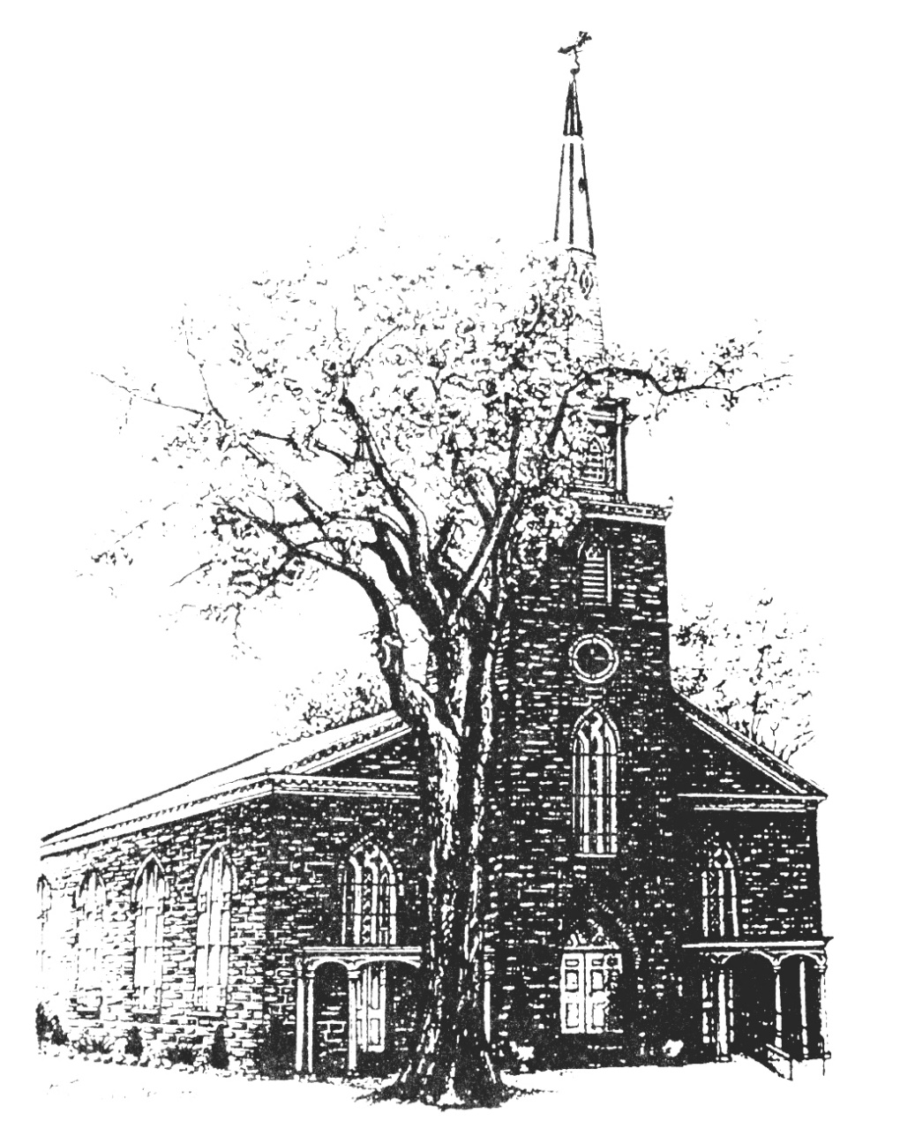

**Old North Reformed Church**

120 Washington Avenue, Dumont, New Jersey 07628

201-385-2243 [oldnorthdumont@gmail.com](mailto:oldnorthdumont@gmail.com)

<https://oldnorth.church>

***Welcome to worship at Old North Reformed Church!***

*If you would like to be added to our mailing list, please leave your contact*

*information in the guest book before leaving today.*

**We encourage you to keep this copy of the liturgy and take it home to**

**share** **with a member of your family, or with a friend.**

**Flowers: If you would like to dedicate flowers for Sunday worship, sign up sheet is in the Auditorium or contact the office. The cost is $45.00.**



We are now in the season of the Church year following Pentecost referred to as Ordinary Time. The parament color is green, which means life and growth. In this season we celebrate the life and teachings of Jesus and what it means to us to be his disciples.

**Prayer Chain:** If you wish to add the power of prayer in times of celebration, healing, or transitions in life, please call Pat Hooey, 201-843-4456.

Your prayer requests are uplifted by our prayer team, and confidentiality is honored.



**Church Family Prayer List:**

**●Adrianne ●Barbara ●Katie ●Nancy**

Uplift those undergoing medical procedures and thanksgiving for those who are recovering; comfort for those in mourning; strength for those fighting cancer and for all caregivers; those seeking spiritual and emotional well-being, those with addictions, and those seeking or beginning new employment. Pray for Peace.

If you are able to supply goodies for fellowship after worship,

please sign up for a Sunday in the Auditorium. We need your support!





Scheduled to serve today… with our thanks:

**Greeters: Marianne & Nate Schmude**

**Coffee Hour: Sign up to bring something and help**

**out our Fellowship Committee.**

|  |  |  |  |  |  |
| --- | --- | --- | --- | --- | --- |
|  |  |  |  |  |  |



**GREETERS FOR SUNDAY WORSHIP:** We have resumed Ushering & Greeting on Sundays! If you would like to be added to the rotation please contact the office. There is a sign up sheet in the Auditorium.

**Congratulations to all of our Church Family who are celebrating a special event!**

**Happy Birthday!**

6/26 Nancy Benell - 7/1 Emily Frohlich – 7/2 Jena Rand Babicz

 7/8 Raymond Lomupo - 7/13 Emma Passarotti – 7/16 Ethan Benell

7/16 Nicholas DiBella – 7/16 Raymond Ruffley – 7/19 Barbara Porter

7/20 Toshiko Sato – 7/20 Mikayla Schmude – 7/25 Jonathan Messina

7/26 John Connolly – 7/27 Diane Huth – 7/27 John Passarotti

**Happy Anniversary!**

6/29 Alan & Shirley Newman – 7/22 Bob & Marilyn Hashway

7/23 Terry & Kate Kenny

**Congratulations to our Confirmands!**

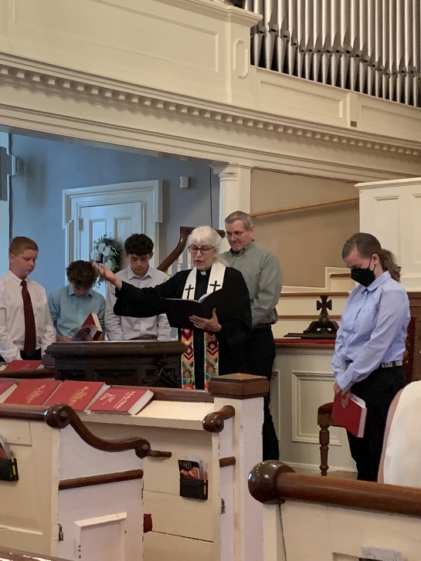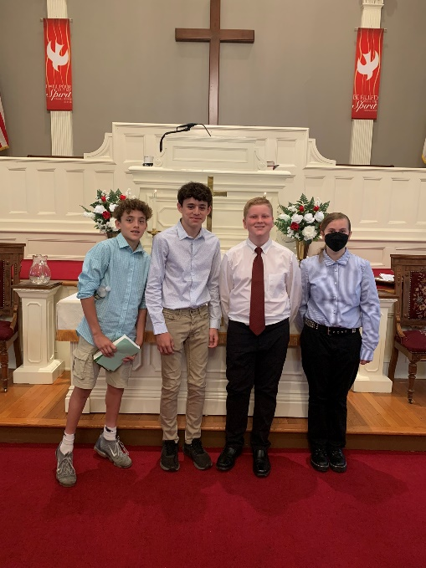

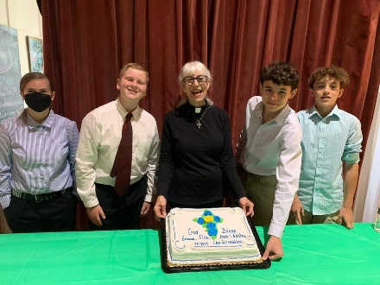

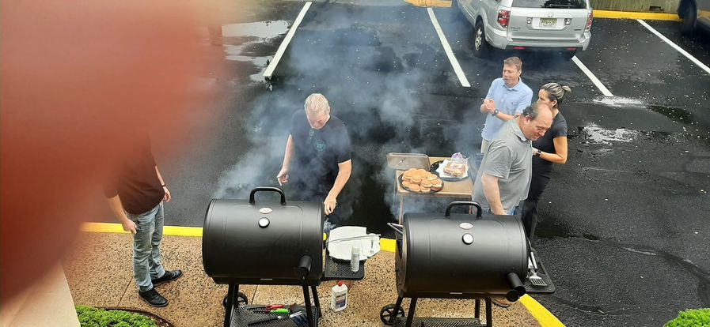**CHURCH PICNIC:** A special thank you to our Fellowship Committee and the Benells for all their hard work and preparation that made our picnic a success!

**TUESDAY TODDLERS**: We had a great experience meeting new people and serving your families! **We will need a new coordinator leader for the fall; please see Pastor Susan asap with questions.**

**THRIFT SHOPPE:** Thank you to all of our volunteers! It has been an amazing season and we look forward to continuing this mission. Enjoy the month off from your hard work here at Old North. We will not be accepting donations for the month of July, but look forward to another wonderful kick-off in September! Contact Kathleen West if you would like to join the team of volunteers!

**MID-YEAR CONGREGATIONAL CHECK-IN:** Join us following worship

on July 10th. Get all the info on where we are, what’s going on,

and where God is leading us next!

Your attendance will ensure that you get accurate information.

Sign up sheet for Pot Luck lunch is in the Auditorium or call the office.

