9:30 a.m. Pentecost Sunday+4, Year C July 3, 2022

Welcome to Old North. We are pleased you chose to worship with us today!

The Reverend Susan E. Kerr Mr. Alan Newman
Minister and Pastor Organist and Music Director

OUR APPROACH TO GOD

PRELUDE and CHIMES “General Washington’s March” Francis Hopkinson
“Variations on America” Charles Ives

ANNOUNCEMENTS and VOTUM

CONGREGATIONAL INTROIT # 629 “LORD, LISTEN TO YOUR CHILDREN PRAYING

CALL TO WORSHIP*
Leader: Through prophets, rulers, and leaders,
All: God passes on the story to the world.

Leader: Through disciples and apostles and followers,
All: God passes on the story to the world.

Leader: Through saint and reformer and mystic,
All: God passes on the story to the world.

Leader: Through you and me and us,
All: God passes on the story to the world.

Leader: Come, let us worship God, and continue the story.

UNISON GATHERING PRAYER:*
God of wisdom and wonder, we gather in this place as prophets and disciples,
as people led by Your Spirit, and as humble followers seeking to do Your will.
Called here by Your love, we come to be renewed in our faith and go from here
ready to serve You again. Open us to Your Spirit, we pray. Amen.

SALUTATION AND SHARING of the Peace (Remain seated.)
L: Peace be with you! ALL: AND ALSO WITH YOU!

- HYMN #262 “REJOICE, THE LORD IS KING”

CHILDREN’S MESSAGE

INVITATION AND UNISON PRAYER OF CONFESSION
Leader: For freedom Christ has set us free.
All: Yet at times we use our freedom for self-indulgence.
Forgive us, God.

Leader: You have called us to love one another,
All: and yet sometimes it seems we would rather snap at one
another. Forgive us, God.

Leader: Often we would rather be guided by what we want
All: rather than what You want. Forgive us, God.

Leader: Transform us by Your Spirit and make us new,
All: we pray in Christ’s name. (time of silent reflection)

KYRIE ELEISON (sung) #444 “Into My Heart”
Into my heart, into my heart, come into my heart, Lord Jesus;
Come in today, come in to stay, come into my heart, Lord Jesus.

ASSURANCE OF GOD’S REDEEMING GRACE Acts 2:28,38
L: Be in touch with God and He will give you His empowering spirit.
All: God has shown us the path of life. He is near us to enrich always, and brings a
fulfilling joy.

THE LAW OF GOD

- GLORIA PATRI #805
Glory be to the Father and to the Son and to the Holy Ghost! As it was in the
beginning, is now and ever shall be, world without end; Amen, Amen.

THE WORD OF GOD
PRAYER FOR ILLUMINATION

READING OF THE SCRIPTURES 2 Kings 5:1-14 Luke 10:1-11, 16-20

SERMON HYMN #417 “MY COUNTRY, ‘TIS OF THEE” (remain seated)

SERMON “Victory and Healing” The Rev. Susan Kerr

OUR RESPONSE TO GOD

THE WORSHIP OF GIVING: OUR OFFERINGS TO GOD

- DOXOLOGY #809 (The Worshiping Church hymnal)
“Praise God from whom all blessings flow. Praise God all creatures here below.
Praise God above, ye heavenly host: Praise Father, Son and Holy Ghost. Amen.”

- PRAYER OF DEDICATION OF OUR GIFTS AND TITHES

- AFFIRMATION OF FAITH: The Apostles’ Creed HYMNAL #14

CELEBRATION OF THE LORD’S SUPPER Insert

PRAYER AFTER COMMUNION (UNISON)
Gracious Host, thank You for showing us again
that we are invited to live and work in Your reign
as honored guests. May our faith grow to bear
the full measure of Your grace,
bringing a lightness to our labors,
and a wonder to our work. Amen.

PRAYERS OF THE PEOPLE AND THE LORD’S PRAYER
Our Father, who art in heaven, Hallowed be thy name
Thy kingdom come. Thy will be done on earth as it is in heaven.
Give us this day our daily bread, and forgive us our debts,
as we forgive our debtors,
and lead us not into temptation, but deliver us from evil.
For thine is the kingdom, and the power, and the glory, forever. Amen.

- HYMN #777 “THE LORD IS HERE!”

- PASTORAL BENEDICTION

POSTLUDE “American Fantasy” Roland Diggle

- Congregation Standing as able. BOLD indicates congregation’s participation.
*Indicates materials used from “Seasons of the Spirit”©.

THE CONSISTORY OF OLD NORTH
Elders: Karen DiBella (2022) Scott Benell (2023) Carol Sushko (2023, 2nd term)
Deacons: Brianna Polbos (2024) John Passarotti (2022) Richard Schmude (2023)
Minister: Rev. Susan Kerr (Parsonage) 201-338-8237; revskerr@gmail.com

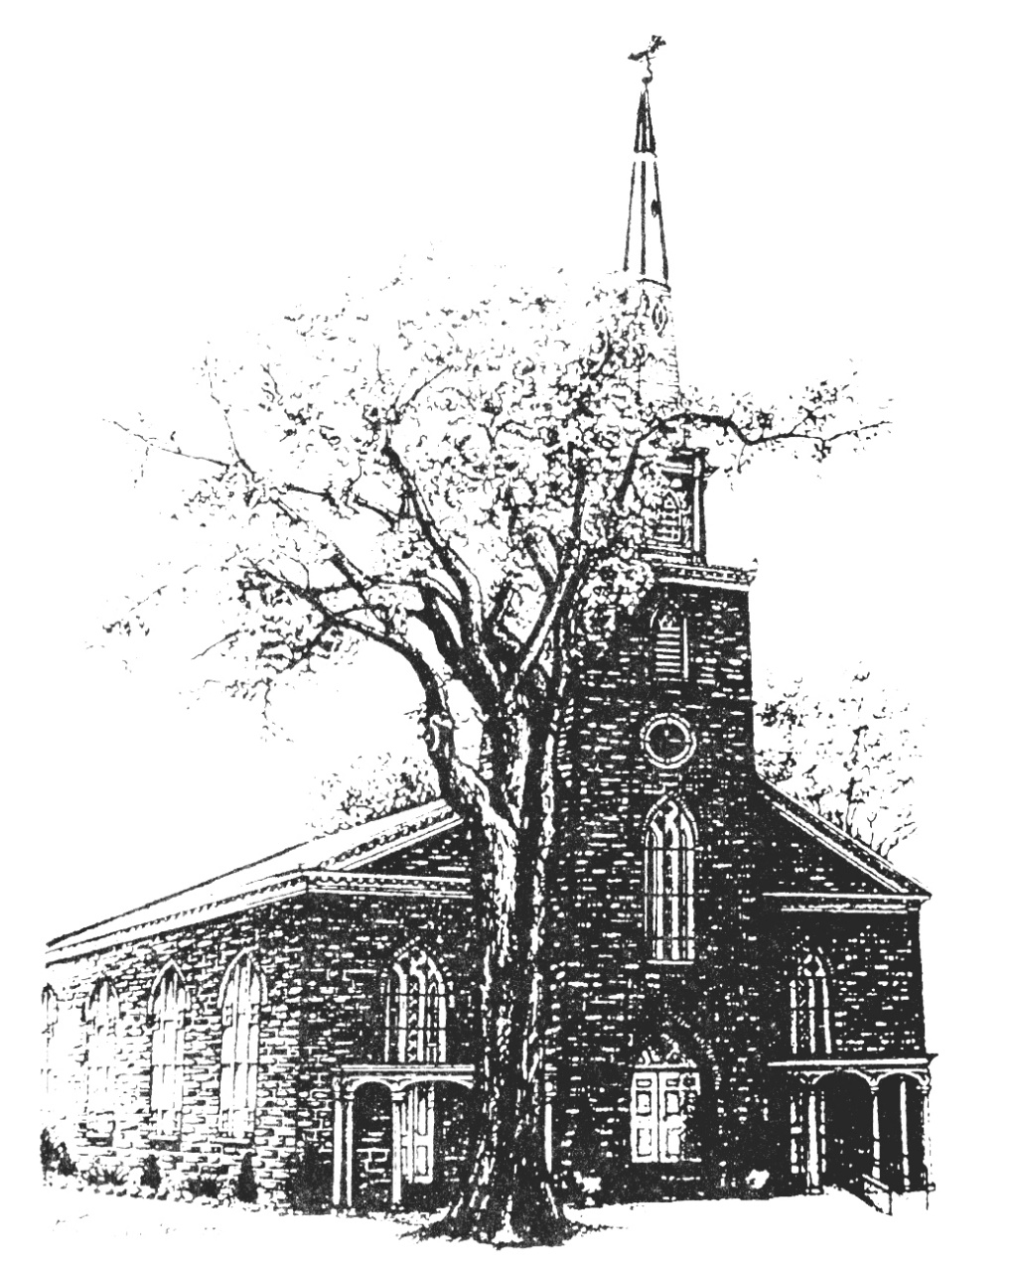

Old North Reformed Church
120 Washington Avenue, Dumont, New Jersey 07628
201-385-2243 oldnorthdumont@gmail.com
https://oldnorth.church

Welcome to worship at Old North Reformed Church!
If you would like to be added to our mailing list, please leave your contact
information in the guest book before leaving today.

We encourage you to keep this copy of the liturgy and take it home to
share with a member of your family, or with a friend.

Flowers: If you would like to dedicate flowers for Sunday worship, sign up sheet is in the Auditorium or contact the office. The cost is $45.00.
The consistory is already looking ahead to the 2023 church budget. As per the recent General Synod the total per-member General Synod assessment for 2023 is set at $55.58. That is in addition to the Regional Synod and Classis assessments. The 2023 Partnership-in-Mission share in support of our missionary
family in Oman is set at $6,900.

Prayer Chain: If you wish to add the power of prayer in times of celebration, healing, or transitions in life, please call Pat Hooey, 201-843-4456.
Your prayer requests are uplifted by our prayer team, and confidentiality is honored.

Church Family Prayer List:
●Adrianne ●Barbara ●Katie ●Nancy
Uplift those undergoing medical procedures and thanksgiving for those who are recovering; comfort for those in mourning; strength for those fighting cancer and for all caregivers; those seeking spiritual and emotional well-being, those with addictions, and those seeking or beginning new employment. Pray for Peace.

If you are able to supply goodies for fellowship after worship,
please sign up for a Sunday in the Auditorium. We need your support!

Scheduled to serve today… with our thanks:

Ushers & Greeters: Scott & Ethan Benell
Coffee Hour: Helen Berthold

Looking Ahead……….
July 10 Kathleen West, Nancy Gorman
17 Donair Karkkainen, Marianne Schmude
24 Jack & Betsy Erhard
31 Nicolas & Ashton DiBella

Congratulations to all of our Church Family who are celebrating a special event!
Happy Birthday!
7/1 Emily Frohlich – 7/2 Jena Rand Babicz
7/8 Raymond Lomupo - 7/13 Emma Passarotti – 7/16 Ethan Benell
7/16 Nicholas DiBella – 7/16 Raymond Ruffley – 7/19 Barbara Porter
7/20 Toshiko Sato – 7/20 Mikayla Schmude – 7/25 Jonathan Messina
7/26 John Connolly – 7/27 Diane Huth – 7/27 John Passarotti
Happy Anniversary!
7/22 Bob & Marilyn Hashway – 7/23 Terry & Kate Kenny

Congratulations to our Grimes-Spring Fund Scholarship recipients!
Ethan Benell and Isabella Marti.

TUESDAY TODDLERS: We had a great experience meeting new people and serving your families! We will need a new coordinator leader for the fall; please see Pastor Susan asap with questions.

THRIFT SHOPPE: Thank you to all of our volunteers! It has been an amazing season and we look forward to continuing this mission. Enjoy the month off from your hard work here at Old North. We will not be accepting donations for the month of July, but look forward to another wonderful kick-off in September! Contact Kathleen West if you would like to join the team of volunteers!

SUMMER GIVING: We pray that the summer months will be refreshing for you as things slow down a bit and vacations are taken. Please remember your support of the church, however. Bills still need to be paid. Thank you!
Half-year giving statements are available upon request for your own book-keeping and discernment processes. Our budget projections for 2023 begin in September. Your faithful support, in every sense, reflects your dedication to the health of this congregation as we live together and bring the love of Jesus into a hurting world so loved by God. Your donations make a real difference! Have you remembered the church in your will?

MID-YEAR CONGREGATIONAL CHECK-IN: Join us following worship
on July 10th. Get all the info on where we are, what’s going on,
and where God is leading us next!
The Bode Family, our Oman Missionaries, will be joining us for worship followed by a brief presentation as a kick off to our Mid-Year Meeting.
Your attendance will ensure that you get accurate information.
Sign up sheet for Pot Luck lunch is in the Auditorium or call the office.

