9:30 a.m. Pentecost Sunday+9, Year C August 7, 2022

Welcome to Old North. We are pleased you chose to worship with us today!

The Reverend Soo Kim Mr. Alan Newman
Guest Minister Organist and Music Director

- Congregation Standing as able. BOLD indicates congregation’s participation.
*Indicates materials used from “Seasons of the Spirit”©.

OUR APPROACH TO GOD

PRELUDE and CHIMES “Hornpipe” Robert Roesch
“In Summer” Charles Stebbins
“Open My Eyes” Van Denman Thompson
ANNOUNCEMENTS and VOTUM

CONGREGATIONAL INTROIT: #4 “FATHER, I ADORE YOU”
1. *Father, I adore you; *lay my life before you. *How I love you!
*2. Jesus, I adore you!… *3. Spirit, I adore you!…

CALL TO WORSHIP
South Aisle: Come, family of God.
North Aisle: Gather in God, O faithful ones.
ALL: The heavens declare God’s righteousness.

South Aisle: Come, brothers and sisters in Christ.
North Aisle: Gather in God, O faithful ones.
ALL: The heavens declare God’s righteousness.

South Aisle: Come, you of every age.
North Aisle: Gather in God, O faithful ones.
ALL: The heavens declare God’s righteousness.

UNISON GATHERING PRAYER:*
Faithful God,
here in the middle of a season, strengthen our spirits.
May we tap into the strong root of faith
and trust your love and grace now,
and into the future that is yet to be revealed. Amen.

SALUTATION AND SHARING of the Peace (Remain seated.)
L: Peace be with you! ALL: AND ALSO WITH YOU!

- HYMN #45 “Come, Thou Fount of Every Blessing”

CHILDREN’S MESSAGE

INVITATION AND UNISON PRAYER OF CONFESSION
Grant unto us, O Lord, the fullness of your promises.
Where we have been weak, grant us your strength.
Where we have been confused, grant us your guidance.
Where we have been distraught, grant us your comfort.
Where we have been dead, grant us your life.
Apart from you, O Lord, we are nothing; in and with you we can do all things.
In your mercy, we trust and pray. (Silent reflection)

KYRIE ELEISON (sung) #629 “LORD, LISTEN TO YOUR CHILDREN PRAYING”
Lord, listen to your children praying; Lord, send your Spirit in this place;
Lord, listen to your children praying; Send us power, send us love, send us grace.

ASSURANCE OF GOD’S REDEEMING GRACE
Jesus promises that he will open our eyes, heal our hurts and brokenness, and lead us to newness of life. Trust him and his promises, and live in his presence.
ALL RESPOND: Thanks be to God. Amen.

THE LAW OF GOD

- GLORIA PATRI #805
Glory be to the Father and to the Son and to the Holy Ghost! As it was in the
beginning, is now and ever shall be, world without end; Amen, Amen.

THE WORD OF GOD
PRAYER FOR ILLUMINATION

READING OF SCRIPTURE John 21:4-14

SERMON HYMN #514 “Blessed Assurance, Jesus is Mine” (remain seated)

SERMON “Discover Your Greatest Calling” The Rev. Soo Kim

OUR RESPONSE TO GOD

THE WORSHIP OF GIVING: OUR OFFERINGS TO GOD

- DOXOLOGY #809 (The Worshiping Church hymnal)
“Praise God from whom all blessings flow. Praise God all creatures here below.
Praise God above, ye heavenly host: Praise Father, Son and Holy Ghost. Amen.”

- PRAYER OF DEDICATION OF OUR GIFTS AND TITHES

- AFFIRMATION OF FAITH: The Apostles’ Creed HYMNAL #14

CELEBRATION OF THE LORD’S SUPPER Insert

PRAYER AFTER COMMUNION (UNISON)
Gracious Host, thank You for showing us again
that we are invited to live and work in Your reign
as honored guests. May our faith grow to bear
the full measure of Your grace,
bringing a lightness to our labors,
and a wonder to our work. Amen.

PRAYERS OF THE PEOPLE AND THE LORD’S PRAYER
Our Father, who art in heaven, Hallowed be thy name
Thy kingdom come. Thy will be done on earth as it is in heaven.
Give us this day our daily bread, and forgive us our debts,
as we forgive our debtors,
and lead us not into temptation, but deliver us from evil.
For thine is the kingdom, and the power, and the glory, forever. Amen.

- HYMN #520 “Tis So Sweet to Trust in Jesus”
=
PASTORAL BENEDICTION

POSTLUDE “Festival March” J. Alfred Schehl

THE CONSISTORY OF OLD NORTH
Elders: Karen DiBella (2022) Scott Benell (2023) Carol Sushko (2023, 2nd term)
Deacons: Brianna Polbos (2024) John Passarotti (2022) Richard Schmude (2023)
Minister: Rev. Susan Kerr (Parsonage) 201-338-8237; revskerr@gmail.com

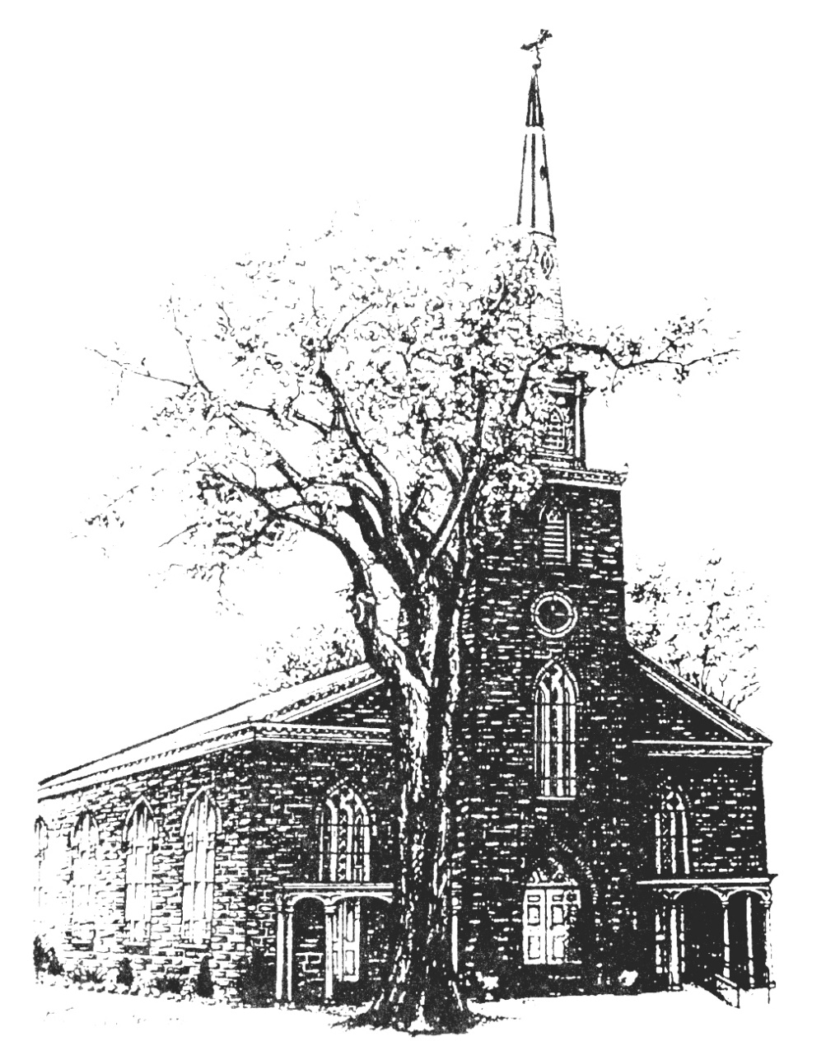

Old North Reformed Church
120 Washington Avenue, Dumont, New Jersey 07628
201-385-2243 oldnorthdumont@gmail.com
https://oldnorth.church

Welcome to worship at Old North Reformed Church!
If you would like to be added to our mailing list, please leave your contact
information in the guest book before leaving today.

We encourage you to keep this copy of the liturgy and take it home to
share with a family member or with a friend. The service can be experienced
anytime on line via Old North's YouTube channel or FaceBook page.

Flowers: The flowers on the chancel are given to the Glory of God by
Sandy Schwarz in loving memory of her Mom, Eleanor Schwarz.

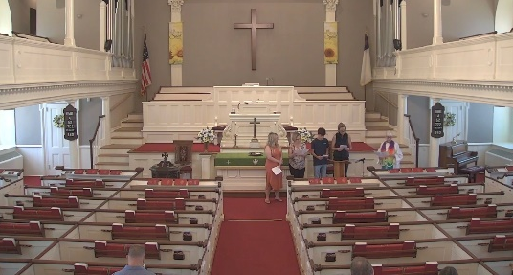
When our online worshippers watch from home, the Sanctuary appears empty because we are all seated behind what the camera shows. Consider moving up! Let the community know that there is a larger attendance.

Prayer Chain: If you wish to add the power of prayer in times of celebration, healing, or transitions in life, please call Pat Hooey, 201-843-4456.
Your prayer requests are uplifted by our prayer team, and confidentiality is honored.

Church Family Prayer List:
●Adrianne ●Barbara ●Katie ●Nancy ●Search Committee
Uplift those undergoing medical procedures and thanksgiving for those
who are recovering; comfort for those in mourning; strength for those fighting cancer and for all caregivers; those seeking spiritual and emotional well-being, those with addictions,
and those seeking or beginning new employment. Pray for Peace.

Scheduled to serve today… with our thanks:

Ushers & Greeters: Scott Benell, Karen DiBella, Nate Schmude
Please be sure to count and record attendance in the
Attendance Binder in the Narthex Podium.
Coffee Hour: Marilyn Hashway

Upcoming Ushers and Greeters……….
August 14 Marianne Schmude, Steven Cordova
21 Ethan Benell, Nancy Gorman
28 Linda Treacy, Donair Karkkainen

l

Congratulations to all of our Church Family who are celebrating a special event!
Happy Birthday!
8/2 Kate Kenny 8/4 Pat Hooey 8/13 Carol Sushko
8/17 Sandra Hooey 8/24 Sandra Toscano
Happy Anniversary!
8/6 John & Eleanor Woerner 8/17 John & Irene Yanick
8/21 Ryan & Brittany Bohan

RETIREMENT CELEBRATION FOR PASTOR SUSAN!

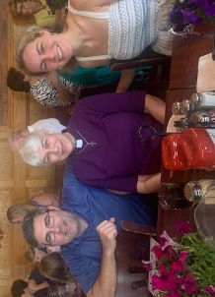
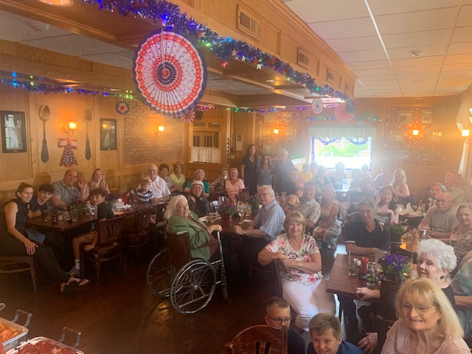

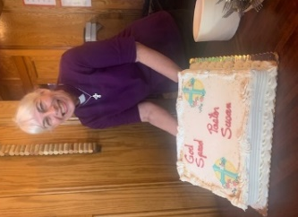

We are excited to participate again this year in the Back2School Outreach.
The program reaches out to underprivileged children.
We are accepting pencil cases filled with the items listed .Please drop your pencil cases in the bin in the Church House Hallway by Thursday, August 11th.
Pencil Case 2 Hole Pencil Sharpener Pack of Glue Stick Pink Erasers
Twelve #2 Pencils Pair of Safety Scissors Package of 24 Crayons

FOOD DRIVE: August 13th from 9:00 a.m. – Noon. Join Scott Benell if you would like to
help out.

SUMMER OFFICE HOURS: The office will be closed at Noon on Fridays for the summer.

SUMMER GIVING: We pray that the summer months will be refreshing for you as routines shift and vacations are taken. Please remember your support of the church, as well. Thank you!

