9:30 a.m. Pentecost + 13 Year C September 4, 2022

***Welcome to Old North.*** *We are pleased you chose to worship with us today!*

The Rev. Anna Jackson Mr. Alan Newman

Supervising Minister Organist and Music Director

***Today we are pleased to welcome Elder Diane Anderson***  ***into the pulpit.***

* Congregation Standing as able. **BOLD** indicates congregation’s participation.

*Indicates materials used from “Seasons of the Spirit”©.

**OUR APPROACH TO GOD**

PRELUDE and CHIMES

“Fanfare Prelude on “All Glory, Laud and Honor”     James Southbridge

                   “Interlude on “ Lead Us, O Father”                Joseph Clokey

                   “Spirit of the Living Lord”                        Robert Thygerson

ANNOUNCEMENTS and VOTUM

**CONGREGATIONAL INTROIT: #4** **“FATHER, I ADORE YOU”**

*1. *Father, I adore you; *lay my life before you. *How I love you!*

*\*2. Jesus, I adore you!… *3. Spirit, I adore you!…*

**VOTUM AND CALL TO WORSHIP\*** Psalm 1

LEADER: Happy are those who do not follow the advice of the wicked,  
**ALL: or take the path that sinners tread,**

LEADER: or sit in the seat of scoffers;  
**ALL: but their delight is in the law of the Lord, and on his law they**

**meditate day and night.**LEADER: They are like trees planted by streams of water,  
**ALL: which yield their fruit in its season, and their leaves do not wither.**LEADER: In all that they do, they prosper.

**ALL: The wicked are not so, but are like chaff that the wind drives away.**LEADER: Therefore the wicked will not stand in the judgment,  
**ALL: nor sinners in the congregation of the righteous;**LEADER: for the Lord watches over the way of the righteous,  
**ALL: but the way of the wicked will perish.**

**UNISON GATHERING PRAYER**

**As you search for us, O God, we seek you.**

**May our words be words of freedom,**

**Our lives be lived in justice,**

**And may our worship be one of spirited truth. Amen.**

SALUTATION AND **SHARING of the Peace** *(Remain seated)*

L: Peace be with you! **ALL:** **AND ALSO WITH YOU!**

* **HYMN #342**  **“HOW BLEST ARE THEY WHO, FEARING GOD”**

CHILDREN’S MESSAGE

**UNISON PRAYER OF CONFESSION\***

LEADER: With the life of Jesus as a vision before us, we recognize the ways we have

yet to be reflections of Christ.

Resting in your loving grace, O God, we consider our efforts…

**ALL: May we be more committed to justice;**

LEADER: O God, we consider our concerns…

**ALL: May we be more focused on the essentials;**

LEADER: O God, we consider our spirituality…

**ALL: May we be more free to live in the way of Jesus;**

LEADER: O God, we consider our actions…

**ALL: May we be more loving and compassionate;**

LEADER: O God, we consider our vision…

**ALL: May it be more challenging for your sake** *(Silent reflection)*

**KYRIE ELEISON (sung) #297**

***Spirit of the living God, fall afresh on me. Spirit of the living God, fall afresh on me.***

***Break me, melt me, mold me, fill me: Sprit of the living God, fall afresh on me.***

ASSURANCE OF GOD’S CONTINUING LOVE

LEADER: The Bible declares: “As far as the east is from the west, so far has God removed our sins from us”. Jesus came “preaching peace to those who are near, and peace to those who are a long way off.” My friends we are set free: to be a forgiven people, and to become a forgiving people in all our dealings with those who sin against us.

**ALL: Thanks be to God. Amen.**

THE LAW OF GOD

* **GLORIA PATRI #805**

*Glory be to the Father and to the Son and to the Holy Ghost! As it was in the*

*beginning, is now and ever shall be, world without end; Amen, Amen.*

**THE WORD OF GOD**

PRAYER FOR ILLUMINATION :

READING OF SCRIPTURE Luke 14:25-33

**SERMON HYMN** **#576** **“I HAVE DECIDED TO FOLLOW JESUS”**  *(remain seated)*

SERMON  “Are You Ready to Foot The Bill?” Elder Diane Anderson

**OUR RESPONSE TO GOD**

**THE WORSHIP OF GIVING:** OUR OFFERINGS TO GOD

* **DOXOLOGY #809** (The Worshiping Church hymnal)

*“Praise God from whom all blessings flow. Praise God all creatures here below.*

*Praise God above, ye heavenly host: Praise Father, Son and Holy Ghost. Amen.”*

* PRAYER OF DEDICATION OF OUR GIFTS AND TITHES

PRAYERS OF THE PEOPLE AND **THE LORD’S PRAYER**

*Our Father, who art in heaven, Hallowed be thy name*

*Thy kingdom come. Thy will be done on earth as it is in heaven.*

*Give us this day our daily bread, and forgive us our debts,*

*as we forgive our debtors,*

*and lead us not into temptation, but deliver us from evil.*

*For thine is the kingdom, and the power, and the glory, forever. Amen.*

* **HYMN #354 (vv. 1,3,5)** **”THE WORKS OF THE LORD ARE CREATED”**

PASTORAL BENEDICTION

POSTLUDE “Toccatina on “Duke Street”      Van Denman Thompson

* Please rise, in body or in spirit. **Bold words indicate unison participation.**

*Indicates materials used from “Seasons of the Spirit” ©.

*Diane Anderson-Butts is a native of Paterson, NJ and a member of United Presbyterian Church of Paterson. Diane is a proud graduate of the Graduate School of Social Services at Fordham University where she earned a master's degree in social work.  Diane recently retired as school social worker in NJ and continues working to provide Family-Based Mental Health services to families in rural Pennsylvania.*

*Married to Alfonso Butts, she is the mother to blended family of 6 adult children, and 3 grandchildren.  She currently resides in East Stroudsburg, Pa.*

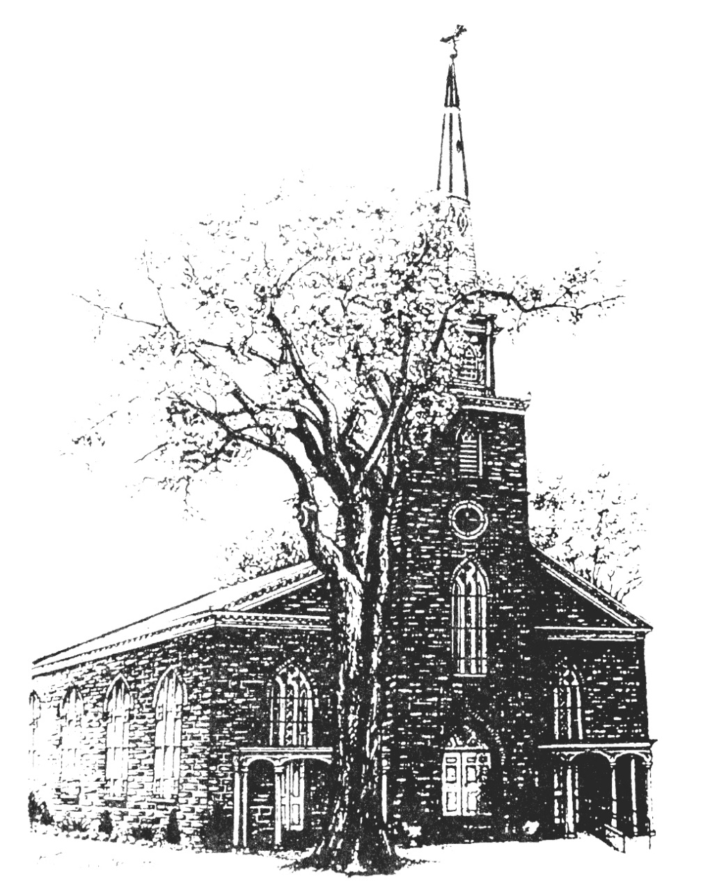

**Old North Reformed Church**

120 Washington Avenue, Dumont, New Jersey 07628

201-385-2243 [oldnorthdumont@gmail.com](mailto:oldnorthdumont@gmail.com)

<https://oldnorth.church>

**THE CONSISTORY OF OLD NORTH**

Elders: Karen DiBella (2022) Scott Benell (2023) Carol Sushko (2023, 2nd term)

Deacons: Brianna Polbos (2024) John Passarotti (2022) Richard Schmude (2023)

Classis supervising minister The Rev. Anna Jackson

***Welcome to worship at Old North Reformed Church!***

*If you would like to be added to our mailing list, please leave your contact*

*information in the guest book before leaving today.*

**We encourage you to keep this copy of the liturgy and take it home to**

 **share** **with a family member or with a friend. The service can be experienced**

**anytime on line via Old North's YouTube channel or FaceBook page.**

**Flowers:** The flowers on the chancel are given to the Glory of God.

*If you would like to dedicate flowers for Sunday worship, sign up*

*sheet is in the Auditorium or contact the office. The cost is $45.00.*

**

that you can access our Facebook page even if you do not have a Facebook account? Do a search for Old North Church Dumont, scroll down to the facebook link and click. You will be on our page!

**Prayer Chain:** If you wish to add the power of prayer in times of celebration, healing, or transitions in life, please call Pat Hooey, 201-843-4456.

Your prayer requests are uplifted by our prayer team, and confidentiality is honored.

**Church Family Prayer List:**

**●Adrianne ●Barbara ●Katie ●Nancy ●Search Committee**

Uplift those undergoing medical procedures and thanksgiving for those

who are recovering; comfort for those in mourning; strength for those fighting cancer and for all caregivers; those seeking spiritual and emotional well-being, those with addictions,

and those seeking or beginning new employment. Pray for Peace.



Scheduled to serve today… with our thanks:

**Ushers & Greeters:** Scott Benell, Karen DiBella, Ethan Cordova

**Please be sure to count and record attendance in the**

**Attendance Binder in the Narthex Podium.**

**Coffee Hour:** Fellowship Committee

Upcoming Ushers and Greeters……….

September 11 Jack & Betsy Erhard

18 Nicolas & Ashton DiBella

25 Kathleen West, Steven Cordova

|  |  |  |  |  |  |
| --- | --- | --- | --- | --- | --- |
|  |  |  |  |  |  |





L

**Congratulations to all of our Church Family who are celebrating a special event!**

9/5 Maureen Van Buren 9/9 Nancy Gorman 9/9 Shawn Gorman

9/17 Dawn Bennewitz 9/17 Jack Erhard 9/29 Eugene Reisser

**Happy Anniversary!**

9/9 Richard & Rhoda Suson

9/11 Scott & Nancy Benell 9/21 Hank & Nancy Gorman

9/18 Jon & Jenna Babicz

**9/10 - FOOD DRIVE:** Our next Food Drive will be on Saturday, 9/10. Perishable and non-perishable items will be collected for the Dumont Food Pantry.

**9/11 – Rally Day/1st Day of Sunday School:** The BBQ grills will be fired up! We will supply the hamburgers and hotdogs. There is a sign up sheet in the Auditorium or you may contact the office to bring a side dishes or desserts.

**9/17 – Thrift Shoppe re-opens!** 9:00 a.m. – 2:00 p.m. Masks are required and we ask that you bring your own bags.

**EYE GLASS COLLECTION:** There is a container in the Library for old glasses to be recycled. The glasses will be going to the Dominican Republic with a local ophthalmologist on his annual mission trip. Thank you for your donation!



**PUMPKIN PATCH AT OLD NORTH**

Proceeds will support the Navajo growers and

Old North’s Restoration Fund.

Pumpkins will be delivered on Saturday, September 24th at 9:00 a.m.

We are looking for volunteers to help unload the truck.

We will also need volunteers to be at the sales. We are required to have the sales for 8 hours per day until 10/31.

Please contact the office if you are available!

