9:30 a.m. Pentecost + 14 Year C September 11, 2022

Welcome to Old North. We are pleased you chose to worship with us today!

The Rev. Rob Miller Mr. Alan Newman
Supervising Minister Organist and Music Director

Today we are pleased to welcome Rev. Sun Ju into the pulpit.

- Congregation Standing as able. BOLD indicates congregation’s participation.
*Indicates materials used from “Seasons of the Spirit”©.

OUR APPROACH TO GOD

PRELUDE and CHIMES “My Jesus, I Love Thee” Andre Campra
“Rigaudon” arr. Diane Bish
“Beach Spring” Kenneth Kosche

ANNOUNCEMENTS

VOTUM Our help is in the name of the Lord, who made heaven and earth. Amen.

CONGREGATIONAL INTROIT: #4 “FATHER, I ADORE YOU”
1. *Father, I adore you; *lay my life before you. *How I love you!
*2. Jesus, I adore you!… *3. Spirit, I adore you!…

CALL TO WORSHIP*
Leader: When we are lost and when we are found,
when we seek, or doubt, or question,
this is our home.
All: Let us gather to worship.
L: When we are worried or anxious, busy or quiet,
be we learner or wise, angry or calm,
this is our home.
All: Let us gather to worship.
L: When we are young and as we grow old,
when we are radical, moderate, or cautious,
this is our home.
All: Let us gather to worship.

UNISON GATHERING PRAYER
Transforming God, may you move us from where we are to where you would like us to be: from our past, into your future; from our hurts, into your healing; from our silence, into your song. May you move us with your grace that acknowledges all we are, and longs for who we shall be. May you move us into life, into love, into worship. Amen.

SALUTATION AND SHARING of the Peace (Remain seated)
L: Peace be with you! ALL: AND ALSO WITH YOU!

- HYMN #29 “O WORSHIP THE KING”

CHILDREN’S MESSAGE

UNISON PRAYER OF CONFESSION*
Psalm 51:1-4,9-10
Have mercy on me, O God, according to your steadfast love;
according to your abundant mercy blot out my transgressions.
Wash me thoroughly from my iniquity, and cleanse me from my sin.
For I know my transgressions, and my sin is ever before me.
Against you, you alone, have I sinned, and done what is evil in your sight, so that you
are justified in your sentence and blameless when you pass judgment.
Hide your face from my sins, and blot out all my iniquities.
Create in me a clean heart, O God, and put a new and right spirit within me. (Silent reflection)

KYRIE ELEISON (sung) #297
Spirit of the living God, fall afresh on me. Spirit of the living God, fall afresh on me.
Break me, melt me, mold me, fill me: Sprit of the living God, fall afresh on me.

ASSURANCE OF GOD’S CONTINUING LOVE
Leader: Believe this gospel and go forth to live in peace! ALL: Amen.

THE LAW OF GOD Matthew 22:37-39
Leader: “Thou shalt love the Lord thy God with all thy heart, and with all thy soul, and with all thy mind. This is the first and great commandment. And the second is like unto it, Thou shalt love thy neighbour as thyself.”

- GLORIA PATRI #805
Glory be to the Father and to the Son and to the Holy Ghost! As it was in the
beginning, is now and ever shall be, world without end; Amen, Amen.

THE WORD OF GOD
PRAYER FOR ILLUMINATION :

READING OF SCRIPTURE Acts 12:6-17

SERMON HYMN #522 “SAVIOR, LIKE A SHEPHERD LEAD US” (remain seated)

SERMON “Then It Happens Actually” The Rev. Sun Ju

OUR RESPONSE TO GOD

THE WORSHIP OF GIVING: OUR OFFERINGS TO GOD

- DOXOLOGY #809 (The Worshiping Church hymnal)
“Praise God from whom all blessings flow. Praise God all creatures here below.
Praise God above, ye heavenly host: Praise Father, Son and Holy Ghost. Amen.”

- PRAYER OF DEDICATION OF OUR GIFTS AND TITHES

- AFFIRMATION OF FAITH: The Apostles’ Creed HYMNAL #14

CELEBRATION OF THE LORD’S SUPPER Insert

PRAYER AFTER COMMUNION (UNISON)
Gracious Host, thank You for showing us again
that we are invited to live and work in Your reign
as honored guests. May our faith grow to bear
the full measure of Your grace,
bringing a lightness to our labors,
and a wonder to our work. Amen.

PRAYERS OF THE PEOPLE AND THE LORD’S PRAYER
Our Father, who art in heaven, Hallowed be thy name
Thy kingdom come. Thy will be done on earth as it is in heaven.
Give us this day our daily bread, and forgive us our debts,
as we forgive our debtors,
and lead us not into temptation, but deliver us from evil.
For thine is the kingdom, and the power, and the glory, forever. Amen.

- HYMN #354 (vv. 1,3,5) ”THE WORKS OF THE LORD ARE CREATED”

PASTORAL BENEDICTION

POSTLUDE “Praise to the Lord, the Almighty” Johann Walther

- Please rise, in body or in spirit. Bold words indicate unison participation.
*Indicates materials used from “Seasons of the Spirit” ©.

Rev. Sun Ju was born and grew up in South Korea. He moved to the U.S. on the last day of 1998 with his wife and two sons. Both sons got married; older one was 2016, and younger one was 2021. He and his wife became a grandparent in this August for the first grandchild, Ella.
He studied his BA and M.Div. at Presbyterian Collage and Theological Seminary in Seoul, Korea. He was ordained as the minister of word and sacrament by Kyung-gi Presbytery of the Presbyterian Church of Korea in 1994. He studied his MATS at NBTS and graduated on the Classis 2002. He served as the senior pastor of Reformed Church of Closter in June 2011 to May 2022. He has served as the Coordinator of Korean Ministry of the Greater Palisades Classis since September 2009 until now.

Old North Reformed Church
120 Washington Avenue, Dumont, New Jersey 07628
201-385-2243 oldnorthdumont@gmail.com
https://oldnorth.church

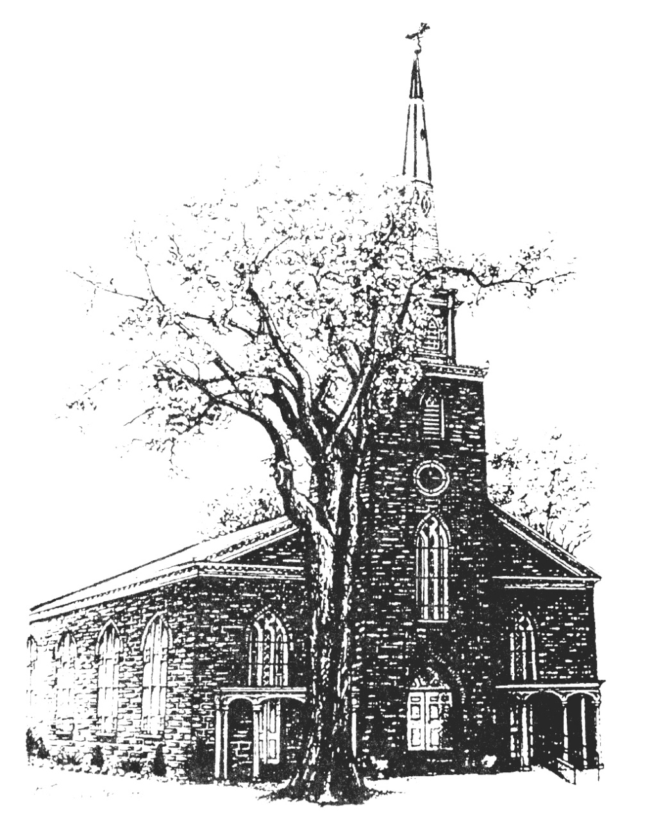

THE CONSISTORY OF OLD NORTH
Elders: Karen DiBella (2022) Scott Benell (2023) Carol Sushko (2023, 2nd term)
Deacons: Brianna Polbos (2024) John Passarotti (2022) Richard Schmude (2023)
Classis supervising minister The Rev. Rob Miller

Welcome to worship at Old North Reformed Church!
If you would like to be added to our mailing list, please leave your contact
information in the guest book before leaving today.

We encourage you to keep this copy of the liturgy and take it home to
share with a family member or with a friend. The service can be experienced
anytime on line via Old North's YouTube channel or FaceBook page.

Flowers: The flowers on the chancel are given to the Glory of God.

If you would like to dedicate flowers for Sunday worship, sign up
sheet is in the Auditorium or contact the office. The cost is $45.00.
that you can access our Facebook page even if you do not have a Facebook account? Do a search for Old North Church Dumont, scroll down to the facebook link and click. You will be on our page!

Prayer Chain: If you wish to add the power of prayer in times of celebration, healing, or transitions in life, please call Pat Hooey, 201-843-4456.
Your prayer requests are uplifted by our prayer team, and confidentiality is honored.

Church Family Prayer List:
●Adrianne ●Barbara ●Katie ●Search Committee
Uplift those undergoing medical procedures and thanksgiving for those
who are recovering; comfort for those in mourning; strength for those fighting cancer and for all caregivers; those seeking spiritual and emotional well-being, those with addictions,
and those seeking or beginning new employment. Pray for Peace.
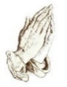

Scheduled to serve today… with our thanks:

Ushers & Greeters: Jack & Betsy Erhard
Please be sure to count and record attendance in the
Attendance Binder in the Narthex Podium.
Coffee Hour: Fellowship Committee

Upcoming Ushers and Greeters……….
September 18 Nicolas & Ashton DiBella
25 Kathleen West, Steven Cordova

Congratulations to all of our Church Family who are celebrating a special event!
9/5 Maureen Van Buren 9/9 Nancy Gorman 9/9 Shawn Gorman
9/17 Dawn Bennewitz 9/17 Jack Erhard 9/29 Eugene Reisser
Happy Anniversary!
9/9 Richard & Rhoda Suson
9/11 Scott & Nancy Benell 9/21 Hank & Nancy Gorman
9/18 Jon & Jenna Babicz

TODAY - Rally Day/1st Day of Sunday School.
Food and fellowship follow worship!

FOOD DRIVE: Thank you to our volunteers and to all who participated.

9/17 – Thrift Shoppe re-opens! 9:00 a.m. – 2:00 p.m. Masks are required and we ask that you bring your own bags.

EYE GLASS COLLECTION: There is a container in the Auditorium for old glasses to be recycled. The glasses will be going to the Dominican Republic with a local ophthalmologist on his annual mission trip. Thank you for your donation!

PUMPKIN PATCH AT OLD NORTH

Proceeds will support the Navajo growers and
Old North’s Restoration Fund.

Pumpkins will be delivered on Saturday, September 24th at 9:00 a.m.
We are looking for volunteers to help unload the truck.
We will also need volunteers to be at the sales.
Please contact the office if you are available!
