9:30 a.m. Pentecost + 15 Year C September 18, 2022

***Welcome to Old North.*** *We are pleased you chose to worship with us today!*

The Rev. Rob Miller Mr. Alan Newman

Supervising Minister Organist and Music Director

***Today we welcome Rev. Richard Bierwas***  ***into the pulpit.***

* Congregation Standing as able. **BOLD** indicates congregation’s participation.

*Indicates materials used from “Seasons of the Spirit”©.

**OUR APPROACH TO GOD**

PRELUDE and CHIMES “I Vow to Thee, My Country”                    Gustav Holst

                   “Three Liturgical Preludes”                George Oldroyd

ANNOUNCEMENTS

VOTUM L: Our help is in the name of the Lord, who made heaven and earth. **Amen.**

**CONGREGATIONAL INTROIT: #4** **“FATHER, I ADORE YOU”**

*1. *Father, I adore you; *lay my life before you. *How I love you!*

*\*2. Jesus, I adore you!… *3. Spirit, I adore you!…*

**CALL TO WORSHIP\***

L: We come together not around the uniformity of experience, belief, or expression

**All: but gathered in the One who is of many names and who is beyond all naming.**

L: May we live in peace.

**All: By God’s Spirit we become community**

L: even as we honor the sacred that exists outside the open windows

**All: and beyond these walls**.

L: May we work for justice for all.

**All: The One who desires for all to know and live in truth is gathering us together**

**to worship in a spirit of truth.**

L: May we become one in heart this day.

**UNISON GATHERING PRAYER**

**Unite our hearts and minds in prayer as we worship you,**

**the one God who is in and through all.**

**Through our prayers, those spoken and those lifted in silence,**

**may your realm of love extend beyond the heart of our ideals**

**to become the prayers we live with our lives. Amen.**

SALUTATION AND **SHARING of the Peace** *(Remain seated)*

L: Peace be with you! **ALL:** **AND ALSO WITH YOU!**

* HYMN **#722**  **“WHEN THE CHURCH OF JESUS”**

CHILDREN’S MESSAGE

**UNISON PRAYER OF CONFESSION\***

Regardless of who we are, what we believe or do not believe, or the names

by which we identify ourselves, we are one in You.

Confident of this reality, we can admit to the ways our personalities

at times become barriers to true community.

Rather than helping us seek peace and justice for all

our associations and ideologies often separate and keep us from working together. Like curtains over a window, they keep us from the grand view of Your realm.

We pray now for mutual understanding and partnership between ourselves and another with whom we struggle to recognize our unity in You.

*(Silent reflection)*

**KYRIE ELEISON (sung) #297**

***Spirit of the living God, fall afresh on me. Spirit of the living God, fall afresh on me.***

***Break me, melt me, mold me, fill me: Sprit of the living God, fall afresh on me.***

ASSURANCE OF GOD’S CONTINUING LOVE John 3:16-17

L: Believe this gospel and go forth to live in peace! **ALL: Amen.**

THE LAW OF GOD Matthew 22:37-39

Leader: “Thou shalt love the Lord thy God with all thy heart, and with all thy soul, and with all thy mind. This is the first and great commandment. And the second is like unto it, Thou shalt love thy neighbour as thyself.”

* **GLORIA PATRI #805**

*Glory be to the Father and to the Son and to the Holy Ghost! As it was in the*

*beginning, is now and ever shall be, world without end; Amen, Amen.*

**THE WORD OF GOD**

PRAYER FOR ILLUMINATION

READING OF SCRIPTURE John 10:1-15

**SERMON HYMN** **#**522“Savior Like a Shepherd Lead Us” (vvs. 1 and 4) *(remain seated)*

SERMON  “Our Good Shepherd” The Rev. Richard Bierwas

**OUR RESPONSE TO GOD**

**THE CELEBRATION OF THE SACRAMENT OF BAPTISM (insert)**

*We are pleased to welcome Dean Ryan Dublirer to the Family of God!*

**THE WORSHIP OF GIVING:** OUR OFFERINGS TO GOD

* **DOXOLOGY #809** (The Worshiping Church hymnal)

*“Praise God from whom all blessings flow. Praise God all creatures here below.*

*Praise God above, ye heavenly host: Praise Father, Son and Holy Ghost. Amen.”*

* PRAYER OF DEDICATION OF OUR GIFTS AND TITHES

PRAYERS OF THE PEOPLE AND **THE LORD’S PRAYER**

*Our Father, who art in heaven, Hallowed be thy name*

*Thy kingdom come. Thy will be done on earth as it is in heaven.*

*Give us this day our daily bread, and forgive us our debts,*

*as we forgive our debtors,*

*and lead us not into temptation, but deliver us from evil.*

*For thine is the kingdom, and the power, and the glory, forever. Amen.*

* HYMN **#20** **”JOYFUL, JOYFUL, WE ADORE THEE”**

PASTORAL BENEDICTION

POSTLUDE   “Alleluia, Song of Sweetness”   G. Winston Cassler

* Please rise, in body or in spirit. **Bold words indicate unison participation.**

*Indicates materials used from “Seasons of the Spirit” ©.

*The Rev. Richard Bierwas grew up in Pompton Lakes, N.J. and attended the Pompton Reformed Church.  He is a 1995 graduate of Western Theological Seminary in Holland, MI.  Over the course of his career in ministry, he has pastored RCA and PCUSA churches in New York and New Jersey.  Before seminary he and his wife, Carol, served as missionaries in Manama, Bahrain.*

*Pastor Richard presently serves The Community Church of Ho-Ho-Kus and is the Minister of the Greater Palisades Classis.  He and his wife have three grown sons.  Their two eldest live in Bergen County while there youngest is in the process of relocating to Reno, NV.  Pastor Richard has served the Community Church of Ho-Ho-Kus for the past 18 years.*

**THE CONSISTORY OF OLD NORTH**

Elders: Karen DiBella (2022) Scott Benell (2023) Carol Sushko (2023, 2nd term)

Deacons: Brianna Polbos (2024) John Passarotti (2022) Richard Schmude (2023)

Classis supervising minister The Rev. Rob Miller

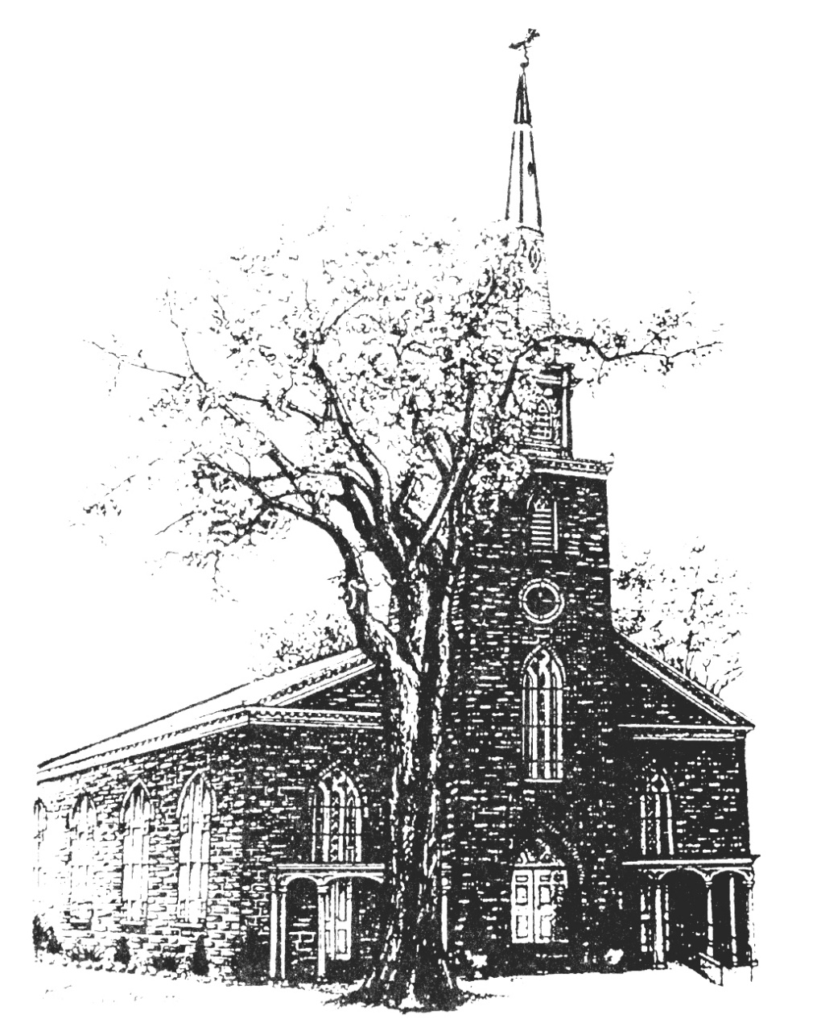

**Old North Reformed Church**

120 Washington Avenue, Dumont, New Jersey 07628

201-385-2243 [oldnorthdumont@gmail.com](mailto:oldnorthdumont@gmail.com)

<https://oldnorth.church>

***Welcome to worship at Old North Reformed Church!***

*If you would like to be added to our mailing list, please leave your contact*

*information in the guest book before leaving today.*

**We encourage you to keep this copy of the liturgy and take it home to**

 **share** **with a family member or with a friend. The service can be experienced**

**anytime on line via Old North's YouTube channel or FaceBook page.**

**Flowers:** The flowers on the chancel are given to the glory by

Cheryl and Jim Rodgers in honor of the baptism of their

Great Grandson, Dean Ryan Dublirer

*If you would like to dedicate flowers for Sunday worship, sign up*

*sheet is in the Auditorium or contact the office. The cost is $45.00.*

**

The search committee is working hard to find a new Pastor for Old North.

Thank you for your patience during this process!

**Prayer Chain:** If you wish to add the power of prayer in times of celebration, healing, or transitions in life, please call Pat Hooey, 201-843-4456.

Your prayer requests are uplifted by our prayer team, and confidentiality is honored.

**Church Family Prayer List:**

**●Adrianne ●Barbara ●Katie ●Search Committee**

Uplift those undergoing medical procedures and thanksgiving for those

who are recovering; comfort for those in mourning; strength for those fighting cancer and for all caregivers; those seeking spiritual and emotional well-being, those with addictions,

and those seeking or beginning new employment. Pray for Peace.



Scheduled to serve today… with our thanks:

**Ushers & Greeters:** Nicolas & Ashton DiBella

**Please be sure to count and record attendance in the**

**Attendance Binder in the Narthex Podium.**

**Coffee Hour:** Fellowship Committee

Upcoming Ushers and Greeters……….

September 25th Kathleen West, Steven Cordova

October 2nd Scott Benell, Karen DiBella, Ethan Cordova

9th Kathleen West, Nancy Gorman

|  |  |  |  |  |  |
| --- | --- | --- | --- | --- | --- |
|  |  |  |  |  |  |



**Congratulations to all of our Church Family who are celebrating a special event!**

9/5 Maureen Van Buren 9/9 Nancy Gorman 9/9 Shawn Gorman

9/17 Dawn Bennewitz 9/17 Jack Erhard 9/29 Eugene Reisser

**Happy Anniversary!**

9/9 Richard & Rhoda Suson

9/11 Scott & Nancy Benell 9/21 Hank & Nancy Gorman

9/18 Jon & Jenna Babicz

**FOOD DRIVE:** Thank you to our volunteers and to all who participated. The demand is great for food in our community! Thank you to Scott Benell for his passion and devotion to this mission!

**THRIFT SHOPPE:** Thank you to our volunteers who work each week to prepare for what has become an amazing mission for Old North.

**BLESSING OF THE ANIMALS:** With our Pumkin Patch starting we will be rescheduling the Blessing of the Animals.

**Our 2021 CROP Hunger Walk**  will be on **Sunday, October 16th**.

**TUESDAY TODDLERS IS BACK BY POPULAR DEMAND!**



**TUESDAYS 9:30-11:00 a.m.**

**Home with the Little One(s)?  
 Here's something fun to look forward to doing together!  
 Free play and social time-- Healthy snack**

**(and goodies for the grown-ups!)**

**9:30 - 10:15 Playtime! 10:15 - 10:30 Snacks 10:30 - 11:00 Group Time & Clean up**

**Invite a friend!**

**For more information please call! 201-385-2243**

**PUMPKIN PATCH AT OLD NORTH**

Pumpkins will be delivered on Saturday, 9/ 24at 9:00 a.m.

We are looking for volunteers to help unload the truck.

We will also need volunteers to be at the sales.

Please contact the office if you are available!

