9:30 a.m. Pentecost + 16 Year C September 25, 2022

***Welcome to Old North.*** *We are pleased you chose to worship with us today!*

The Rev. Rob Miller Mr. Alan Newman

Supervising Minister Organist and Music Director

***Today we welcome Rev. Leah Ennis***  ***into the pulpit.***

* Congregation Standing as able. **BOLD** indicates congregation’s participation.

*Indicates materials used from “Seasons of the Spirit”©.

**OUR APPROACH TO GOD**

PRELUDE and CHIMES Pilgrim Chorus from “Tannhauser”          Richard Wagner

                    “When I Survey the Wondrous Cross”     Albin Whitworth

                     “Deck Thyself, My Soul”                             Joseph Clokey

ANNOUNCEMENTS

VOTUM L: Our help is in the name of the Lord, who made heaven and earth. **Amen.**

**CONGREGATIONAL INTROIT: #4** **“FATHER, I ADORE YOU”**

*1. *Father, I adore you; *lay my life before you. *How I love you!*

*\*2. Jesus, I adore you!… *3. Spirit, I adore you!…*

**CALL TO WORSHIP\***

Leader: Travelers on the way, bring with you your burdens.

**All: We carry our living to be held by God.**

Leader: Explorers of life, bring your stories into this space.

**All: We let our stories be loved by God.**

Leader: Bent over with hurt, bring your brokenness here.

**All: We hold out our pain and long for God.**

Leader: Journeyers with God, move into this place.

**All: We come here to meet with God.**

**UNISON GATHERING PRAYER\***

**May we always be open to Your love, O God:**

**a love shaped by justice,**

**a love grounded in life,**

**a love that transforms,**

**a love that speaks out,**

**a love that is revealed in the life of Jesus.**

**May we always be open to Your love, O God,**

**that Your love also may be revealed in our living. Amen.**

SALUTATION AND **SHARING of the Peace** *(Remain seated)*

L: Peace be with you! **ALL:** **AND ALSO WITH YOU!**

* **HYMN** (Insert)  **“ON EAGLE’S WINGS”**

CHILDREN’S MESSAGE

**UNISON PRAYER OF CONFESSION\***

Creator, may we be content with what we have that is good,

and question what we pursue.

Forgive us when we seek too much comfort for ourselves,

when we find priority in the wrong things,

when we hold on to those things that limit Your love.

Enable us to take hold of the life that is truly life.

Let us live within truth, to walk beside justice, to practice kindness,

to seek out forgiveness, and to pursue love. *(Silent reflection)*

KYRIE ELEISON (sung)#297

***Spirit of the living God, fall afresh on me. Spirit of the living God, fall afresh on me.***

***Break me, melt me, mold me, fill me: Sprit of the living God, fall afresh on me.***

ASSURANCE OF GOD’S CONTINUING LOVE John 3:16-17

L: Believe this gospel and go forth to live in peace! **ALL: Amen.**

THE LAW OF GOD Matthew 22:37-39

Leader: “Thou shalt love the Lord thy God with all thy heart, and with all thy soul, and with all thy mind. This is the first and great commandment. And the second is like unto it, Thou shalt love thy neighbour as thyself.”

* **GLORIA PATRI #805**

*Glory be to the Father and to the Son and to the Holy Ghost! As it was in the*

*beginning, is now and ever shall be, world without end; Amen, Amen.*

**THE WORD OF GOD**

PRAYER FOR ILLUMINATION

READING OF SCRIPTURE Psalm 91; Luke 16:19-31

**SERMON HYMN** **#115 "FAIREST LORD JESUS"**

SERMON  “How Much is Enough?” The Rev. Leah Ennis

**OUR RESPONSE TO GOD**

**THE WORSHIP OF GIVING:** OUR OFFERINGS TO GOD

* **DOXOLOGY #809** (The Worshiping Church hymnal)

*“Praise God from whom all blessings flow. Praise God all creatures here below.*

*Praise God above, ye heavenly host: Praise Father, Son and Holy Ghost. Amen.”*

* PRAYER OF DEDICATION OF OUR GIFTS AND TITHES

PRAYERS OF THE PEOPLE AND **THE LORD’S PRAYER**

*Our Father, who art in heaven, Hallowed be thy name*

*Thy kingdom come. Thy will be done on earth as it is in heaven.*

*Give us this day our daily bread, and forgive us our debts,*

*as we forgive our debtors,*

*and lead us not into temptation, but deliver us from evil.*

*For thine is the kingdom, and the power, and the glory, forever. Amen.*

* **HYMN #395** **”HOW CLEAR IS OUR VOCATION, LORD”**

PASTORAL BENEDICTION

POSTLUDE “O God, Our Help in Ages Past”                   Joseph Clokey

* Please rise, in body or in spirit. **Bold words indicate unison participation.**

*Indicates materials used from “Seasons of the Spirit” ©.

The Reverend Leah Ennis graduated (and was ordained) in 2013. She has held both chaplain and pastoral roles. Currently Leah works as a Teacher's Assistant through Bergen County Special Services and as a project manager at Hudson River Care and Counseling Center working with spiritual and religious abuse survivors. Leah is mom to Zechariah. They reside with their cats in New Milford, New Jersey.

**THE CONSISTORY OF OLD NORTH**

Elders: Karen DiBella (2022) Scott Benell (2023) Carol Sushko (2023, 2nd term)

Deacons: Brianna Polbos (2024) John Passarotti (2022) Richard Schmude (2023)

Classis supervising minister The Rev. Rob Miller

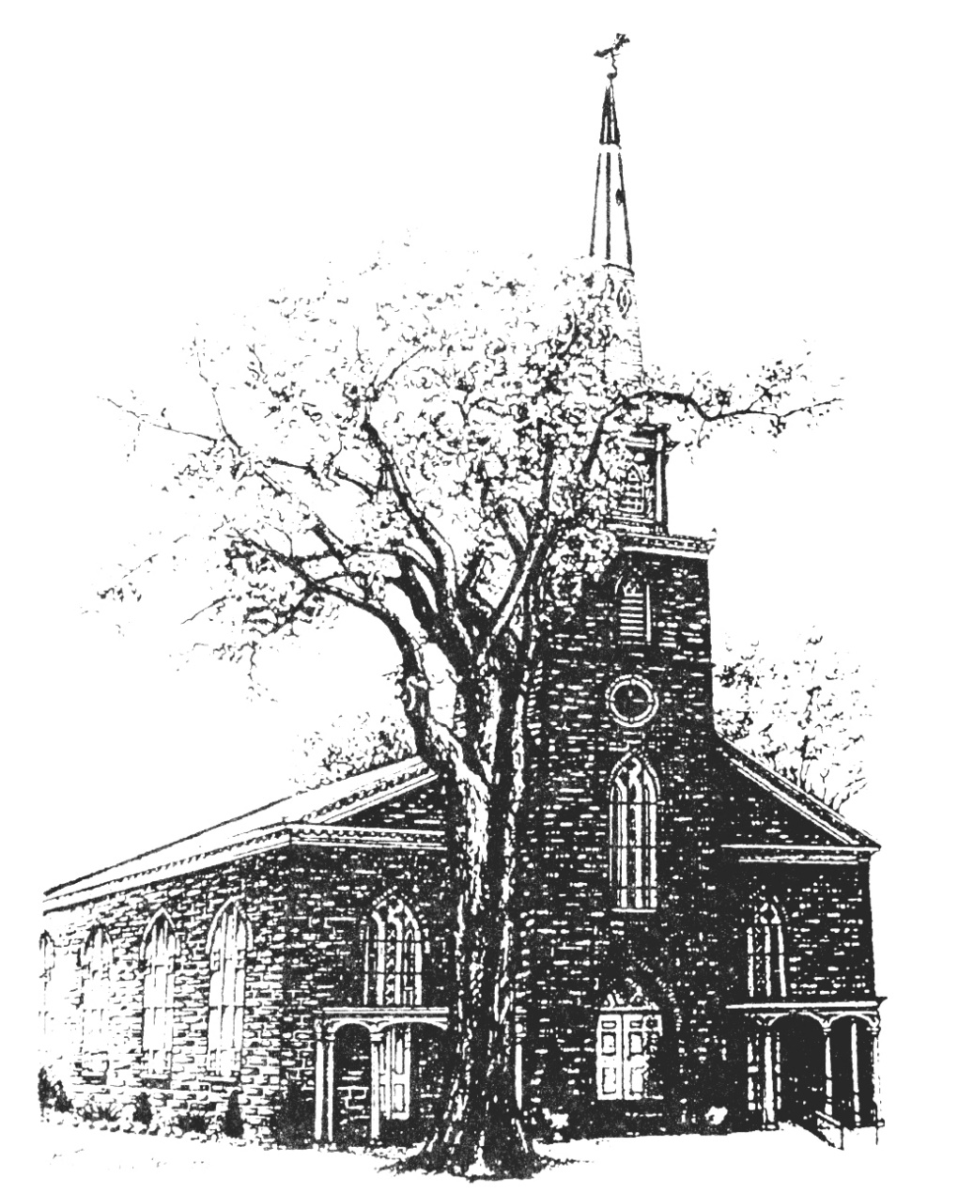

**Old North Reformed Church**

120 Washington Avenue, Dumont, New Jersey 07628

201-385-2243 [oldnorthdumont@gmail.com](mailto:oldnorthdumont@gmail.com)

<https://oldnorth.church>

***Welcome to worship at Old North Reformed Church!***

*If you would like to be added to our mailing list, please leave your contact*

*information in the guest book before leaving today.*

**We encourage you to keep this copy of the liturgy and take it home to share** **with a family member or with a friend. The service can be experienced anytime on line via Old North's YouTube channel or FaceBook page.**

**Flowers:** The flowers on the chancel are given to the glory of God by

Gail McNeill in memory of her husband John H. McNeill.

*If you would like to dedicate flowers for Sunday worship, the sign up*

*sheet is in the Auditorium or contact the office. The cost is $45.00.*

**

Our Search Committee: John Babicz, Steven Cordova, Karen DiBella,

Tim Frohlich, Brianna Polbos and Kathleen West. Thank you!

**Prayer Chain:** If you wish to add the power of prayer in times of celebration, healing,

or transitions in life, please call Pat Hooey, 201-843-4456.

Your prayer requests are uplifted by our prayer team, and confidentiality is honored.

**Church Family Prayer List:**

**●Adrianne ●Barbara ●Katie ●Search Committee**

Uplift those undergoing medical procedures and thanksgiving for those

who are recovering; comfort for those in mourning; strength for those fighting cancer and for all caregivers; those seeking spiritual and emotional well-being, those with addictions,

and those seeking or beginning new employment. Pray for Peace.



Scheduled to serve today… with our thanks:

**Ushers & Greeters:** Kathleen West, Steven Cordova

**Please be sure to count and record attendance in the**

**Attendance Binder in the Narthex Podium.**

**Coffee Hour:** Fellowship Committee

Upcoming Ushers and Greeters……….

October 2nd Scott Benell, Karen DiBella, Ethan Cordova

9th Kathleen West, Nancy Gorman

13th Donair Karkkainen, Marianne Schmude

23rd Linda Treacy, Donair Karkkainen

30th Nate Schmude, Nicolas & Ashton DiBella

|  |  |  |  |  |  |
| --- | --- | --- | --- | --- | --- |
|  |  |  |  |  |  |



**Congratulations to all of our Church Family who are celebrating a special event!**

9/5 Maureen Van Buren 9/9 Nancy Gorman 9/9 Shawn Gorman

9/17 Dawn Bennewitz 9/17 Jack Erhard 9/29 Eugene Reisser

**Happy Anniversary!**

9/9 Richard & Rhoda Suson

9/11 Scott & Nancy Benell 9/21 Hank & Nancy Gorman

9/18 Jon & Jenna Babicz



**PUMPKIN PATCH AT OLD NORTH: September 24th – October 31st**

Hours of Operation:MONDAY – FRIDAY: 3:00 – 7:00 P.M.

SATURDAY: 10:00 A.M. – 7:00 P.M.

SUNDAY: 11:00 A.M. – 7:00 P.M.

Volunteer sign up board is in the Church House hallway. Fun Fellowship at Old North!

**FOOD DRIVE: Our next food drive is on Saturday, October 8th.**

**THRIFT SHOPPE:** Thank you to our volunteers who work each week to prepare for what has become an amazing mission for Old North. Our total sales from last Saturday was $2,465.75!

**BLESSING OF THE ANIMALS:** With our Pumkin Patch starting we will be rescheduling the Blessing of the Animals.

**Our 2021 CROP Hunger Walk**  will be on **Sunday, October 16th**.

**TUESDAY TODDLERS IS BACK BY POPULAR DEMAND!**



**TUESDAYS 9:30-11:00 a.m.**

**Home with the Little One(s)?  
 Here's something fun to look forward to doing together!  
 Free play and social time-- Healthy snack**

**(and goodies for the grown-ups!)**

**Invite a friend!**

**LIFE SAVING CLASSES:** 25% off for Old North member. A new program here at Old North teaches life saving skills: adult and pediatric first aid CPR/AED, stop the bleeding/ first aid for severe trauma, basic life support, bloodborne pathogens, fire prevention and safety and much more!

How it works: 1. Go to <https://grftraining.com/classes>

2. Select the class you would like to attend.

3. When you checkout enter coupon code: OLDNORTHCHURCH and receive 25% off your order.

If you are interested in bundling classes together, for a discount email GRF Training at

[Info@grftraining.com](mailto:Info@grftraining.com)