9:30 a.m. Pentecost + 20 Year C October 23, 2022

Welcome to Old North. We are pleased you chose to worship with us today!

The Rev. Rob Miller Mr. Alan Newman
Supervising Minister Organist and Music Director

Today we welcome Rev. Leah Ennis into the pulpit.

- Congregation Standing as able. BOLD indicates congregation’s participation.
*Indicates materials used from “Seasons of the Spirit”©.

OUR APPROACH TO GOD

PRELUDE and CHIMES Prelude on “Hyfrydol” Raymond Haan
“I Love the Lord” James Southbridge

ANNOUNCEMENTS

VOTUM L: Seek the Lord while he may be found, call upon him while he is near. Amen.

CONGREGATIONAL INTROIT: #4 “FATHER, I ADORE YOU”
1. *Father, I adore you; *lay my life before you. *How I love you!
*2. Jesus, I adore you!… *3. Spirit, I adore you!…

CALL TO WORSHIP

L: Open our hearts and minds to receive you in a new way;
All: We come into community
ready for Spirit’s presence among us.
L: Open our hearts and minds to receive you in a new way;
All: We come into this sacred space
ready to worship.
L: Open our hearts and minds to receive you in a new way;
All: We come into a place of challenge and grace
ready for your word.
L: Open our hearts and minds to receive you in a new way.

UNISON GATHERING PRAYER*
Loving God, send Your Spirit upon us in our worship today. Send Your Spirit of love and peace and joy and mercy. Move us in our speaking and our doing, in our dreaming and in our praying, as we seek to live out Your hopes and dreams in our community and in our world. Amen.

SALUTATION AND SHARING of the Peace (Remain seated)
L: Peace be with you! ALL: AND ALSO WITH YOU!

- HYMN #669 “GOD OF GRACE AND GOD OF GLORY”
CHILDREN’S MESSAGE

UNISON PRAYER OF CONFESSION*
There are times, O God, when our prayers do not come from our hearts,
when we try to hide the truth of who we are.
At those times, forgive us, God of mercy, and change our hearts,
so that we may honestly and openly come before You in prayer.
O God, there are times when we close our hearts,
believing that we have all the answers.
At those times, forgive us, God of mercy, and
open our hearts to listen to Your guidance.
O God, there are times when we come before You in judgment of others.
At those times, forgive us, God of mercy.
Empty our hearts, that we may approach You in humility.
Hear us now, O God, as we offer You the confession of our hearts.
(Time for silent reflection)

KYRIE ELEISON (sung)#297
Spirit of the living God, fall afresh on me. Spirit of the living God, fall afresh on me.
Break me, melt me, mold me, fill me: Spirit of the living God, fall afresh on me.

ASSURANCE OF GOD’S CONTINUING
Leader: God offers healing, forgiveness, and new life to all people.
All: Thanks be to God. Amen.

THE LAW OF GOD Matthew 22:37-39
Leader: “Thou shalt love the Lord thy God with all thy heart, and with all thy soul, and with all thy mind. This is the first and great commandment. And the second is like unto it, Thou shalt love thy neighbour as thyself.”

- GLORIA PATRI #805
Glory be to the Father and to the Son and to the Holy Ghost! As it was in the
beginning, is now and ever shall be, world without end; Amen, Amen.

THE WORD OF GOD
PRAYER FOR ILLUMINATION

READING OF SCRIPTURE Luke 18:9-14

SERMON HYMN

SERMON "Walk In Repentance" The Rev. Leah Ennis
OUR RESPONSE TO GOD

THE WORSHIP OF GIVING: OUR OFFERINGS TO GOD

- DOXOLOGY #809 (The Worshiping Church hymnal)
“Praise God from whom all blessings flow. Praise God all creatures here below.
Praise God above, ye heavenly host: Praise Father, Son and Holy Ghost. Amen.”

- Prayer of Dedication of our Gifts and Tithes

PRAYERS OF THE PEOPLE AND THE LORD’S PRAYER
Our Father, who art in heaven, Hallowed be thy name.
Thy kingdom come. Thy will be done on earth as it is in heaven.
Give us this day our daily bread, and forgive us our debts,
as we forgive our debtors,
and lead us not into temptation, but deliver us from evil.
For thine is the kingdom, and the power, and the glory, forever. Amen.

HYMN #638 “PRECIOUS LORD, TAKE MY HAND“

PASTORAL BENEDICTION

POSTLUDE “Little Prelude in G Minor” Paul Taylor
The Reverend Leah Ennis graduated (and was ordained) in 2013. She has held both chaplain and pastoral roles. Currently Leah works as a Teacher's Assistant through Bergen County Special Services and as a project manager at Hudson River Care and Counseling Center working with spiritual and religious abuse survivors. Leah is mom to Zechariah. They reside with their cats in New Milford, New Jersey.

THE CONSISTORY OF OLD NORTH
Elders: Karen DiBella (2022) Scott Benell (2023) Carol Sushko (2023, 2nd term)
Deacons: Brianna Polbos (2024) John Passarotti (2022) Richard Schmude (2023)
Classis supervising minister The Rev. Rob Miller

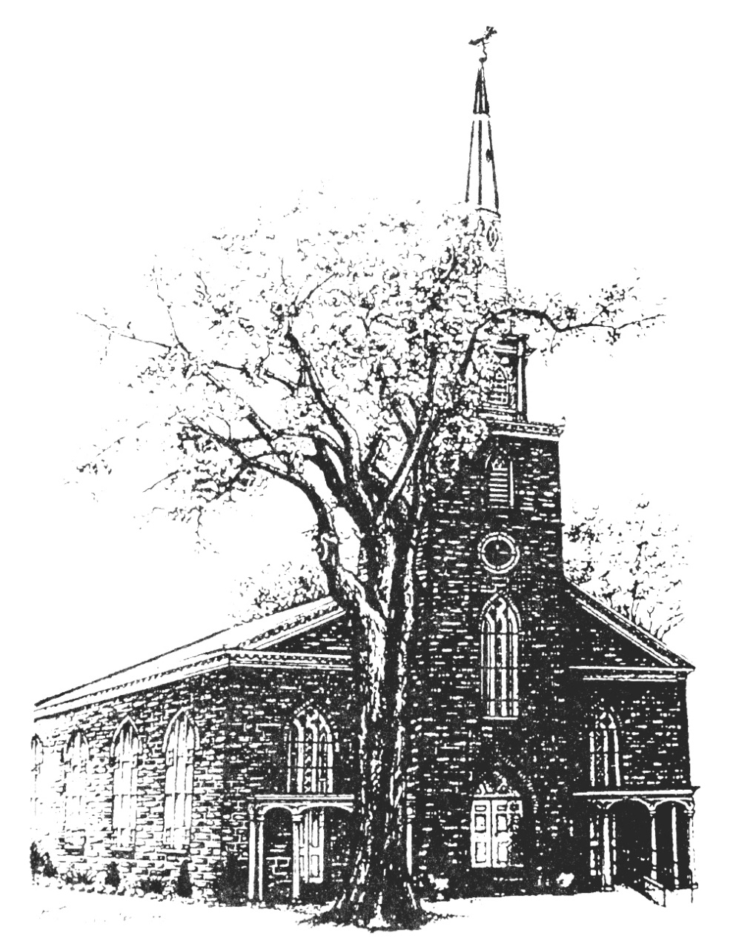

Old North Reformed Church
120 Washington Avenue, Dumont, New Jersey 07628
201-385-2243 oldnorthdumont@gmail.com
https://oldnorth.church

Welcome to worship at Old North Reformed Church!
If you would like to be added to our mailing list, please leave your contact
information in the guest book before leaving today.

We encourage you to keep this copy of the liturgy and take it home to share with a family member or with a friend. The service can be experienced anytime on line via Old North's YouTube channel or FaceBook page.

Flowers: The flowers on the chancel are given to the Glory of God by
Jon & Jena Babicz in loving memory of Jena’s father William Robert Rand III.

As of 10/20 our Pumkin Patch has brought in $6,921.00. The more Pumpkins that we sell, the higher the percentage Old North will receive.

Prayer Chain: If you wish to add the power of prayer in times of celebration, healing,
or transitions in life, please call Pat Hooey, 201-843-4456.
Your prayer requests are uplifted by our prayer team, and confidentiality is honored.

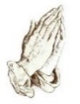
Church Family Prayer List:
●Adrianne ●Barbara ●Katie ●Search Committee ●Tom
Uplift those undergoing medical procedures and thanksgiving for those
who are recovering; comfort for those in mourning; strength for those fighting cancer and for all caregivers; those seeking spiritual and emotional well-being, those with addictions,
and those seeking or beginning new employment. Pray for Peace.

Scheduled to serve today… with our thanks:

Ushers & Greeters: Rene Gallagher and Ethel Reitsema
Please be sure to count and record attendance in the
Attendance Binder in the Narthex Podium.
Coffee Hour: Fellowship Committee

Upcoming Ushers and Greeters……….
Oct 30th Nate Schmude, Nicolas & Ashton DiBella
Nov. 6th Scott Benell, Karen DiBella, Nate Schmude
13th Marilyn and Skylar Hashway
20th Jack and Betsy Erhard
27th Nicolas and Ashton DiBella

Congratulations to all of our Church Family who are celebrating a special event!
10/7 Dorothy Reisser - 10/12 Bob Hashway - 10/18 Doris Vogt
10/22 Ethan Cordova - 10/29 Pastor Susan - 10/31 Lois Anderson
Happy Anniversary!
10/7 Ben & Sandra Toscano – 10/29 Richard & Dawn Bennewitz

THRIFT SHOPPE: There is a meeting today following worship. Thanks you to all our volunteers for another great sale and for the effort it takes them to prepare for each sale. Many Dumont High School students volunteered their time and were a tremendous help! If you are interested in volunteering please let us know. The jewelry department is looking for donations of Christmas Jewelry. Donair Karkkainen will be collecting it. Our next sale will be on 11/12/22.

OUR 2022 CROP HUNGER WALK: We are still accepting donations through October!
To make a donation, follow the link and search for Old North so our team gets the credit, or donate by check payable to: CWS/Crop. https://events.crophungerwalk.org/2022

TUESDAY TODDLERS: TUESDAYS 9:30-11:00 a.m. Home with the Little One(s)? Here's something fun to look forward to doing together! Free play and social time-- Healthy snack. We are looking for a new instructor to take over the group starting in January.

CHILDREN’S CHRISTMAS WORSHIP SERVICE: On December 18th our Sunday School students will lead us in worship. Choir rehearsals for the students will begin on November 6th in the Sanctuary following worship.

PUMPKIN PATCH AT OLD NORTH HOURS OF OPERATION
Volunteers are needed from 3 – 5 p.m. each day during the week.
MONDAY – FRIDAY: 3:00 – 7:00 P.M.
SATURDAY: 10:00 A.M. – 7:00 P.M.
SUNDAY: 11:00 A.M. – 7:00 P.M.
Volunteer sign up board is in the Church House hallway.
Fun Fellowship at Old North!

