HOPE and
HAPPENINGS
Old North Reformed Church
May, 2018 Newsletter

Dear Friends and Members of Old North,
After nearly three years here, I am getting used to the rhythm of summers at Old North: lots of vacations taking congregants all over the place and away from here on Sunday mornings, lots of hot hazy humid days (and nights!), lots of day-dreaming about what might be accomplished come September-- and wondering when we will be able to get together to plan Fall activities, Advent, and yes—Christmas (only 131 days away as I type this!).
Yet even while looking ahead, the work of the church goes on: volunteers are pulling together on Tuesday mornings to get things ready for Ye Olde North Thrift Shoppe’s Grand Re-Opening on September 22; the Consistory has cleared the way for air conditioning to be installed in the Auditorium, opening our building to a broader spectrum of year-round activities (THANK YOU to John Woerner and Jack Erhard for their legwork in sorting that out for us!); Pastor Susan has “twinned” a toilet in the Church House (more on that inside the newsletter); our church secretary, Judy, has had and is recovering nicely from shoulder surgery (THANK YOU to everyone who covered the office in her absence!); we had an evening of pie-baking for fun in July; the plantings around the church entrances are thriving (THANK YOU Gay Gravina and Assistants!); we’re all learning more about the Heidelberg Catechism on Sunday mornings… and behind the scenes, much prayer, thought, hope, and planning is going on for Old North’s fall programs…and indeed, future!
There is room for everyone here to worship God, to share the Good News of Jesus Christ, and to be a part of the family of Christians here in the heart of Dumont. Where do you see yourself in relationship to our church now? Where would you like to be?
--Pastor Susan

LOOKING FORWARD TO SUNDAY SCHOOL
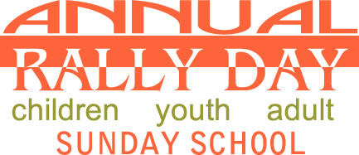

SUNDAY SEPTEMBER 9
Potluck Lunch following Worship!

THRIFT SHOPPE NEWS
Work is underway for the season opening of Ye Olde North Thrift Shoppe! The shop committee is busy sorting through old and new donations in preparation for the shop’s grand reopening on September 22. We have a great new array of clothing, jewelry, shoes, household items, CDs, books, and treasures for the discovering, so mark your calendars, alert your friends and neighbors!
Thanks to the generosity of many ON congregants and friends of the church, the committee was able to share the largesse with Father English Community Center in Paterson. Due to a devastating fire last fall, the center’s Community Closet lost its inventory of clothing and household items. The center recently reopened the Community Closet and put out a call for help restocking it with summer clothing for children and adults. Old North was able to answer that call by delivering 15 bags of clothing to the Community Closet in July. Carlos Roldan, director of the Community Closet and the Food Pantry at Fr. English, was thrilled and very appreciative of Old North’s assistance.
The committee greatly appreciates the continued support of Old North members who donate time, merchandise, and energy for making the shop the success that it is. If you haven’t already, please consider signing up to help at one of the Saturday sale days or one of the sorting/set up days. It’s a fun time of fellowship!

SUMMER SURVEYS

FALL BIBLE STUDY
Which would you be more interested in attending?

Christianity & Islam Sexuality in the Bible

-------------------------------------------------------------------------------------
“Luke is the featured Gospel in the Revised Common Lectionary readings beginning in Advent 2018, and into 2019. Luke's Gospel is uniquely inclusive, involving all people. The Good News is for the outcast and the establishment, for the religious and those searching. Luke speaks to women, to men, to the strong and healthy, to the weak and dispossessed. Its relevance today inspires faith, spirituality and action.” (Dr. Carol J. Miller)

ADVENT 2018 THEME?
Pastor Susan is working on the lectionary themes for Advent and Christmastide this year and would like input to settle on an over-all worship theme for our Sunday Advent Candle-lighting and prayers. Can you help?
Check the title that best describes this year to you, cut it out, and return to church in the offering plate.
Light into darkness
The Coming Messiah
Waiting in Hope
Seeking Peace
Love for All
Something Else? _____________________

____________________________________

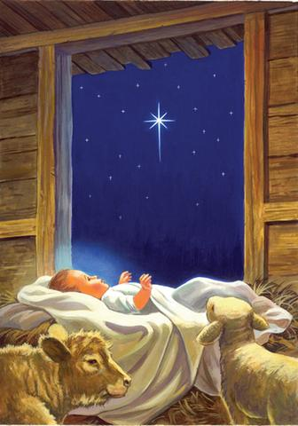

CLASSIC CAKE DECORATING CLASS WITH PASTOR SUSAN
You’re invited to join Pastor Susan on Friday, September 28, 6 – 9 p.m., for a time of fun and fellowship in the Auditorium.
No previous experience necessary!
Beginners encouraged!
There will be a fee just to cover ingredients and basic tools, which you will get to keep. For more information, stay tuned!

DID YOU KNOW
If you go to the hospital, PLEASE let Judy at the church office know of your situation so Pastor Susan and the church family can support you with prayer and in other ways as possible. Unlike in days past, the hospital DOES NOT inform your pastor or church of your hospitalization.
(If you are a Dumont resident, please know that transport to a hospital is FREE when you utilize the Dumont Volunteer Ambulance Corps versus a commercial ambulance. The police will call the ambulance corps when you dial 911 for emergency assistance.)

You can visit the church website at https://oldnorth.church

GRATITUDE CORNER
Thank you to all of you who have faithfully maintained your financial support of Old North throughout the summer months! While many families and individuals budget carefully for vacations every year, the habit of including church support in family budgets has fallen out of favor in our culture, which adds to the burden of building and program maintenance and renovation, just to keep current in the church!
There is plenty of time before year-end to make up your tax-deductible, charitable contribution amount to Old North in support of our ministries, to preserve and renew our facilities, and to give glory to God!
If you would like a summary of your giving to date, just call the office—a year-to-date record of your giving can be provided to help you plan through December!
Prayer Chain: If you have a celebration or concern that you would like to have included in our prayer chain, please call Pat Hooey, 201-843-4456.

Upcoming Events in Brief:
Sunday School registration is now open.
Call the church office to reserve your space.

September 9th: Rally Day
First day of Sunday School - Potluck Lunch! Sign up to bring a side dish, main dish or dessert. A fun day of family and fellowship!

October 21st: The Annual Crop Walk

October 27th: Heritage Weekend
Tours of the church and cemetery.

November 18th: Thanksgiving Sunday
Potluck Lunch.

December 2: First Sunday of Advent

WHAT IS TOILET TWINNING?
While on vacation, one of the churches Pastor Susan visited had “This toilet is twinned” signs on EVERY bathroom stall in the church! Needless to say, in raised questions and sparked curiosity! If YOU are curious, visit www.toilettwinning.org. We would be proud to have you “twin” one of the church’s toilets!

CONSISTORY: Serving Together in Christ’s Name
Elders: Scott Benell, Gay Gravina, Carol Sushko, Leslile Maro
Deacons: Ralph Condis, Karen DiBella, Richard Schmude
Minister: Rev. Susan Kerr 201-338-8237; revskerr@gmail.com
Church: 201-385-2243; OLDNORTHDUMONT@gmail.com
Website: https://oldnorth.church
Consistory next meets on Thursday, September 13, at 7 p.m.

OLD NORTH THRIFT SHOPPE
GRAND RE-OPENING
Old North Reformed Church
120 Washington Avenue
Dumont, NJ

The Shoppe is bigger & better than ever!
Saturday, September 22, 2018 - 9 a.m. – 2 p.m.

Clothing for Adults & Children…Home Goods…
Crystal & Dinnerware…Toys…Books…DVDs & CDs
Fun Halloween Décor!

Additional Dates:
October 20th
November 17th
December 15th

Donations always welcome!

Back 2 School Bookbag Outreach

Building bridges between students and their education

thru the Back2School Outreach.
The Back2School Outreach mission is to provide underprivileged children with a free quality backpack filled with school supplies for her/his new school year. We work closely with principals and teachers of our schools and have become a bridge between the teacher and student by providing the student the supplies they need to succeed during the year.
Help provide students with free quality filled backpacks for their 2018-2019 school year by either starting a collection in your church, civic group, business, or you can fill a backpack and drop it off at a location listed below.
Simply purchase a book bag and fill it with new school items like number 2 pencils and a sharpener, folders, glue sticks, and erasers. Feel free to include a note of encouragement for your sponsored child.
Please drop your items off by Sunday, 8/19.

Thank you to Deacon Karen DiBella for organizing this mission again for Old North.
Looking forward to the final installation of Air conditioning units in our Auditorium.
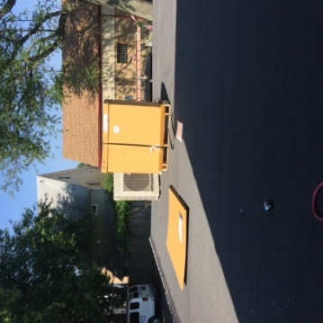
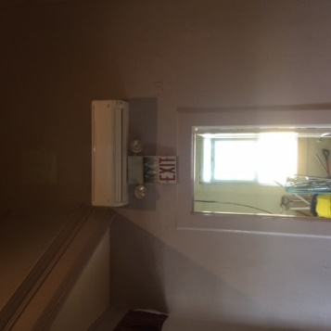

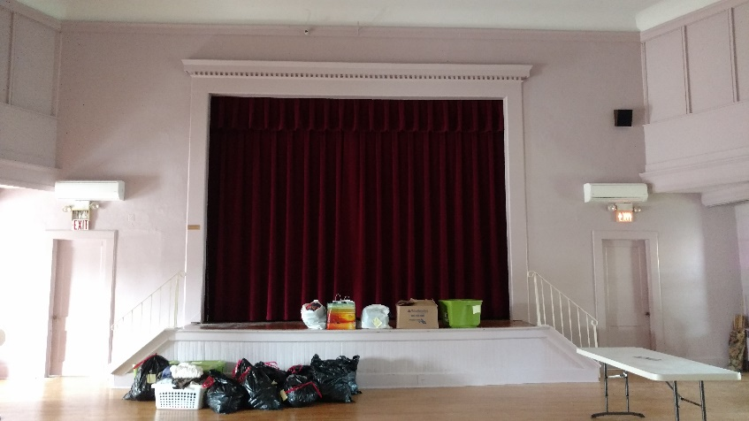

The Theology and Place of Music in Worship
The people of God sing. After escaping from the Egyptians and crossing the Red Sea, the people of Israel sang a song to the Lord (Exod. 15). Singing was part of Israel's formal worship in both tabernacle and temple (1 Chron. 6:31-32, 16:42). The Psalms bear rich testimony that in joy and sorrow, in praise and lament, the faithful raise their voices in song to God. Hymn singing was practiced by Jesus and his disciples (Matt. 26:30). The Apostle Paul instructed the Colossians, "Let the word of Christ dwell in you richly; teach and admonish one another in all wisdom; and with gratitude in your hearts sing psalms, hymns, and spiritual songs to God. And whatever you do, in word or deed, do everything in the name of the Lord Jesus, giving thanks to God the Father through him" (Col. 3: 16-17).
Music and song continue to play a vital role in the life of God s people today. Outside the church there are few occasions or opportunities in
North American culture for people to sing together. Much of the popular music (including popular Christian music) composed today is for performance rather than for participation.
- Music is a gift of God and part of the created order. Human music-making participates in the music of creation and reflects the order, beauty, and diversity of God s creation.
- Of all the musical instruments that may be employed in the praise of God, the human voice has priority. Reformed theologian Karl Barth pointed out that singing is not an option for the people of God; it is one of the essential ministries of the church:
“The Christian church… is not a choral society. Its singing is not a concert. Singing is the highest form of human expression....What we can and must say quite confidently is that the church which does not sing is not the church....The praise of God which finds its concrete culmination in the singing of the community is one of the indispensable forms of the ministry of the church.”
- Singing is a ministry that belongs to all the people of God. The congregation is always the primary choir. While anthems or vocal and instrumental solos may be offered, they do not have to be. Congregational singing, however, is essential.
- Of all the art forms that may be employed in worship, singing is especially corporate. Indeed, it is most suited to expressing the church's unity in the body of Christ.
- The church's ministry of song is for the glory of God. The principal direction of congregational singing is to the Lord (Ps. 96:1). Music is made first of all to the Lord and only secondarily to each other. Music should lead our thoughts toward God rather than toward ourselves.
- The church's ministry of song is for the edification of God's people. Through congregational singing Christian faith is not only expressed; to a very real degree it is formed. People tend to remember the theology they sing more than the theology that is preached!
- The emotional power of music, rightly employed, is a vital and moving aid to worship. It is also important that the emotional power of music in worship be evocative rather than manipulative, honest rather than manufactured, and that the congregation's singing allow for the full range of emotions in worship.
--from the RCA website

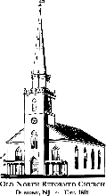
O
LD
N
ORTH
R
EFORMED
C
HURCH

120 Washington Avenue

Dumont, NJ 07628
https://oldnorth.church

