HOPE and
HAPPENINGS
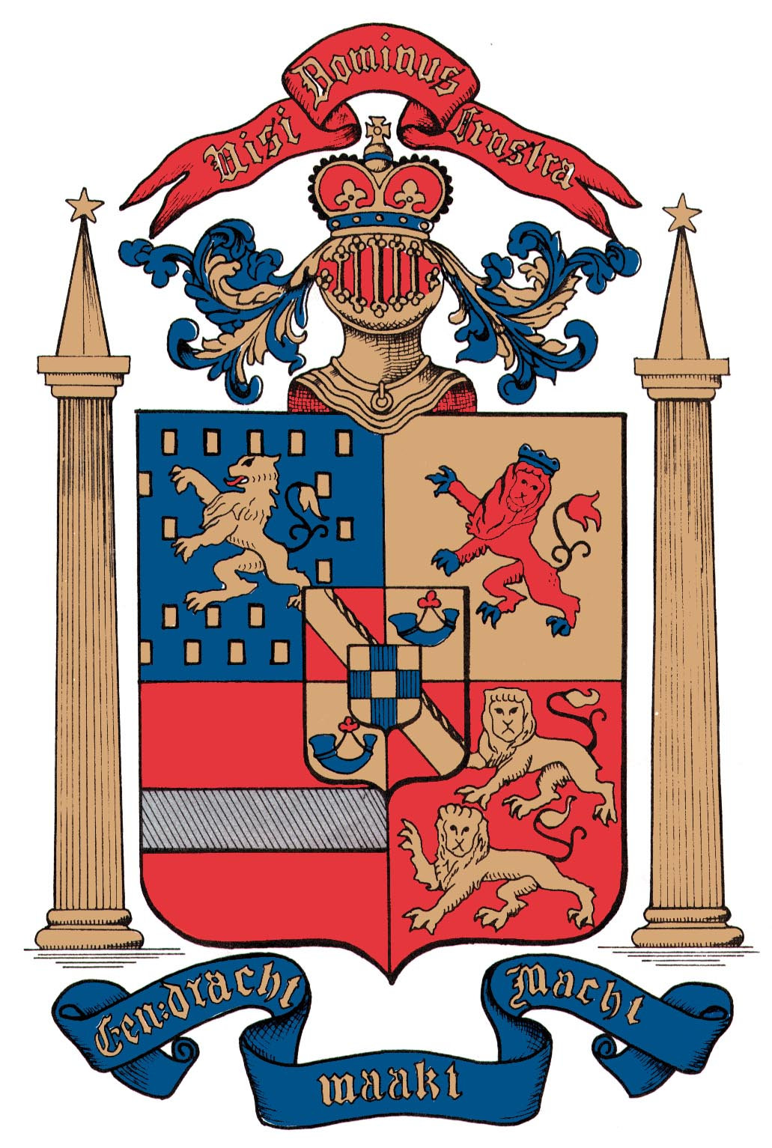
Old North Reformed Church
October, 2018 Newsletter

Dear Friends and Members of Old North,
Advent—the season of preparation and waiting to celebrate the coming of the Christ—is nearly upon us! This year as we journey to Christmas as a congregation our focus will be to explore, experience, and celebrate the indwelling of the Peace of God that surpasses our understanding.
Let us pause first to give thanks: for the opportunity to be bold in our love, courageous in our faith, and open to new ways of being in the love of God, shown us by God in coming once again as the Baby of Bethlehem!
What a risk God took—to be fragile, to be at the mercy of people, to be dedicated to loving God and others as the most important quality of life—the kingdom-building way of Jesus-- blessed and blessing. Yet we must admit, it’s such a risky and challenging way to live our lives!
Let’s face it: Christianity is a risky business:
- We risk having to work alongside people with whom we disagree on biblical interpretation because we trust that it is God who knows best;
- We risk opening our minds, hearts, spirits, and strengths to be modified—or even turned around completely—as we strive to grow ever closer to God’s ideal of Love for all of Creation;
- We risk having to choose to participate in difficult conversations with patience and respect for one another, trusting God’s Holy Spirit;
- We risk being changed into a new thing—where God is in charge, leading our way in this scary yet remarkably gift-giving, glorious world.
Last month I shared an effective discussion-guiding strategy with the Consistory that recommends asking two questions: 1) What do we know? (What is true?), and 2) What do we need to find out?
I pray for each of you, and for us as a congregation of Jesus Christ’s, that the answer to the first question will always begin with, “We know God is love, and loves us!” And that the answer to the second question will be, “How to better share that Love—the Good News—with the world!”
If we work on answering those two questions together in the days ahead, then in truth, we will be living thankful lives, blessed and full of blessing!
--Pastor Susan
CLASSIS OF GREATER PALISADES
At the October Stated Session of Classis, the finance committee presented a budget for 2019, which the Classis approved. The Assessment for 2019 was approved at $86.70 per confessing member (This is the total for General Synod, Regional Synod and Classis assessment). The Classis also approved the Classis portion of that assessment at $9.75 per confessing member.
The Supervision of Churches Committee asked for each church to submit the minutes of their elders’ meetings for 2018 (a minimum of four are required by the BCO annually).
The Classis conducted and sustained the senior exams for Soo Kim. Soo Kim was received as a licensed candidate in the RCA and is able to receive a call to ministry. (We are delighted to report that he will be providing pulpit supply at ONRC in January, when Pastor Susan visits family in Scotland.)
Old North’s Classis delegates are your Minister (Pastor Susan), and Elder Scott Benell.

THRIFT SHOPPE
SATURDAY NOVEMBER 17TH
9 A.M. – 2 P.M.
Clothing for Adults & Children…
Home Goods…Kitchen Items…
Crystal & Dinnerware…Toys…Books…
DVDs & CDs…

Check out our Christmas Corner!

Happy Thanksgiving to You!

Prayer Chain: If you have a celebration or concern that you would like to have included in our prayer chain, please call Pat Hooey, 201-843-4456.

SUMMER SURVEYS REPORT
There were two surveys in the last newsletter, both followed up in Sunday bulletins. Here are the results: Of the two Bible Study topics offered, “Christianity & Islam” nudged “Sexuality in the Bible” by three votes (out of a total of less than 10 responses). Wonderful study materials, including power point slides, will be offered on Christianity & Islam, in January. Stay tuned!
The more pressing survey, choosing a theme for Advent, received similarly scant responses, but the concept of Peace won out over the other options. Listen for Peace to be woven throughout our Advent preparations here at Old North, as we once again ready ourselves to celebrate Christmas, the indwelling of Immanuel. Advent begins on the first Sunday in December, when we turn to Luke as the featured gospel in the Revised Common Lectionary, Year C, for the next year.
STAY INFORMED
There is a copy of the most recently approved Consistory minutes provided in the Library for congregants to sit and read. If you wish to read through previous minutes, or financial reports, you may come into the office, M-F, and review the binders in the back office, or in the comfort of the Lounge.
If another time is needed, appointments can be made with the Pastor or a Consistory member. Note: These are legal records, and may not be removed from the church office. Thank you for your interest, and understanding!
GRATITUDE CORNER
Thanks to God for our Board of Elders-- Scott, Gay, Carol, and Leslie—for their faith, thoughtfulness, wisdom, and care.
Thanks to God for our Board of Deacons—Richie, Karen, and Ralph—for their industriousness, focus, and hope.
Thanks to God for Alan Newman and the gift of his musical ability!
Thanks to God for the congregation of Old North, for choosing to spend time on Sunday mornings and during the week, to pray together, work towards unity in Christ Jesus, now and for the future that God is calling and directing us to live into.
Thanks to God for the church’s Staff: Judy, who manages the church office with wisdom and aplomb even on the most difficult days; Lisa, who keeps our numbers straight and our bills paid; Kenny, who changes lightbulbs, and cleans the nooks and crannies of these old buildings every week!

Upcoming Events in Brief:
Saturday, Nov 17: Thrift Shoppe
-- Scripture-Art-and Music on the Lawn --
November 18th: Thanksgiving Sunday
Potluck Lunch; Rededication of the Auditorium
in Memory of The Rev. Richard and Joan Vander Borgh.
Wednesday, November 28: Advent Bible Study Begins (4 weeks)
December 2: First Sunday of Advent

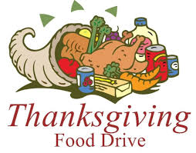
The Food Pantry is collecting food items for Thanksgiving. Please bring canned yams, stuffing mix, mashed potatoes mix, canned green beans, canned fruit, cranberry sauce, and pumpkin, etc., to our collection boxes in the Church House hallway.

Heritage Weekend: Dumont Historians Tom Kelly and Carol Banicki, and Pastor Susan, shared their expertise about the area and our church, with two groups of about thirty people on Saturday, Oct. 27. They and the Cresskill historian also provided fascinating artifacts for display in the auditorium. Pastor Susan’s Dusk Cemetery Tour drew a crowd of about ten, despite the blustery cold and rain. Reformation Sunday worship was followed by a Potluck Luncheon. Thanks to Scott Benell, Gay Gravina, and Brianna Polbos for serving as hosts!

You can visit the church website at https://oldnorth.church

ADVENT BIBLE STUDY AT OLD NORTH
WEDNESDAYS 7-8:15 p.m.
Nov. 28; Dec. 5, 12, 19.
Since 1892, children and adults alike have enjoyed the music, ballet, and story of The Nutcracker. Draw closer to Christ through this endearing Christmas classic as we explore why the baby born in Bethlehem is God's greatest gift - and learn about the kingdom that Jesus came to establish.
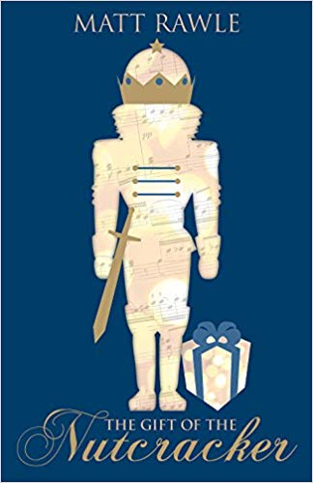
Sign Up Now in order to assure your book is ordered.
Book & Class = $12, payable to Old North.

CONSISTORY: Serving Together in Christ’s Name
Elders: Scott Benell, Gay Gravina, Carol Sushko, Leslie Maro
Deacons: Ralph Condis, Karen DiBella, Richard Schmude
Minister: Rev. Susan Kerr 201-338-8237; revskerr@gmail.com
Church: 201-385-2243; OLDNORTHDUMONT@gmail.com
Website: https://oldnorth.church
Consistory next meets on Thursday, November 15, at 7 p.m.

Art Music Scripture Event
SATURDAY NOVEMBER 17TH
10:00 A.M.
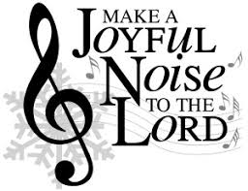
Concert on the Front Lawn
at Old North.
Join Deacon Ralph &
“The Holy Ghost Band”!

A View from Just One Pew
Leslie Maro, 10/12/18
Hopefully, we have all had a chance to process what “went down” at the Special Consistory Meeting of October 7. It was intended to be an opportunity to share information and opinions regarding the purchase of an electronic sign for Old North. In addition, it was meant to engage us all in creative thinking on how we can become a more vibrant presence in Dumont and surrounding communities while sharing the Word. We accomplished much of that, so that’s good. Getting there, though, was difficult and at times, sadly contentious and hurtful.
I’m the new kid on the Consistory block, so I realize that I lack the experience and wisdom that my fellow elders and deacons possess. And I’m also a relatively new church member without any Old North history in my blood, so what the heck do I know anyway? Well, admittedly, not much. But what I do know is that certain comments about Consistory left me feeling like I’d been sucker-punched. They were not accurate as to who we are, how we interact with one another, or how Pastor Susan guides and leads us. What was said has not been my experience at all and it should not deter anyone who thinks they have the heart to serve.
Without a doubt, there have been difficult discussions and differing opinions. Yet through those tough conversations, and the blessedly easy ones, we always strive to work together respectfully and inclusively in the best interest of Old North. We are ever cognizant that everyone in Old North is charged with reflecting Christ’s grace and love in how we work together, how we speak to one another, and how we reach out to the community that lies just outside our doors. I am humbled and gratefully challenged to be a part of this team. It’s exciting to help shepherd new ideas and ministries into fruition (just wait until you hear about the chamber music series and toddler program!). I highly recommend this experience and strongly encourage anyone who wants to serve Christ and the body of Christ in a new and challenging way to join this amazing group of people whom I deeply admire for their kindness, wisdom, and good fellowship.

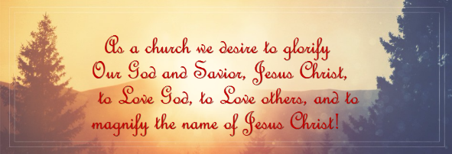

From the Keyboard of our Music Director, Alan Newman…
OUR MUSICIANS
We sincerely appreciate the musical offerings of Adrian Condis, Ralph Condis, and Ian Kerr-Mace. Adrian is a recent graduate of William Paterson where he was a woodwind major. He sings tenor in our Senior Choir and is frequently called upon to perform in our worship services. Adrian plays professionally for weddings, cocktail hours, social events and other gigs. Ralph Condis attended NJ College and also performs frequently in our worship services. Ralph sings in the Senior Choir, singing bass. Ian Kerr-Mace is the nephew of our pastor and he is attending Rutgers University on a scholarship as a brass major. Ian performs with various musical organizations and is often out of state. We look forward to his musical talent in church.

CHOIR PREPARATIONS
Our choirs are preparing the music for the upcoming seasons – Reformation Day, Thanksgiving, Advent and Christmas. I am thankful for the members of the choirs who rehearse their musical numbers every week – the children at 10:30 and the adults at 11:00 AM. We are asked to sing our praises to Him with our voices and our God-given talents. “Be glad and rejoice! Sing to the Lord a new song of praise in the assembly of the faithful.” Psalm 149:1
Don’t sing alone in the congregation but come and sing with us!

THE SENIOR CHOIR
The Senior Choir is very pleased to welcome its newest members, Danielle and Sandra Toscano. They come from a great distance to be at Old North and we appreciate their efforts to sing with us. We welcome all new additions to the choir with open arms. The choir rehearses every Sunday at 9:00 AM before church, and again at 11:00 following Coffee Hour. All rehearsals are held in the Chapel. Come join us!
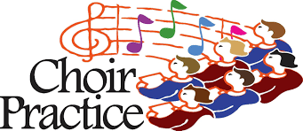

OUR TELLERS PIPE ORGAN
The pipes in our organ range in size from the size of a pencil to sixteen feet in length. Installed in 1973, the organ has served our congregation very well for all these years. The organ is considered one of the finest instruments in Bergen County and is lovingly maintained by the Emery Brothers Company of Allentown PA. I thank the congregation for their wisdom in keeping the instrument in excellent playing condition.

CHRISTMAS CANDLELIGHT VESPERS CONCERT
We look forward to our annual Christmas Candlelight Vespers Concert to be held on Sunday, December 16 at 4:00 PM. Come and enjoy the Christmas season with the beautiful music of the season in our historic sanctuary bathed in candlelight. Our choirs will sing, we’ll feature the singing of our favorite carols and enjoy the musical offerings of guest musicians include Katy Wong, harpist. Katy is a virtuoso harpist studying in her senior year at Juilliard School of Music. Invite your family, friends and neighbors.

A GIFT
I received a lovely handmade stained-glass ornament from Mikayla Schmude made in Sunday School. It hangs on my back door and it brightens my home. Thank you, Mikayla!

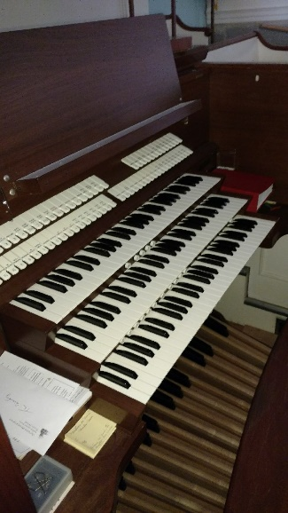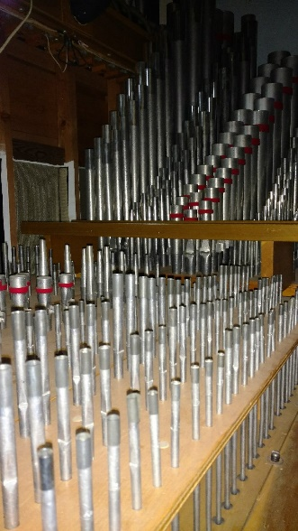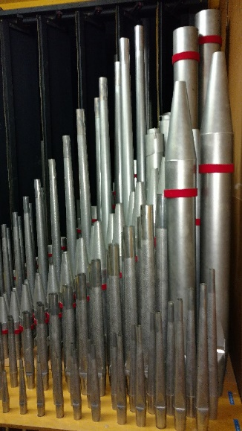

Old North’s magnificent Tellers organ, and SOME of the pipes that
make the sound come alive and fill the sanctuary!

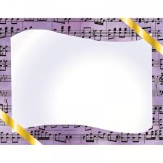
FREE
CHAMBER CONCERT SERIES
AT OLD NORTH
SUNDAYS AT 4 P.M.

December 16, 2018
Candlelight Christmas Vespers Concert

2019: January 13, March 17, May 19th

Mark your calendars,
stay tuned for details of each event!

Mission Update from the Bode Family: We've settled in through the very first phases of establishing a home base and life in a new country. The biggest deal by far has been Erica's illness, which was properly diagnosed after a few weeks of ineffective treatment for a supposed parasite infection. She has ulcerative colitis and was severely anemic. Two blood transfusions and a pile of steroids and meds, and she's back on her feet. Future specifics unknown on that front right now. Josh continues to learn toward an understanding of what he ultimately can uniquely contribute to the Christian community in Oman. The kids are by the mysteries of grace doing exactly very well.
We invite everybody to join our Facebook Group:
www.facebook.com/groups/BodesInOman
And to sign up to receive our family's email newsletter:
bit.ly/BodesInOman
Please pray this month:
- Join us in prayers of gratitude for high quality health care in Oman (in part this is the legacy of decades of RCA medical mission in this country).
- That Erica will get better and better
- That Josh may see well how he can fit here, and how to act on what he sees
- That the PCO increasingly be a city on a hill and a light for Christ (Matthew 5:14) in Oman
ACTIONS TAKEN BY YOUR CONSISTORY
(Moved, Seconded, Discussed, Carried)
In order to keep you informed, Actions of the Consistory will be published in the newsletters after the Minutes have been approved.
From the 9/13 Minutes:
-- Rescind the previous recommendation of 75%/25%, Church Maintenance Expenses/Benevolences, and inform the Thrift Shoppe team that 100% of Thrift Shoppe profits will be donated to the DiBella Fund for the calendar year 2018 as requested. M/S/C.
--Approved use of room in building to Tiffany Sanders for purpose of
photography on 11/23 and 11/24 (and, possibly, another day) at no charge, pending insurance liability clarification. M/S/C.
Recommendations Addressed via email between stated meetings:
- Approved: Pianos moved from sanctuary to auditorium, from former choir room to sanctuary. (Piano cover to be ordered for auditorium.)
- Approved: Installation of AC in Auditorium initiated and completed; heartfelt thanks to Tim Frohlich for his expert electrical work, and John Woerner and Jack Erhard for their legwork on the project.
--Denied: Removal of auditorium basketball backboard and net.
--Purchase a VISA card in the amount of $200 as gift for donated electrical work on AC installation, and request invoice for charitable gift-in-kind donation. M/S/C
--Re-affirm vote, after 10 months of discussion and information, in favor of proceeding with purchase and installation of an electronic LED outdoor church sign, to be paid from the $50,000 set aside in the next year for public programming. noting 3 bids are being sought. M/S/C
--(TABLED pending further information, including clarification on a potential Eagle Scout project.)--Revisited as per last meeting: The Consistory authorize the church office to proceed in accepting the best bid as provided, to repair/contain the tile floor in the Fellowship Hall as described and to lay new flooring and baseboards, to be paid for from the second bequest check received from the Rev. Richard VanderBorgh estate.
--Launch a new resident outreach communications program, coordinated by Pat Hooey, who has volunteered to gather addresses from the property transactions listings in weekly newspapers and will handle envelope stuffing of mailers to include: Pastor welcome letter,
calendar of events, event flyers and, possibly, a pamphlet/brochure describing ON. M/S/C

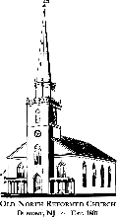
O
LD
N
ORTH
R
EFORMED
C
HURCH

120 Washington Avenue

Dumont, NJ 07628
https://oldnorth.church

