HOPE and
HAPPENINGS
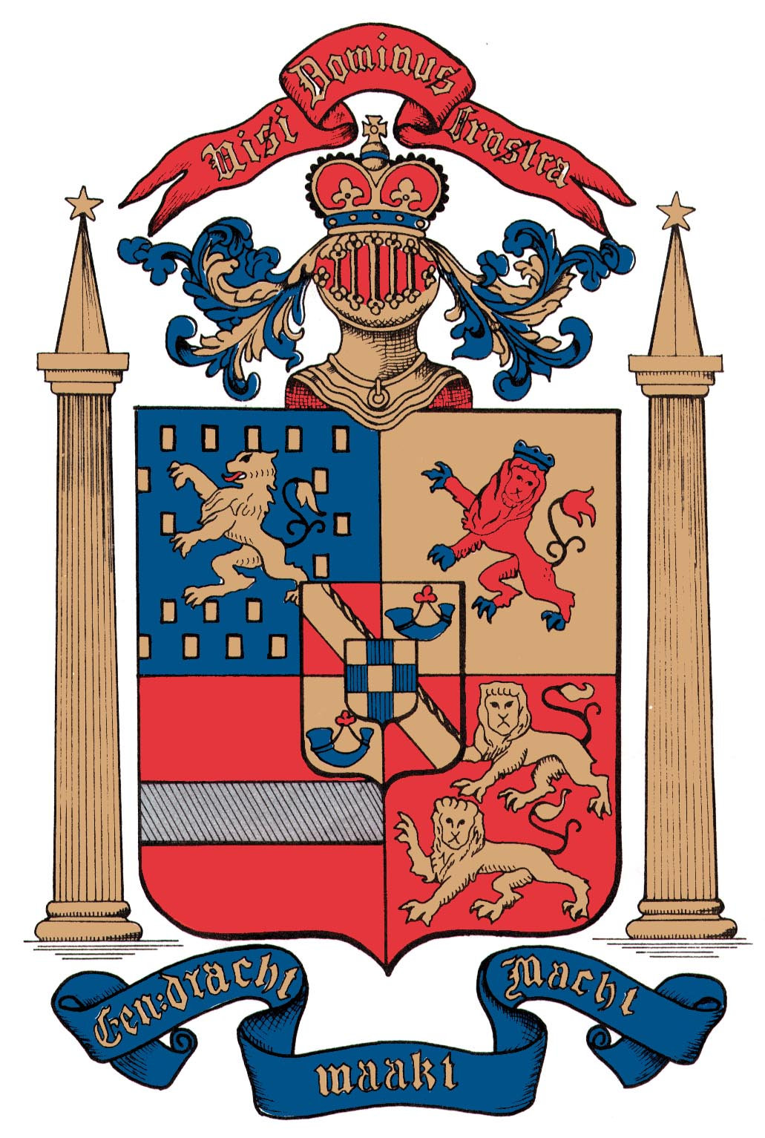
Old North Reformed Church
March/April, 2022 Newsletter

Dear Friends and Members of Old North,
This year’s Lenten journey is upon us—and once again, there are signs of Spring creeping into our yards, and hopefully, into our hearts and minds. It feels like not only are the daffodils pushing up through warming soil, but also that our immediate world is brightening up with more maskless smiles and familiar faces reappearing: thank God!
If the face of God in your life has felt like God has also been wearing a mask over these past many months, let me reassure you that the Spirit of God is alive and well and has been working God’s love at Old North, just as it has for nearly 300 years in this congregation: our buildings are beautifully and faithfully ready for continuing both old and exciting new ministries in the community, and are still committed to assisting with missions of help and hope around the world wherever we can. It is a joy to share with you in these pages some of the bright spots of light, love, and hope that our congregation—your church—is working to share in God’s name and glory.
Although online and hybrid activities have become a norm that will not be going away, there is nothing in life to replace the power and joy, and potential for personal growth—spiritual, emotional, practical—that gathering in person provides to us mortals. When we are able to actually experience in-the-moment words of encouragement, the laughter of children, standing together to sing hymns, being present to give to God our thoughts, time, and talents…to share a meal and the work of putting it together… it is a gift both from us and for us. It is the strength to be found in Communion, and being part of a community—however flawed, however striving to better reflect and share the love of Jesus in this world. It is Lent. Let’s join together to celebrate Easter not only in another month, but for every day we are given!

In Christian Love --Pastor Susan

JOHN
The Gospel of Light and Life

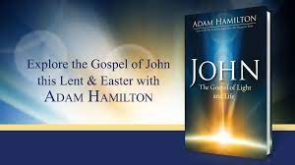

6 Wednesdays
March 9, 16, 23, 30, April 6, 13
7:00-8:30 p.m.
Lenten Program:

Preparing for Easter 2022
with Pastor Susan Kerr

SIX SESSIONS

1. The Word Made Flesh
White light is made up of all the colors
of the rainbow.
What is the Light of Christ made up of?

2. The Miraculous Signs of Jesus
How has God given you gifts and opportunities to
bring beauty to an ugly situation?

3. The “I AM: Sayings of Jesus
What does it mean to you that Jesus is God in human form?

4. The Farewell Discourse
“I feel God’s Holy Spirit in my life when…”
“I can connect with and grow closer to Christ by…”

5. The Arrest, Trial, and Crucifixion of
the King
What does Christ save us from?
What does Christ save us for?

6. Eternal Life
What do you know about the story of Easter?
What questions do you have about Jesus’ resurrection?

Contact the Church if you would like to participate.
Books are in the Library. A donation of $12 is requested.

A JOURNEY THROUGH LENT 2022

3/16,23,30,4/6,13 Lenten Bible Study - 7 – 8:30 p.m.
3/12 Thrift Shoppe 9:00 a.m. – 2:00 p.m.
3/13 Daylight Savings Spring Ahead 1 Hour
4/9 Thrift Shoppe 9:00 a.m. – 2:00 p.m.
4/10 Palm Sunday/Holy week begins
Pancake Breakfast following worship
4/15 Good Friday/Stations of the Cross
4/17 Easter Sunrise Service
Gather at the Cross 6:00 a.m.
Easter Family Service 9:30 a.m.

THRIFT SHOPPE - NEXT DATE: MARCH 12TH
^{9 a.m. 2 p.m.}
Thank you once again to all the Donors & Volunteers, and to the Community Shoppers who make our sales such a success!

Home with the Little One(s)?
Here's something fun to look forward to doing together!
Free play and social time-- Healthy snack
(and goodies for the grown-ups!)
Guided Song and Story Activity.

TUESDAYS 9:00-10:30 a.m.
What to Expect
9:00 - 9:45 Playtime!
9:45 - 10:00 Snacks
10 - 10:30 Group Time & Clean up
Thank you for coming!
Invite a friend!

contact: oldnorthtoddlers@gmail.com
Ministry for Children and their Care-Givers
201-385-2243

THE CONSISTORY OF OLD NORTH
Elders: Karen DiBella (2022) Scott Benell (2023)
Carol Sushko (2023, 2nd term)
Deacons: Brianna Polbos (2021) John Passarotti (2022) Richard Schmude (2023)
Minister: Rev. Susan Kerr (Parsonage) 201-338-8237;
revskerr@gmail.com

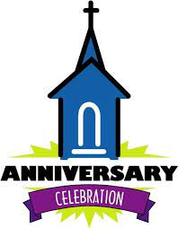
300 Years as a Congregation Celebration in 2023!
We are looking for volunteers to be on the committee for our celebration Heritage Weekend Celebration this year. Please contact the office if you are interested in learning more about potential plans.

CELEBRATION CHOIR FOR
PALM SUNDAY AND EASTER.
Can you carry a tune? Rehearsals will begin
Sunday at 11-11:30 a.m. in the Chapel, for a multi-age Celebration Choir for Palm Sunday and Easter. Please consider sharing your gift of song for God this holiday!
(Come forward for the anthem and regain your pew boxes for worship.)

LOOKING AHEAD
The Consistory affirmed exploring the fund-raiser and mission that provides support for the Navajo Indian Reservation in Farmington, NM., by hosting a Pumpkin Patch this fall!
Stay tuned!

2021 Church Benevolence Recipients: Center for Food Action, Dumont Fire Dept., River Mission Ministry through
the RCA, Dumont Food Pantry, Bode Missionary Family and RCA Projects, Dumont Ambulance Corps., Meals on Wheels, Chance at Life Cat Rescue, Pony Power, Mobility Mentoring Program, and Kentucky Tornado Relief through the RCA.

ANNUAL PALM SUNDAY PANCAKE BREAKFAST IS BACK!
Receive your palms and
stay for pancakes.
Sunday, April 10, 2022
following 9:30 a.m. worship.
Adults $7.00, Children $3.00 - Pay at the door.
Contact to the office to reserve your space.

From the Keyboard of our Music Director, Alan Newman…
Calling all singers – young and old and anyone in between!
We are planning to form a choir to sing short anthems in the beginning of our worship services on Palm Sunday and Easter. I’ve missed working with you and I thought it would be good to have special singing on these two important days in the Church Year.
The music is easy, fun to sing and add the sounds of praise on Palm Sunday and Easter. We will not wear robes and the music will be suited for children and adults alike. We will sing early in the service and will join our families in the pews.
Rehearsals will be every Sunday after church for 20 minutes in the Chapel. Come and join us as we praise God in song. All are invited!

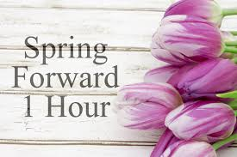
MARCH 13

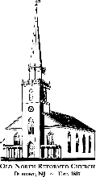

120 Washington Avenue

Dumont, NJ 07628
https://oldnorth.church

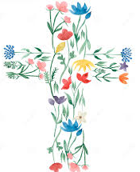

OLD NORTH REFORMED CHURCH

