**HOPE and**

**HAPPENINGS**

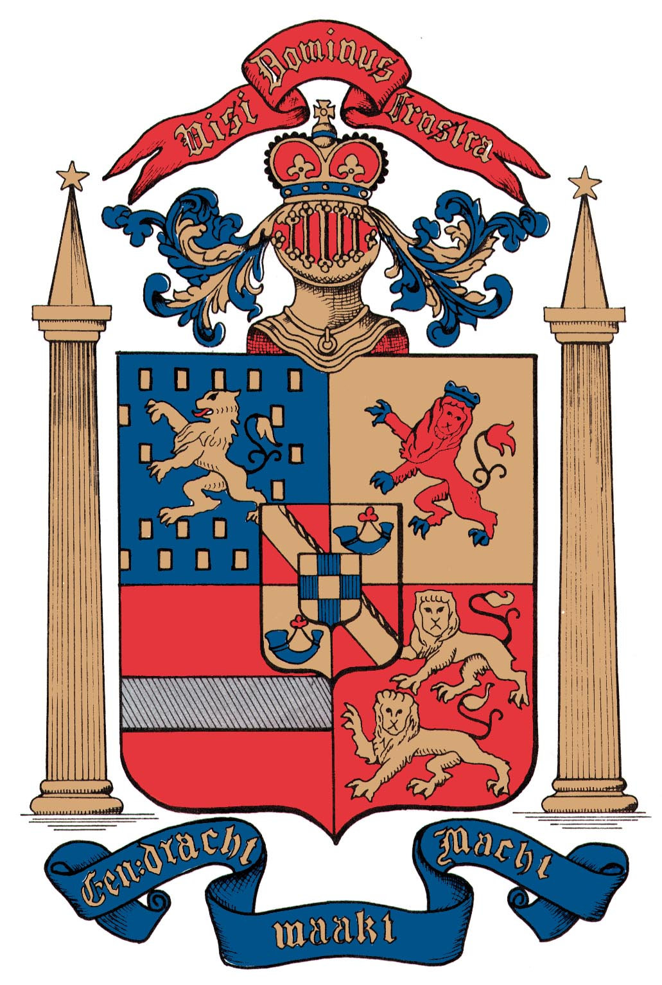

**Old North Reformed Church**

**April, 2019 Newsletter**

Dear Friends and Members of Old North,

We have moved from Ash Wednesday through Lent, and after this Sunday, Palm (or Passion) Sunday, we begin our countdown to Holy Week and our most important holy day: Easter Sunday, on April 21.

Lent is a period that is at the heart of what it means to be Christian: it is a season of grace: grace offered, and grace sought and received.

Very often, Christians have been sort of beat over the head during Lent with penitential guilt about our failures. We have this historical notion that we are supposed to suffer in some way, in order to “get” the joy of Easter. This year, I would like to make another suggestion for our journey through Holy Week together. Let’s make this year’s intention one of being together in what we promise in our covenanting liturgies: let’s work for “unity, purity, and peace” with one another, and in the world, and mourn that which divides us.

What would it be like to spend the uncertainty and confusion of those days of Holy Week before Easter sharing strategies to build up one another? What if we made it our goal to recognize one another’s strengths and celebrate them? What if we lovingly acknowledged our challenges, collaborating to improve our lives? Might we all become better Christians by Easter Sunday?

I invite you to join me in praying for, and watching over, one another as tenderly in the next week as we are watching over the greening, growing shoots coming up in our gardens: hopefully, thankfully, trustingly, lovingly… the way God watches us. And see what happens!

In Christian Love **--Pastor Susan**



**MEET OUR NEW CONSISTORY MEMBERS**

Brianna Polbos has been a part of the Old North community since she was a child. She graduated from Hofstra University last May, where she received her BBA in Marketing. Currently, she is enjoying her new job working as a Marketing Assistant. In her spare time, she enjoys playing with her two dogs, Belle and Louie. Usually, on Sundays, she can be seen assisting the Sunday School. Brianna is looking forward to serving and spreading the word of God as a Deacon.

  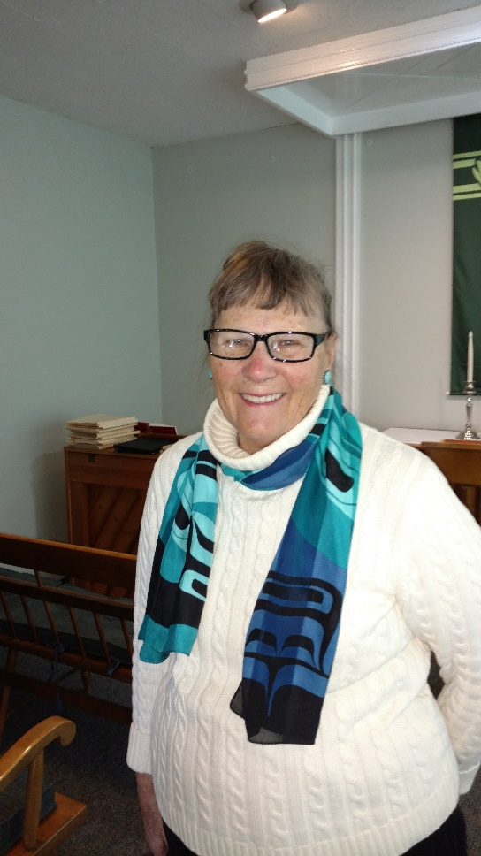

***Brianna Betsy***

Betsy Erhard became a member of Old North along with husband Jack in 1972. They joined in order for their 4 children to be in a good Sunday School program. Throughout the years, Betsy has sung in the choir, taught Sunday School, was a member of Consistory and the Women's Guild. She has lived in Haworth for 55 years, and enjoys reading and travel. Betsy looks forward to serving the Lord as a Deacon.

**CONSISTORY NEWS**

The annual Consistory Retreat/Training Day was held on Saturday, February 23, at Old North. It was a day of fellowship, information, food, fun, and orientation for new board members, as well as an opportunity to deepen our faithful attendance to the work of the church in the name of God. Thanks to those Elders and Deacons who are willing to serve!

**THRIFT SHOPPE - NEXT DATE**

**SATURDAY APRIL 13TH**

9 A.M. – 2 P.M.

**Crazy Sales…Wonderful Selection…**

**NOT TO BE MISSED!**

*Thank you once again to all the Donors & Volunteers,*

*and to the community Shoppers who made*

*“March Madness” such a success!*

**Consistory next meets on Thursday, April 25, at 6:45 p.m.**



Join us every Friday evening for Basketball and Board Game Night

at Old North between the hours of 6-9pm.

The only thing you need to bring is an appetite and your sneakers.

Pizza and refreshments will be served.

Electronic devices will be confiscated at the door!!!!

Questions? See Deacons Karen or Richie!

**You can visit the church website at** [**https://oldnorth.church**](https://oldnorth.church)

**INTERESTED IN MEMBERSHIP AT OLD NORTH?**

There will be an opportunity for individuals interesting in becoming members of Old North by (re)affirmation of faith or transfer,  to meet with the Elders in the Lounge following worship on Sunday, April 28.  If you are interested or have questions, please see Pastor Susan.



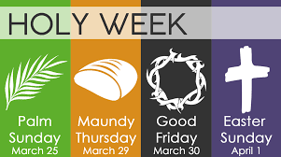

Palm Sunday: Worship at 9:30 a.m.

Pancake Brunch follows in Fellowship Hall

($6 adults, $2 children)

Maundy Thursday: Remembrance of the Last Supper

6:30 p.m., Auditorium

Good Friday: Stations of the Cross, 2 & 7 p.m.

Chapel

Easter Sunday: Celebration of the Resurrection

6 a.m. Sunrise Service (with Bagpipes)

9:30 Family Worship (with Brass)

**GRATITUDE CORNER**

Did you know Old North has “church mice” there

who work so you are scarcely aware,

who make our church and buildings inviting,

tending to details enriching, if not always exciting!

There are those who sort both bag and box,

and set things out for our Thrift Shoppe stocks.

There’s one who decorates for each season as it comes,

who coordinates the flowers at the Table every week,

and makes the recyclables disappear



so the sexton doesn’t shriek.

There is a “mouse” who comes in here

and takes donated bottles away,

then brings us back some cash

so our kids at Warwick can go and play!

Yes indeed we have some “church mice”

who make Old North a special place —

We thank you, thank you, for your grace

And the talents you do share,

And want to let you know, always…

We see, we appreciate, we care!

***From the Keyboard of our Music Director, Alan Newman…***



AMERICAN GUILD OF ORGANISTS

I joined the American Guild of Organists (AGO) during my college years in 1959 and I have been an active member ever since.  The AGO was founded in NY City by a handful of organists in 1896.  Today it has 16,000 members nationwide.  I am a member of the Northern NJ Chapter and I served as Dean from 1976 until 1978.  The Guild seeks to set and maintain high standards and to promote understanding and appreciation of all aspects of organ and choral music.  The chapter members attended a brief recital at Old North last year and they were very impressed by our Tellers pipe organ.  I am looking forward to hosting the group again next year.

On President’s Day, I attended an all-day excursion to New York City to hear and see the new organ installed in St. Thomas Episcopal Church on Fifth Ave. and see and hear the restoration of the huge organ in St. Patrick’s Cathedral.  We were joined by the Metropolitan Chapter of the AGO.  Various organists of both St. Thomas and St. Patrick’s demonstrated their instruments.

ASH WEDNESDAY

On March 6, Ash Wednesday, we will hold our annual service at 7:00 PM.  I have invited the choirs of the Haworth Congregational Church, the Oradell Reformed Church, the Clinton Avenue Reformed Church of Bergenfield, and Calvary Methodist of Dumont to join us in worship.  I do not know if any or all of these churches have a worship service on Ash Wednesday, but an invitation has been extended to their choirs to join us.

CHOIR

Speaking of invitations, we welcome you to join our Senior Choir to help us lift our voices together in worship.  The choir warms up at 9:00 a.m. every Sunday morning, and rehearses again in the Chapel at 11:00 a.m. following Coffee Hour.  The choir is pleased to welcome its newest member, Megan Passarotti.  Megan sings in her school chorus in Cresskill and she is a welcome addition to our alto section.





**FREE* CONCERT SERIES**

**AT OLD NORTH**

**SUNDAY AT 4 P.M.**

**May 12th**

**“Jazz in the Sanctuary!”**

• Performance will be a **jazz quartet**, led by

Old North's own **Adrian Condis**

* Weather permitting, the **doors will be open** to

the public for their enjoyment;

•  **Informal** program, **flowers** for the ladies;

• **75 minutes of "jazz standards and classics"**

with a short intermission;

*Mark your calendars! A perfect complement to*

*Mothers’ Day lunch or dinner plans!*

***\*Donations gratefully accepted but not required.***

**NEW CHURCH LEADERSHIP PROGRAM**

“Encouraging Thriving Congregations” is a 12-month sharing community initiated by our Regional Synod and the RCA to focus on re-engaging our congregations in ministries specific to our individual contexts.  It is not a “cookie-cutter” approach to learning, but rather an organic approach to look at what is needed in each church or community, and see how we might be able to minister to that need.  Through monthly conversations with other church teams in our area, we have the opportunity to grow together!

We need to identify a team (or teams) of 3-5 members to gather monthly for conversation and input from Andy Bossardet, RCA Coordinator for Encouraging Thriving Congregations. Quarterly, starting in May, we will gather in person, with pastors meeting on Friday evening, and the entire team gathering on Saturday.  In between we will gather via Zoom Conferencing.  Each team will develop its own particular focus, and will report back on our gains, obstacles, successes, and struggles. Questions? Care to join ON’s team? Check in with Pastor Susan, Scott Benell, Gay Gravina, Betsy Erhard, Carol Sushko, or John Passarotti, all of whom attended the first meeting.

[[](https://www.facebook.com/oldnorthdumont/photos/a.210798192438620/1082596248592139/?type=3&eid=ARCtlbLU2fy6u5Zxd3ZR91MgiklonBwa7syeWyfIoYdmEmZ0NR47-DyQlojjZKswUfMW8n6ktJlFf5Ci&__xts__%5B0%5D=68.ARAr8BAc79PhHQrAdmG_tXE0ck0aOgyNCcXrT8QDKbsQ5tba7Xk75e9nuE7XbKd9eyiSc8yTusZE2GlAFsXqWwCeCkbBSHJlHcmk7bJoDffQzqjApE1ywzF6lcl0kioBPVBoiDWdwgqwofayXVdbk08wjZqZY-y5xkntSQ26kqCY3AYKAmZGLn7foj_9XTyxSBSG0PCWvHY69z7MajyVKScTPt996Uw-7rhBHRzD10aLplxfy44qBBsOVB-bsh90K1K3tsnBnwjyZa7LXzGmSdKmV29GbW-Xx5hcZwy6Elz1dSdRDoUNBOW9IyaghlAST9hY2_DDrKUDHw01KwIoLEycfg&__tn__=EHH-R)](https://www.facebook.com/oldnorthdumont/photos/a.210798192438620/1082596248592139/?type=3&eid=ARCtlbLU2fy6u5Zxd3ZR91MgiklonBwa7syeWyfIoYdmEmZ0NR47-DyQlojjZKswUfMW8n6ktJlFf5Ci&__xts__%5B0%5D=68.ARAr8BAc79PhHQrAdmG_tXE0ck0aOgyNCcXrT8QDKbsQ5tba7Xk75e9nuE7XbKd9eyiSc8yTusZE2GlAFsXqWwCeCkbBSHJlHcmk7bJoDffQzqjApE1ywzF6lcl0kioBPVBoiDWdwgqwofayXVdbk08wjZqZY-y5xkntSQ26kqCY3AYKAmZGLn7foj_9XTyxSBSG0PCWvHY69z7MajyVKScTPt996Uw-7rhBHRzD10aLplxfy44qBBsOVB-bsh90K1K3tsnBnwjyZa7LXzGmSdKmV29GbW-Xx5hcZwy6Elz1dSdRDoUNBOW9IyaghlAST9hY2_DDrKUDHw01KwIoLEycfg&__tn__=EHH-R)

[Join us Palm Sunday, April 14, for Old North's annual tradition: Pancake Brunch after worship: Adults $6, Children $2](https://www.facebook.com/oldnorthdumont/photos/a.210798192438620/1082596248592139/?type=3&eid=ARCtlbLU2fy6u5Zxd3ZR91MgiklonBwa7syeWyfIoYdmEmZ0NR47-DyQlojjZKswUfMW8n6ktJlFf5Ci&__xts__%5B0%5D=68.ARAr8BAc79PhHQrAdmG_tXE0ck0aOgyNCcXrT8QDKbsQ5tba7Xk75e9nuE7XbKd9eyiSc8yTusZE2GlAFsXqWwCeCkbBSHJlHcmk7bJoDffQzqjApE1ywzF6lcl0kioBPVBoiDWdwgqwofayXVdbk08wjZqZY-y5xkntSQ26kqCY3AYKAmZGLn7foj_9XTyxSBSG0PCWvHY69z7MajyVKScTPt996Uw-7rhBHRzD10aLplxfy44qBBsOVB-bsh90K1K3tsnBnwjyZa7LXzGmSdKmV29GbW-Xx5hcZwy6Elz1dSdRDoUNBOW9IyaghlAST9hY2_DDrKUDHw01KwIoLEycfg&__tn__=EHH-R)

[Downstairs Fellowship Hall.](https://www.facebook.com/oldnorthdumont/photos/a.210798192438620/1082596248592139/?type=3&eid=ARCtlbLU2fy6u5Zxd3ZR91MgiklonBwa7syeWyfIoYdmEmZ0NR47-DyQlojjZKswUfMW8n6ktJlFf5Ci&__xts__%5B0%5D=68.ARAr8BAc79PhHQrAdmG_tXE0ck0aOgyNCcXrT8QDKbsQ5tba7Xk75e9nuE7XbKd9eyiSc8yTusZE2GlAFsXqWwCeCkbBSHJlHcmk7bJoDffQzqjApE1ywzF6lcl0kioBPVBoiDWdwgqwofayXVdbk08wjZqZY-y5xkntSQ26kqCY3AYKAmZGLn7foj_9XTyxSBSG0PCWvHY69z7MajyVKScTPt996Uw-7rhBHRzD10aLplxfy44qBBsOVB-bsh90K1K3tsnBnwjyZa7LXzGmSdKmV29GbW-Xx5hcZwy6Elz1dSdRDoUNBOW9IyaghlAST9hY2_DDrKUDHw01KwIoLEycfg&__tn__=EHH-R)



**O**

**LD**

**N**

**ORTH**

**R**

**EFORMED**

**C**

**HURCH**

120 Washington Avenue

Dumont, NJ 07628

https://oldnorth.church

