HOPE and
HAPPENINGS
Old North Reformed Church
July, 2020 Newsletter

Dear Friends and Members of Old North,
For all of us, 2020 has been a year like no other. In the past four months, Old North has been called on to be the church in ways we could have never anticipated. We’ve stepped up to share worship on line and through the post. We’ve given support and we’ve asked for and received support in unexpected ways, detailed in the articles herein. As a community, we continue to work through these challenging times together with strength, humility, and faith.
As we passed the midpoint of our fiscal year, we’ve been mindful of the fiscal needs of those we serve. At the same time we find ourselves challenged with on-going maintenance and building repairs that are needed to sustain our historic property, looking to be ready to celebrate three hundred years of ministry as a congregation in 2024.
It has always been my experience that when a church gives generously, we receive generously from the bounty of others. God finds a way! Please consider giving what you can to help us continue to support our church, and our community. We are grateful to every one of you who have continued to give your thank offerings to God by your donations to Old North, and ask those who are able, to step up in any way possible now more than ever, as we have seen an approximate 50% reduction in our income to date for this year because of losing the Shoppe income for Missions, and Building Use income to help offset General Expenses… every bit supports our mission.
We do not know what tomorrow will ask of us. However, we do know that if we stand together, we will continue to be here for our congregation, our community, and for the world, in sharing the Good News of Jesus Christ wherever and however we are called to.
Yours In Faith-- Pastor Susan

MATCHING OUR COFFEE TO OUR VALUES

(From the RCA website): “The 2004 General Synod adopted a resolution “to encourage RCA congregations to use fair trade and/or organic coffee and encourage individual members to do the same in their homes.” They affirmed that: “Of course, churches do not want to intentionally participate in the destruction of God’s creation or the abuse of the poor. In the face of these discouraging realities, what can a church do? There are simple steps that can be taken, which make a big difference. Churches can be intentional about which coffee they purchase and use. Alternative coffees that keep the poor and the environment in mind are becoming more available.
Fair trade coffee may cost more, but churches and individual Christians can see their coffee purchasing as a missional opportunity, gladly paying more for a product that benefits the poor.”(MGS 2004: 314-315)
Old North’s Consistory, at the February meeting, voted to purchase and serve fair trade coffee as a faith partner from Equal Exchange, and to minimize waste by purchasing a commercial, individual-pot brewer for the service kitchen. We are hopeful that in the future, these steps forward in our Christian witness will be useful through a contemporary hospitality mission to the community, and simplify handling and serving while minimizing waste.

- Elders approved “virtual” communion at worship service on Sunday, May 3rd.
- TO DISTRIBUTE THE FOLLOWING OLD NORTH BENEVOLENCES, WITH THANKS TO THE THRIFT SHOPPE FOR PROVIDING FUNDING:
- Meals on Wheels-$1,000.
- Center for Food Action-$1,000.
- River Mission-$1,000.
- Dumont Fire Dept-$1,000.
- Dumont Ambulance-$1,000.
May: RECOMMENDATIONS: M/S/C (moved, seconded, carried)
- To authorize repair and general set up of office computer by Chris at needatechguy.com.
- To award additional Thrift Shoppe Revenue Benevolences to:
- Local Dumont Food Pantry (supermarket gift cards)- $500.
- Unbridled Heroes, Allendale, NJ - $1,000.
- Adler Aphasia in Memory of Warren Van Buren - $500.
- To research RCA Mission website, specifically missions serving children.
- In recognition of June as Pride Month, a message of God’s love for all His children and our mutual responsibility to love and not judge one another be added to the rotation of messaging on Old North’s electronic sign. Message to read as follows: “Love is a Human Right & Responsibility”. Graphic elements will incorporate rainbow colors or an image of a rainbow. Design will adhere to all of Dumont’s regulations regarding signage. Message will run from June 14-28, 2020 (the date range for many Pride events and the commemorations of the 50th Pride parade in NYC – all of which have been cancelled due to the novel coronavirus pandemic).
- Friendly Amendment: Change days of running to June 14-30.
- Adding to the rotation of messaging on Old North’s electronic sign a message to read as follows: “Spread hope, kindness and love”. Graphic elements will incorporate rainbow colors or an image of a rainbow. Design will adhere to all of Dumont’s regulations regarding signage. Message will run from May 31-June 13.
- To approve Gay Gravina planting flowers of her choice in front of Church house. (With our thanks!)
- Approved Trunk-to-Trunk collection for Dumont Food Pantry.

CONSISTORY ACTIONS CONTINUED:
JUNE: RECOMMENDATIONS: M/S/C (moved, seconded, carried)
- To suspend rental payments from Light of Christ Church until such time as they may resume regular worship.
- Approved 2nd Trunk-to-Trunk collection for Dumont Food Pantry.
- Approved Boy Scouts’ request to meet as requested via email (troop of 7 boys).
- We will require building users to submit a plan on their sanitizing procedure in the building, furnish us with name of person in the organization that we may contact with any concerns, and to notify us if anyone in their group has been sick. We will give them a copy of state website Covid19 guidelines, requiring signed acknowledgment of receipt of guidelines and signed release of responsibility of Old North regarding Covid19.
- To resume work projects at ON through holding “work parties” with safety measures in place (masks, social distancing), scheduling work party/barbecue/children’s activity on Saturday, July 11 (rain date-July 25), 9:00-12:00. (Deacon Passarotti coord.)
- To donate $1500. to the Remember Nhu Mission, an RCA mission focused on ending child sex slavery through prevention, listed on the RCA Mission page, from ON benevolence fund.
https://www.rca.org/give/bob-and-amy-abel-remember-nhu/
- To donate $1,000. to Salvation Army N.J. Division.
- To donate $500. to the RCA Maasai Outreach Mission (MOM).
https://www.rca.org/give/maasai-medical-ministry/
- Devote remaining benevolence funds to other local needs (in addition to what we have already donated to locally) and USA needs/projects when we determine those needs.
JULY: RECOMMENDATIONS: M/S/C (moved, seconded, carried)
- That the Consistory award Grimes Scholarship checks to Jacqueline
Toscano and Allison Kenny in the amount of $850 each, with our commendations for successfully continuing in their chosen trainings.
- To have Terry Lowe refresh estimate on re-pointing, window repair, gutter repair, west window repair / wood refurbishment on exterior west side of sanctuary.
- To purchase mulch and rose food as needed for parsonage grounds.

“Give thanks to the Lord for he is good; his steadfast love endures forever.”
Psalm 118:1

THE CRAZY DAYS OF 2020
What a peculiar spring and summer season this has been and something to talk about for years to come – no church attendance other than virtual worship services. No congregations together, no choirs, the building closed, no Thrift Shop, etc., and being told to stay home. But we have been worshipping together on YouTube and Facebook, with Bible studies on Zoom. We miss seeing each other and being a part of our church family. I’ve been going over to the empty church to record the Prelude and Postlude on the organ every week. I need to give special thank you’s to Pastor Susan for organizing the worship services incorporating the music and to Marilyn Hashway for recording the music on her iPhone. I Forwarded the service to a friend in California and he remarked about the professionalism of the presentation.
But as wonderful as the Virtual worship services are – some churches record their pastors giving a sermon in their office – I look forward to our reopening the Church on August 2nd. Absence truly makes the heart grow fonder. In His service,
Alan Newman, Director of Music

Visit the church website at https://oldnorth.church

RECOMMENDED READING
Looking for some thoughtful Christian reading in the morning? Then check out Glenn McDonald’s Morning Reflection. Several ON members already subscribe and can attest to the quality of the content.

To sign up, simply write to Glenn at Glenn.McDonald@ascension.org. He will sign you up personally and said that he’ll be delighted to do so. (He’s very responsive to e-mails and happy to hear from folks!)

Glenn is the Director of Mission Integration for the Ascension Ministry Service Center in Indianapolis, Indiana, a role in which he serves as the workplace mission leader for 1,000 associates in the healthcare industry. He is an ordained Presbyterian minister, has 33 years of congregational leadership experience, and is the author of ten books on discipleship and spiritual formation.

CONSISTORY ACTIONS CONTINUED:
- To suspend building user groups through 3/29, pro-rating rent for 2 weeks if requested (EXCEPTIONS to suspension: Old North and Korean congregations.)
- To set up a Thrift Shoppe Instagram account with Deacon Brianna Polbos as Administrator.
- To appoint a task force of 3-4 church members (including but not limited to at least 1 but not more than 2 currently serving on Consistory) to review current processes for management of Old North’s investment account(s), research alternatives, and make a recommendation as to how future investment management shall be handled.
- To purchase new folding chair/table combo cart.
- To contact Jan-Pro cleaning contractor for price and earliest availability date that we can engage them and upon agreement with them, give present cleaning service notice of termination and 1 month severance pay. NOTE: Action Suspended due to Covid-19 building closing.
- To coordinate a “photo both” at the Palm Sunday Pancake Breakfast in order to take individual’s pictures for a new church photo directory.
- To enable ON to host the Dumont Annual Christmas Train Show, “Old North Polar Express” this Nov./Dec.
- That the Consistory of Old North solicit bids to install solar energy panels on the south-facing roof of the Church House, w/ decision to install pending receiving and favorably accepting that information.
Suspended (S) / Cancelled (C) Programs Due to Pandemic:
Toddlers Group Program (S) Wed. Lenten Bible Study (S)
Boy Scouts / Girl Scouts (S) All building users (S)
Sunday School (S) Fri. Night Basketball/games (S)
Choir Rehearsal (S) Thrift Shoppe (C)
Tuesday Bible Study (S) Concert (C)

April: RECOMMENDATIONS: M/S/C (moved, seconded, carried)
- Suspension of all building use by outside groups and church gatherings indefinitely.
- To provide a Benevolence check from the Fleishman Fund dividends to pay May’s rent for a friend of the church.
- To provide paint from Benjamin Bros. to paint the church office, and begin painting the Auditorium trim/woodwork this summer (Building Maintenance & Repairs).

DID YOU KNOW…that Marilyn Hashway’s weekly Musing is posted on Facebook, and on our website (oldnorth.church)? Here’s her Musing for this newsletter…
“As everyone knows who has been reading my “musing” each week during this pandemic, I have been doing a lot of thinking about God and Nature. Now I have added music to my thoughts. My weekly emails started out trying to keep in touch with the Tuesday Morning Ladies that I saw while working at the Thrift Shop. I enjoyed those mornings at lot and had laughs and fun. Tuesday mornings at the church was one of the first things I really missed when we had to stop them along with Sunday worship.
Each week when I start my weekly email I am not sure what I will say. Then an idea comes into my head (and, I know, I get “eye rolls” when I say that, LOL) and I write. I was never a writer before and didn’t do much “musing”. Having the time to think about things and see things differently was one of the benefits of the “lockdown” time we had. I have enjoyed sharing my thoughts with everyone and plan on continuing to do so. There is a big wide beautiful world out there for all of us to enjoy. We can see things differently through different eyes, and it has been so enjoyable for me when I get replies from you with comments about my thoughts.
We will all be together when the time is right but until then you will know on Tuesday, Marilyn will be back with more thoughts to share. Be safe, Be happy and find joy in every day in the little things. Miss you all."
THRIFT SHOPPE - NEXT DATE: ???
Thank you once again to all the Donors & Volunteers, and to the community Shoppers who made our last (February’s) sale such a success!
Because of your generosity in 2019, we were able to provide $11,400 in support to local and global missions.
Be assured, we are working on protocols for
opening again as soon as it is safe for everyone!

(OLD BUT STILL) HOT NEWS!
After many decades of service, the boiler system that services the Church House was rusted out, leaking, beyond repair, and failed inspection (left photo). Old North’s newest Deacon, John Passarotti, worked with the church’s other House & Properties volunteers and Consistory to sort out what comes next. Bids were solicited from several companies, received and reviewed. The Consistory voted to install two linking high efficiency boilers that are sensitive to outside temperature as well as building heat needs, and basically “tag-team” firing up as needed, only doubling up when warranted. (right). We anticipate that the new system will save us running costs and heat the building as efficiently as possible, given the age and complexity of the lay-out. Concerns regarding the existing chimney were addressed, and installation of the new boilers was completed! As one would imagine, the cost for a new boiler system is high, but Old North has been blessed by faithful members in the past who bequeathed investment funds to the church which are more than enough to pay for the new system. Thanks be to God, and to them for their love and foresight!
NOTE: If you would like to leave a future legacy to Old North, consult with your investment accounts manager to designate Old North as a beneficiary. You may also simply stipulate a dollar amount or percentage of your estate to be given to Old North in your will. God only knows what a difference your gift could make for the future of the church!
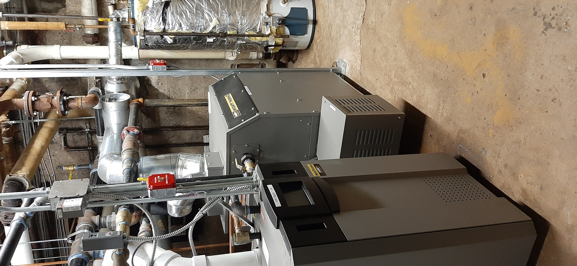

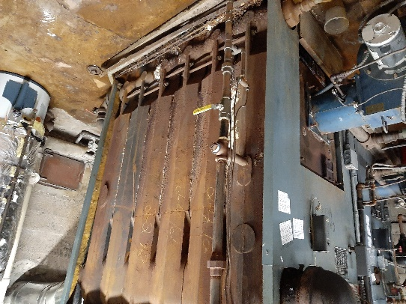

CONSISTORY NEWS
The annual Consistory Retreat/Training Day, held on Sunday, February 2, seems like it was decades ago already—certainly in another time! Nonetheless, we remembered to Give Thanks to those Elders and Deacons who are willing to serve, with special thanks to Deacon Richard Schmude and Elder Scott Benell for their many years of service as they rotate off the active Board to serve as ambassadors for Christ in the congregation and community.
For Your Information: ON’s by-laws stipulate terms of office as three years with a second consecutive term allowed by election. Individuals may be nominated thereafter for election following a minimum of one year off. Usually all of the consistory terms of office are staggered so that there is maximum continuity from year-to-year, but because ON has been “playing catch up”, the rotation is somewhat skewed at present, with the terms of office of two deacons and elders finishing simultaneously. The year following the names of each Member indicates the year their term will be completed. Everyone but Elder Gay Gravina is serving their first term of office.
If you have ANY QUESTIONS about Consistory, RCA Polity (governance), or Old North’s By-Laws, just ask at the Office, and Pastor Susan will be DELIGHTED to answer, or refer you to another source!

THE CONSISTORY OF OLD NORTH
Elders: Gay Gravina (2nd term; 2022), Carol Sushko (2020),
Leslie Maro (2020), Karen DiBella (2022)
Deacons: Betsy Erhard (2021), Brianna Polbos (2021)
Ralph Condis (2022), John Passarotti (2022)
Minister: Rev. Susan Kerr (Parsonage) 201-338-8237; revskerr@gmail.com
Church website https://oldnorth.church
The work of the church continues:
ACTIONS TAKEN DURING QUARANTINE:
March: RECOMMENDATIONS: M/S/C (moved, seconded, carried)
- To cancel March 22nd Concert
- PANDEMIC RESPONSE LETTER sent.
- To suspend Boy Scout and Girl Scout Troop meetings through 3/29 and re-evaluate at that time.
- To suspend ALL groups meeting in building through 3/29.

OUTDOORS Work Day & BBQ

Saturday 7/25 9 a.m. - 2 p.m.

RSVP IS REQUIRED

There will be children’s activities!

We will wear masks, sanitize,

wash our hands and social distance.

What to Expect on Sunday, Aug. 2
When Sanctuary Worship Resumes:
How we will care for one another:
- Take your temperature before you leave home. If you feel sick, have a cough, or are not sure… PLEASE STAY HOME AND JOIN WORSHIP VIRTUALLY! It will be live-streamed on the church’s FaceBook page. Self-quarantine for 2 weeks if you are exposed to the virus before returning to church.
- WEAR A MASK (REQUIRED).
- Entry and Exit will be through the sanctuary doors on Washington Avenue ONLY.
- Use the touch-free hand sanitizing stations at the doors.
- Bulletins will be handed out by one usher (with clean hands).
- Sit in the same pew every week, LABELLED, safely distanced as designated. Only touch your hymnal/Bible.
- Do not touch ANY surfaces you don’t need to.
- Go to the bathroom before you come. Restrooms will be one-at-a-time if needed.
- We will disinfect frequently, especially “high- touch” surfaces before and after each service.
- Passing of the Peace will be from your own pews.
- Indoor Fellowship Hour is suspended. Outdoor socializing after worship is optional, and social distancing and masks are expected. No food or beverages will be provided.
- Collection plates will be at the Sanctuary doors for you to place your offerings in.

OLD NORTH REFORMED CHURCH
120 Washington Avenue
Dumont, NJ 07628
https://oldnorth.church

