HOPE and
HAPPENINGS
Old North Reformed Church
June, 2021 Newsletter

Dear Friends and Members of Old North,
It’s hard to believe, but just fifteen months ago, we began Lent 2020 with our third Drive-Through Ashes in the parking lot, and began the Wednesdays in Lent Group Study. We were preparing for Easter and the arrival of the usual Spring events in and around Old North. Then when Covid struck, we had to reassess on the fly and adapt to all sorts of unexpected changes. We had to take time to acknowledge and somehow grieve the loss of familiar routines and community interactions. And we had to ask ourselves as a community of faith, as church leaders, “What is our purpose in this world as it is now?”, and, “How are we going to continue the missions of the church-- to share the Good News of the Way of Jesus Christ in the world, to serve the people of God’s creation in this time of need, and to live into the closeness of the realm of God? How are we going to live into our faith in God’s future for us and Old North?”
We’ve done a lot in response to those questions, and continue to do much more!
The Consistory has demonstrated renewed commitment to grow the church in ways that invite and welcome the community safely in, and to model our Christian values in outreach and generous hospitality, underpinned by unwavering faith in God’s ability to sustain the ministries and life of Old North for now AND the future.
As we anticipate celebrating 300 years as a congregation (2024), we are fitting the church properties for another 100 years of service.
It’s called the Legacy Project, in honor of what we have been privileged to inherit, as well as a vision of what we would like to bequeath to future generations of seekers and faithful followers of Jesus at Old North.
Thanks be to God, we continue to live out our faith, trusting God to bring us to a joyful celebration of what is now, and prepare for what is to come — thanks be to Christ! Yours in Christian love,
-- Pastor Susan
THRIFT SHOPPE NEWS!
The Thrift Shoppe is back! It was indeed a challenging few months getting everything unpacked, sorted, and display-ready for the May 15 grand re-opening. Fortunately, Old North is blessed with an amazing team of volunteers who work together with the same goals in mind – serve the needs of the local community, support the mission and ministries of ON, and continue to forge strong fellowship – all as Jesus would have us do.
The May sale was a success by all accounts, and it just felt good to be back. We welcomed 127 people to the Shoppe, some old friends and some new. Total revenue for the day was close to $1,400. Sales went so well that we have begun to accept donations again for the next sale on June 19. While there are no July or August sales, we will continue to accept donations during that time in preparation for the fall season which kicks off with a Back-to-School Sale in September.
The Shoppe is moving to an exciting new level in the world of social media thanks to the efforts of newest team members, Jena Rand and Jon Babicz. After meeting with the TS Committee in early May, Jena and Jon quickly developed a marketing strategy to use various forms of online media to promote the May sale. They began by creating a Thrift Shoppe Facebook page and promotional Facebook ads. Through various posts and the ads, over 11,000 people on Facebook were reached with a total of 53 page likes. The May sale was also posted on Craigslist and Facebook Marketplace. Post-sale, they worked with Brianna Polbos to connect the Facebook page and Instagram account that she had previously set up. This will allow us to increase the audience that we can reach in the future. Jena and Jon will continue to use the Facebook page to keep our followers engaged and to message about relevant events concerning the Thrift Shoppe. Most recently, they boosted a post about donations opening back up on May 25 and reached over 1,400 people. Future work also includes building an eBay store (for the TS) to continue to sell in between sales.
Now it’s back to work on the first big wave of new donations!
God is good!

Our trunk-to-trunk food drives for the

Dumont Food Pantry began last November,

coordinated by Elder Scott Benell and church administrator Judy Klein. Since then they have continued with overwhelming success, as our wonderful community has turned out to generously help one another with your giving!

THE NEXT FOOD DRIVE IS SATURDAY, JUNE 26

9 a.m. - Noon

“Come, you that are blessed by my Father, inherit the kingdom prepared for you from the foundation of the world; for I was hungry and you gave me food, I was thirsty and you gave me something to drink, I was a stranger and you welcomed me...” Matthew 25:35b-36

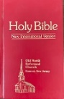
Pastor Susan’s Weekly Lectionary Bible Study, held by
Zoom for the past year, is on vacation to allow for
program planning throughout the Summer--
With hopes and prayers to see you all again
IN PERSON in September.

PRAYER CHAIN
If you have a celebration to give thanks for, or seek support for yourself or a loved one and would like to uplift it on our (confidential) prayer chain, please call Pat Hooey, 201-843-4456.
If you would like to be part of the Prayer Chain ministry, please call
the church office, 201-385-2243.

In Romans 1:9 Paul wrote, “For God, whom I serve with my spirit by announcing the gospel of his Son, is my witness that without ceasing I remember you always in my prayers”
MARILYN’S MUSING
We are officially in the summer season as it starts Memorial Day Weekend. Wow – it seems like only a few months ago we were dealing with snow and cold weather – now some of us are arguing with the weeds in our garden. For me - I don’t mind arguing with the weeds – but the snow is another whole story. We don’t have to worry about that for another 6 months so let’s enjoy our summer and fall first!
As I look back on this past winter and early spring, I realize how far we have come in many ways. The news this past weekend has been about changing the mask restrictions in many states. Many people have gotten the vaccine and are feeling a little less anxious about going out and doing things we couldn’t even think about a year ago, even 6 months ago. Old North Reformed Church is in the midst of change. Our Fellowship Hall is so bright and new and clean looking. We had our first Thrift Shoppe sale this year in May, and it was wonderful to be back and see old faces (or should I say “eyes over the masks”) and new ones too. We have been worshipping in the auditorium since Easter and are enjoying the new, fresh look with the new paint colors in there. And the sanctuary…what can be said about that? The renovation work going on in there is amazing! When it is finished it will be beautiful, fresh and new and so welcoming to everyone.
I have been able to come to church to worship since we opened up last August, but for those couldn’t come back Pastor worked very hard to get our virtual worship working. I watched a service I missed because of being away camping and it felt like I was right there in the room with everyone else. She has mentioned that we reach well over 100 people every Sunday virtually. Alan has been playing the piano for us every week and Pastor doing her usual great job leading us in worship. I am so happy to be able to hear everyone singing, even behind their masks, on Sunday morning with the windows open and sunlight coming in.
Let’s all look forward to the summer months and enjoy our church together. We have our church picnic to look forward to, another Thrift Shoppe Sale in June, and our weekly services that bring us all together – physically or virtually – growing in our faith. Enjoy the sun that God gives us along with the rain to show us that He is taking care of everything. He loves the world He made for us, so let’s enjoy every part of it, even the weeding that needs to be done.

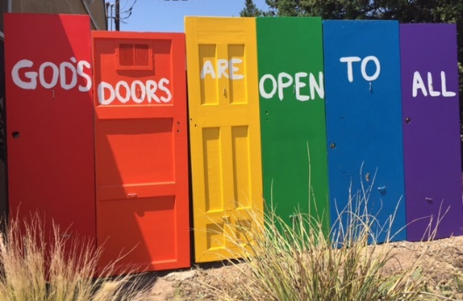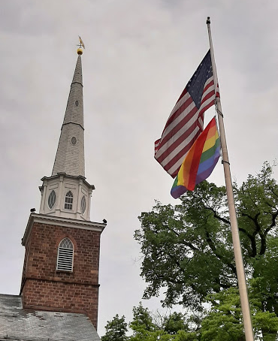

APRIL CONSISTORY ACTION TAKEN
At the April 15th meeting of Consistory, the following motion was made, seconded, discussed at length, and passed as a witness to our faith in God: To purchase and raise a rainbow flag beneath the U.S. flag in front of Old North for the month of June 2021 in recognition of Pride Month.
Reasoning: God's covenant of love extends to ALL of God's creation, and those whom God has created.
*“Sustaining, life-giving love between people in the Bible like Jonathan and David, Naomi and Ruth, and Jesus and his Beloved Disciple remind us that from the very beginning, God said it is not good for human beings to be alone (Genesis 2:18). Though the Bible does not provide a blueprint for 21st century relationships, Jesus gave us a new command that would last forever.”
I give you a new commandment, that you love one another. Just as I have loved you, you also should love one another. By this everyone will know that you are my disciples, if you have love for one another. (John 13:34-35)
We at Old North profess by word our love for others and indeed live out that profession of love through various ministries (food drives, thrift shop, Christian ed) and generous benevolences. We profess that we are naturally welcoming to all who enter our sanctuary, and indeed we are.
Sometimes, however, an outward, public statement is called for as in the case for reaching out to our LGBTQIA+ sisters and brothers. Let us now take a step toward radical love for these "others" in our community who may be feeling called to God, but who have not yet found a safe, welcoming, supportive, and empowering community for Christian fellowship.
*This quote is from a Faith Statement of The Reformed Church of Highland Park.

So far, so good— SO --
What to Expect at Worship in Church:
How we care for one another:
- If you feel sick, have a cough, or are not sure… PLEASE STAY HOME AND JOIN WORSHIP VIRTUALLY! It is on the church’s FaceBook page, and uploaded onto YouTube Sunday afternoon. Self-quarantine for 2 weeks if you are exposed to the virus before returning to church.
- WEAR A MASK (REQUIRED) until we return to the sanctuary.
- Entry and Exit is through the south parking lot (side) entrance.
- Use the touch-free hand sanitizing stations at the doors.
- Bulletins will be handed out by one usher (with clean hands).
- Do not touch ANY surfaces you don’t need to.
- Go to the bathroom before you come. Restrooms are one-at-a-time if needed, and please disinfect surfaces on your way out.
- We disinfect frequently, especially “high- touch” surfaces before and after each service.
- Passing of the Peace is from your own seat.
- Indoor Fellowship Hour is suspended. Outdoor socializing after worship is optional, and social distancing is expected. We will “take a poll” at the June 13 Barbeque to gauge everyone’s comfort level on when to start up indoor Fellowship again.
- The Collection plate is at the Auditorium door for you to place your offerings in as you enter. You may also give online through our website at https://oldnorth.church by PayPal or Visa/Mastercard.

LOVE YOUR NEIGHBOR: WEAR A MASK!

PONDERINGS FROM THE ORGAN BENCH

Mary Elizabeth Collins
On January 24, our good friend, Mary Elizabeth Collins, passed into Life Eternal at the age of 97. She lived in Ho Ho Kus and was a member of the West Side Presbyterian Church in Ridgewood. Mary performed many times in our Christmas concerts with her harp. She always added a special touch with her beautiful music. Her husband, John, died many years ago. He was a Presbyterian pastor and in their younger years, they served a congregation as missionaries in Hong Kong. She had many rare and expensive harps. When she no longer performed, she recommended Katy Wong. Mary Elizabeth introduced the harp to Katy many years ago at the Paramus Community School. She became Katy’s friend, teacher and mentor. Mary passed on her Aoyama lever harp to Katy. Years later, Katy played her Aoyama harp in a competition in Japan. Katy went on to study at Juilliard, where she earned her performance degree. Katy said in a letter to me that she will never forget Mary Elizabeth’s passion for the harp and that she was a wonderful and inspiring woman. In His service,
Alan Newman, Director of Music
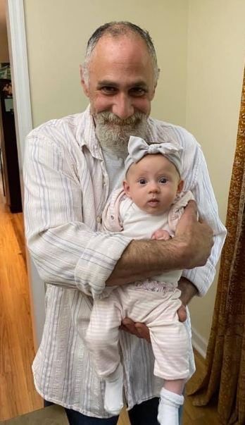
Remembering Elder Gay Gravina
If you knew Gay, who died suddenly and unexpectedly last August following a brief illness, you knew she had hoped to live long enough to meet and hold her first great-grand daughter, born this past February 21st.
Meet Sevarina Lily, 6 lb. 8 oz., 19”. (Here she is with Gay’s son Andy.) God bless them!

Visit the church website at https://oldnorth.church

OLD NORTH WILL BE HOST to The Art Teachers LLC
for Summer Art Camp., July 19 – 22 (Two Sessions)
- Cost: $250 per student per session
- Includes supplies
- Ages 8-13 years old
- Small class size
- The Art Teachers LLC will adapt the projects
based on age and skill levels.

TRAVEL TO A CARIBBEAN ISLAND 9 - 11 am
Create projects that will take you away on an adventure. Travel to a Caribbean Island and produce colorful pieces of art with new techniques. Learn about the elements of art, create your own painted paper, hands-on activities, learn about different artists and cultures.

HANDS-ON 3-D PROJECTS 1 - 3 pm
Learn about 3 dimensional art and create hands-on projects. Turn toilet paper tubes into cute owls, learn the art of weaving, take a picture frame and turn it into a stained glass painting, take found objects and learn how to print.

Visit their website or email for more information:
https://www.theartteachers.com/summer-art-camp
theteachersofart@gmail.com

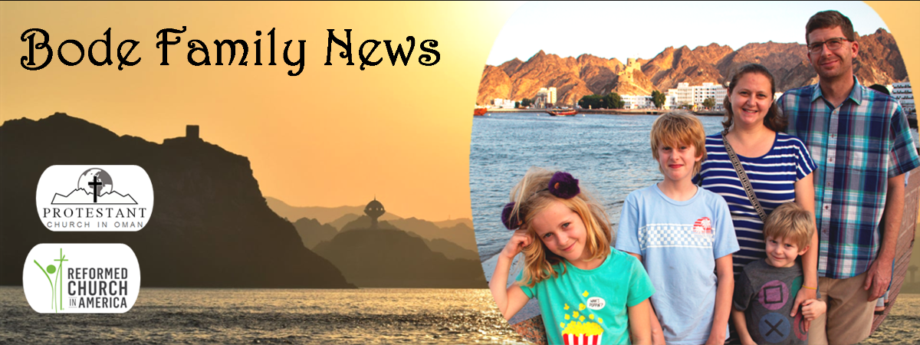

The Bode family will be in the States this summer. Josh isn’t vaccinated yet, which is limiting in-person visit plans, but for starters they wish to invite you all to join them in a Zoom conversation about what’s been going on in the mission in Oman. Log on to any of the following 60-90 minute sessions—stay for a while, or the whole time!
Tuesday, June 22, 7:00pm EST Thursday, June 24, 7:00pm EST
Tuesday, June 29, 7:00pm EST Thursday, July 1, 7:00pm EST
Zoom link will be emailed from the church office.
LEGACY PROJECT UPDATES
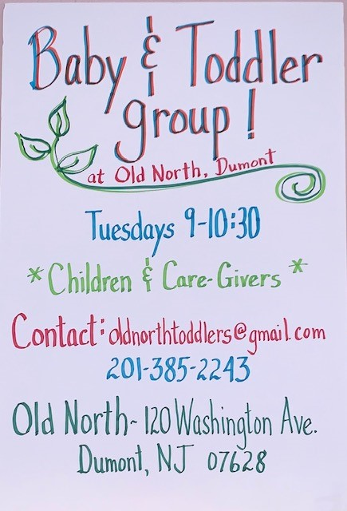
What is The Legacy Project?
The Legacy Project has been instituted to renovate, repair, restore, and renew the church’s buildings to serve our community for the next 50-100 years, in time to celebrate Old North congregation’s 300th anniversary!
How are we paying for it? First, we are using money from the memorial funds received by the church over the years that were given to sustain the ministries that meant so much to those who generously included Old North in their wills and funeral directives. The names of those remembered by their generosity in this restoration project—dead and living-- will be etched on a brass plaque, dedicated at the time we rededicate the sanctuary. If you would like to contribute now (or posthumously), contact the church office for information on how to proceed. For instance, the cost of each window restoration and re-covering is valued at $7,500. Several people have established pledges toward that amount (or whatever level they can afford), and are giving weekly, monthly, or in one gift against their pledge, in addition to their regular offerings. You may choose to contribute: to the Legacy Windows Fund, to honor God’s Creation by underwriting the cost of the solar panel installation, to the cost of replacing the slate roof over our historic sanctuary, to help pay for repointing the brickwork that is the church’s west wall facing the cemetery, or earmark a contribution toward repairing and relining with copper the Yankee gutter system.
Vanco, our new online giving platform, will be “up”soon.

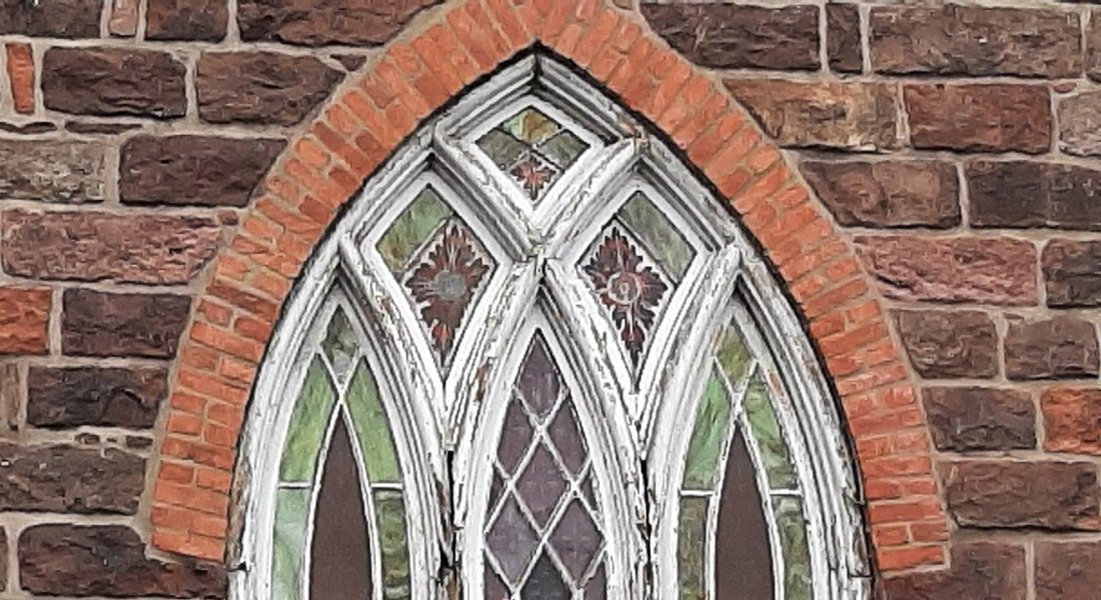

PROGRAMS FOR CHILDREN AT OLD NORTH
SEEKING A TEACHER
FOR
SEPTEMBER
RE-START
OF SUCCESSFUL
FLEDGLING PROGRAM
SIDE-LINED BY COVID.
CONTACT
PASTOR SUSAN
FOR DETAILS.
Ready to move into our new Fellowship Hall!

SUNDAY SCHOOL RESUMES IN SEPTEMBER: IS THIS YOU?
- I feel called by God to commit to serve the children and families of Old North by teaching Sunday School from: September Advent AND/OR Advent Epiphany; Epiphany Easter; Easter June.
- I have a personal relationship with Jesus Christ which I desire to model for children.
- I enjoy studying God’s Word regularly and desire to grow in my faith and commitment to Him (through personal study, adult classes or home or on-line Bible study groups).
- I do/will worship regularly with our church family.
- I support the doctrinal statements and leadership of our church.
- I enjoy children and desire for them to know of God’s love and concern for their lives.
- I will take the necessary time to prepare my lessons during the week, incorporating my own God-given gifts into each lesson.
- I will be faithful in attendance.
- I will participate in scheduled teacher meetings.
IF THIS TUGS AT YOUR HEART, PLEASE CONTACT PASTOR SUSAN IMMEDIATELY TO INVESTIGATE AND FIND OUT MORE!

OLD NORTH REFORMED CHURCH
120 Washington Avenue
Dumont, NJ 07628
https://oldnorth.church

