HOPE and
HAPPENINGS
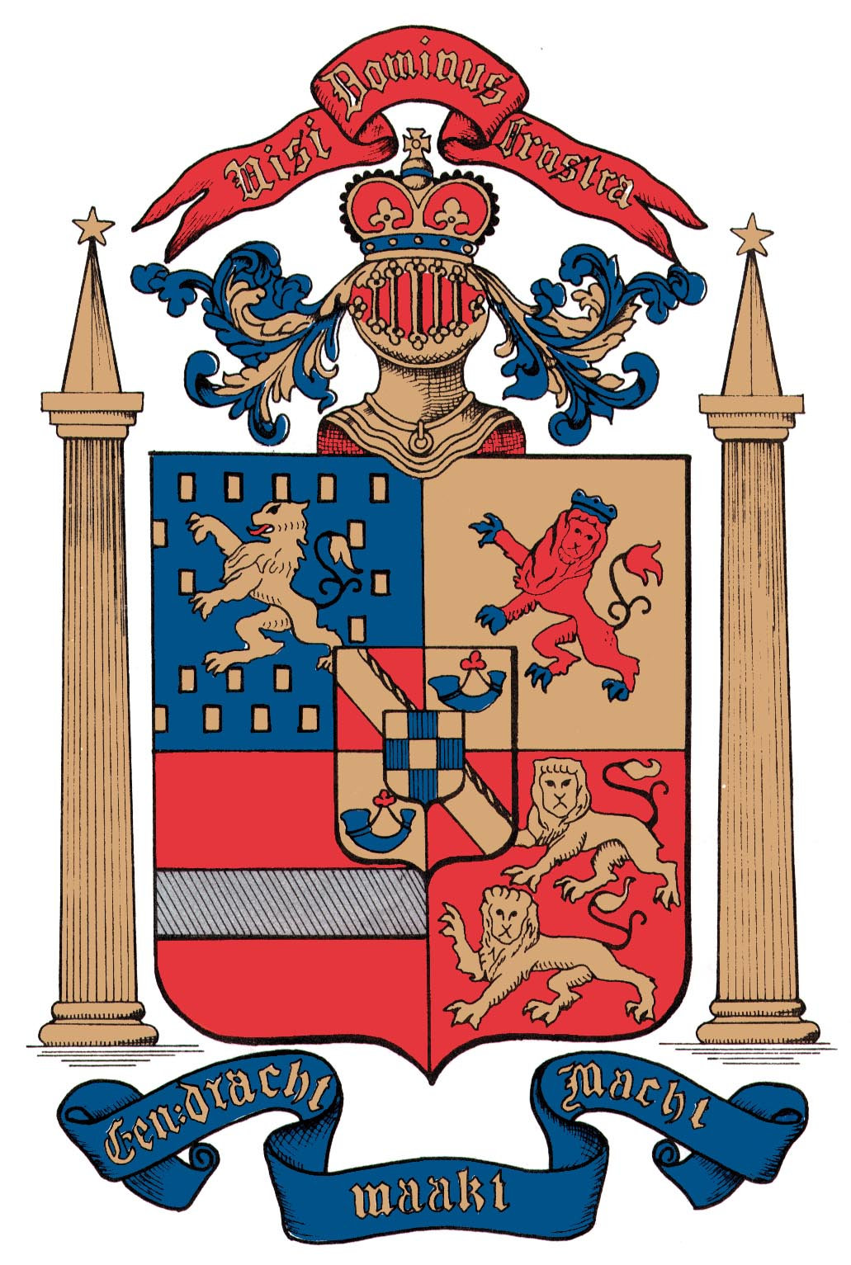
Old North Reformed Church
November, 2019 Newsletter

Dear Friends and Members of Old North,
It’s the season of swirling: swirling leaves, swirling thoughts, swirling plans for the upcoming holidays, budget numbers for next year, swirling dreams, swirling Spirit (and in some places, even swirling snow!).
In case you haven’t given any thought yet to some of those, this newsletter is full of information and opportunities to engage your mind, heart, and spirit in constructive and helpful ways, as together we live into our call to share the Good News of the Way of Jesus Christ in the world. Here are some of my “ponderings”—
I’ve been reading through the consistory minutes from the 1950’s and ‘60’s. What a different church it was then! What a different world! Money was tight, opinions were at times contentious, but it is clear that folks put their money, time and prayers into building up Old North for the next generation. Have you looked at your budgets of time and financial support given to your church lately? Could you do better?
Another challenge (not only ours) is finding ways to support an old building built for a different era, in ways that minister to the needs of now and soon, in a time when financial support for non-profits, religious and otherwise, is so competitive! Can you help us dream about ways to answer that challenge? I trust that God has a plan for Old North’s future; how might you help make it a reality?
Here’s a thought: it’s just two months until the Annual Meeting, when we look at the year past, and present plans for the year to come. Are you tugged to serve on Old North’s consistory, using your talents for service as a Deacon or Elder? Talk to me or a consistory member about that urging voice to find out what it might entail for you, and how you might participate in Old North’s governance.
There are so many things to be thankful for this time of year, thoughts swirling: wonderful occasions of fellowship and friendship here, new ministries launched, the joy of having multiple generations come together at Old North under the roof of God’s house… See you at church! In Christian Love --Pastor Susan
SURVEY RESULTS ARE IN
Because of the 2020 Commission established by our General Synod in 2018, the attention of our consistory and congregation has been drawn to the subject of homosexuality and the stance of the Christian church, particularly Old North’s, in relation to practicing homosexual persons. The fact that the spotlight is on the subject now does not mean that the subject has been ignored in the past by our denomination. Indeed, as in all faith groups, sexuality and scripture has been a matter of passionate debate for decades. Now, the General Synod seeks to achieve a recommendation for a definitive position for the denomination.
The Consistory has affirmed that it would be a step forward for our congregation to be clear and public about who we are as we continue to keep open our doors to those seeking a church home. We want to be a voice in the denomination-wide discussion. To that end, a simple survey was taken to establish our base-line understanding of where we stand at the moment in order that we might have constructive conversations about how best to move forward.
Here are some features of that process that will help us be successful:
•frank and respectful talk,
•careful and open-minded listening
•individual willingness to think, pray, read, and discuss
•constructive argument together rather than taking and defending
sides, with the recognition that we aren’t likely to achieve perfect agreement but that we can, with the grace of God, move forward together in the spirit of our Reformed tradition’s call to be always reforming, acknowledging that our starting point and our ending point needs to be obedience to Christ’s commandment that we love the Lord our God with all that we are, and that we love our neighbors as ourselves. It is in that spirit that I propose we engage each other as we begin to process the Survey Results:
“I believe that marriage is between a man and a woman and that scripture prohibits homosexuality.” – 34%
“I believe LGBTQ individuals have the right to full acceptance and blessed marriages within the church.“ – 46%
“I do not have an opinion at this time regarding LGBTQ inclusion.”--20%
Not open to further study – 29% Willing to learn – 71%
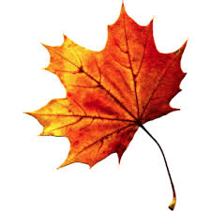
You can visit the church website at https://oldnorth.church

Consistory next meets on Tuesday, November 19, at 6:30 p.m.

ENCOURAGING THRIVING CONGREGATIONS
On September 6th & 7th Old North hosted the Encouraging Thriving Congregations program groups -- ministers and representatives from nine congregations in our Regional Synod. One of the Saturday activities was to list (at least) one mission/community asset of the congregation. Our Old North team’s list just kept going and going, demonstrating that for a “normal-sized” congregation, we are extra-large in our ministries and blessed with enormous assets! Here’s the list we’ve come up with; have we missed anything?!
Souper Sunday CROP Walk Heritage Weekend
Recycle bottles Thrift Shoppe Sharing Thrift Shoppe donations
Sunday School Bible Studies School supplies backpacks
Choirs Outdoor sign Plant Swap
Chimes Location/Building Food Pantry donations
Ashes to Go Scouts Blessing of the Animals
Concerts Missionaries Spring Scholarships
Friday Night Kids Benevolences to Community & World Helpers
Building space availability for diverse groups.
Which of these ministries of the church are you involved with already?
Which of them is the Holy Spirit nudging you to use your talents or assests to support?

FROM “SNAPPY SQUIBS FOR THE CHURCH CALANDAR” (1931)
HOW Don’t attend; but if you do, come late, and sit back.
NOT Find fault with everything and everybody.
TO Let it all to the preacher, that’s what (s)he’s paid for.
HAVE Don’t invite anybody to come.
A Don’t sing. Don’t compliment the choir or soloists.
REVIVAL Just go through the revival; don’t let it go through you.

Why Join the Church? By Henry Ward Beecher
I ought to belong to the church because I ought to be better than I am. “The church is not a gallery for the exhibition of eminent Christians, but a school for the education of the imperfect ones.”

2019 - 2020
THRIFT SHOPPE DATES

December 14th
February 8th
March 14th
April 25th
May 16th
June 13th
Saturdays 9 a.m. – 2 p.m.

Thanks to our community we have been receiving donated
merchandise on a regular basis.
Help to sort and set up is ALWAYS needed!
Please contact Linda Treacy or Kathleen West for the work schedule
in any given week.

“Sing to the Lord a new song! Sing to the Lord all the earth!” Psalm 96:1

2019-2020 CONCERT SERIES DATES
(all at 4:00pm)
Sunday, January 12 -- Music for (Winter) Winds
Sunday, March 23 -- Strings Sing for Spring
Sunday, May 3 -- Jazz in the Sanctuary
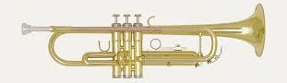

WE APPRECIATE YOUR DONATIONS, BUT EVEN MORE, YOUR PRESENCE!
It’s a wonderful way to introduce your children to live performance,
and a perfect time to bring friends into our lovely church!

From the Keyboard of our Music Director, Alan Newman…

CHRISTMAS CANDLELIGHT VESPER CONCERT
Our annual Christmas Candlelight Vespers Concert, the highlight of our music program here at Old North, will be presented to the public on Sunday afternoon, December 15. The concert features our choirs, harpist and guest musicians. Katy Wong, a recent graduate of Juilliard School of Music, will begin the Harp Prelude at 3:45, setting the mood for a wonderful afternoon of Advent and Christmas music. There is no better way to enjoy the music of the season than in our historic sanctuary by candlelight.
Members of various local church choirs have been invited to join us in a wide range of music from various composers. Come join us and invite your friends and neighbors. Cider and cookies will be offered in our church lounge following the concert.

ORGAN MAINTENANCE
The Consistory, with my recommendation, has decided to engage the Peragallo Organ Company of Paterson, to maintain and tune our 27 rank Tellers organ. The organ was installed and designed by Howard Oakie and me in 1973. The organ was carefully maintained in wonderful condition in these many years. The previous organ maintenance company was located in Allentown, PA, and I felt it was important to engage a local company in the case of emergency repairs. I thank the Emery Brothers Company of Allentown for their service the past few years. But I felt the time had come for a local service. Peragallo serviced my last two positions – Grace United Methodist of Wyckoff and the First Congregational of Park Ridge. They also service St. Patrick’s Cathedral in NYC and St. John’s Cathedral of Paterson.

CHOIRS
Our choirs are busy preparing the special music for Thanksgiving, Advent and the Christmas season. The choirs extend a sincere invitation for new members. All rehearsals are held on Sunday mornings in our Chapel. The children practice their songs at 10:30 following our worship service and the Senior Choir, open to all young people and adults, rehearses at 11:00 AM, following Coffee Hour. Come join us and everyone is very welcome to swell our ranks.

ADRIAN CONDIS
One of our musically talented young men is a new member of a band called the Lucky Chops. They are currently touring Europe and travelling to many countries by a chartered touring bus. As of the writing of this note, they have been to Norway, Denmark, Germany, Poland, Hungary, Greece, Austria, Italy, Switzerland and France. The band will return to the US in time for the holidays. Adrian is a member of our Senior Choir and performs often in church on one of his woodwind instruments. This trip is a wonderful opportunity for Adrian. Years from now, he will be able to say, “I’ve been there!”
Please keep Adrian and his travels in your prayers!

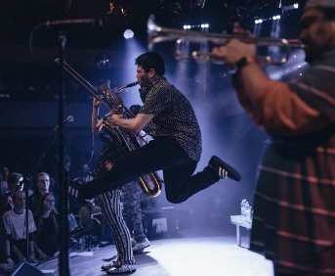

WHAT’S NEW?
Following the Thriving Congregations workshop day, conversations arose regarding the benefits of having a projector, proper speakers, and microphones in the Auditorium to enable ONRC to offer options for events and increase building rental opportunities in a variety of contemporary ways. A brain-storming session by consistory members identified the following possibilities: - Performance space - Theater group - Dance group - Contemporary worship! - Other Congregations - Choral groups - Children’s Workshop - Bible study movies - Fellowship events - Movie nights - Hosting youth worship/praise rock concerts
- Training films (ex: RCA/teaching/“Thriving Congregations” Film)
- Skyping during coffee hour with the missionaries whom we support
- Kids’ summer theater arts camp
Discussion centered on taking another step toward increasing building marketability. It was decided to purchase an audio/video system to include projector/new screen/(2) hanging mics/speakers/ (2) standing mics/ (2) clip mics/ sound board and other additional items, at a cost of $11,530, to be paid from the Vander Borgh Special Events Fund, which has a balance of approximately $17,000 left from the original $50,000 designated by the consistory in 2018.

FOR THE HOLIDAYS
Advent Sundays, Worship at 9:30 am
December 1st Wisdom
Family Movie: “Muppet Christmas Carol”
December 8th Jesus
December 15th Blooming
December 22nd Joy

Wednesdays in Advent 6:30– 8:00 pm

Dec. 4th Christmas Past
11th Christmas Present
18th Christmas Future
FAMILY BIBLE STUDY: Sign up required;
Bring yourself/children/grandchildren/parents/siblings/spouse!
Dessert and study guide included.

Candlelight Christmas Vespers Concert
December 15th at 4:00 pm
Harp Prelude begins at 3:45 p.m. Invite your family, friends, and neighbors to this Old North tradition!
Blue Christmas in the Chapel
December 17th at 7:00 pm
Join Pastor Susan in a contemplative service during this sometimes difficult season of joy: for those who have experienced loss and need the space to grieve.

Family Christmas Program
in the Auditorium
December 22nd at 11:30 am
“Twas the Evening Before Christmas”, presented with Carols and Story by our Sunday School! The true meaning of Christmas explained for all ages.

Christmas Eve Candlelight Service
December 24th at 7:00 pm

Wednesdays in Advent 6:30– 8:00 pm
This year we’ll be trying something different for Wednesdays in Advent: a FAMILY Bible Study, based on themes from Charles Dickens’s short story, “A Christmas Carol”. We’ll kick it off by an “open house” viewing of “The Muppet Christmas Carol” with Pastor Susan in the church auditorium at 11:30 a.m. on Sunday, December 1—which is also the first Sunday in Advent.
For the next three Wednesday evenings, you are invited to gather at the church over dessert with a workbook to discuss and share “Christmas Past, Present, and Future”. The Study Guide Intro says:
“To illustrate a principle, Jesus often used a parable—an earthly story with a heavenly meaning. Parables allow listeners to recognize real-life events as relevant examples of spiritual truth. In this way, these short stories link what we already know to what we should believe. Those that resist only hear a trivial story, while those that look past the surface find meaning.” (Stephen Skelton)
Let’s find new and special meaning for Christmas together this year!

Dec. 4th Christmas Past – “A Past of Regret”
11th Christmas Present – “A Present Repentance”
18th Christmas Future – “The Salvation of Scrooge”
Whether you are a household of 1 or a member of a large or small extended family, you are invited to Sign Up and come get to know one another better as a member of the Family of Jesus Christ at Old North!

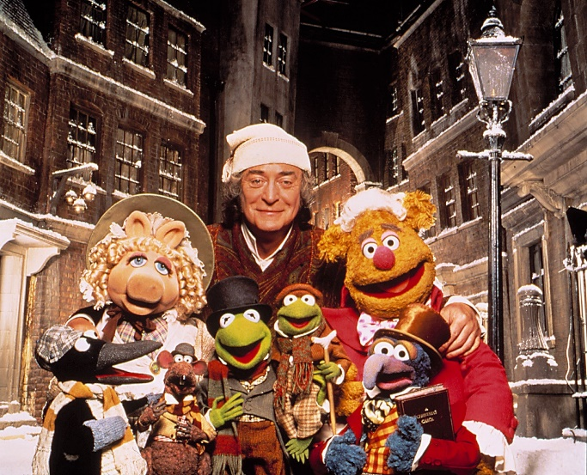

WHAT IS BLUE CHRISTMAS AND WHEN IS IT?

Blue Christmas, also called the Longest sleep in the Western Christian tradition, is a day in the Advent season marking the longest night of the year. In honor of this day, we hold a church service which recognizes that the holidays are sometimes "blue" or filled with difficult feelings around painful life events such as death, disease,

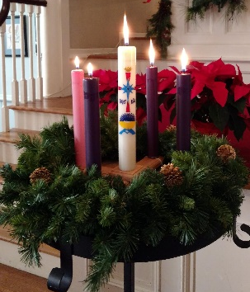

poverty, or abuse. We especially invite people who have lost loved ones this year or at this time of year. This year, Holy Eucharist will be included in the service, which is traditionally held on or around the longest night of the year (December 21, the Winter Solstice). There is an interesting convergence for this day as it is also the traditional feast day for Thomas the Apostle. This linkage invites making some connections between Thomas's struggle to believe the tale of Jesus' resurrection, the long nights just before Christmas, and the struggle with darkness and grief faced by those living with loss.
Our Worship includes a safe space for expression of grief and pain as well as an opportunity to focus on the promise of hope. The images of the longest night losing to the increasing longer day is a significant part of the imagery used in the elements of this particular worship event. This year at Old North Blue Christmas will be celebrated in the Chapel at 7 p.m. on Tuesday, December 17.
Thanks to Our CROP Walk Team
On a rainy day in October, Old North’s CROP Walk team of eleven walkers raised $1,380 to add to the amounts raised by similar numbers of walkers from other local churches, walking to help end hunger both locally and abroad! Yay! Thank you to Elder Scott Benell, with Karen Frohlich DiBella, Marianne Van Buren Schmude, Sandra Van Buren Toscano and Richard W Schmude Jr and kids!

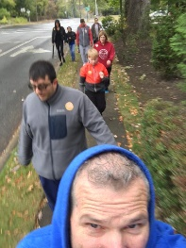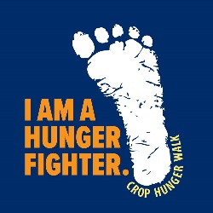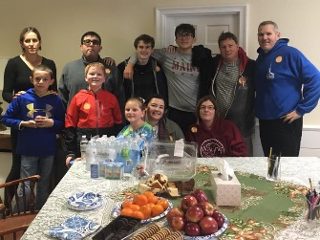

THRIFT SHOPPE KEEPS GIVING
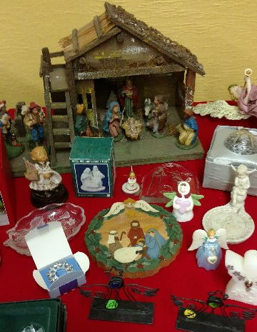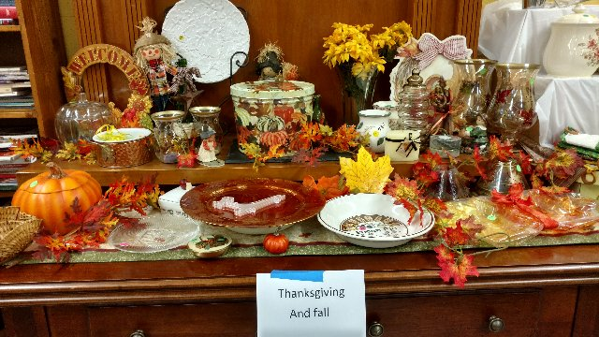
If you haven’t yet made it to the Thrift Shoppe this season, now’s a great time to get down there to shop, and bring a friend along, too! Old North’s amazing and faithful volunteers are doing a wonderful job going through the volumes of donations, sorting and setting up for the next sale (November 16th, 9 a.m.-2 pm.). Not only are there amazing bargains for home, kith and kin, but whatever does not sell here is recycled to another non-profit or needy entity. So far this season in two months they have raised $2,700 for Benevolences. Thank you one and all! New Volunteers are welcomed: there’s always something to do.

ANNUAL CHRISTMAS GIFTS PROJECT

The Eastern Christian Children’s Retreat (ECCR) in Wykoff is a non-profit organization that provides residential programs and services for individuals with intellectual and developmental disabilities.
For another year, Old North’s consistory has affirmed the Christmas Giving Project to provide gifts for residents of the ECCR, whose names and needs are provided us by their Chaplain. If you are able, please choose a name from the Angel Tree in the Auditorium to purchase a gift for a resident this holiday season. The deadline for the unwrapped gifts with their tags is Sunday, December 8th. Thank you!
For additional information about ECCR check out www.eccretreat.org

FAMILY CHRISTMAS PROGRAM
“Twas the Evening before Christmas” is a wonderful story for all ages as it tells the story of Christmas but to the rhythm of “The Night before Christmas”. The Program is on the calendar for Sunday, December 22, in the auditorium from 11:30 – 12:30. Coffee hour will be in the lounge that morning. The doors will open for the auditorium at 11:15 for guests to go in. There is also a reception planned in the lounge for all our guests and children afterwards. We hope you and your family will join us!

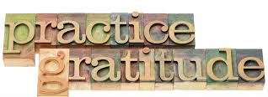

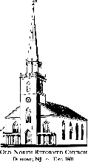

OLD NORTH REFORMED CHURCH
120 Washington Avenue
Dumont, NJ 07628
https://oldnorth.church

