**HOPE and**

**HAPPENINGS**



**Old North Reformed Church**

**August, 2020 Newsletter**

Dear Friends and Members of Old North,

Yes indeed, it's been a crazy time so far—calling this “Covid Time”—since March, with no actual end in sight.

I *hope* we've all just been doing the best we can with whatever can be done, and holding expectations lightly, with flexibility towards staying on whatever paths open before us.

In some senses, this lockdown/quarantine/suspension has given us as a congregation unexpected time to assess what is good and important in our ministry, and what is perhaps surprisingly unimportant. It has certainly forced us to learn to reach out and interact in new and different ways, and... to try not to get exhausted in the *now*, nor be discouraged in what has been lost—but instead, to formulate new questions and discern inspired answers for Old North’s ministry.

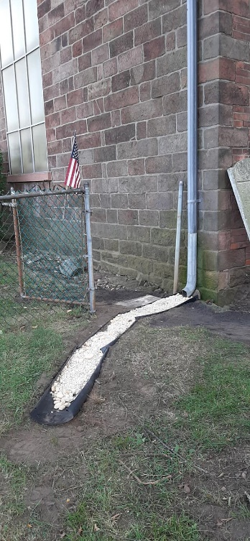There are lots of exciting things to look forward to at Old North! We are the living legacy of a congregation formed in 1724… which means that in four short years, Old North will celebrate **300 YEARS** of life within this community and in the world that God created!

By now, most of us have adapted many aspects of our life routines to new and careful ways of maneuvering: grocery shopping, trips to the doctor’s or dentist, even dining away from home in unexpected outdoor venues. We are wearing our masks for our own safety, and for others’. We are washing our hands more than ever—and staying on top of disinfecting high touch surfaces as we minimize the possibilities of transmitting ANY germs. It’s the way we take care of one another. In the next several weeks, we will continue to define ways to open our doors safely and responsibly, to let the public know that we care, not only for ourselves, but for one another.

I am confident that God knows what God is doing, and has a much longer view than do we. Our task now is to meet God wherever God is… out ahead—in faith. Yours In Christ**-- Pastor Susan**

## Outdoors Work Day & BBQ

## Thank you to the 19 people who came out

## on 7/25 to help start to tidy up

## outdoors and in! And the burgers were great!

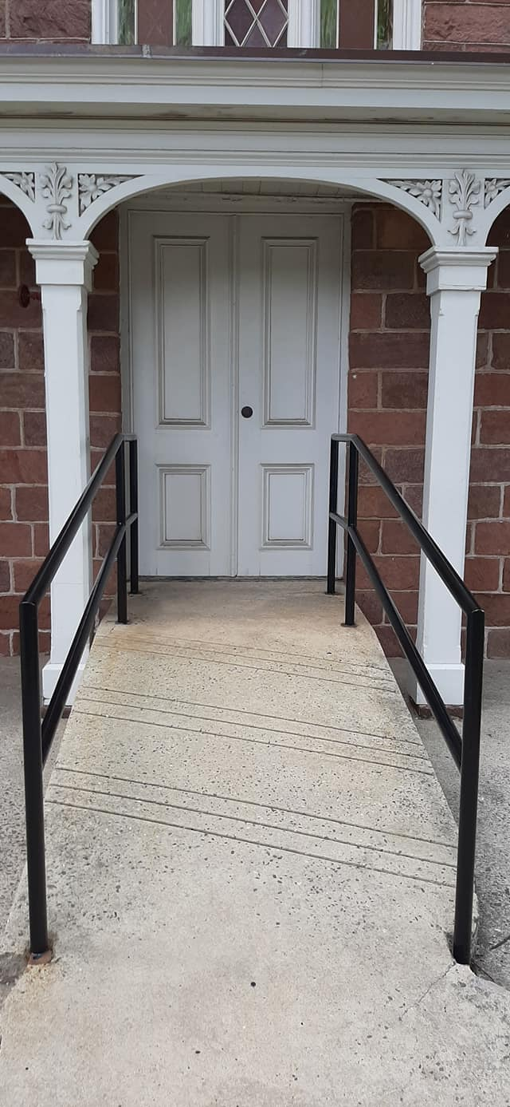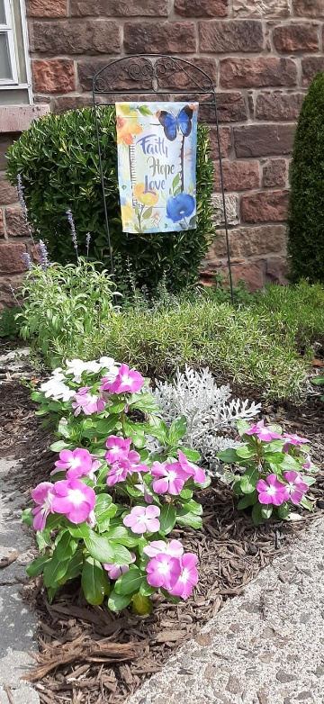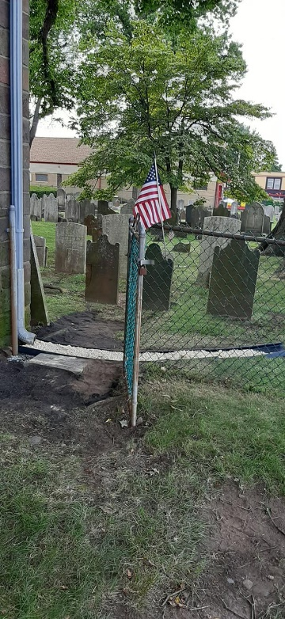

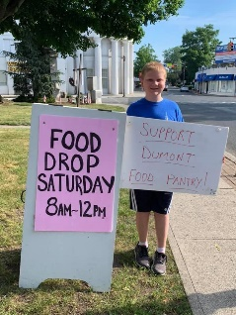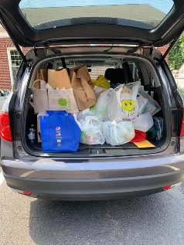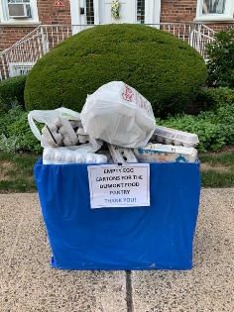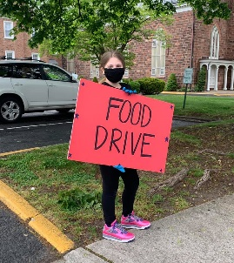

**MAKING A DIFFERENCE FOR THE COMMUNITY AT OLD NORTH**

Many hands continued to pitch in to help out in God’s name for the local food pantry this summer. Thanks to church secretary Judy Klein for organizing and managing the egg carton collections to manage the bulk eggs received to give to families; and to Elder Scott Benell and Ethan, the Schmudes and Passarottis, as well as everyone who lent your support and presence, both from the congregation and the community at large. Both initiatives have been highly successful!

**OUR NEXT TRUNK-TO-TRUNK FOOD COLLECTION IS OCTOBER 10.**

**CONSISTORY NEWS**

We have recently experienced two vacancies on the Consistory due to the deposition of Ralph Condis from the office of deacon, and the death of Elder Gay Gravina. In the event that such vacancies occur, the Book of Church Order provides for the Consistory to appoint previously ordained church members to fill the chairs until such time as the next congregational election (Article 2, section 14 *f*, pg. 18). We are pleased that Deacon Richard Schmude and Elder Scott Benell are willing to serve the congregation in that capacity in these challenging times.

We wish to thank Ralph for his service, and wish him well in his passion to pursue personal initiatives outside the scope of old North’s ministries.

**THANKS** to the generous folks who brought in school supplies for this year’s drive! Once again, we are pleased to have helped kids in need around our communities. A big thanks to Elder Karen DiBella for delivering them for us all!



**GROWING THE KINGDOM IN NEW WAYS: VIRTUAL STATISTICS**

In the last month, Old North’s Facebook page has reached 3,732 people with 640 engagements (clicks or comments). Last Sunday’s livestreamed worship service has, as of this writing, reached 1,977 people with 124 engagements. The same worship service on our YouTube channel was viewed 13 times. “Marilyn’s Musing” from last Tuesday was read by 87 people. If you are a Facebook user, please view and “share” our page and posts; that’s a wonderful way to witness to others who we are at Old North, and for the gospel of Jesus Christ in the world!



**PRAYER CHAIN**

If you have a celebration to give thanks for, or seek support for yourself or a loved one, and would like to uplift it on our (confidential) prayer chain, please call Pat Hooey, 201-843-4456.

If you would like to be part of the Prayer Chain ministry, please call

the church office, 201-385-2243.

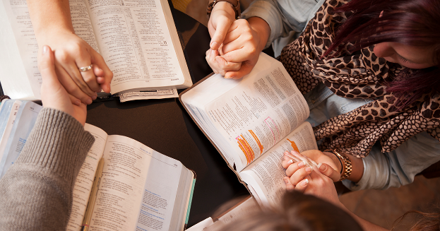

**BIBLE STUDY CONTINUED THROUGHOUT THE SUMMER**

For the first time ever, Pastor Susan continued to lead Lectionary Bible Study throughout the summer months, to bring folks together who were interested in looking ahead at the readings for the following Sunday in a small group on line via “zoom”. The number of participants varied from 12-6 individuals, stretching from Colorado to Scotland and from Upstate NY to… well… Cresskill. It’s a good group! If you would like to give it a try, contact the office to have your email added to the weekly zoom invitation.



SUNDAY SCHOOL ADVENT/CHRISTMAS PROJECT

It is September and time to plan our holiday celebrations at Old North. As you know by now, there will be no regular Sunday School this fall. But…there will be a Christmas Program put on by the youth of Old North. It will be presented completely virtually but will tell the same wonderful Christmas Story of Jesus’ Birth, prerecorded at 11 a.m. on Sunday mornings.

Pastor Susan will lead the children in prayer and exploration of the story at the beginning of each session.

Emails and letters will be sent out this month to the parents with more information and your children’s parts. They will be reading from Luke’s Gospel. We are looking at a number of ways to have the children do this safely and have fun. We will be asking you to bring your children to the church at a certain time so we can video record them reading their part.

We have everything safe at the church with hand sanitizing stations and wearing masks. The children can read with the masks on or they can be recorded from a safe distance with everyone else around wearing masks while they read. The costumes are cleaned from last year before being put away, so with your permission they can be worn when they come to read.

We look forward to another wonderful Christmas sharing the story of God’s gift to the world!

THE CONSISTORY OF OLD NORTH

Elders: Carol Sushko (2020), Leslie Maro (2020),

Karen DiBella (2022), Scott Benell (2020, appointed)

Deacons: Betsy Erhard (2021), Brianna Polbos (2021)

Richard Schmude (2020, appointed), John Passarotti (2022)

Minister: Rev. Susan Kerr (Parsonage) 201-338-8237; [revskerr@gmail.com](mailto:revskerr@gmail.com)

Church website <https://oldnorth.church>

**What to Expect at Worship in Church:**

**How we will care for one another:**

* **Take your temperature before you leave home. If you feel sick, have a cough, or are not sure… PLEASE STAY HOME AND JOIN WORSHIP VIRTUALLY! It is live-streamed on the church’s FaceBook page, uploaded onto YouTube Sunday afternoon. Self-quarantine** for 2 weeks if you are exposed to the virus before returning to church.
* **WEAR A MASK (REQUIRED).**
* **Entry and Exit will be through the sanctuary doors ONLY on Washington Avenue.**
* **Use the touch-free hand sanitizing stations at the doors.**
* **Bulletins will be handed out by one usher (with clean hands).**
* **Sit in the same pew every week, safely distanced as designated. Only touch your hymnal/Bible.**
* **Do not touch ANY surfaces you don’t need to.**
* **Go to the bathroom before you come. Restrooms will be one-at-a-time if needed.**
* We will disinfect frequently, especially “high- touch” surfaces before and after each service.
* Passing of the Peace will be from your own pews.
* Indoor Fellowship Hour is suspended. Outdoor socializing after worship is optional, and social distancing and masks are expected. No food or beverages will be provided.
* The Collection plate will be at the Sanctuary door for you to place your offerings in as you enter (you may also give on line at our website at <https://oldnorth.church> by PayPal or Visa/Mastercard.

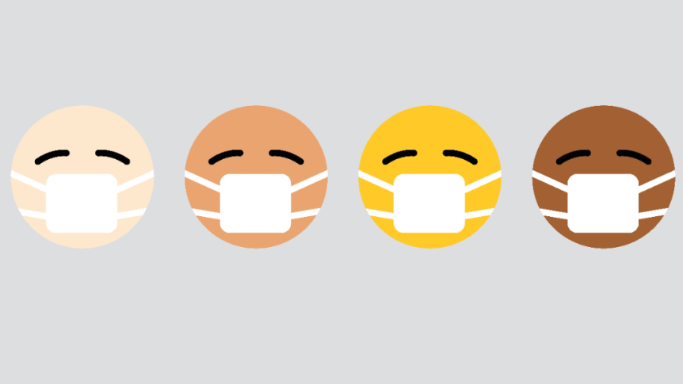

**LOVE YOUR NEIGHBOR: WEAR A MASK!**

**PONDERINGS FROM THE ORGAN BENCH**

At Old North we had Virtual worship services on the Internet since March, when our doors were closed and the pandemic reached our shores. Weekly services were recorded, thanks to Marilyn Hashway’s iPhone and to Pastor Susan for putting the words and music together to be sent out on Facebook and YouTube.  It seemed strange to play the organ each week in an empty church.  Fortunately, we opened our doors for regular church services in August.  It is surprising to me how many churches have chosen to keep their doors closed during the pandemic.  We wear masks, keep the same seating week after week, sanitize our hands, and keep our distances.  Our church is big enough that social distancing is not a problem.  In fact, church is probably the safest place to spend an hour on Sunday morning, with the exception of staying home.  But you are very welcome to join us again in church, to hear God’s Word and sing His praises. Church services are still at 9:30 AM with the Organ Prelude at 9:20 AM. Come join us!

In His service,

Alan Newman, Director of Music



*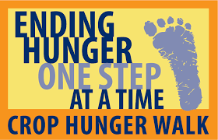***Our 2020 CROP Hunger Walk** celebrates its 42nd anniversary on **Sunday, October 18th**.  Most walks this autumn will be family units putting together their separate results as congregations, with possible virtual events.  Details to follow!

**Visit the church website at** [**https://oldnorth.church**](https://oldnorth.church)

**BLESSING OF THE ANIMALS**

**SUNDAY, OCTOBER 4TH AT 3:00 P.M**. on the front lawn of Old North. All are invited. Bring pets small or large for a special blessing. There will be a Rainbow Bridge Candle Station for those who wish to remember beloved past pets.

**SEPTEMBER 16TH AT 7:00 P.M. - ZOOM THRIFT SHOPPE MEETING.**

If you would like an invitation to the meeting,

please contact the office.

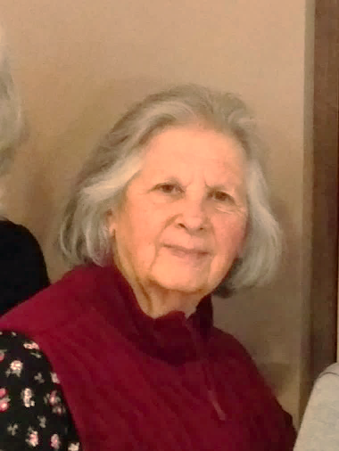**A SERVICE OF CELEBRATION OF THE RESURRECTION** in honor of Elder Gabriella Gravina will be held at the church at 11 a.m. on Saturday, October 26. It is planned to share via zoom to those who contact the church office by Wednesday, Oct. 23. Gay passed from this life into eternal life on Tuesday, August 25, safely in the peace and comfort of her own home, surrounded by loving family. We give thanks for Gay's extraordinary life and faith, and uplift her family and loved ones in our prayers in this time of loss, secure in the confidence of the resurrection in Jesus Christ.

**

A memorial fund has been set up in honor of Gay Gravina.

If you would like to contribute please send your contribution to the church office or place it in the offering plate.

**CASTING A NEW VISION**

As as we move forward post Covid to serve God by modeling Christ-like behaviors in and to the community, we need to re-examine our short and long-term goals to cast a new vision for the future. A good way to start is by asking ourselves two questions:

1.) What is great about God? 2.) What is great about Old North?

How would you answer those two questions?

After we answer each of those questions as individuals, as a congregation and as a Consistory, we also need to be aware of how God’s Spirit leads. In the Reformed Church in America, our foundational structure is based on the understanding that God’s Holy Spirit is always present, and leads us reliably when we work together as the body of Christ, not only listening to one another, but HEARING one another.



**“**For surely I know the plans I have for you, says the Lord, plans for your welfare and not for harm, to give you a future with hope.” [Jeremiah 29:11](https://www.biblegateway.com/passage/?search=Jeremiah%2029%3A11&version=NRSV)

**USING THE CHURCH BUILDINGS FOR MISSION**

Suddenly this week the church office has been inundated with building use requests! In order to address space requirements with social distancing and maximize income potential moving forward (to continue to whittle down our monthly operating deficit), we threw the entire building into a pot and stirred it up to match up room needs with income options, all the while focusing on community service considerations. We are asking everyone to be flexible and open to compromise in order to safely care for all. Additionally, our buildings must be decluttered to accommodate enhanced cleaning and disinfecting by our new crew to meet new standards as a public building. Let’s work together to foster a climate of everyone being welcoming and accommodating, working together to be safe and caring for one another!**PREPARING FOR A CONGREGATIONAL CONVERSATION**

In order to move forward as a congregation in our conversations about the issues underlying the RCA’s Vision 2020 Committee Report, which is available on the denomination’s website, here are some “Ground Rules for Constructive Communication”, sourced from “Managing Church Conflict” from a Consistory Training workshop:

* Speak for yourself, not for others.
* Listen to understand, not to refute.
* Don’t label people.
* Be specific by citing bases or examples of your views.
* Challenge others’ behaviors and ideas not their motives or their worth.
* Don’t lay blame on yourself or others.
* Don’t allow people to say, “people are saying.” Give facts or cite names.
* Paraphrase what you heard another say before responding to it.
* When you oppose, go on to say what you propose.
* Address difference, not personal motives, intentions, or character.

**“Hear, O Israel: The Lord is our God, the Lord alone.” Deuteronomy 6:4**

* Don’t personalize issues.

|  |
| --- |
|  |

**“ZOOM” COFFEE HOUR**

In these “new times”, churches are practicing new ways to keep in touch with one another, including reinventing fellowship and “coffee hour” times. One way is to sign on to “zoom” for a virtual visit with one another! It requires access to the internet on a device that will accept the link, has a camera and microphone. Stay tuned to your email; we will be sending out a link soon to such an event! The format will be:

2 minutes per person (or less!) to share with the group:

What’s new in your life? What challenges have you met lately?

What can we pray with you about?



OLD NORTH REFORMED CHURCH



120 Washington Avenue

Dumont, NJ 07628

https://oldnorth.church

