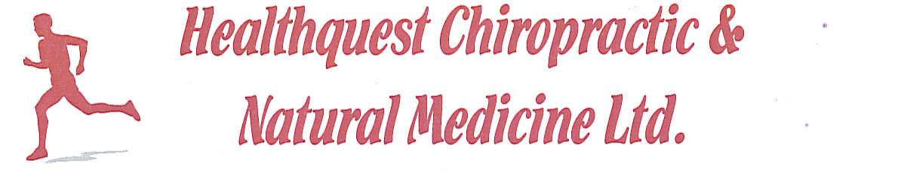
Naturopathic Intake Form
Date: ____________________________
Last Name: _______________________ First Name: _________________________
Gender: __________________________ Age: _______________________________
Date of Birth: ______________________ Alberta Health Care #: _________________

Address: ________________________________________________________________
City: ____________________________ Province: _____ Postal Code: ______
Primary Phone: ___________________ Secondary Phone: ____________________
Email: ___________________________ Occupation: _________________________
Marital Status: ____________________ Children: ____________________________

Emergency Contact: ________________ Phone: ______________________________
Relationship: ______________________ Family Doctor: ________________________

How did you hear about us? _________________________________________________

Chief Health Concerns/Priorities:
- ______________________________________________________________________

- ______________________________________________________________________

- ______________________________________________________________________

- ______________________________________________________________________

- _______________________________________________________________________
Allergies:______________________________________________________________________
Medications (name & dose): ______________________________________________________ ____________________________________________________________________________________________________________________________________________________________
Supplements (name & dose): ______________________________________________________ __________________________________________________________________________________________________________________________________________________________________________________________________________________________________________
Personal Medical History (hospitalizations, medications, surgeries, past diagnoses):
__________________________________________________________________________________________________________________________________________________________________________________________________________________________________________
Family Medical History (circle any relevant):
Cancer Diabetes Heart Disease Stroke High Blood Pressure
Asthma Allergies Addiction Mental Health Obesity
Autoimmune Disease Thyroid Disorders Others (please specify):

Symptoms Checker (please circle all applicable):
Fatigue Insomnia Weight gain Weight loss Anemia
Eczema Psoriasis Acne Brittle Nails Thinning/Loss of Hair
Headaches Migraines Chronic Pain Arthritis Numbness or Tingling
Chronic Muscle Tension Chronic Stress Jaw Pain/TMJ Neck Pain
High Blood Pressure Low Blood Pressure Heart Palpitations Fainting/Dizziness
Seasonal Allergies Frequent colds/flu’s Asthma Chronic Cough
Heartburn Excess Gas & Bloating Diarrhea Constipation
Abdominal Pain Nausea Hemorrhoids Varicose Veins
Poor Memory Anxiety Depression Recreation Drug & Alcohol Use
Low Libido Painful intercourse Erectile Dysfunction
PMS Irregular Periods Painful Periods Abnormal Pap Smears
Naturopathic Consent Form
Full Name (please print): _____________________________________
As a patient of Dr. Jatish Kaler, I understand that the form of medical care that I will receive is based on naturopathic principles, practices and therapies. These may include, but not be limited to: physical examination, diagnostic procedures, nutritional counseling, botanical medicine, traditional Chinese medicine (acupuncture, herbs, cupping…), vitamin & mineral supplementation, massage therapy, injection therapies, physical therapy and counseling. As with any therapy, I understand that no treatment is guaranteed to be successful. I also understand that a record will be kept of health services provided to me. This record will be kept confidential and will not be released to others unless directed by myself or unless required by law. Though naturopathic therapies are proven safe when used correctly, I recognize the potential risks that include, but are not limited to: aggravation of pre-existing symptoms, allergic reactions to supplements or herbs, pain, fainting or bruising from venipuncture or acupuncture, infection at site of needle insertion, muscle strains and sprains from physical therapies, inconvenience or lifestyle changes.
I have read and understood the above statement, accept the risk and thereby consent to treatment.
I also confirm that I have the ability to accept or reject this care of my own free will and choice, and that I am not an agent of any private, local, county, provincial or federal agency attempting to gather information without stating.
I accept full responsibility for any fees incurred during care and treatment.

Signature: _________________________________
Date: ______________________________________

Parent/guardians name: ___________________________________________
Signature of parent/guardian: _______________________________________

