
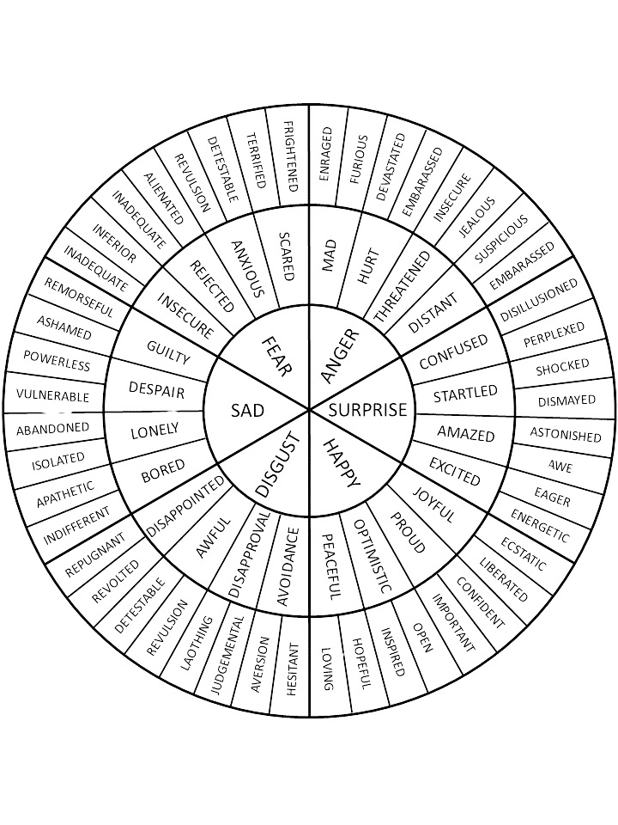
Emotion Wheel
©

Fight or Flight Club Counselling and Therapy 2026
The emotion wheel below can be useful for helping to identify and name what you are feeling. If you are struggling to name your emotion, try starting from the centre, and working your way out.

