Sleep Hygiene 
Sleep hygiene means the set of habits, behaviours, and environmental factors that help you get consistent, good-quality sleep. Poor sleep hygiene can contribute to insomnia, daytime fatigue, mood changes, and reduced focus. Good sleep hygiene supports your natural circadian rhythm and makes it easier to fall asleep, stay asleep, and feel rested.

Below are some tips on how to practice good sleep hygiene:
Create a wind-down routine
Try to do 30–60 minutes of relaxing activities before bed (reading, gentle stretching, calming music). Avoid stressful conversations, work, or intense exercise right before sleep. Limit bright screens for at least an hour before bed and try to get natural daylight exposure during the day to support your body clock.

Keep a consistent schedule and environment

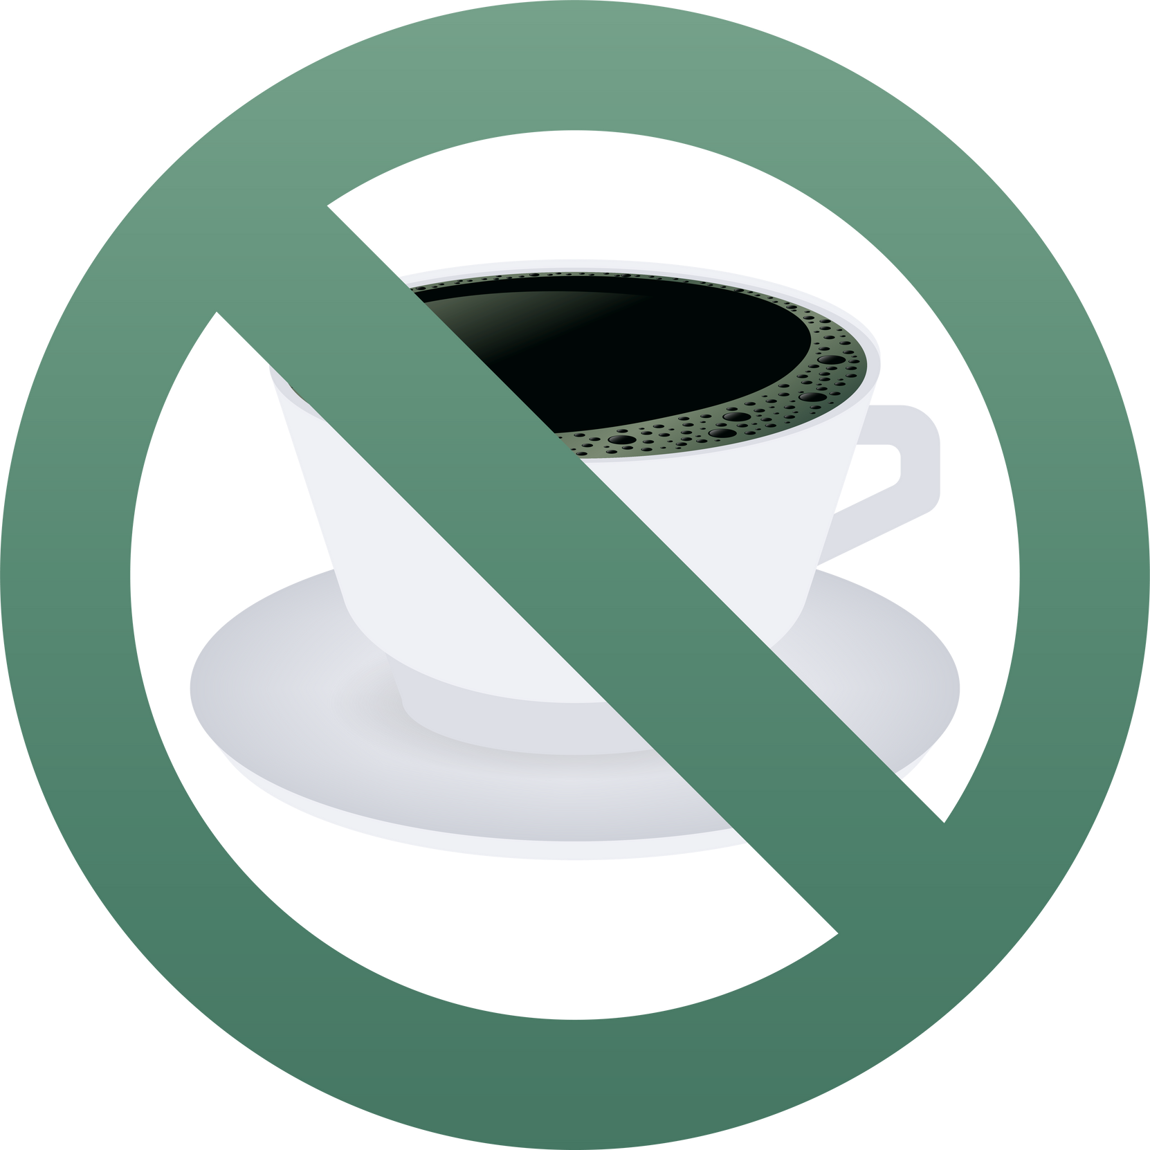
Go to bed and wake up at the same time every day (even weekends). For a sleep-friendly environment, have your bedroom Dark, quiet, and cool at night (about 18–20°C).
Limit stimulants and alcohol. Stay active.
Avoid caffeine in the afternoon/evening. Alcohol can disrupt deep sleep so try to
limit consumption. Regular exercise can help you sleep but avoid very vigorous workouts late at night.

Bed = Sleep and Intimacy only
Avoid using your bed for work, eating, or scrolling through your phone as this can train your brain to associate bed with wakefulness.
©

Fight or Flight Club Counselling and Therapy 2026

