MATTED PET RELEASE FORM

Dog's Name _________________________________________ Date: ____________________

Your Pet is IMPORTANT to US!

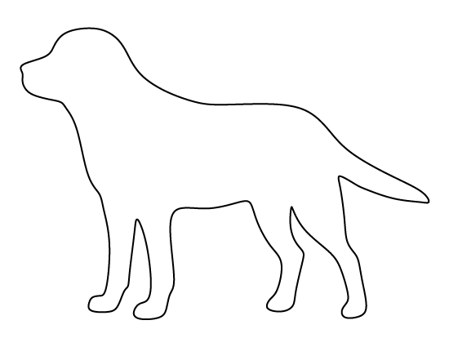
Because we care about your pet’s safety and well-being, we want to assure you that every effort will be made to make your pet’s visit as pleasant as possible.

Since your pet is severely tangled or matted, they are at greater risk of injury, stress, and trauma. All precautions will be taken. However, problems occasionally arise, during and after grooming, such as nicks, clipped irritation and mental or physical stress.

In the best interest of your pet, we request your permission to obtain immediate treatment should it be necessary.

I hereby grant permission to Marie’s Pet Grooming to obtain emergency veterinary treatment for my pet at my expense. Also, realizing that matted pets have a greater chance of injury during grooming, I will not hold this grooming establishment responsible for accident or injury to my pet.

Owner's Name: ___________________________________________

Owner's Signature: _______________________________________

*** There will be an additional matting fee. ***
** Prices will be determined after services have been completed. **

