Andrews Spring Farm
Lewisburg, TN.
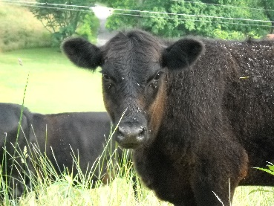

We are now offering our naturally raised local beef direct to you.
This is a great option if you have concerns about what is in your food, and the manner in which it was raised or if you want to save money by buying in bulk and have the security of a stocked freezer! Our cattle do not graze on chemically fertilized pasture, receive antibiotics, growth hormones or steroids. They are not confined in feed lots, nor do they consume genetically modified grains. We simply feed them grass, the food they were intended to eat. We rotationally graze our cattle to ensure fresh forage, mimicking nature to keep them happy and healthy!

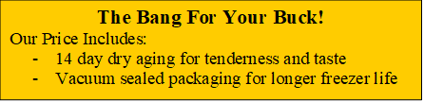

In order for us to get you the best price possible, we sell shares of live beef cattle. You will pay the butcher fee directly to our butcher in Lynnville, TN. All of the weights listed are approximations*. The butcher fee includes a $50.00 kill fee, a $15.00 disposal fee and $0.92/lbs. of hanging weight (example based on 700lbs). Final weights will be determined at the butcher.

USPS or Email this form to:
Andrews Spring Farm
C/O Daniel or Kaitlyn Brindle
1452 New Columbia Hwy.
Lewisburg, TN 37091
andrewsspringfarm@gmail.com
(931) 652-2199

2022 Beef Order Form
* Weights and prices listed are approximations*
Whole Beef
 | Live Beef | Finished Product
Weight in lbs | 1155 lbs* | 375 lbs*
Price / lb | $1.82 | $7.50*
Butcher Fee | --- | $709*
Total Cost | $2102.00* | $2,811.00*

Half Beef
 | Live Beef | Finished Product
Weight in lbs | 577.5 lbs* | 187.5 lbs*
Price / lb | $1.82 | $7.50*
Butcher Fee | --- | $354.5*
Total Cost | $1051* | $1405.5*

Quarter Beef
 | Live Beef | Finished Product
Weight in lbs | 288.75 lbs* | 93.75 lbs*
Price / lb | $1.82 | $7.50*
Butcher Fee | --- | $177.25*
Total Cost | $525.5* | $702.75*

Name___________________________________________
Address_________________________________________
__________________________________________________
Phone___________________________________________
Email___________________________________________
Deposit: (Whole $1,049) (Half $524.50) (Quarter $262.25)

● 50% deposit due with order.
● Pick up your order at Light Hill Meats in Lynnville, TN,
● Home delivery available for a fee.
● For any questions, please contact us directly!

Thank you for supporting local farms and businesses and for giving us the opportunity to provide you with a great deal on something worth eating!

