

Staff Handbook
Education and Training Requirements
At Around the Clock Childcare Center of Learning and Development, we prioritize the education and training of our staff to ensure the highest quality of care and learning for the children we serve. Below are the detailed education and training requirements for various roles within our center.

Director
Pre-Service and Hiring Requirements:
- Background Check: Required
- Tuberculosis (TB) Test: Required
- Licensing Orientation: If applicable
- Minimum Age: 18
- Hiring Education Requirement: (Only one person in this role must meet the requirement upon hire)
  - 10 ECE credits (for 12 or fewer children)
  - 25 ECE credits (for 13-24 children)
  - 45 ECE credits (for 25+ children)
- Full Education: WA ECE State Certificate (47 credits) or equivalent
- Time Allowed from Date of Hire or Promotion: 5 years
Training:
- Child Care Basics
- First Aid/CPR
- Bloodborne Pathogens
- Food Handler’s Permit (if applicable)
- Safe Sleep (if applicable)
- Electronic Attendance Training (if applicable)
- Subsidy Billing (if applicable)
In-Service Training:
- 10-Hour Annual In-Service Training
- Enhancing Quality of Early Learning
- Leadership Practices
- Occasional in person training, zoom training, attending conferences, open houses, and other extracurricular job events
Full Education Requirement:
- WA ECE State Certificate (47 credits) or equivalent
Time Allowed from Date of Hire or Promotion:
- 5 years

Lead Teacher, Teacher Assistant, and Floats
Pre-Service and Hiring Requirements:
- Background Check: Required
- Tuberculosis (TB) Test: Required
- Licensing Orientation: If applicable
- Minimum Age: 18
Training:
- Child Care Basics
- First Aid/CPR
- Bloodborne Pathogens
- Food Handler’s Permit (if applicable)
- Safe Sleep (if applicable)
- Electronic Attendance Training (if applicable)
- Subsidy Billing (if applicable)
In-Service Training:
- 10-Hour Annual In-Service Training
- Enhancing Quality of Early Learning
- Occasional in person training, zoom training, attending conferences, open houses, and other extracurricular job events
Full Education Requirement:
- ECE Initial Certificate (12 credits)
- ECE Short Certificate (20 credits) or equivalent
Time Allowed from Date of Hire or Promotion:
- Initial Certificate: 5 years
- Short Certificate: 2 years from completing the Initial Certificate

Center Volunteer
Pre-Service and Hiring Requirements:
- Background Check: Required
- Tuberculosis (TB) Test: Required
- Minimum Age: 14
Training:
- Bloodborne Pathogens
- Safe Sleep (if applicable)
- Federal Health and Safety Trainings:
  - Recognizing and Reporting Child Abuse
  - Emergency Preparedness
  - Serving Children Experiencing Homelessness
  - Prevention of Shaken Baby Syndrome (if applicable)
In-Service Training:
- No requirement
Education:
- No requirement

Other Staff
Pre-Service and Hiring Requirements:
- Background Check: If applicable
Training:
- Food Handler’s Permit (if applicable)
Education:
- No requirement
By adhering to these education and training requirements, Around the Clock Childcare Center of Learning and Development ensures that our staff are well-prepared to provide exceptional care and a safe, nurturing environment for all children in our program.
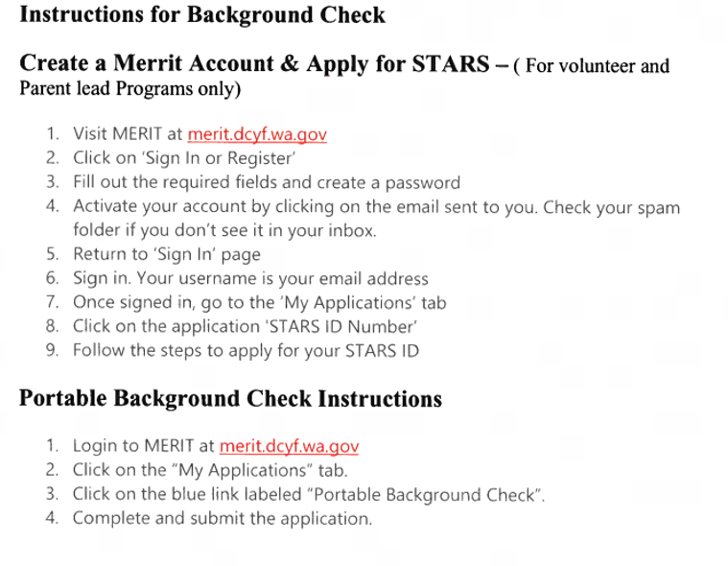

New Hire Check list: Director, Assistant Director-
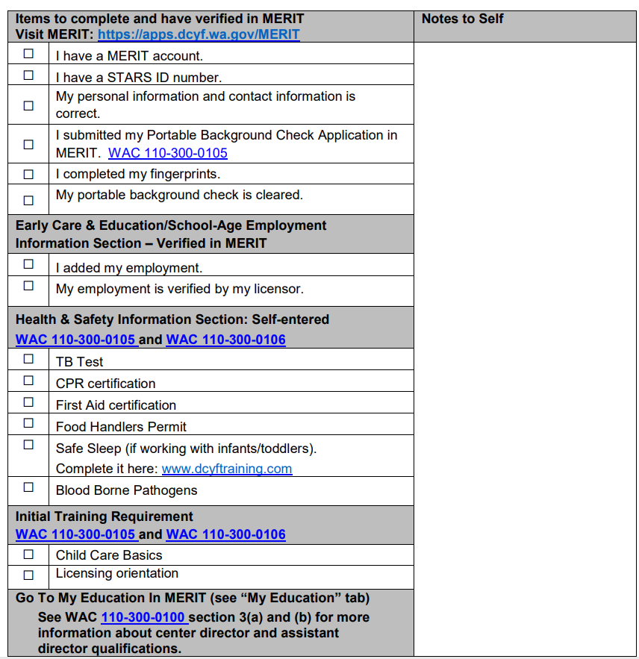
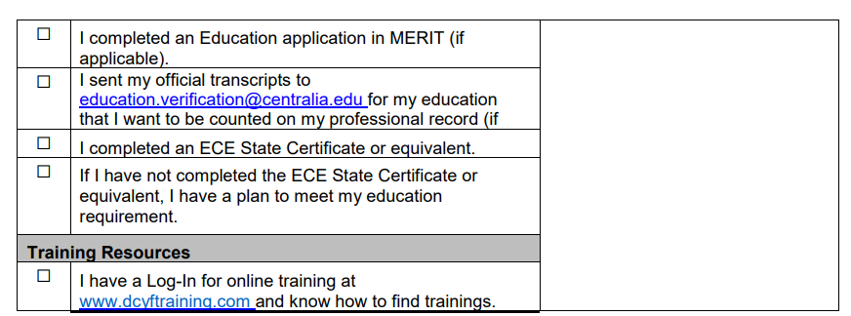
New Hire Check List: Lead, Asst, Float
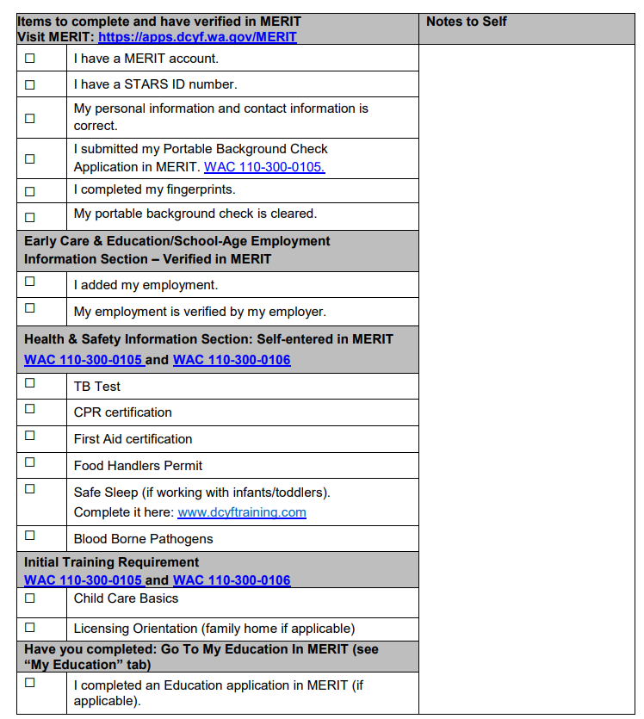

To ensure compliance with WAC standards and provide clear guidance for staff roles and expectations, we can develop comprehensive job descriptions for each position within the Around the Clock Childcare Center of Learning and Development. Below are detailed job roles for each staff position, aligned with the requirements and responsibilities specified in the WAC:

Center Director
Qualifications:
- At least 18 years old.
- Must have an ECE state certificate or equivalent, verified in the electronic workforce registry by the department.
  - Complete an ECE state certificate or equivalent within 5 years
  - New hires or promotions after the effective date must obtain the certificate within five years.
- Two years of experience as a teacher in any age group within the early learning program.
- At least six months of experience in administration or management, or have a department-approved plan.
- Complete the applicable preservice requirements (WAC 110-300-0105).
- Annual documentation of professional development progress.
Responsibilities:
- Manage the early learning program and set staff expectations.
- Be on-site for at least 50% of weekly operating hours, up to 40 hours per week, or designate a qualified assistant.
- Develop and communicate a curriculum philosophy to staff and parents, ensuring the philosophy serves all children.
- Have knowledge of community resources, including those for children with special needs, and share these resources with families.
- Oversee professional development plans for staff, including creating and maintaining staff records, setting educational goals, coordinating state-approved training, and observing and mentoring staff.

Assistant Director
Qualifications:
- At least 18 years old.
- Must have an ECE state certificate or equivalent, verified in the electronic workforce registry by the department.
  - Complete an ECE state certificate or equivalent within 5 years
  - New hires or promotions after the effective date must obtain the certificate within five years.
- Two years of experience as a teacher or in administration/management, or have a department-approved plan.
- Complete the applicable preservice requirements (WAC 110-300-0105).
- Annual documentation of professional development progress.
Responsibilities:
- Assist in managing the early learning program.
- Be on-site for at least 50% of weekly operating hours, up to 40 hours per week, or designate a qualified assistant.
- Support the development and communication of the curriculum philosophy.
- Share knowledge of community resources with families.
- Assist in overseeing professional development plans for staff, including maintaining records, setting educational goals, coordinating training, and mentoring staff.

Program Supervisor
Qualifications:
- At least 18 years old.
- Must have an ECE state certificate or equivalent by August 1, 2026.
- Two years of experience as a teacher in any age group within any early learning program.
- Complete the applicable preservice requirements (WAC 110-300-0105).
- Annual documentation of professional development progress.
Responsibilities:
- Plan early learning program services under the oversight of the center director or assistant director.
- Guide the planning of curriculum philosophy, implementation, and environmental design.
- Ensure compliance with foundational quality standards.
- Act as a teacher or director when necessary, provided it does not interfere with primary responsibilities.
- Manage professional development plans and requirements for staff.

Lead Teacher
Qualifications:
- At least 18 years old.
- High school diploma or equivalent.
- Complete the applicable preservice requirements (WAC 110-300-0105).
- Must have an ECE initial certificate or equivalent, or within five years of being hired or promoted.
  - Obtain an ECE short certificate or equivalent within two years of receiving the initial certificate.
- Annual documentation of professional development progress.
Responsibilities:

Lead Teacher Responsibilities
- Program Implementation:
  - Implement the early learning program effectively, ensuring alignment with the center’s goals and regulatory standards.
- Learning Environment:
  - Develop and maintain a nurturing and responsive learning environment that promotes children’s overall development.
- Curriculum Development:
  - Create and implement developmentally appropriate curriculum plans and activities.
  - Write detailed lesson plans that cater to the varying needs and developmental stages of the children.
- Health and Safety Compliance:
  - Ensure strict compliance with health and safety standards at all times.
  - Conduct regular safety checks and implement necessary measures to maintain a safe environment.
- Medication Administration:
  - Administer medication with strict adherence to established policies and procedures.
  - Ensure medication is not expired, properly measured, and documented.
  - Verify medication administration with a second staff member before giving it to a child.
  - Log all instances of medication administration accurately, including the child's name, medication, dosage, and time.
- Mentorship and Support:
  - Provide guidance, mentorship, and support to assistant teachers and aides.
  - Offer constructive feedback to improve teaching practices and classroom management.
- General Administration:
  - Handle general administrative tasks, including maintaining accurate records of children’s progress and attendance.
  - Ensure all documentation is up-to-date and complies with center policies and regulatory requirements.
- Supervision:
  - Supervise assistant teachers, aides, and volunteers to ensure the smooth operation of the classroom.
  - Provide oversight during activities to ensure the safety and well-being of all children.
- Activity Planning and Preparation:
  - Plan, prepare, and implement engaging and educational activities that support the curriculum.
  - Set up learning stations and organize materials needed for daily activities.
- Student Progress Monitoring:
  - Monitor and assess student progress regularly.
  - Adjust lesson plans and teaching strategies to meet the individual needs of learners.
- Record Maintenance:
  - Maintain accurate and confidential records of children’s development and progress.
  - Document observations and assessments to inform planning and reporting.
- Promoting Center Philosophy:
  - Promote and uphold the center’s philosophy and objectives in all interactions and activities.
  - Foster an environment that reflects the center’s values and educational goals.
- NAEYC Code of Ethical Conduct:
  - Support and adhere to the NAEYC Code of Ethical Conduct.
  - Model ethical behavior and decision-making in the classroom.
- Classroom Management:
  - Manage classroom behavior effectively to create a positive learning environment.
  - Implement strategies for conflict resolution and positive discipline.
- Positive Learning Environment:
  - Create and maintain a classroom environment that is conducive to learning and growth.
  - Encourage a positive and inclusive atmosphere for all children.
- Student Assessment:
  - Conduct regular assessments to evaluate student progress and development.
  - Use assessment data to inform instruction and individualized learning plans.
- Lesson Plan Adjustment:
  - Adjust lesson plans as necessary to address the diverse needs and abilities of individual learners.
  - Ensure that all children are challenged and supported appropriately.
- Teacher Feedback:
  - Provide constructive feedback to assistant teachers and aides to support their professional growth.
  - Encourage continuous improvement and collaboration among staff.
- Collaboration:
  - Collaborate with other school staff to enhance the overall educational experience.
  - Participate in team meetings and contribute to the development of the program.
- Parent and Guardian Communication:
  - Provide regular feedback to parents and guardians about their child’s progress and development.
  - Maintain open and effective communication with families to support children’s learning.
- Diverse Populations:
  - Work effectively with diverse populations of children and adults.
  - Promote an inclusive environment that respects and values diversity.
- Age-Appropriate Lesson Plans:
  - Prepare lesson plans that are tailored to the age, developmental maturity, and needs of the students.
  - Ensure that all activities are engaging and developmentally appropriate.
- Diaper Changes and Hygiene:
  - Perform diaper changes as needed, following proper hygiene and safety protocols.
  - Ensure all children are clean, comfortable, and well-cared for.
- Child Well-being Checks:
  - Conduct daily checks to ensure the well-being of each child upon arrival.
  - Monitor children for signs of illness or distress and take appropriate action.
- Mandatory Reporting:
  - Adhere to mandatory reporting laws and center policies regarding child abuse and neglect.
  - Report any concerns immediately to the appropriate authorities.
- Cubby Audits:
  - Regularly audit children’s cubbies to ensure they are organized and contain necessary items.
  - Communicate with parents about any missing or needed items.
- Environmental Safety:
  - Conduct regular safety inspections of the classroom and playground.
  - Ensure all equipment and materials are in good condition and safe for use.
By encompassing these detailed responsibilities, lead teachers can ensure they meet the high standards of quality early childhood education and create a positive, supportive, and effective learning environment for all children.

Assistant Teacher
Qualifications:
- At least 18 years old.
- High school diploma or equivalent.
- Must have an ECE initial certificate or equivalent, or within five years of being hired or promoted.
- Complete the applicable preservice requirements (WAC 110-300-0105).
- Annual documentation of professional development progress.
Responsibilities:

Assistant Teacher Duties in Preschool
- Child Supervision and Instructional Support:
  - Assist the lead teacher in providing a safe, nurturing, and responsive learning environment.
  - Supervise children at all times to ensure their safety and well-being.
  - Implement developmentally appropriate programs and activities as guided by the lead teacher.
  - Provide individualized attention and support to children as needed.
- Diaper Changes and Personal Care:
  - Assist with diaper changes and toilet training following the center's health and safety protocols.
  - Help children with personal care routines, such as hand washing, dressing, and eating.
- Meal and Snack Preparation:
  - Assist in preparing and serving meals and snacks according to the center’s schedule.
  - Ensure that all food safety and hygiene standards are followed.
  - Help children during meal times, including setting up food carts and ensuring all children have access to their meals.
- Classroom Management and Cleanliness:
  - Help maintain a clean, organized, and inviting classroom environment.
  - Assist with daily cleaning tasks, including sanitizing toys, equipment, and surfaces.
  - Ensure the classroom and facilities are tidy and stocked with necessary supplies.
- Break Coverage and Staff Support:
  - Provide coverage for lead teachers and other staff members during their breaks.
  - Assist with the supervision of children during transition times, such as arrival, departure, and outdoor play.
- Curriculum and Activity Preparation:
  - Assist the lead teacher in planning and preparing educational activities and materials.
  - Set up and organize learning stations and activity centers as directed by the lead teacher.
  - Participate in the development and implementation of lesson plans and curriculum themes.
- Observation and Assessment:
  - Observe and document children’s behavior, development, and progress.
  - Share observations with the lead teacher to help inform planning and individualized instruction.
- Communication and Collaboration:
  - Communicate effectively with lead teachers, staff, and parents.
  - Participate in team meetings and contribute to discussions about classroom activities and child development.
  - Collaborate with lead teachers to ensure consistency in implementing classroom routines and policies.
- Professional Development:
  - Complete required training and professional development courses as specified by the center and WAC standards.
  - Continuously seek opportunities for growth and improvement in early childhood education practices.
- Additional Responsibilities:
  - Follow all center policies and procedures, including health, safety, and emergency protocols.
  - Provide emotional support and encouragement to children, fostering a positive learning environment.
  - Assist with special projects, events, and field trips as needed.
These responsibilities ensure that assistant teachers provide comprehensive support to lead teachers, contributing to a well-managed, educational, and nurturing preschool environment.

Aide
Qualifications:
- At least 14 years old.- NEVER Left Unattended with students.
- High school diploma or equivalent, or currently enrolled in high school/equivalent program.
- Complete the applicable preservice requirements (WAC 110-300-0105).
- Annual documentation of professional development progress.
Responsibilities:
- Provide classroom support to teachers and supervisors.
- Can be counted in staff-to-child ratio if working under continuous oversight.
- Must complete additional training if working more than 19 hours per month.

Volunteers
Qualifications:
- At least 14 years old (written permission from parent/guardian if under 18).
- Work under continuous oversight.
- Regular volunteers must pass a background check, complete a TB test, and complete training requirements.
- Annual documentation of professional development progress.
Responsibilities:
- Assist with various tasks in the early learning program.
- May count in staff-to-child ratio if meeting all qualifications and training requirements.
- Occasional volunteers (e.g., field trips, special events) do not count in staff-to-child ratio.

Other Personnel
Qualifications:
- Complete and pass a background check (chapter 110-06 WAC).
- Negative TB test (WAC 110-300-0105).
- Complete program-based staff policies and training (WAC 110-300-0110).
Responsibilities:
- Support the early learning program as needed.
- Ensure compliance with health and safety standards.
- Assist with administrative and operational tasks.
These job descriptions ensure that all staff members at Around the Clock Childcare Center of Learning and Development meet the necessary qualifications and are aware of their roles and responsibilities in providing a high-quality early learning environment.

Kitchen Manager Responsibilities
- Food Preparation and Delivery:
  - Prepare and cook meals according to the monthly rotating meal menus.
  - Deliver meals to classrooms and assist with cleanup.
  - Ensure meals are served every 3 hours, with specific meal times at 8:30 AM, 11:30 AM, 2:30 PM, and 5:30 PM. Provide an additional morning snack at 10:00 AM for children younger than 2.5 years.
- Allergy Management:
  - Maintain updated allergy lists and ensure they are readily accessible.
  - Prepare and label allergy-specific meals, cooking them with separate equipment to avoid cross-contamination.
  - Transport allergy meals separately and ensure proper handling to avoid exposure.
- Temperature and Safety Monitoring:
  - Log and monitor food temperatures daily to ensure safety and compliance.
  - Keep updated records of temperature logs, including refrigerator and freezer temperatures.
  - Have a contingency plan for power outages and other disaster situations to ensure proper nutrition is maintained.
- Communication and Coordination:
  - Communicate directly with the director and office manager regarding kitchen operations, inventory, and any issues.
  - Coordinate with lead teachers to schedule and assist with cooking experiences in classrooms as necessary.
- Inventory Management:
  - Keep an inventory of plates, cups, dishes, and utensils.
  - Order food and supplies, ensuring adequate stock is maintained.
  - Create and update shopping lists and perform shopping as necessary.
- Sanitation and Cleanliness:
  - Wash and sterilize dishes, pots, and utensils daily.
  - Clean countertops, sinks, refrigerator, freezer, cupboards, common areas, restrooms, laundry rooms, and multi-purpose rooms daily.
  - Sweep and mop the kitchen area, clean and wash ovens and refrigerators, and take out the trash from the kitchen area.
- Laundry:
  - Collect, wash, and distribute laundry as needed daily.
- Record Keeping:
  - Maintain accurate and up-to-date records, including food temperature logs, rescue medication logs, and inventory audits.
- Health Department Compliance:
  - Ensure all kitchen operations comply with health department regulations and requirements.
  - Maintain proper sanitation practices to meet health standards.
- Support and Other Duties:
- Eat with children during meals, prioritizing classrooms that may need assistance.
- Report any deviations from the meal menu to the director.
- Perform other duties as assigned by the director.

Qualifications and Requirements
- Must have a High School degree or GED and be at least 18 years of age.
- Must present a current physical (within 6 months) and TB test (Mantoux 3-step version).
- Must obtain a Food Service & Sanitation Certificate at their own expense, with reimbursement of all expenses incurred after 3 months of employment without disciplinary action on the employee’s file.
- Must be in good health and agile enough to work with small children.
- Ability to relate well to children, staff, parents, and volunteers.
- Ability to read, write, and keep records.
- Experience working in a kitchen.
- Good personality and presents a neat and clean appearance.
- Must have a contingency plan for power outages and other disaster situations to ensure proper nutrition is maintained.
By adhering to these duties and qualifications, the kitchen manager will play a crucial role in ensuring the safe, efficient, and compliant operation of the kitchen while providing nutritious meals to the children.

Comprehensive SOP for Office Manager Duties and Responsibilities
Introduction: As the Office Manager at ATC Center, your role is vital in ensuring the smooth and efficient operation of the center. This comprehensive standard operating procedure (SOP) outlines your key responsibilities and duties, from daily tasks to monthly activities. By following this SOP, you will contribute to creating a positive and nurturing environment for both children and staff.
Daily Duties:
- Handling Emails and Communication:
  - Monitor the Support@atccenter.org email daily and respond promptly and efficiently to building maintenance requests, time-off requests, marketing inquiries, parent and staff concerns, broken toy reports, scheduling conflicts, and any other communication requiring urgent attention.
- Answering and Returning Phone Calls:
  - Always answer incoming calls with a smile and in a professional manner, ensuring a positive first impression for parents and callers. Avoid answering calls while multitasking or driving to maintain undivided attention for each caller. Return phone calls promptly to address inquiries or concerns, providing excellent customer service to parents and staff.
- New Student Enrollment:
  - Ensure all required documents for onboarding new students are collected before their start date. Create a name tag and add the student's information, including a photo, to Brightwheel. Email the facility to notify them of the new student's start date.
- Bill Payment:
  - Handle weekly bill payments for various vendors, such as dishwasher, Comcast, Mountain Mist, and utility bills. After making the payment, photocopy the check and email the copy to Support@atccenter.org with the subject line "Bill Paid (Vendor) - ($Amount) - (Location)."

Weekly Duties:
- Marketing Activities:
  - Twice a week, search Facebook child care groups for promotional content. Any content to be posted must be approved by the Regional Director or Founder before being shared. Engage in enrollment activities and promotions to attract new families to ATC Center.
- Inventory Review and Supply Ordering:
  - Review inventory reports and order supplies as needed to maintain a well-stocked and organized learning environment.
- Zoom Playbook Meetings:
  - Create a Zoom link for biweekly playbook meetings for each individual center. Issue playbook content to Support@atccenter.org and attend the playbook meeting at one of the centers. Ensure each facility manager hosts a playbook meeting.
- Camera Audit:
  - Conduct a 1-hour camera audit at each center weekly, providing a written report of the evaluation and communicating findings with the director.
Biweekly Duties:
- Staff Biweekly Observation Reports:
  - Collect the biweekly observation end-of-shift reports from the Facility Manager and review them for any actions requiring documentation. Condense the reports into a summary and send them to Support@atccenter.org for further review.
Ongoing Responsibilities:
- Community Engagement and Networking:
  - Build and maintain positive relationships with local businesses, schools, and community organizations.
  - Attend community events and network to promote the center's services and strengthen community ties.
- Maintaining Confidentiality:
  - Handle sensitive information with the utmost confidentiality.
  - Ensure that parent and staff records are protected and in compliance with privacy regulations.
- Conflict Resolution and Mediation:
  - Act as a mediator in resolving conflicts between staff members, parents, or other stakeholders.
  - Foster open communication and create a harmonious work environment.
- Professional Development:
  - Stay up-to-date with current trends and best practices in early childhood education and management.
  - Participate in professional development opportunities to enhance leadership skills and knowledge.
- Recruitment and Hiring:
  - Create job postings and utilize various recruitment platforms to find qualified candidates for new hires.
  - Engage in networking and outreach efforts to actively seek potential candidates.
  - Collaborate with the Regional Director and Facility Managers to identify staffing needs and ensure timely recruitment.
- Orientation and Onboarding:
  - Prepare orientation materials and conduct sessions for new hires.
  - Familiarize new employees with the center's policies, procedures, and culture.
  - Ensure that new staff members feel welcomed, supported, and well-prepared to begin their roles.
- Enrollment Management:
  - Maintain an up-to-date waitlist for enrollment across all centers.
  - Regularly review and manage enrollment data, and communicate with parents regarding availability.
  - Coordinate with facility managers to ensure accurate enrollment records.
- Staffing and Waitlist Analysis:
  - Collaborate with the Regional Director and Facility Managers to analyze staffing needs based on enrollment demands.
  - Determine the necessity for new hiring or accommodating waitlisted children.
  - Provide vital input on staff allocation to maintain a stable and nurturing environment for enrolled children.
- Waitlist Communication and Follow-Up:
  - Promptly respond to inquiries from parents regarding the waitlist.
  - Provide information on enrollment status and keep families informed about availability.
  - Regularly follow up with parents to ensure awareness of updates and upcoming enrollment opportunities.
Monthly Duties:
- Monthly Newsletter Creation:
  - Prepare a monthly newsletter to keep parents and staff informed about important updates, events, and activities at ATC Center. The newsletter should include the following sections:
    - New Student Enrollment: Highlight new students who have joined ATC Center during the month. For each new student, add their photo to the "Birthday Wall" and create a personalized name tag.
    - Birthdays and Celebrations: List the birthdays of students and staff members who will be celebrating their special day during the month. Add cheerful birthday greetings and well wishes.
    - Food Menu: Provide a glimpse of the food menu for the upcoming month, showcasing the nutritious and delicious meals planned for the children.
    - Curriculum Overview: Offer a brief overview of the curriculum for the month, outlining the exciting themes, activities, and learning objectives.
    - At-Home Activity Tip: Include a helpful tip or activity suggestion for parents to engage their children in learning and fun activities at home.
    - Weekend Family Events: Highlight family-friendly events and activities happening in the community during the weekends. Utilize resources like Facebook events and Parent Map to gather information.
    - Quarterly Classroom Theme Update: Encourage teachers to update their classroom themes in line with ATC Center's quarterly curriculum. Showcase photos of classroom transformations and engaging learning spaces.
    - Positive Affirmation: Share a positive affirmation or quote to inspire and uplift both parents and staff.
    - Word Search or Coloring Picture: Add a word search or coloring picture related to the monthly theme for children to enjoy with their families.
  - Utilize the newsletter template available under the Staff Resource page at ATCcenter.org for consistency in formatting and branding.
  - Seek approval from the Regional Director or Founder for the content before finalizing and distributing the newsletter.
  - Distribute the monthly newsletter to parents and staff via email. Ensure it is accessible and easy to read on various devices.
  - Encourage feedback from parents and staff regarding the newsletter's content and format. Use the feedback to make improvements in subsequent editions.
- Monthly MERIT Audit:
  - Conduct a monthly audit of MERIT profiles for each staff member at all facilities. Verify that their employment, training, and educational accomplishments are accurately recorded.
  - Regularly communicate with Facility Managers and staff to understand their training needs and progress. Ensure they have sufficient time to complete their training requirements and update their profiles accordingly.
  - Assist staff in completing the Portable Background Check application when necessary, ensuring it is submitted and processed in a timely manner.
  - Stay informed about available training opportunities and share relevant information with staff to support their professional development.
  - Manage employee records for each facility or site, ensuring that all information is properly documented and up to date.
  - Encourage staff to pursue professional achievements and recognition in the early learning field. Provide support for award applications when applicable.
  - Perform a monthly file audit to ensure all student and staff records are accurate and up to date. Verify that all licenses and certifications are current and not expired.
- Monthly Staff Recognition Program:
  - Implement a Monthly Staff Recognition Program to acknowledge and appreciate the hard work and dedication of staff members.
  - At the end of each month, all staff members, including facility managers, teachers, and support staff, are eligible to nominate a fellow staff member for exceptional performance during that month.
  - Nominations should be submitted via email to the Office Manager at support@atccenter.org, with the subject line "Monthly Staff Recognition Nomination."
  - Nominations should highlight specific instances where the staff member demonstrated exceptional dedication, creativity, problem-solving skills, teamwork, or any other remarkable qualities that had a positive impact on the center or its community.
  - The Office Manager will review all nominations received and seek input from the Regional Director, when applicable, to make a final decision.
  - The chosen staff member will be announced as the "Monthly Staff Star" during the biweekly playbook meeting and mentioned in the monthly newsletter.
  - The selected "Monthly Staff Star" will receive a monetary compensation of $100 in their next paycheck.
  - Their achievement and recognition will also be prominently featured in the newsletter, showcasing their valuable contributions to the ATC Center community.
  - Encourage all staff members to continue participating in the Monthly Staff Recognition Program by actively nominating colleagues who inspire them through their outstanding dedication and commitment.
- Monthly Manager Meeting with Regional Director and Facility Managers:
  - Conduct a monthly in-person meeting with the Regional Director and Facility Managers to review facility operations, enrollment and marketing updates, financial status, staffing needs, curriculum assessment, facility maintenance, policy and procedure updates, recognition and celebrations, action plans, and goals.
    - Facility Operations Review: Each facility manager will provide a comprehensive overview of their center's operations, including staff performance, daily routines, parent feedback, and any challenges encountered.
    - Enrollment and Marketing Updates: Share updates on enrollment trends, upcoming marketing initiatives, and strategies for attracting new families. Review the effectiveness of recent marketing campaigns and identify opportunities for improvement.
    - Financial Status and Budgeting: Discuss the financial performance of each facility, including revenue, expenses, and budget adherence. Identify any financial concerns and develop strategies to optimize financial stability and growth.
    - Staffing and Training Needs: Assess current staffing levels, identify gaps or areas for improvement, and discuss training and professional development needs. Ensure staff members are equipped with the necessary skills and resources to excel in their roles.
    - Curriculum and Program Assessment: Evaluate the effectiveness of the current curriculum and educational programs. Identify any modifications or enhancements needed to meet the evolving needs of the children and families served.
    - Facility Maintenance and Upkeep: Review the condition of each facility, address any maintenance issues, and plan for necessary repairs or upgrades. Ensure a safe and welcoming environment for children and staff.
    - Policy and Procedure Updates: Discuss any updates or changes to policies and procedures, ensuring alignment with WAC standards and best practices in early childhood education. Communicate these changes effectively to staff and parents.
    - Recognition and Celebrations: Highlight the achievements and contributions of staff members, parents, and children. Plan for upcoming events, celebrations, and recognition activities to foster a positive and supportive community.
    - Action Plans and Goals: Collaboratively develop action plans and set measurable goals for the upcoming month. Assign responsibilities and timelines to ensure accountability and progress.
  - Meeting Minutes and Follow-Up: Take detailed minutes during the meeting and distribute them to all attendees. Follow up on action items and monitor progress toward achieving the set goals.
Quarterly Duties:
- Quarterly Marketing Event:
  - Host a marketing event for ATC Center once a quarter to engage the community and promote the center's services. Coordinate with the Regional Director and Facility Managers to plan and execute the event. The event may include:
    - Open House: Invite prospective families to tour the facilities, meet the staff, and learn about the programs and services offered by ATC Center.
    - Community Fair: Participate in or organize a community fair where ATC Center can set up a booth, distribute promotional materials, and engage with local families.
    - Educational Workshop: Offer a free workshop or seminar for parents on topics related to early childhood education, parenting tips, or child development.
    - Fun Day: Organize a family fun day with activities, games, and entertainment for children and parents to enjoy together.
    - Social Media Campaign: Launch a targeted social media campaign to promote the event and increase visibility for ATC Center.
  - Ensure all marketing materials and event details are approved by the Regional Director or Founder before execution.
Emergency Responsibilities:
- Emergency Response Coordination:
  - In the event of an emergency, the Office Manager will coordinate with Facility Managers and staff to ensure the safety and well-being of all children and staff. This includes overseeing emergency procedures, communication, and evacuation if necessary.
- Crisis Communication:
  - Act as the primary point of contact for communication during a crisis. Ensure timely and accurate information is relayed to parents, staff, and emergency responders as needed.
Conclusion:
By adhering to this comprehensive SOP, you will play a pivotal role in maintaining the high standards of ATC Center and ensuring a positive experience for children, parents, and staff. Your dedication to these responsibilities will contribute to the success and growth of the center, fostering an environment where children can thrive and families can feel confident in the care provided.

Call Out Grievance Vacation SOP
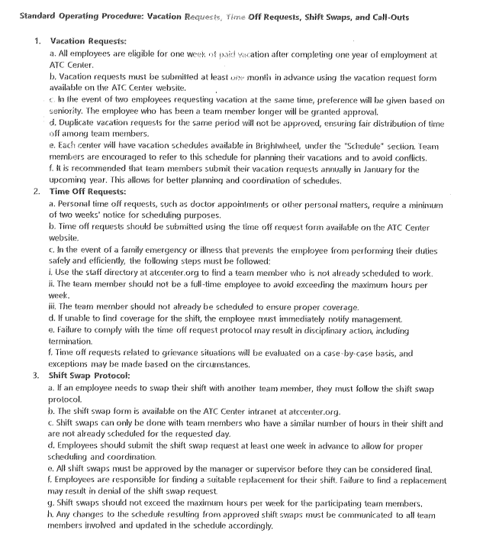

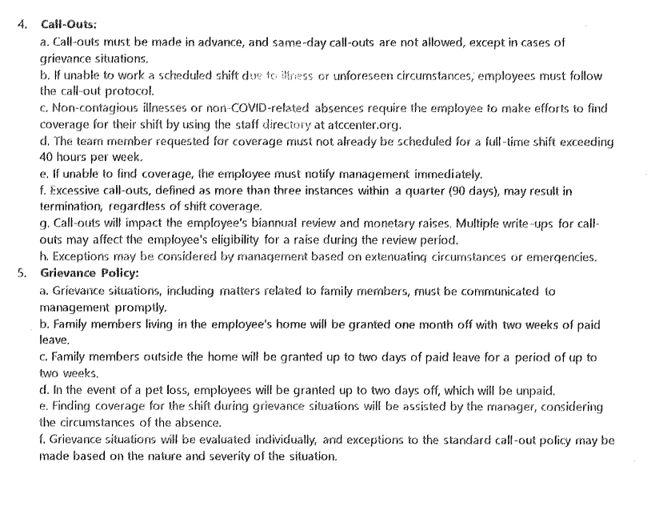
Attendance Policy:
- Timecard Punching: Employees must punch in at the start of their shift. Failure to punch in will result in the system automatically recording the start time. Similarly, if an employee fails to punch out, the system will record the time as 30 minutes prior to the scheduled end of their shift.
- Time Tracking Responsibility: It is the responsibility of each employee to accurately track their time using the provided digital system. A paper time card is also available for monitoring and tracking hours outside of the digital system.
- Infractions: Five infractions in a quarterly period (90 days) will result in termination.
- Resignation Notice: Quitting without providing a two-week notice will be considered abandonment of duties and may result in the reporting of your STARS number, which could impact future employment in this industry.
- No Call, No Show: More than two 24-hour no call, no shows in a 90-day period will result in termination.
- At-Will Employment: Employment is at-will, meaning either party may terminate the employment relationship at any time, with or without cause or notice. However, we monitor for training and compliance to ensure a stable work environment.

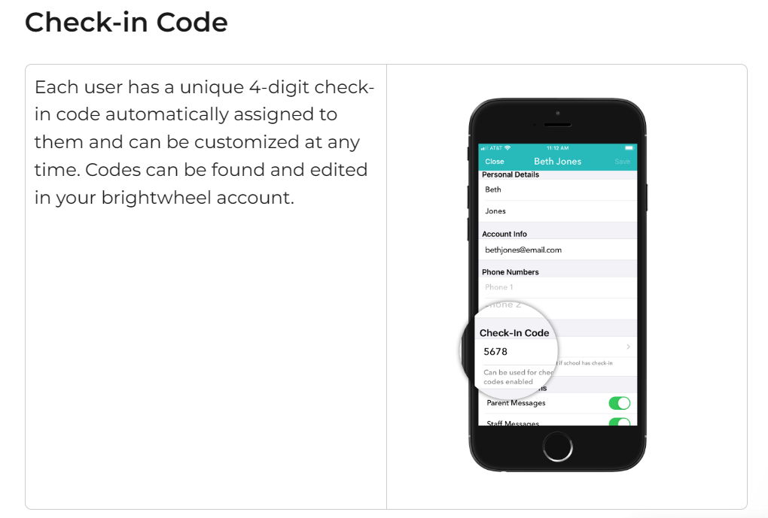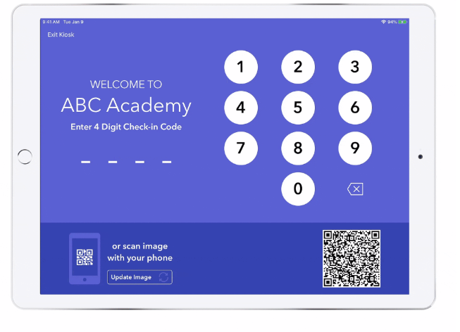

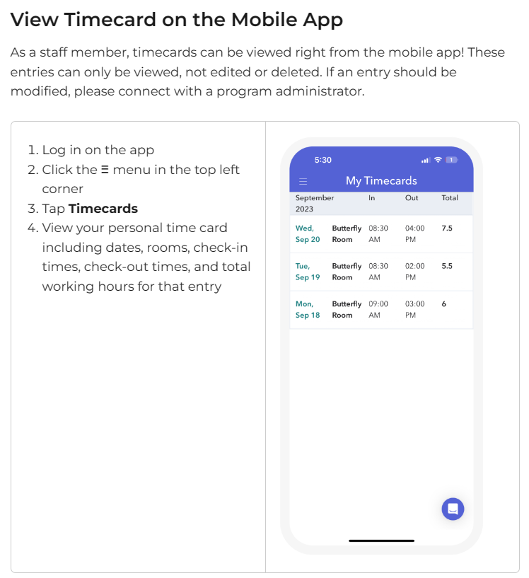
Pay Day Policy
Pay dates for Around the Clock Childcare Center of Learning and Development are scheduled for once a month on the 5th. Should the 5th fall on a weekend or holiday, checks or direct deposits will be processed on the following business day, including holidays.
After completing 90 days of employment, staff members are eligible to enroll in benefits, including medical, dental, and vision coverage, at an additional expense.
In the event that a staff member does not continue or terminates employment within the first 6 months, all fees related to CPR, First Aid, and badges will be deducted from their final check. Final checks will be mailed to the staff after termination, contingent upon the return of all keys, materials, and security badges to the director.
In case of a work-related emergency, a drawl (advance payment) may be requested, provided it is submitted a week in advance and meets certain conditions. Staff must have exceeded their regular working hours and not have submitted more than 3 drawl requests in a year.
While these provisions are intended to assist our team during hardships, they are conditional and do not guarantee approval of a drawl request.

Title: Daily Information Sharing Protocol for Staff Working with the Same Classroom or Group of Children
Instructions:
- Sharing Information: Staff working, transitioning, or covering breaks with the same classroom or group of children must share relevant information daily.
- Signing In and Out: This includes signing in and out of the classroom through Brightwheel to track responsibilities and transitions.
- Documentation: Staff must document milestones, injuries, and concerns during their shift, whether or not the classroom is their assigned one. All documentation is to be completed in Brightwheel; however, paper copies are available in each classroom for notes if it is unsafe to document electronically at that moment.
- Emergency Protocol: In the case of a head injury or when blood is drawn, teachers should use a walkie-talkie to request assistance.
- End-of-Shift Report: At the end of each shift, all staff are required to complete an end-of-shift report detailing the day's events, successes, areas needing improvement, and the overall climate of the day.
- Transitioning Procedures: Transitioning staff should always arrive 10 minutes early, be prepared to work, and review end-of-shift reports to ensure they understand. They should also communicate effectively with team members.
- Playbook Conference: Every other week, staff are required to attend a Zoom conference titled "Playbook." During these sessions, all staff discuss in-center findings from the previous two weeks and review refresher materials provided by their supervisors.

Communications to the Family- Hippa
The director, during onboarding or any changes, will effectively communicate with lead staff to update them on:
(a) Child's Health Needs, Allergies, and Medication: Ensure allergy information is up-to-date and match faces to names in each classroom. Advise the kitchen manager to ensure all staff understand the child's health policy and needs before the child's first day.
(b) Changes in a Child's Daily Schedule: All communications to families regarding changes in a child's schedule will be documented in Brightwheel.
(c) Significant Educational or Developmental Information: Observation reports may be pulled to sit down with the director and have conversations with parents to encourage and support any resources they may need for the success of their student.
(d) Communications from the Family: If a teacher encounters a situation and needs support in communicating with the parents, they should request a meeting with the director for support and strategy.
(e) Information to be Shared with the Family: Quarterly, the program will request updated schedules from parents to ensure the proper amount of time and in-center care is being met for significant concerns on a child's developmental progress. A child must have an established dentist and physician to be enrolled in our program. The director may suggest wellness exams or further evaluations to help support the child's development, but only with proper reporting and observations. Per HIPAA, health records of these encounters will stay between the director, office manager, and teacher caring for the student on a regular basis to ensure they are getting optimal and proper support. No information about the student will leave the main caregiving staff assigned to this student.

HIPAA Compliance Notice
Around the Clock Childcare Center of Learning and Development (ATC Center) complies with the Health Insurance Portability and Accountability Act of 1996 (HIPAA) Privacy Rule to protect the privacy and security of protected health information (PHI).
Covered Entities: ATC Center is considered a covered entity under HIPAA. This includes health plans, health care clearinghouses, and health care providers who transmit health information electronically.
Protected Health Information (PHI): PHI includes any individually identifiable health information held or transmitted by ATC Center, in any form or media, whether electronic, paper, or oral. This information relates to an individual's past, present, or future physical or mental health or condition, the provision of health care to the individual, or the past, present, or future payment for the provision of health care to the individual.
Use and Disclosure of PHI: ATC Center may use and disclose PHI for treatment, payment, and health care operations, as permitted by HIPAA and required by law. PHI may also be disclosed for other purposes with the individual's authorization.
Patient Rights: Individuals have rights regarding their PHI, including the right to access, amend, and request restrictions on the use and disclosure of their PHI. Individuals also have the right to file a complaint if they believe their privacy rights have been violated.
Business Associates: ATC Center may disclose PHI to business associates who perform functions or services on behalf of ATC Center that involve the use or disclosure of PHI. Business associates must also comply with HIPAA regulations.
Security Measures: ATC Center has implemented security measures to protect PHI, including administrative, physical, and technical safeguards.
Compliance and Enforcement: ATC Center is committed to complying with the HIPAA Privacy Rule and will take appropriate action in response to any violations.
For more information about HIPAA and your privacy rights, please visit the HHS website at www.hhs.gov/hipaa.
This notice is provided for informational purposes only and does not constitute legal advice. For specific questions regarding HIPAA compliance, please consult with legal counsel.

ATC Center Cell Phone Policy
1. Use of Personal Phones: Personal phones are not to be used during working shifts except during personal breaks and mealtime.
2. Acknowledgement and Adherence: By acknowledging this form, you agree to adhere to ATC Center's compliance policy regarding cell phone usage.
3. Exemptions and Technicalities:
- In the event of ATC Center's phone lines going down, a Brightwheel message should be immediately sent to all parents and posted on the social media page.
- If ATC Center does not have an established phone line, staff are authorized to have personal phones for emergency situations only.
- Brightwheel is to be used on iPads only during working hours.
4. Printing Policy: Printing from personal phones should only be done at designated times for planning or prep. Do not interrupt your classroom by walking away to print. Lesson plans and Playbook material are located on the communication board. Delegate printing tasks to support staff if needed, and communicate via walkie talkie.
5. Brightwheel Tablet Usage: ATC Center has provided tablets for Brightwheel use. Brightwheel information should be entered during downtime. In case of an injury requiring immediate attention with Brightwheel, ask a float or assistant teacher for support in your classroom to act accordingly. Follow protocol when writing injury reports.
6. Property Respect: Be respectful of ATC Center's property. Staff may be charged for equipment damage depending on circumstances.
7. Communication Protocol: Use admin-only communications for offsite staff communication and speak through Brightwheel to log communications for record and stay in policy.
8. Group Thread Usage: The group thread should only be used for communications relevant to the entire group.
9. Conflict Resolution: If you have a conflict with this policy or need further instruction, seek management for clarity and communication.
Note: This summary is for informational purposes only. For the full policy and any updates, refer to the official ATC Center Cell Phone Policy document.

ATC Center Food Protocol
- Preparation for Transition:
  - Clean up miscellaneous items in the classroom before the transition to the lunchroom.
- Head Count and Allergy Awareness:
  - Line up children and conduct a head count, ensuring awareness of any allergies in your class. Refer to the allergy guide for reference.
- Handwashing:
  - Ensure all children wash their hands before seating.
- Seating:
  - Seat children before serving. A staff member should be sitting with students at lunch as well and encouraging healthy eating and proper table manners.
- Serving Protocol:
  - All food should be served to children without exception.
  - Use the stocked cart, including gloves, ATC Center wipes, food items from the menu, serving supplies, milk, water (offered at every meal), dumping bin, and option for second servings.
  - Allergy plates should come prepared and wrapped as indicated on the allergy ticket.
- Children's Movement with Food:
  - Children should not walk around the center with food.
- Outside Food Policy:
  - No outside food should be brought into the center.
  - Food should not be served outside of scheduled meal hours.
- Staff Eating Protocol:
- Staff are encouraged to eat lunch during their break time. However, if demonstrating eating to children, it is allowable and aligns with the Montessori approach.
- All staff must store personal items, including food, in designated staff areas. Staff food should be stored in the staff refrigerator and must never be stored with facility food.
- Any drinks brought into the center, such as morning coffee and energy drinks, must be in a clear cup. Hot beverages must remain in unlicensed areas to ensure the safety of the children and prevent accidental spills, contamination, and burns.
- Staff are not permitted to snack or eat in the classroom outside of designated meal times for students. Please consume food during designated meal times or on your breaks.
- Table Manners:
  - Encourage children to talk about their food and use good table manners.
- Choking Awareness:
  - Be aware of signs of choking, including silent choking.
- Transition to Nap Time:
  - Do not start the transition to nap until all food is cleaned and removed from the lunchroom.
- Food Cart Pickup:
  - Place your food cart outside your door by noon for kitchen pickup.
- Late Arrivals:
  - If a child arrives after the lunch hour and has not eaten, remind the family that this is not allowable.
- Meal Duration:
  - Children should have at least 30 minutes of mealtime. After 30 minutes, it is acceptable to discard food.
- Recording:
  - Enter any food-related concerns or observations in Brightwheel along with other miscellaneous observations and content during nap time.

Diaper Policy Standard Operating Procedure (SOP)
Introduction: As an early learning provider, we are committed to maintaining a safe and hygienic environment for all children and staff. This SOP outlines the standards and procedures for diapering, bathroom spaces, and toilet training at our program.
Bathroom Space and Toilet Training Standards: Our indoor bathroom spaces must meet state regulations (WAC 110-300-0220), including:
- One working flush toilet and sink, appropriately sized for children.
- Privacy provisions for children.
- Toilet paper dispensers suitable for children.
- Adequate ventilation and cleanliness standards.
For bathtub or shower use:
- Parental consent is required.
- Use is limited to cleaning after accidents or during overnight care.
- Safety measures, like slip-resistant surfaces or grab bars, must be in place.
Toilet Training: Training procedures must be discussed with parents, using positive reinforcement and culturally sensitive methods. Equipment must be cleaned and disinfected daily.
Diaper Changing Areas: Each classroom or age group must have a designated diaper changing area, separate from food areas, with a sink for handwashing and a washable, moisture-resistant surface.
In some centers a standing diaper change policy is in place with ground mats available.
Employee Standards: Personal hygiene practices, including handwashing and glove use, are essential. Gloves must be changed for each diaper change and disposed of properly.
Diaper Changing Procedure:
- Gather supplies.
- Place child on a safe surface.
- Remove soiled diaper and dispose of it.
- Clean diaper area thoroughly with wipes.
- Apply diaper cream if needed. - ONLY WITH APPROVED AUTHORIZATION
- Place clean diaper on child.
- Fasten diaper properly.
- Wash hands thoroughly.
- Record the diaper change on the child's daily log.
- Sanitize changing station with bleach
- Audit child’s diaper cubby for go home items, inventory request such as wipes and pampers, swapping seasonal clothes or any relatable item to child’s needs.
Be mindful if a student has more than 3 BM’s to contact parent for pick up as diarrhea is a symptom of illness.
By following these procedures, we ensure the health and safety of all children and staff in our care.
ATC Center Uniform Policy SOP
Purpose: The purpose of this policy is to ensure that all staff members of ATC Center maintain a professional appearance while adhering to proper hygiene standards, in order to provide a safe and healthy environment for the children in our care.
Uniform Requirements: All staff members are required to wear scrubs and closed-toe shoes. During summer months, moisture-resistant knee-length shorts and Crocs are acceptable, but they must still meet the same standards for cleanliness and maintenance as our other uniform items. All uniforms should be clean, well-maintained, and odor-free. A fun cartoon scrub top is encouraged but must be appropriate for the workplace. One set of black scrubs with an optional cartoon top will be provided after orientation. Any additional uniform purchases are at the discretion of staff and are not reimbursed.
Personal Hygiene: Personal hygiene is essential in maintaining a safe and healthy environment for the children in our care. Communicable diseases, such as lice and scabies, can easily spread in a close-knit environment like ours. Clean fingernails are also essential in preventing the spread of MRSA and other harmful infections. Staff members are required to maintain proper hygiene at all times and take the necessary steps to prevent the spread of germs.
Badge and Identification: Upon completion of orientation, a name badge will be issued to each staff member, which must be worn at all times. The badge must be displayed prominently, and should include the staff member's name, title, and photograph. In addition, the badge should also contain the staff member's CPR and food handler's card, which must be kept in the badge sleeve at all times. The badge should be left on-site after the working shift. A replacement badge fee of $25 will occur after two reprints.
Clocking In and Out: All staff members are required to clock in and out of their shift via Brightwheel or ADP, whichever is relevant to your site. In addition, staff members must also handwrite their time in and out on their timecard. Checking your hours worked is a personal matter and should not be done while on the clock.
Communication: Staff members will be provided with a walkie-talkie set to channel 10, which must be kept with them throughout their entire shift. Staff members are assigned a walkie-talkie, and it is their responsibility to maintain the functionality of this device. Should the device be lost or damaged, a replacement fee of $30 will occur. Tablets are provided in each classroom for documenting in Brightwheel and communicating with staff. Please use this device properly and charge both devices at the end of the working shift. If the shift ends midday, the closing teacher is responsible for charging the tablet.
Friday Free Day: Fridays are considered a free day, and while uniforms are not required, standard clothing is still expected. Tank tops, low-cut shirts, short shorts, ripped jeans, slippers, and any clothing with offensive messages or symbols are not permitted.
Comprehensive Childcare Facility SOP for Safety, Supplies, Responsible Play, and Compliance Audits
Introduction: In a childcare setting, maintaining efficient supply management, systematic project cleanup, ensuring outdoor play safety, and promoting responsible toy usage are fundamental aspects of providing a safe and enriching learning environment for children. This comprehensive standard operating procedure (SOP) outlines key practices and safety measures to promote responsible behavior, maintain an organized facility, and foster a positive and safe learning experience for all children at our center. As a new hire, this SOP will provide you with clear instructions and examples to ensure the well-being and optimal learning experience for the children under our care.
Supply Management and Organization:
- Utilizing Puzzle Pieces, Markers, Legos, and Blocks as References: Encourage children to treat supplies like puzzles, markers, Legos, and blocks with care. After using a puzzle, guide the children to put all puzzle pieces back into the designated puzzle bin. Similarly, emphasize the importance of returning markers and crayons to their respective containers after use. For building materials like Legos and blocks, make sure children know to place them in the correct bins.
- Limiting Stations and Sequential Activity Completion: Designate each station for no more than 5 children at a time to ensure efficient supervision and a cleaner learning environment. Encourage children to complete one activity fully before starting another.
- Labeling and Identifying Kids' Names: Ensure that children's names are clearly labeled on their workspaces and projects. This practice promotes a sense of ownership and pride in their creations and helps teachers keep track of individual progress.
- Inventory Loss Prevention and Consequences: Implement a system of inventory control and tracking. Designate a staff member to oversee and restock supplies. Use a weekly inventory sheet to document the availability of essential items. If supplies are running low, promptly reorder them to maintain an adequately stocked inventory.
Project Cleanup and Training Kids:
- Promoting Responsible Clothing Practices: Assist children in removing shirts during meals to minimize spills and keep their clothing clean. Provide visual cues to show children how to properly put on smocks before engaging in activities like painting.
- Teaching Cleanup After Projects: Teach children the value of proper cleanup after each project. For example, after an art activity where paint was used, guide them on how to wash paintbrushes thoroughly under running water and clean them using mild soap.
Responsible Toy Usage during Themed Activities:
During themed activities, ensure that all equipment is used appropriately and under proper supervision. Provide clear instructions on the safe use and handling of sports-related toys and equipment. Actively engage with the children during the activity to prevent misuse and potential injuries. Promptly remove any hazardous or unused materials to maintain a safe environment.
Outdoor Play Safety:
- Monitoring and Cleanup: Conduct a thorough inspection of the play area after each themed activity and ensure that all toys and equipment are safely stored. Collect and store any items that require special care or supervision to prevent unauthorized use and potential accidents.
- Educating Children on Proper Toy Use: Take the opportunity to educate children on the importance of responsible toy use and the potential consequences of misuse.
- Supervision During Activities: Closely supervise the children during themed activities to ensure that they are using the toys and equipment appropriately.
- Reporting Misuse and Accidents: Promptly report any toy misuse or accidents to the designated supervisor and record it in the "Toy Misuse and Accident Report" to identify potential safety concerns and prevent similar incidents in the future.
Availability of Supplies and Weekly Facility Manager Audit:
- Availability of Supplies: Ensure that all essential supplies are restocked and readily available for outdoor play and other activities. Designate specific staff members to check and refill supplies as needed throughout the day.
- Weekly Facility Manager Audit: Conduct weekly audits to assess the cleanliness and organization of the learning environment. This audit will help identify areas that need attention and ensure that the facility remains tidy and welcoming.
Compliance Audits and Consequences:
- Quarterly Compliance Audits: Perform classroom checks to ensure adherence to the SOP guidelines. Randomly select items to ensure proper organization, supply management, and compliance with safety measures.
- Consequences for Non-Compliance: Reduce the lead teacher's bonus by 75% and the assistant teacher's bonus by 50% for missing or broken pieces or poor inventory management. This measure reinforces the importance of following the SOP guidelines and maintaining a safe and organized learning environment.
Reporting Broken Toys:
- Reporting Broken Toys: Promptly report any broken toys or equipment to support@atccenter.org. Proper documentation helps ensure a safe play environment and timely replacement of damaged items.
Conclusion: By understanding and implementing these practices and safety measures, you play a vital role in creating a secure, organized, and enriching learning environment for the children in our care. Use examples, visual cues, tracking systems, and compliance audits to guide you in promoting responsible behavior, maintaining a clean facility, and fostering a positive and safe learning experience. Adhering to these guidelines ensures the well-being and positive experiences of all children under our care.

Safe Sleep Best Practices and Napping SOP
Safe Sleep Practices
To ensure the safety and well-being of all infants and children in our care, the following guidelines are established for safe sleep and napping practices:

SIDS Risk Reduction
- Infants at higher risk of SIDS include those born weighing less than 3.5 pounds, with a sibling who died of SIDS, exposed to drugs during pregnancy, born to teenage mothers, or who have experienced a life-threatening event.
- Parents can reduce SIDS risk by:
  - Placing babies on their backs to sleep.
  - Using a firm crib mattress with tight-fitting sheets.
  - Keeping blankets, pillows, and stuffed animals out of the crib.
  - Avoiding smoking around the baby.
  - Keeping the baby warm, not hot.
  - Ensuring the baby stays healthy and breast-feeding whenever possible.
  - Avoiding exposure to people with respiratory infections and ensuring good hygiene.

Safe Sleeping Environment
- Always place infants on their backs to sleep.
- Use a firm mattress in a safety-approved crib or bassinet. Ensure the mattress fits snugly.
- Avoid using waterbeds, bean bags, or soft surfaces.
- Keep cribs away from window blinds or curtain cords.
- Test smoke detector batteries monthly and replace them twice a year.
- Plan and practice a family fire escape route.

Additional Resources
- Washington State Department of Health - Newborn Screening Resources
- CHILD Profile - Identifies children's health needs by age, including immunizations.
- Child Support Resource Center - Administers state and federal child support laws.
- American SIDS Institute
- Safe Sleep for Your Baby - Brochure from the Department of Health
Napping SOP
To maintain a safe and structured napping environment, the following Standard Operating Procedures (SOP) are to be adhered to by all staff:

Napping Guidelines
- Each child will have an assigned blanket stored in their cubby. Blankets are washed every Friday and redistributed at the start of the business week.
- Nap cots must be placed at least 2 feet apart and arranged in a head-to-toe formation to reduce the spread of germs.
- Each cot should have a sheet barrier topped with the child's blanket. Blankets are removed after nap time and stored in the child's cubby.
- Children are not allowed to bring stuffed animals, blankets, or pillows from home to maintain a clean and fair environment.

Nap Time Procedures
- Nap time is scheduled for approximately 2 to 2.5 hours.
- All students, except those aged 5 and 6, are required to rest their bodies. Students aged 5 and 6 may engage in quiet activities such as worksheets or reading during nap time.
- If a student struggles to wake up or shows signs of fatigue, notify the on-site director for assistance.

Compliance and Monitoring
- Teachers must ensure compliance with safe sleep and napping practices, including preventing children's access to unlicensed spaces.
- Daily communication among staff transitioning or covering breaks is mandatory, using Brightwheel to sign in and out of the classroom and document milestones, injuries, and concerns.
- An end-of-shift report is required to maintain continuity of care and safety.
By adhering to these guidelines and procedures, we ensure a safe, healthy, and nurturing environment for all children at Around the Clock Childcare Center of Learning and Development.

Interactive Policy for Staff-Child Interaction

Purpose
To establish clear expectations for staff interactions with children, ensuring nurturing, respectful, supportive, and responsive environments. Staff should encourage positive interactions, foster child development, and maintain a culturally responsive atmosphere.

Policy
- General Interaction Guidelines
  - Staff must be aware of and responsive to children's developmental, linguistic, cultural, and academic needs.
  - Use a calm and respectful tone of voice.
  - Utilize positive language to explain what children can do and provide descriptive feedback.
  - Engage in relaxed conversations with children, listening and responding to their input. Adult conversations should not dominate the overall sound of the group.
  - Unrelated to work conversations should be limited and appropriate to the learning environment. Should you experience unpleasant conversations politely excuse yourself. Should this become habitual or selective to a specific team member reach out to HR team for guidance and support.
  - Greet children upon arrival and departure.
  - Use facial expressions such as smiling and enthusiasm to match a child's mood.
  - Utilize physical proximity in a culturally responsive manner, speaking to children at their eye level. Warm physical contact should be minimal and appropriate.
  - Validate children's feelings and show tolerance for mistakes.
  - Encourage children to share experiences, ideas, and feelings.
  - Observe children to learn about their families, cultures, interests, ideas, and theories.
  - Model and teach emotional skills, including recognizing feelings, expressing them appropriately, and accepting others' feelings.
  - Represent the diversity found in the program and society, respecting cultural traditions, values, religions, and beliefs of enrolled families.
  - Interact with staff and other adults in a positive, respectful manner.

- Physical Interaction
  - Staff should reduce physical touch as much as possible.
  - Instead of physically guiding a child, use verbal encouragement. For example, instead of touching a child to get in line, ask, "What do we do when we go outside?" Encourage children to respond with "Line up." Make this fun by saying, "Let's hop like bunnies to line up!"
  - Physical touch is permitted only when necessary to prevent harm. If a child is causing harm to themselves or others, gently remove the child from the situation by holding them at the trunk of their body from the side. Document and report such incidents as needed.
- Diapering and Potty Training
  - When changing diapers, communicate with the child, letting them know you are helping them get cleaned up.
  - Engage the child in conversation about potty training efforts, never discouraging natural body functions or using negative language about bodily functions.
  - There is zero tolerance for emotional, verbal, or physical abuse. Any such incidents must be reported immediately.
- Mandatory Reporting
  - Each staff member is a mandatory reporter. If you witness any form of abuse, report it to the director immediately.
  - Complete investigation reports and follow the guidance of support staff and licensing authorities for appropriate actions.
- Encouraging Positive Interactions
  - Provide several opportunities daily for children to interact with each other during play or routine tasks.
  - Model social skills and encourage socially isolated children to find friends.
  - Help children understand the feelings of others.
  - Include children with special needs in play activities with others.

- Support for Child Development
  - Assist children in sharing ideas, experiences, and feelings to support their development in understanding themselves and others.
  - Provide age-appropriate opportunities for intellectual growth, including reading readiness, language skills development, encouraging questions, counting, matching objects, differentiating between large and small, and sorting.
  - Allow independence in selecting routine activities and projects.

Staff Write-Up and Termination Policy

Purpose
To outline the procedures and consequences for staff write-ups and terminations, ensuring fair and consistent application of disciplinary actions.

Policy
- Write-Up Guidelines
  - A staff member who receives three (3) write-ups within any 90-day period for the same infraction (e.g., cell phone use) will be placed on final warning. A fourth write-up for the same infraction will result in immediate termination.
  - If a staff member receives three (3) write-ups within any 90-day period for different infractions (e.g., two for food-related issues and one for cell phone use), a fourth write-up for a different infraction will not result in immediate termination.
  - Staff members can have a total of five (5) write-ups within 90-day period before termination is considered. This ensures that proper training and techniques have been demonstrated.
  - More than five (5) write-ups within a six-month period will negatively affect the staff member’s bi-annual employee review.
  - Write-ups reset at the beginning of each quarter however stay on file for review biannually.
- Monetary Deductions
  - If a staff member resigns or is terminated within the first six months of employment, any costs incurred by the company for their employment, such as badges, CPR, First Aid certifications, and uniform fees, will be deducted from their final paycheck.
  - Final paychecks will be mailed to the staff member's address on file.
  - Terminated staff are not permitted on the facility premises immediately following termination.
- Termination Procedures
  - Staff members are required to give a two-week notice prior to resignation.
  - Failure to provide a two-week notice will be considered abandonment of duty and will be documented in their employment file. This will also be reported to the licensing authority.
  - If a terminated staff member has children enrolled at the center, they may choose to unenroll their child immediately without the requirement of a two-week notice.
- Reporting and Documentation
  - All write-ups and terminations will be documented and reviewed by the director.
  - Staff members are required to report any witnessed violations or concerns to the director immediately.
  - Investigation reports will be completed, and appropriate actions will be taken following guidance from support staff and licensing authorities.
- Mandatory Reporting
  - Staff members are mandatory reporters. Any observed emotional, verbal, or physical abuse must be reported to the director immediately.
  - Complete investigation reports and follow the guidance of support staff and licensing authorities for appropriate actions.

Implementation
- This policy will be reviewed during staff training sessions and reinforced through regular evaluations.
- Staff are expected to adhere to these guidelines and maintain professional conduct at all times.

Conclusion
By following these procedures, we aim to maintain a professional and supportive environment for all staff and children at our center. Consistent application of this policy ensures fairness and accountability.

Implementation
- This policy should be reviewed during staff training sessions.
- Staff must adhere to these guidelines and maintain a nurturing, respectful, and supportive environment for all children.
- Regular evaluations and observations will be conducted to ensure compliance with these interaction expectations.

Conclusion
By following these guidelines, we aim to create a safe, supportive, and developmentally appropriate environment for all children in our care.

Title: Around the Clock Child Care Center Inc. Phone Call Handling Standard Operating Procedure (SOP)
Introduction: At Around the Clock Child Care Center Inc., we are committed to delivering exceptional customer service to all parents and guardians who contact us. Our phone call handling procedures are designed to ensure that all calls are answered promptly, professionally, and with the highest level of care. This manual outlines the guidelines for answering phone calls, taking messages, and logging them accurately.
Phone Call Handling Guidelines:
- Maintain a consistent universal greeting to enhance brand recognition. Answer the phone promptly with a friendly "Thank you for calling Around the Clock. How can we HELP?"(Smile when you talk)
- Avoid answering the phone in unsafe environments. If you are engaged in an activity with children, wait until you are in a safe and quiet location before answering.
- Do not disclose any information about our students or staff over the phone. We adhere to HIPAA laws and prioritize privacy and security. If asked for such information, politely explain that we cannot disclose it over the phone.
- Be prepared to take messages properly. Ask the caller for their name, phone number, and reason for calling.
- When discussing our programs, mention that we offer a preschool dual program with non-affiliated early learning centers, including transportation. Note that these centers are not represented or affiliated with ATC Center.
- To maintain confidentiality, refrain from disclosing program details over the phone. If unsure, respond with "We can have someone get back to you within 24 hours," or direct them to our website or email for information.
- Do not verify the presence or absence of a staff member or student. If asked, explain that we cannot confirm that information.
- If a staff member has a personal call without an extension to our directory, advise the caller to contact the staff member's personal phone. We do not verify employment or confirm presence at the center.
Taking a Message:
- Look up the staff member's contact information in the company intranet staff directory.
- Ask the caller for their name, phone number, and reason for calling.
- Log the message accurately in our Brightwheel system.
- Forward the message to the appropriate staff member.
- Place the call back message in the designated bin for management review.
- In rare emergencies involving family court orders, restraining orders, or privacy violations, refer to the management list for instructions. Use your chain of command or contact HR through ADP.
Note: Maintain a professional and neutral tone throughout conversations. Avoid using informal terms and keep discussions focused on business-related matters.
By adhering to these guidelines, we can ensure that all phone calls are handled professionally, and messages are forwarded promptly to the appropriate staff members.
Title: Substance Use Policy for Child Care Staff
Purpose: The purpose of this policy is to ensure the safety and well-being of the children in our care by establishing guidelines regarding the use of substances such as marijuana, narcotics, alcohol, smoking, and other drugs by staff members at Around the Clock Child Care Center of Learning and Development.
Policy Statement: Around the Clock Child Care Center of Learning and Development is committed to providing a safe and healthy environment for all children in our care. We recognize the importance of maintaining a drug-free workplace and have established the following guidelines regarding substance use by our staff:

- Prohibition of Substance Use:
  - Staff members are prohibited from using, possessing, distributing, or being under the influence of marijuana, narcotics, alcohol, smoking, Vaping or any other illegal drugs while on duty or on the premises of the childcare center.
  - This policy applies to all staff members, including full-time, part-time, and temporary employees, as well as volunteers and contractors.
  - Should you smoke or vape you may do so on your break time offsite in a designation where children, staff, or parents cannot visual see you. Please note you must be aware of odors from vaping and tabaco products and remove these odors and wash hands before coming back to shift.
- Prescription Medication:
  - Staff members who are prescribed medication that may affect their ability to perform their duties safely must inform their supervisor and provide documentation from a healthcare provider.
  - Staff members must not operate any machinery or equipment, including vehicles, while under the influence of prescription medication that may impair their ability to perform their duties safely.
- Reporting:
  - Staff members who suspect that a colleague may be under the influence of drugs or alcohol must report their concerns to their supervisor immediately.
  - Any staff member found to be in violation of this policy will be subject to disciplinary action, up to and including termination.
- Assistance and Support:
  - Around the Clock Child Care Center of Learning and Development recognizes that substance abuse is a serious issue and is committed to providing assistance and support to staff members who may be struggling with substance abuse problems.
  - Staff members are encouraged to seek help through our Employee Assistance Program (EAP) or other resources if they are experiencing substance abuse issues.
- Compliance:
  - All staff members are expected to comply with this policy as a condition of their employment.
  - Failure to comply with this policy may result in disciplinary action, up to and including termination.
This policy is intended to ensure the safety and well-being of all children in our care. All staff members are expected to always adhere to these guidelines.
Title: Non-Discrimination Disclosure for Employees
At Around the Clock Child Care Center of Learning and Development, we are committed to providing equal employment opportunities to all employees and applicants without regard to race, color, religion, gender, sexual orientation, gender identity or expression, national origin, age, genetic information, disability, or veteran status. This policy applies to all terms and conditions of employment, including hiring, placement, promotion, termination, layoff, recall, transfer, leaves of absence, compensation, and training.
Around the Clock Child Care Center of Learning and Development complies with applicable federal, state, and local laws governing nondiscrimination in employment, including the Americans with Disabilities Act (ADA), the Rehabilitation Act of 1973, and the Genetic Information Nondiscrimination Act of 2008 (GINA).
Reasonable Accommodation: Around the Clock Child Care Center of Learning and Development is committed to providing reasonable accommodations to qualified individuals with disabilities and disabled veterans, unless doing so would cause undue hardship. If you require an accommodation to apply for a position or to perform the essential functions of your job, please contact [HR Manager/Supervisor] at [Contact Information].
Employment Decisions: Employment decisions at Around the Clock Child Care Center of Learning and Development are based on merit, qualifications, and abilities. We are committed to ensuring that all personnel actions, such as compensation, benefits, transfers, layoffs, return from layoff, company-sponsored training, education, tuition assistance, and social and recreational programs, are administered without regard to race, color, religion, gender, sexual orientation, gender identity or expression, national origin, age, genetic information, disability, or veteran status.
Retaliation: Around the Clock Child Care Center of Learning and Development prohibits retaliation against individuals who report discrimination or participate in the investigation of such reports.
Confidentiality: All information provided by employees and applicants regarding disabilities and accommodation requests will be kept confidential, except as necessary to provide accommodations or as required by law.
Reporting Discrimination: If you believe you have been subjected to discrimination, harassment, or retaliation, or if you have any questions about this policy, please contact [HR Manager/Supervisor] at [Contact Information]. You may also contact the U.S. Equal Employment Opportunity Commission (EEOC), the Washington State Human Rights Commission (WSHRC), or the Tacoma Human Rights Commission (THRC).
We are committed to creating a diverse and inclusive workplace where all employees feel valued, respected, and empowered to contribute their unique talents and perspectives.
- Consent to Monitoring:
  - You consent to being monitored by our third-party systems, including videography and photography, while on our premises.
  - You understand that these monitoring systems are used for security, safety, and operational purposes.
- Use of Recorded Material:
  - You understand that any recordings made by these monitoring systems may be used for security, safety, and operational purposes, including but not limited to:
    - Monitoring and addressing safety and security issues.
    - Investigating incidents or accidents.
    - Reviewing and improving our programs and services.
  - You agree that Around the Clock Child Care Center of Learning and Development owns all rights to the recorded material and may use it as necessary and appropriate.
- Privacy and Confidentiality:
  - We are committed to protecting your privacy and confidentiality to the extent possible while using these monitoring systems.
  - We will not use the recorded material for any purpose other than those stated in this policy, unless required by law or authorized by you.
- Right to Refuse Monitoring:
  - If you do not wish to be monitored by our third-party systems, including videography and photography, please notify a staff member immediately. However, please note that refusal to be monitored may result in restricted access to our premises or participation in our programs.
- Compliance with Laws and Regulations:
  - We will comply with all applicable laws and regulations regarding the use of monitoring systems, including but not limited to privacy laws and regulations.
By entering our facility and/or participating in our programs, you acknowledge that you have read, understood, and agree to this policy regarding monitoring by third-party systems.

Water Activity Policy for Around the Clock Childcare Center of Learning and Development
Purpose
To ensure the safety and well-being of all children during water activities, the following policy outlines the guidelines and procedures for supervising and managing water-related activities at Around the Clock Childcare Center of Learning and Development (ATC Center).
Permitted Water Activities
- Sprinklers
- Water tables
Annual Celebration Exception
An annual celebration may include the use of a water slide. During this event, the following policy must be strictly adhered to.
General Water Activity Guidelines
- Written Permission
  - Obtain written permission from each child's parent or guardian for all water activities.
- Certified Lifeguard
  - Ensure a certified lifeguard is on duty during any water activity where the water depth exceeds 24 inches, including the annual celebration with a water slide.
- Supervision Ratios and Requirements
  - Maintain appropriate staff-to-child ratios as outlined below:
    - Infants and Toddlers:
      - Water depth 24 inches or less: Staff must stay within reach of infants and toddlers.
      - Water depth greater than 24 inches: One-to-one staff-to-child ratio. Staff must hold or be in constant touch contact with each infant or toddler.
    - Wading Pools:
      - Direct supervision by the licensee or a primary staff person is required. Maintain staff-to-child ratios as per regulations.
      - Infants or toddlers in the wading pool must be within reach of staff.
    - Swimming Pools (if applicable):
      - One certified lifeguard must be present.
      - One additional staff member more than the required staff-to-child ratio for preschool-aged children and older.
      - One-to-one staff-to-child ratio for infants and toddlers. Staff must hold or be in constant touch contact with each infant or toddler.
- Water Slide Supervision
  - During the annual celebration, ensure a certified lifeguard is present.
  - Maintain a one-to-one staff-to-child ratio for infants and toddlers using the water slide.
  - Preschool-aged children and older must be supervised by one additional staff member more than the required staff-to-child ratio.
Safety and Sanitation Measures
- Accessibility and Safety
  - Ensure pools or any other water sources are inaccessible to children when not in use.
  - Test and maintain smoke detectors regularly, and plan and practice a fire escape route with the children.
- Sanitation
  - Keep all water play equipment clean and sanitized.
  - Regularly check and maintain the water quality of any water used in activities.
- Health Precautions
  - Avoid exposing children to individuals with respiratory infections.
  - Encourage good hygiene practices, such as handwashing before and after water activities.
Training for Staff
- All staff members must be trained on the water activity policy and understand the supervision requirements and safety protocols.
- Staff must be informed of the specific procedures for the annual celebration with the water slide.
- Regular refresher training sessions should be conducted to ensure compliance and understanding of the policies.
By following these guidelines and procedures, we aim to provide a safe and enjoyable environment for all water activities at Around the Clock Childcare Center of Learning and Development.

Staff Compliance and Professional Conduct Disclosure
All staff at Around the Clock Childcare Center of Learning and Development (ATC Center) are required to adhere to the following guidelines and policies:
- Adherence to Policies
  - All staff must comply with the Staff Handbook, the Parent Handbook, and all written policies of ATC Center Corporation.
- Training Requirements
  - Staff are required to complete annual training on time and effectively.
- Lunch Breaks
  - Staff are responsible for ensuring their lunch breaks are taken within the fifth hour of being on-site.
- Classroom and Student Well-being
  - Staff are responsible for the well-being and safety of their assigned classroom and all students in the facility.
  - Mandatory reporting is required when necessary.
- Learning Environment
  - Staff must provide an appropriate early learning environment.
- Professionalism and Support
  - Staff must maintain professionalism at all times.
  - Staff should provide support to other staff members and families.
- Referrals for Crisis Situations
  - Staff should refer peers or families experiencing crises to the appropriate resources and not contact or provide care outside of work hours without authorization.
- Off-Hours Childcare Requests
  - If a parent requests a staff member to watch their child outside of work hours (e.g., weekends), the staff member must seek permission from the director on a case-by-case basis.
  - Staff should ensure there is no affiliation of care between themselves and the family while outside of ATC Center’s premises and hours.
  - Although we strongly discourage personal caregiving relationships outside of work, we will review requests to ensure liabilities and expectations are clearly separated.
By adhering to these guidelines, staff contribute to maintaining a safe, professional, and supportive environment for all children, families, and colleagues at ATC Center.

Medication Management and Administration Policy

Authorized Personnel
Directors, lead teachers, and assistant teachers are authorized to administer medication. The following procedures must be adhered to for medication management:
- Documentation and Verification
  - Log and photograph all medications.
  - Have a second team member sign off to confirm the medication details.
  - Verify the amount of medication against the student's age, weight, and the information on file.
- Authorization
  - Medication must not be administered to any child without a medication authorization form on file.
  - Return medication to the parent if there is no authorization form.
  - Medication must not be administered past the prescription refill expiration date.
- Storage
  - All medications brought into the facility must be stored in a sealed, dated, and labeled medicine cabinet with the student’s information.
  - Rescue medications must be stored out of children's reach but accessible to staff in emergencies.
  - Rescue medication will be kept in an emergency bag hanging in the classroom. During fire drills or outdoor time, staff will take the emergency bag outside.
  - The emergency bag is only for emergency use. A designated outside tote with first aid equipment, band-aids, sanitizer, a charged walkie-talkie, paper towels, Dixie cups, and a jug of water is available for routine use.
- Safety Practices
  - Staff should not distribute medication to other staff members. Taking medication from another peer can cause adverse side effects or unexpected reactions.
  - Staff are permitted to keep their own medication in the cabinet under the same guidelines as student medication for safekeeping.
  - Narcotic medications are not allowed in the facility.
  - Non-prescribed medications are not permitted in the facility.
By following these procedures, we ensure the safety and well-being of all children and staff at Around the Clock Childcare Center of Learning and Development. Staff must familiarize themselves with this policy and complete annual training on medication management and administration.

Staff Responsibilities in the Absence of Upper Management

Purpose
To ensure continuity of operations and maintain a high standard of care when the Director, Assistant Director, or Program Supervisor is absent from the program.

Policy
- Chain of Command
  - In the absence of the Director, Assistant Director, and Program Supervisor, the chain of command will be directed to the Lead Teacher or someone in a higher authority role such as the Office Manager or Assistant Manager.
  - If the aforementioned staff members are unavailable, the Lead Teacher will assume the role of Director.
- Duties and Responsibilities
  - All job duties and functions should continue as normal during the absence of upper management.
  - Staff should refer to their job descriptions and duties to ensure all responsibilities are met.
  - Utilize on-call staff for additional coverage as needed.
  - Staff members should make best practice decisions and exercise a level of executive authority when necessary to maintain the program’s standards and operations.
- Decision-Making and Authority
  - The designated Lead Teacher or temporary Director has the authority to make executive decisions in the best interest of the program.
  - This authority includes, but is not limited to, addressing immediate concerns, managing staff schedules, and ensuring the safety and well-being of the children.
- Communication and Reporting
  - Maintain clear communication with all staff members regarding the temporary changes in leadership.
  - Any significant decisions or incidents should be documented and reported to the Director, Assistant Director, or Program Supervisor upon their return.
  - Staff should use established communication channels to report any concerns or seek guidance when needed.

Implementation
- This policy will be reviewed during staff training sessions and reinforced through regular evaluations.
- Staff are expected to adhere to these guidelines and maintain professional conduct at all times.

Conclusion
By following this policy, we ensure that the program operates smoothly and maintains its high standards of care even in the absence of upper management. This approach fosters a collaborative and responsible work environment where staff are empowered to take necessary actions for the benefit of the children and the program.

Health, Safety, and Sanitization Procedures

Purpose
To ensure the health and safety of children and staff by maintaining strict hygiene and sanitization practices.

Policy
- Handwashing Procedures
  - Staff and children are strongly encouraged to follow these handwashing steps, as defined by the United States Center for Disease Control and Prevention:
    - Wet hands with warm water.
    - Apply soap to the hands.
    - Rub hands together to wash for at least twenty seconds.
    - Thoroughly rinse hands with water.
    - Dry hands with a paper towel, single-use cloth towel, or air hand dryer.
    - Turn off the water faucet using a paper towel or single-use cloth towel unless it turns off automatically.
    - Properly discard paper towels or single-use cloth towels after each use.
  - Cloth towels must be washed and sanitized after a single use. Soiled and used towels must be kept inaccessible to children.
  - Air hand dryers must have a heat guard (a barrier that prevents users from touching the heating element) and must turn off automatically to prevent burns.
- Handwashing Requirements for Staff
  - Staff must wash their hands following the procedures listed above in the following situations:
    - When arriving at work.
    - After toileting a child.
    - Before and after diapering a child (use a wet wipe in place of handwashing during the middle of diapering if needed).
    - After personal toileting.
    - After attending to an ill child.
    - Before and after preparing, serving, or eating food.
    - Before preparing bottles.
    - After handling raw or undercooked meat, poultry, or fish.
    - Before and after giving medication or applying topical ointment.
    - After handling or feeding animals, handling an animal's toys or equipment, or cleaning up after animals.
    - After handling bodily fluids.
    - After using tobacco or vapor products.
    - After being outdoors.
    - After gardening activities.
    - After handling garbage and garbage receptacles.
    - As needed or required by the circumstances.
- Handwashing Requirements for Children
  - Staff must direct, assist, teach, and coach children to wash their hands using the steps listed above in the following situations:
    - When arriving at the early learning premises.
    - After using the toilet.
    - After diapering.
    - After outdoor play.
    - After gardening activities.
    - After playing with animals.
    - After touching body fluids such as blood or after nose blowing or sneezing.
    - Before and after eating or participating in food activities, including table setting.
    - As needed or required by the circumstances.
- Hand Sanitizer Use
  - Hand sanitizers or hand wipes with alcohol may be used for adults and children over twenty-four months of age under the following conditions:
    - When proper handwashing facilities are not available.
    - Hands are not visibly soiled or dirty.
  - Children must be actively supervised when using hand sanitizers to avoid ingestion or contact with eyes, nose, or mouth.
  - Hand sanitizer must not be used in place of proper handwashing.
  - An alcohol-based hand sanitizer must contain sixty to ninety percent alcohol to be effective.
- Sanitization Procedures
  - Staff are responsible for sanitizing surfaces and equipment according to the following procedures:
    - Clean and Disinfect Changing Tables: Clean and disinfect changing tables after each use.
    - Sanitize Toys and Play Areas: Sanitize toys and play areas daily, or immediately if contaminated.
    - Sanitize Eating Areas: Clean and sanitize eating areas before and after each meal.
    - Sanitize High-Touch Areas: Sanitize high-touch areas such as door handles, light switches, and shared equipment multiple times throughout the day.
- Three-Step Sanitization Process
  - Step 1: Clean
    - Remove visible dirt and debris from surfaces using soap and water.
  - Step 2: Rinse
    - Rinse the cleaned surfaces with clean water to remove soap residue.
  - Step 3: Disinfect
    - Apply an appropriate disinfectant to the rinsed surfaces, following the manufacturer’s instructions for contact time and dilution.
- Personal Protective Equipment (PPE)
  - Staff must wear gloves when handling bodily fluids, cleaning, and sanitizing.
  - Dispose of gloves immediately after use and wash hands thoroughly.
- Hygiene Practices
  - Encourage children to wash their hands regularly, especially before meals and after using the bathroom.
  - Provide hand sanitizer in accessible areas for staff and children to use as needed.
  - Ensure proper disposal of tissues, wipes, and other personal hygiene items.
- Monitoring and Compliance
  - Supervisors will conduct regular checks to ensure compliance with health and sanitization procedures.
  - Staff must report any health or hygiene concerns to the supervisor immediately.
  - Non-compliance with these procedures will result in disciplinary action, up to and including termination.

Implementation
- This policy will be reviewed during staff training sessions and reinforced through regular evaluations.
- Staff are expected to adhere to these guidelines and maintain professional conduct at all times.

Conclusion
Adhering to these health, safety, and sanitization procedures ensures a clean and safe environment for children and staff. Maintaining high standards of hygiene is essential to prevent the spread of illness and promote a healthy learning environment.

Conclusion
Adhering to these health, safety, and sanitization procedures ensures a clean and safe environment for children and staff. Maintaining high standards of hygiene is essential to prevent the spread of illness and promote a healthy learning environment.

Implementation of Individual Care Plans and Special Needs Plans

Purpose
To ensure that the needs of each child, including those with special needs, are met through individualized care plans, promoting an inclusive and supportive environment.

Policy
- Development of Individual Care Plans
  - Upon enrollment, an individual care plan or special needs plan will be developed for each child requiring special accommodations.
  - These plans will be created in collaboration with the child’s parents or guardians, healthcare providers, and relevant specialists to ensure all necessary accommodations are identified and addressed.
- Documentation and Communication
  - The office manager and director are responsible for documenting each child's individual care plan or special needs plan.
  - This information will be communicated to the lead teacher and all relevant staff members to ensure that all accommodations are met within reason and integrated into the program.
- Confidentiality
  - All individual care plans and special needs plans will be handled with strict confidentiality.
  - Only staff members directly involved in the child's care will have access to these plans.
- Implementation
  - The lead teacher will oversee the implementation of the individual care plans and special needs plans in the classroom.
  - Staff will be trained on any specific procedures or accommodations required for the child.
  - Adjustments to the classroom environment, schedule, or activities will be made as needed to accommodate the child's needs.
- Monitoring and Review
  - The lead teacher will regularly monitor the effectiveness of the individual care plan or special needs plan.
  - Regular check-ins with the child's parents or guardians will be conducted to discuss progress and any necessary adjustments.
  - The individual care plan or special needs plan will be reviewed and updated at least annually, or more frequently if needed, to ensure it continues to meet the child's needs.
- Staff Training
  - All staff will receive training on the implementation of individual care plans and special needs plans.
  - Training will include information on recognizing and accommodating various special needs, as well as proper communication and documentation procedures.
- Support and Resources
  - The center will provide necessary resources and support to implement individual care plans and special needs plans effectively.
  - This may include specialized equipment, additional staff support, or access to external specialists.
- Compliance and Accountability
  - Compliance with individual care plans and special needs plans is mandatory for all staff.
  - Any failure to follow these plans will result in disciplinary action, up to and including termination.

Implementation Steps
- Initial Meeting:
  - Schedule a meeting with the child's parents or guardians, healthcare providers, and relevant specialists to discuss the child's needs and develop the individual care plan or special needs plan.
- Plan Documentation:
  - Document the plan in detail, including all necessary accommodations and specific procedures.
- Staff Briefing:
  - Brief the lead teacher and all relevant staff members on the plan and their roles in its implementation.
- Training:
  - Provide training to staff on any specialized procedures or accommodations required by the plan.
- Ongoing Monitoring:
  - Monitor the child’s progress and the effectiveness of the plan, making adjustments as needed.
- Regular Reviews:
  - Conduct regular reviews of the plan with the child’s parents or guardians and update it as necessary.

Conclusion
Implementing individualized care plans and special needs plans ensures that every child receives the appropriate care and support, promoting their well-being and development in an inclusive and responsive environment.

Emergency Response Plan Preparedness

What Is an Emergency Response Plan?
An emergency response plan is a comprehensive document that outlines the series of steps our organization will take during critical events, such as fires, natural disasters, or active shooter threats. This plan is designed to ensure the safety of all employees and minimize the impact on operations during emergencies.

ATC Center Emergency Preparedness Plan
- Location of Emergency Plans
  - Our emergency preparedness plan is located in each emergency "to-go" purple backpack and in our earthquake bins.
  - The plan is also available online at atccenter.org.
- Staff Training and Review
  - Each staff member reviews the emergency preparedness plan during new hire orientation.
  - Drills are conducted monthly to practice emergency procedures.
  - The success of each drill is documented, and the results are reviewed to ensure continuous improvement.
- Annual Review
  - The emergency preparedness plan is reviewed annually during staff training sessions to ensure all staff members are familiar with the procedures and any updates to the plan.
By adhering to this plan, we aim to ensure the safety and well-being of all children, staff, and visitors at Around the Clock Childcare Center of Learning and Development. Staff members are expected to familiarize themselves with the emergency response procedures and participate actively in all drills and training sessions.

Ratio Compliance

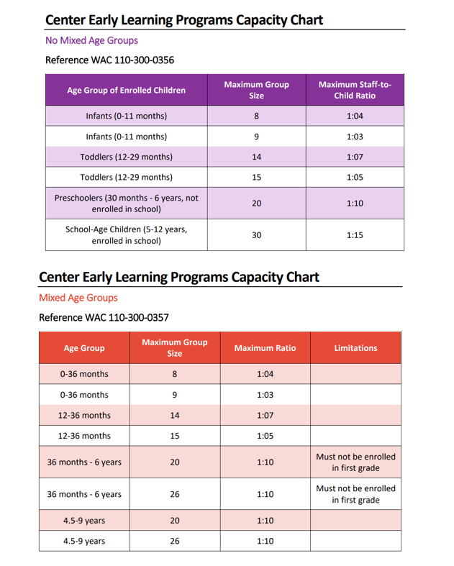
Ratio Compliance and Emergency Procedures Policy
Overview: At Around the Clock Childcare Center of Learning and Development, maintaining proper teacher-to-child ratios is crucial for ensuring the safety and well-being of all children in our care. In the event of an emergency, it is important for teachers to follow specific procedures to ensure the safety of the children.
Ratio Compliance:
- Each teacher is responsible for ensuring that they are within their assigned ratio at all times.
- In the event of an emergency, teachers should utilize any available staff who are not assigned to a classroom to help maintain ratios.
- If no additional staff are available, the teacher should immediately contact the emergency staff on call, the director, or the founder for assistance.
Emergency Procedures:
- In the event that a child escapes from the classroom, the teacher should stay with the group of children and inform center staff that the child is out of the classroom and needs to be escorted back.
- If a child becomes lost on site, designated staff not in charge of a classroom should conduct a thorough search of the facility, including classrooms, nooks, bathrooms, and the perimeter of the building.
- If the child is not located, a call should be made to 911, the licensor of the site, and the child's family.
Communication:
- All teachers should communicate on a walkie-talkie for in-center support as soon as they are aware that they need assistance.
Prohibited Actions:
- Under no circumstances should a teacher leave a classroom with the remaining children unattended to search for the unattended or missing child.

Unlicensed Space:
- Children must be always kept out of all unlicensed spaces. Under no circumstances should children be allowed to enter or remain in areas that are not designated as licensed childcare spaces.
- Parents shall have access to licensed spaces during business hours, however, to participate in our program for volunteering purposes a background check and authorization must be obtained
Standard Operating Procedure (SOP) Job Duties 2.5+
Basic Breakdown of Job Duties:
- Supervise and ensure the safety of children.
- Assist with maintaining children's hygiene.
- Implement curriculum-based activities.
- Monitor children's development and behavior.
- Maintain accurate records of children's progress.
- Minimum of 90 minutes of planned activity per day
Opening Shift Duties:
6:00 AM - Walk the Building:
- Safety Check: Ensure the building is hazard-free, including outdoor areas.
- Trash Management: Verify that all trash bins are emptied, liners replaced, and disposed of properly.
- Sanitation: Refill soap dispensers in bathrooms and ensure cleaning supplies are adequately stocked.
- Classroom Organization: Straighten and organize classroom materials for the day.
- Cleaning: Sweep floors to maintain cleanliness and remove any debris.
- Inspect Restrooms: Ensure toilet paper and paper towels are stocked, soap dispensers are filled, and trash is removed.
- Be in uniform ready to work with a charged walkie talkie.
- Sign off on closers duties and submit to Building Manger

6:30 AM - Parent Interaction:
- Welcoming: Greet parents warmly and facilitate the sign-in process.
- Wellness Checks: Conduct visual assessments of children for any marks or signs of illness.
- Assuming care: Be aware of items from home, food, or any unauthorized things coming in to center with student at drop off
6:00am-8:00 AM - Child Supervision:
- Group Management: Keep children aged 2.5 and in morning groups to ensure safety and engagement.
- Environment Control: Maintain a calm environment, dimming lights until class transitions begin.
- DONOT Exceed 10:1 Ratio during in your morning group
8:00 AM - Morning Routine:
- SEE SOP Food Carts
- Assist with Breakfast: Ensure proper setup for breakfast and facilitate handwashing for all children.
- Check allergy list in classroom to ensure allergy plates are correct every time
- Support and encourage your students to eat by engaging.
- Talk about what they are eating.
- What color of food are they eating what does that do for there body (see vitamin and food color chart)
- Look and listen for choking hazards.
- Encourage them to eat by eating with them (this should be demonstration not sitting in one spot)
- Keep moving between students, be prepared for spills and clean up during breakfast not after breakfast. This ensures a smooth transition and keeps the environment sanitary.
- After breakfast is picked up students should line up for Bathroom break and Teeth brushing
- Teeth Brushing Each student should be assigned their own toothbrush. You will help assist and guide for best practices on teeth brushing to prevent accidents.
- Depending on age a float may be required to assist.
- All Hygiene products kept in appropriate area maintained and used properly.
- Toothpaste and spit should be sprayed and cleaned before transitioning back to class.
- Moving students through the building: When leaving a classroom, you must count your student’s outload and communicate on your walkie talkie how many kids you are moving to and where you are moving them to. Your students should be in a line, and you should practice a quite line to each activity outside of their designated classroom. When you arrive at the desired location you must re-count to ensure all students have made it to their destination. When leaving this area, you must recount your student’s outload and communicate on walkie talkie that you’re moving back to your classroom. In classroom re-count your students to ensure all students are accounted for

9:00 AM - Curriculum Implementation:
- Circle Time: Conduct circle time activities focusing on monthly sight words and curriculum-related songs.
- 3 SONGS REQUIRED: 1. Movement 2. Interactive 3. Seasonal
- Song Requirements: Age appropriate, relevant to curriculum, Songs to be changed once a month.
- Learning Rug: Weather, show and tell, about me, sign language, Numbers, Letters, emotional wellness, Yoga
- Story Time: Read a story to the children related to quarterly curriculum.
- Individual Learning: Rotate small groups for individualized learning sessions based on curriculum needs. At this time, you move students in to stations and keep 2/3 with you where you will work on phonics and relevant curriculum. You will continue this rotation until all children have had a smaller academic session with you.
10:00 AM - Break Time: Your float will be taking students to the bathroom and outside time 30 Min. After playing outside before coming back to class students wash hands and take bathroom break for any students potty training see Diaper Changing SOP
- Authorized Breaks: Take breaks as scheduled. 10 min Paid or 15 min unpaid. Or 30 min lunch.
- Float Support: Coordinate with float staff for bathroom breaks and outdoor supervision.
10:15 AM - Activity Preparation: while students are playing outside.
- Craft Setup: Organize materials for afternoon craft projects related to the quarterly curriculum.
- Learning Stations: Set up interactive learning stations with educational toys and puzzles.
10:30 AM - Mid-Morning Activities: During this time, you will have 2 table stations and each group will spend 30 min at the table and then switch.
- Learning Sheets: Guide students in completing learning activity sheets based on the quarterly curriculum.
- Table works: Interactive learning tying shoes, brushing teeth, learning blocks, sight word puzzles.
- Supervision: Ensure engagement and participation of all students during table work and curriculum work sheets

11:30 AM - Lunch Procedures: - Mealtime Guidance: Encourage healthy eating habits and proper table manners during lunch. Talk about what students are eating. Encourage safe eating habits. Help with holding silverware.
Unauthorized to take breaks during this 30-minute period or anytime food is involved.
Choking- Listen and watch for choking and hazards. Keep the volume of the classroom low. Do not play music during lunchtime. No other task is permitted during any eating time. Stay within 2 feet of the table where students are eating. Walk around the table. Staff are permitted to eat with students, however not in sitting position and to be used as an encouragement method, this is not your break time be available for students needs first.
Clean-Up: Clean around tables and assist students with self-serving, ensuring allergy precautions are followed. Clean student’s hands, faces, and inspect for soiled clothing address where necessary Check allergy list and meal provider before serving to student.
Anything that comes into the classroom on the lunch cart needs to be sent away on the lunch cart to ensure a clean and safe environment.
Handwashing and bathroom break after all lunch is cleaned up.
12:00 PM - Post-Lunch Inspection: - Hygiene Check: Inspect students for cleanliness and readiness for naptime. - Nap Setup: Coordinate with float staff to set up nap cots and ensure a calm environment.
12:30 PM - Naptime Procedures: - Calm Environment: Create a soothing atmosphere for naptime, ensuring proper spacing and comfort. - Blanket Distribution: Collect and distribute blankets, ensuring each child receives their assigned blanket. Shoes must stay on children’s feet during nap.
NON-Napping students- Students who do not nap should have a designated quite area with work sheets, coloring, reading, or quite independent play during this time.
During nap time the following things are authorized and should be executed by lead teacher
1:30 PM - Administrative Tasks: - Communication: Communicate with parents and managers regarding any incidents or updates during naptime. - Curriculum Updates: Review and update curriculum materials as needed. Stars training. Organizing classrooms, cleaning toys, updating poster boards or learning curriculum.
Break: Authorized Breaks: Take breaks as scheduled. 10 min Paid or 15 min unpaid if opt out of lunch. ( you cannot choose daily on your lunch routine should you want to revise your lunch and break schedule you will need to inquire with building manager to ensure children and activities will flow with ease on break request adjustments) Float Support: Coordinate with float.

2:00 PM - Craft Projects and Cleaning: - Craft Work: Engage in craft projects related to the quarterly curriculum during naptime. - Toy Cleaning: Clean and sanitize classroom toys and materials to maintain hygiene standards.
12:30-2:30pm- On Fridays all linens are stripped from labeled beds and cots are sanitized by closer.
2:30 PM - Wake-Up Routine: - Gentle Wake-Up: Gently awaken students, collect blankets, and prepare for transition to afternoon activities. Clean up all entities of your nap session entirely before transition. - Line Up: Line up students for bathroom breaks and handwashing before snack time.
2:45 PM - Shift Handover: - Communication: Coordinate with the closing teacher for a smooth transition, providing updates on the day's activities and any relevant information.
Closing duties
3:00- 3:30- Snack Mealtime Guidance: Encourage healthy eating habits and proper table manners during lunch. Talk about what students are eating. Encourage safe eating habits. Help with holding silverware.
Unauthorized to take breaks during this 30-minute period or anytime food is involved.
Choking- Listen and watch for choking and hazards. Keep the volume of the classroom low. Do not play music during lunchtime. No other task is permitted during any eating time. Stay within 2 feet of the table where students are eating. Walk around the table. Staff are permitted to eat with students, however not in a sitting position and to be used as an encouragement method, this is not your break time be available for students needs first.
Clean-Up: Clean around tables and assist students with self-serving, ensuring allergy precautions are followed. Clean student’s hands, faces, and inspect for soiled clothing address where necessary Check allergy list and meal provider before serving to student.
Anything that comes into the classroom on the lunch cart needs to be sent away on the lunch cart to ensure a clean and safe environment.
3:30-4:00pm Outside time Be sure to offer bathroom breaks and handwashing after snack coming in from outside time you must wash hands and offer bathroom break. SEE Diaper Changing SOP for potty training students.
4:15pm – 5:30 Execute Craft Provided by Lead Teacher this craft should be done in a small group of no more than 5 students while the others are in stations and rotate until all children have completed the afternoon craft. Encourage your students to clean up after their craft. Clean up Art area while children continue to play in stations in small groups. See Facility Organization SOP
5:30pm-6:30PM As your student ratio drops start closing duty tasks. See closer duty SOP

Conclusion: It is important for all staff to be familiar with and adhere to these procedures to ensure the safety and well-being of all children in our care. Training on these procedures will be provided regularly to ensure compliance and readiness in case of an emergency.

This policy is effective immediately and may be updated as needed.

Training at ATC Center is essential to ensure that all staff members are knowledgeable about our policies and procedures, as well as state and federal regulations. Training will be updated regularly to reflect any changes in program policies or regulations. It is important to note that ATC Center reserves the right to add additional training or job requirements based on the organization's needs or changes in the law. Staff members will be notified of any changes in training requirements in a timely manner.

Acknowledgment of Staff Handbook
I acknowledge that I have reviewed and understand the Staff Handbook for Around the Clock Childcare Center of Learning and Development. I agree to adhere to all policies and procedures outlined in the handbook and participate in all required training sessions and drills.
Signature: ____________________________________
Date: _________________________________________

