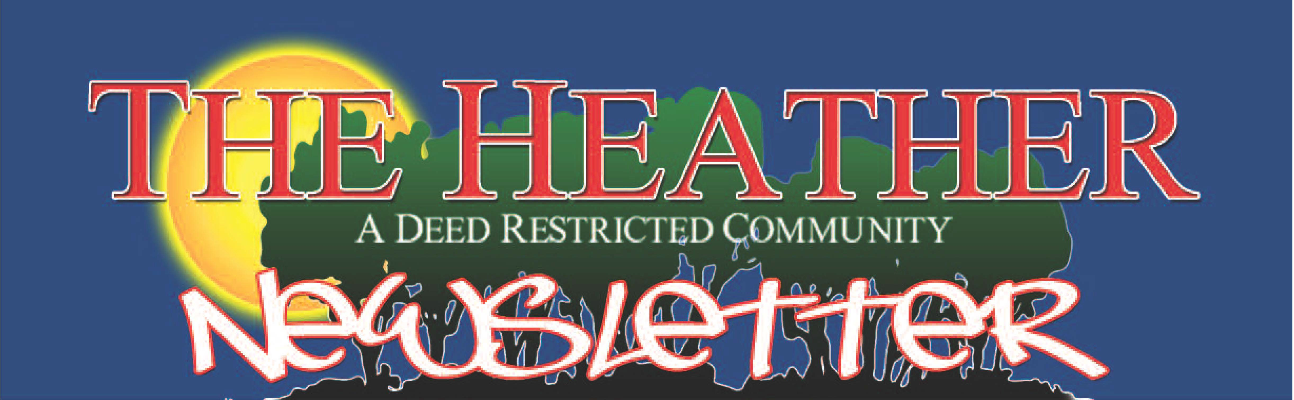

.Jt11., 2020 A GREAT PLACE TO LIVE \'oL. 39 • l\o. 7

President’s Corne
r
Joseph Cuccio

I want to wish everyone a SAFE and HAPPY Fourth of July Celebration. With everything going on today in our Country I think it’s time to come together and to appreciate what we have in this Great Country we live in. I make it a rule not to discuss Politics or Religion in our Newsletter but I think we need to look back and I don’t care what Party you belong to or what religion you choose to follow Rioting, Looting and Vandalism play no part in a peaceful demonstration and certainly doesn’t help what you are trying to express by protesting.
I want to thank the following Board Members as well as one community member for helping to replace the rotted Picnic Tables in our outside recreation area: James Perretto, Richard Rivers and Tony Torregrossa. The four of us worked hard at assembling them rather than paying an outside con- tractor to do the assembly. Just another example of your Board and Community working together. There are 8 new tables which replaced 14 rotted ones and should the need arise we will purchase additional tables as required.
The office and Community Center are now fully open to serve the Community. Bingo has resumed and the card games as well. Hand sanitizer is being provided and the cleaners have been wiping down every table with alcohol when cleaning the center. Restrooms are also being cleaned and disinfected
with extra bleach to safeguard our residents against any infecttious germs or virus.
We are still hopeful the Traffic Light will be installed this month. In checking with the FLDOT it is still scheduled to be installed. I think we should have a celebration when it happens. I con- tinue to observe vehicles not stopping for the STOP sign and speeding into the left lane in spite of oncoming traffic. I guess saving that extra 5 seconds it takes to stop is worth risking your life.
I don’t think I need to remind everyone we are in Hurricane Season and in 8 days 3 named storms. I guess they might be right in forecasting a very active season this year. Don’t wait for the forecast to announce the storm is here to get ready. Prepare in advance and you won’t be the one running around to get needed supplies. I would probably think that 50% of generator owners have not started them since last year. Losing your power is not the time to check the generator.

In closing I want to Thank ALL who support the Board and attend a meeting to show their support. We do need some vol- unteers for the A&D Committee as well as some of the other Committees to keep our Community looking good and func- tioning without interruption.

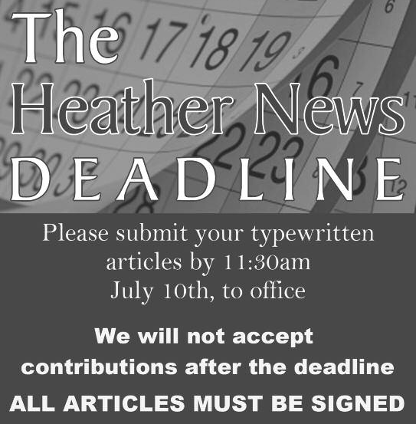

Barbara Dohm
HPOA Office-9100 Nakoma Way
Ruth Grim, Office Administrator 596-5028
Gate House (NOT FOR EMERGENCY) 596-4011
Hernando County Sheriff Office 754-6830
Police (EMERGENCY ONLY) 9-1-1
Joseph Cuccio President
Thomas Taylor 1st Vice President
Treasurer Barbara J. Dohm 2nd Vice President
James Perretto 3rd Vice President
Richard Rivers Corporate Secretary/Director
Barbara J. Dohm Heather News Editor
Staff & Phone Numbers
I am taking the time to answer a letter written to me by a res- ident, Donna K.
As a matter of information, the newsletter mailed to us every month does not cost the association one cent! The advertis- ers pay for the production, printing, and mailing. A lot of resi- dents don't use or like computers, so the newsletter is a great form of communication that most residents enjoy. and is for all residents. We are actually very blessed to have this!
In answer to your comments about the “ridiculous and frivo- lous" articles I write in my column, From The Editor's Desk, if the residents who now live in the homes, The Greens, The Bluffs, The Fairways, Heather Sound and Heather Walk would participate and write articles that are of interest to the community, the newsletter would contain a lot of great articles and I wouldn't have to be the only contributor writing this “ridiculous and frivolous" column..
Instead of complaining which is not helping, why not be proac- tive and get involved! How about articles about cooking, nature, dogs and cats, COVID - 19, community services and many more subjects?,
Please everyone, consider writing an article! You will find it is very rewarding and fun.

MILITAWRYANITTEMTSO&BFUIRYEARMS

Private Collector & Heather Resident since 1980 Call Don 352-596-3311

Bridge
Invitation to all Bridge players. We play a social game (no duplicate) Join us on Thursdays at 1:00pm at the Community Clubhouse.

OR
D ER
Page 6 • The Heather • July 2020
F
A V
TISING INFORMATION CALL 727-846-0367

SUNDAY | MONDAY | JULY 2020  TUESDAY WEDNESDAY THURSDAY |  |  | FRIDAY | SATURDAY
 |  |  | 1  2:00PM BiNGO | 2  1:00PM Bridge 6:30PM Cards,  Pinochle, etc. | 3 | 4  iNDEPENDENCE DAY
5 | 6  1:00PM Bunco | 7  1:30PM Library  3:30PM A & D Mtg. | 8  2:00PM BiNGO | 9  1:00PM Bridge 6:30PM Cards,  Pinochle, etc. | 10 | 11
12 | 13  Heather Sound Board Meeting  1:00PM Bunco | 14  1:30PM Library | 15  TAX DAY 2:00PM BiNGO | 16  1:00PM Bridge 6:30PM Cards,  Pinochle, etc. | 17 | 18
19 | 20  1:00PM Bunco  7:00PM HPOA  Board Mtg. | 21  1:30PM Library  3:30PM A & D Mtg. | 22  2:00PM BiNGO | 23  1:00PM Bridge 6:30PM Cards,  Pinochle, etc. | 24 | 25
26 | 27  1:00PM Bunco | 28  1:30PM Library | 29  2:00PM BiNGO | 30  1:00PM Bridge 6:30PM Cards,  Pinochle, etc. | 31

FAIRWAY AT THE HEATHER

Here it is July. I hope that you all are faring well and searching for every positive thing you need to do to survive all that is going on in the world, our country, our neighborhood, and our homes.
I did receive one call wanting to meet at a safe distance to talk and share what is going on and hopefully help each other by participating in a positive gathering to hopefully keep moving forward in peace. We decided to hold off for a week in case more calls come in. I will let you know the results in next month’s Newsletter.
It appears that there are certainly enough events hap- pening to teach us some lessons about reaching out and doing our individual part in showing love and kind- ness to way more people than we possibly have ever thought about. Wonder how we are doing with this as individuals!
I have a book I read from each day and thought this day’s reading fit in nicely with our lives today.
We must be ready to allow ourselves to be interrupted.
Who is ready? We have our plans, things we’re looking forward to — life going on at its sometimes unpleasant but nonetheless predictable pace.
Then something happens — like an accident, or a death, or an illness — that changes everything, forces us to reappraise our priorities and, often, reset our lives.
People who have come close to disaster and been able to wheel free have shown a renewed appreciation for the simple pleasures of life, for the gift of each day, and a resolve not to put off pleasures or acts of kindness until “another day,” because “another day” may not come.
We who have lost loved ones have also learned the value of simple gifts, of not putting off kind words or actions, because we never know when events will change our world, the expected developments of our lives, and the intended recipients of our kind words and actions my be gone.
The preciousness of this day is its own gift. Saundra Piercy
President of the Fairway Condominium Association
(352)346-7267

2020 Events

November 7th
Saturday Garage Sale

November 1 th
Veterans Day (Possible)

November 14th
Name That Tune

December 5th
Christmas Party

Garbage Cans Out of Sight!
Respectfully I ask, how can anyone leave their garbage cans, after pick up, in front of their house? (This goes on at street, driveway, and front door entrance).Is this pleasing to you for your next door neighbor or your neighbor across the street to look at? Let's not lower personal nor community standards. Kindly place your empty cans after pick up out of sight. Thank you for your attention to this request.

July 2020 • The Heather • Page 9
Computers wanted dead or alive!
UUCIP is collecting computers to teach homeless people how to use them. Help the homeless find and keep employ- ment. Any make or model computer with a windows plat- form is appreciated. We will update obsolete models and repair broken computers.

Call 352-600-9555 for information or to schedule your donation.

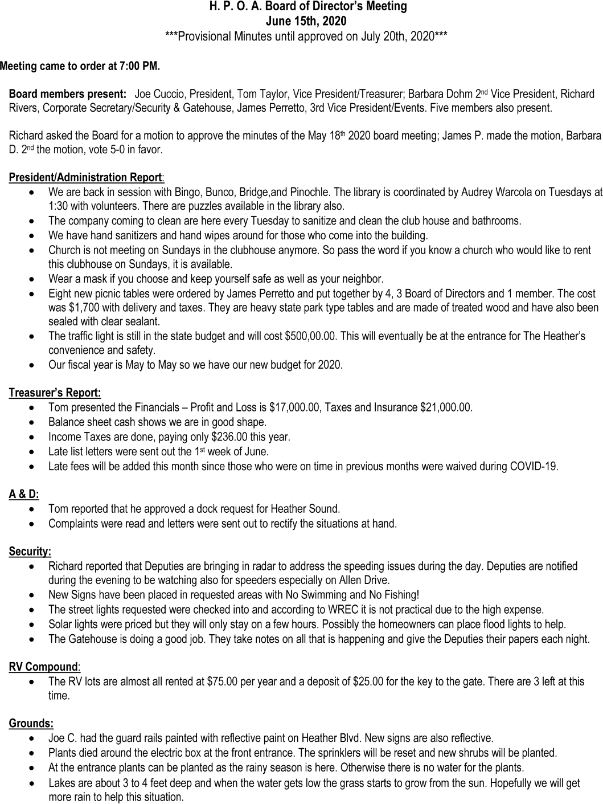

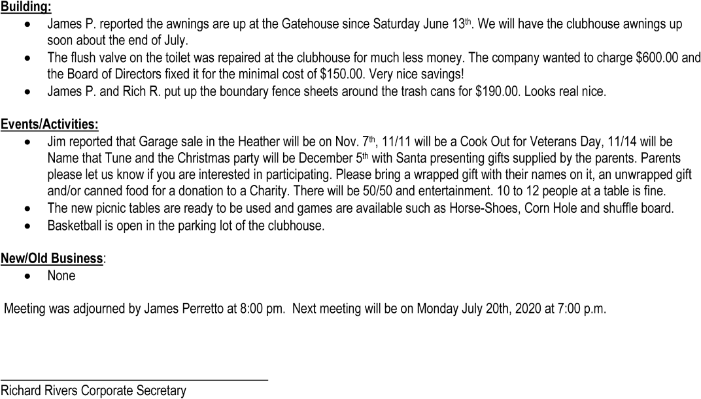

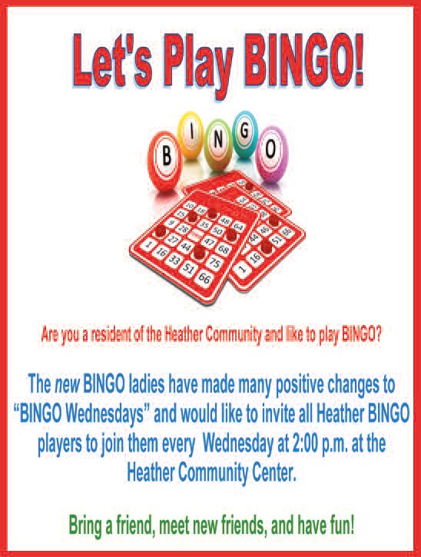

COLOR ME FOR FUN!
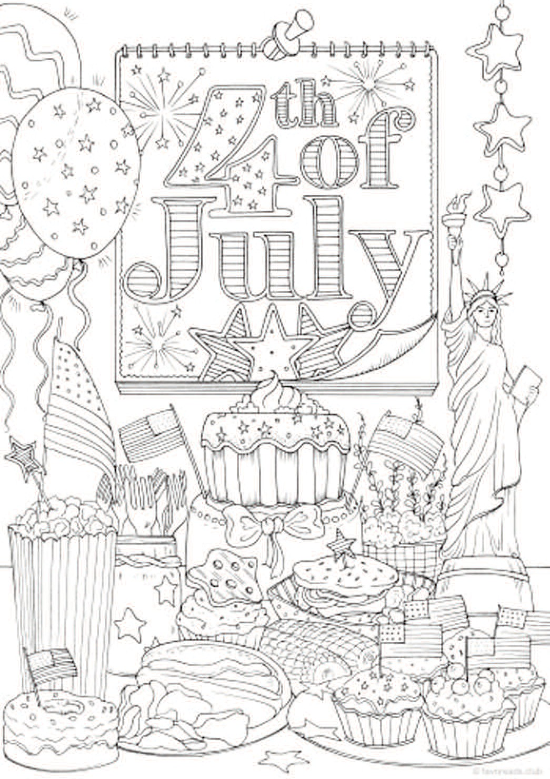

Fun Facts about the 4th of July/independence Day

- Congress made Independence Day an official unpaid holiday for federal employees in 1870. In 1938, Congress changed Independence Day to a paid federal holiday.

- Only John Hancock actually signed the Declaration of Independence on July 4, 1776. All the others signed later.

- The Declaration of Independence was signed by 56 men from 13 colonies.

- The average age of the Signers of the Declaration of Independence was 45. The youngest was Thomas Lynch, Jr (27) of South Carolina. The oldest delegate was Benjamin Franklin (70) of Pennsylvania. The lead author of The Declaration, Thomas Jefferson, was 33.

- One out of eight signers of the Declaration of Independence were educated at Harvard (7 total).

- The only two signers of the Declaration of Independence who later served as President of the United States were John Adams and Thomas Jefferson.

- The stars on the original American flag were in a circle so all the Colonies would appear equal.

- The first Independence Day celebration took place in Philadelphia on July 8, 1776. This was also the day that the Declaration of Independence was first read in public after people were summoned by the ringing of the Liberty Bell.

- The White House held its first 4th July party in 1801.

- President John Adams, Thomas Jefferson and James Monroe all died on the Fourth. Adams and Jefferson (both signed the Declaration) died on the same day within hours of each other in 1826.

- Benjamin Franklin proposed the turkey as the national bird but was overruled by John Adams and Thomas Jefferson, who recommended the bald eagle.

- In 1776, there were 2.5 million people living in the new nation. Today the population of the U.S.A. is 316 million.

- Fifty-nine places in the U.S. contain the word “liberty” in the name. Pennsylvania, with 11, has more of these places than any other state. Of the 59 places nationwide containing “liberty” in the name, four are counties: Liberty County, Ga. (65,471), Liberty County, Fla. (8,276), Liberty County, Mont. (2,392) and Liberty County, Texas (76,571).

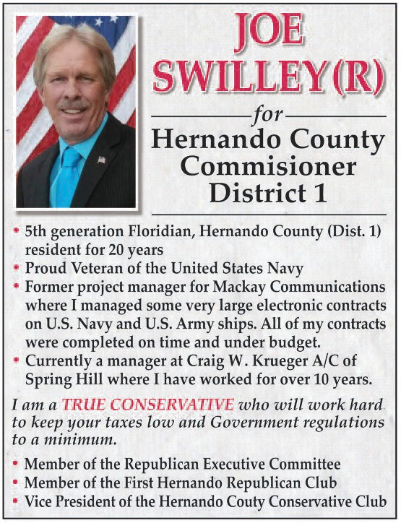

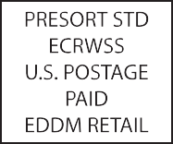

FOR ADVERTISING INFORMATION CALL 727-846-0367

