Close
Your shop has video reviews!
We're testing video reviews where buyers can show off your item in action. Since we're still fine-tuning this feature, video reviews will only be visible to you for the time being. Learn more about video reviews.
Average item review

5 out of 5 stars

(119)
Sort by: Most recent
- 
Deb on Feb 7, 2026
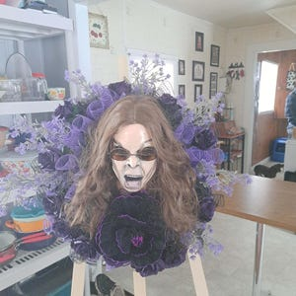
5 out of 5 stars
I love how both of my mannequin heads came out especially this one.. hes my favorite.
Contact buyer
Post a public response


Custom for Deb, Rock Legend Mannequin Head, Mannequin Head Art, Mannequin Art

Report this review
- 
Sharie on Dec 24, 2025
5 out of 5 stars
Oh my gosh, this is an amazing piece of art. So well done. Great communication with the seller. Extremely well packed so it arrived safely. Thank you very much for this very special piece of art. I love it. Please check out other one of a kind piece of art from HausofHolidayLLC. You will be amazed!
Contact buyer
Remove response

Alicia responded on Jan 15, 2026
I am so grateful and honored you trust me to purchase my art. Thank you with all of my heart for such a beautiful review. You are such a sweetheart and it was a total pleasure. All of my love and friendship always.

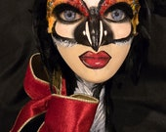
Holiday Penguin Head, Penguin Head, Penguin, Penguin Mannequin, Mannequin, Mannequin Head, Head Art

Report this review
Raven on Dec 5, 2025
5 out of 5 stars
I am so pleased with the quality of her work. She was very kind and thoughtful and sent my item right out. My angel is absolutely beautiful and I would buy from her again definitely
Contact buyer
Remove response
Alicia responded on Dec 6, 2025
Wowwwww. My heartvis singing with joy and gratitude. Thank you Raven for taking the time and leaving such a beautiful review. You are so kind and I loved all of the exchanges we had along the way. You have a talent for design. I hope you continue to do what you love and makes your heart sing. All of my love and friendship always. Let's stay in touch my friend!

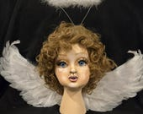
Cherub, Cupid, Cherub Head, Cherub Mannequin, Mannequin, Head, Head Art, Mannequin Art

Report this review
Cheryl on Nov 13, 2025
5 out of 5 stars
She is beautiful will look great on my mermaid Christmas tree
Contact buyer
Remove response
Alicia responded on Nov 13, 2025
OMGEEEEE! Be still my heart. I love that. I would love to see your gorgeous tree when it is done. The idea of this is inspiring. Thank you so much for believing in my art and leaving such a beautiful review. I am truly grateful. Have a blessed Holiday Season my beautiful friend. All of my love and friendship always.


Mermaid Mannequin, Mannequin head

Report this review
Sign in with Apple user on Oct 29, 2025
5 out of 5 stars
Another pieces of Art from this super talented lady! Phenomenal!💕
Contact buyer
Remove response
Alicia responded on Nov 13, 2025
It is ALWAYS an incredible honor to create for you. You are such an amazing talent with a truly fun and artistic vision. It's so inspiring. I love when I hear from you because I know your requests are going to be something to look forward to. I love you to pieces my gorgeous friend. Happiest of Holidays to you and yours.

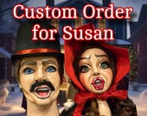
Custom Order for Susan, Christmas Carolers, The Carolers, Caroler Mannequins, Caroler Heads, Head Art, Mannequin Art

- 
Shantrelle on Oct 13, 2025
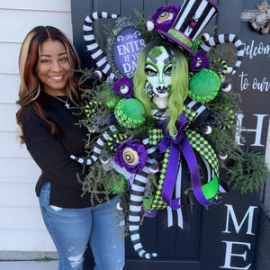
5 out of 5 stars
SheetleJuice was so amazing I ordered her twice. 10 out 10 highly recommend.
Contact buyer
Alicia responded on Oct 23, 2025
Pinch me please! What dreams are made of. Thank you for your continued support and belief in my art. I am beyond honored and thankful you took a chance on me. Your designs are fire girl. So lucky to have designed for someone I respect so much. All of my love and friendship always

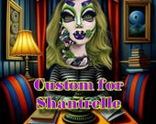
Sheetlejuice, Mannequin head, Mannequin art, Head Art, Halloween head, Halloween Mannequin

- 
Kim on Oct 2, 2025
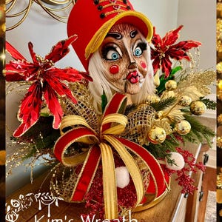
5 out of 5 stars
I can’t say enough how much I love this hand painted mannequin head. The artistry and details are simply amazing!!
Contact buyer
Alicia responded on Oct 23, 2025
I am completely floored and without words that you took a chance on me. Thank you with all of my heart for such a beautiful review and sharing yoir gorgeous design and incredible talents. The piece you designed is absolutely magical!


The Nutcracker, Nutcracker Mannequin, Nutcracker Head, Nutcracker, Mannequin Art

betty on Sep 28, 2025
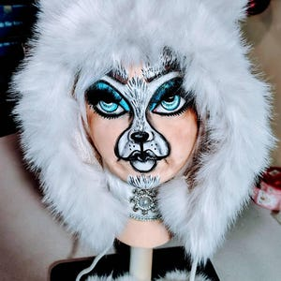
5 out of 5 stars
Excellent beyond words. She is amazing. She inspires me.
Contact buyer
Alicia responded on Oct 23, 2025
Betty, I am always so honored when you purchase a piece. Your designs are out of this world. Super fan!!!!!

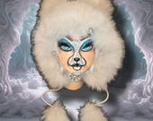
Winter Polar, Polar Bear Head, Polar Bear Mannequin, Mannequin Art, Head Art

- 
W on Sep 24, 2025
5 out of 5 stars
It was amazing thank you for a great piece
Contact buyer
Alicia responded on Oct 23, 2025
Thank you so much my beautiful friend for such a sweet review. I absolutely love your design. She is incredibly STUNNING. Thank you so much much for sharing. All of my love


Custom order for Wendy. Jacky the Pumpkin, Jackolantern Mannequin, Jackolantern Head Art

- 
Pamela on Sep 18, 2025
5 out of 5 stars
I highly recommend customer service is amazing. I am so happy with my purchase can wait to create a wreath with her . I’ll definitely update with pictures. Definitely be ordering again soon. Thank you once again for awesome experience
Contact buyer
Alicia responded on Sep 26, 2025
Thank you with all of my heart. Your wreath is absolutely magical. You are such a talented creator. I am honored you chose my art to he a part of your gorgeous design work. All of my love and friendship

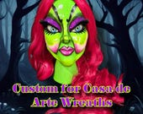
Custom for Casa De Arte Wreaths, The Witch Mannequin, The Witch Head, Mannequin, Head Art, Mannequin Art

Average item review

5 out of 5 stars

(119)
Sort by: Most recent
LaShelle on Sep 6, 2025
5 out of 5 stars
I love it! It’s looks even better in person! Thku!
Contact buyer
Alicia responded on Sep 6, 2025
Thank you my beautiful friend for such a sweet review. It was an honor and a true pleasure to design for you. I am beyond excited to see your magical design. I lokm foward to us staying connected. All of my love and friendship always


Custom for LaShelle, Witch Head, Witch Mannequin, Mannequin Head, Mannequin Art, The Witch 2025

- 
surichards on Sep 6, 2025
5 out of 5 stars
She’s the absolute best at her designs. Everyone has the true authentic signature of a masterpiece.
Contact buyer
Alicia responded on Sep 6, 2025
Wowwwww. This really touched my heart. I truly appreciate your kind words and support. This was a head that received a lot of views. Thank you for trusting me with your vision. I cannot wait to to see your incredible design my beautiful friend. All of my love and friendship.... Ps.. I would love to see your black swan costume. Send me pics... Lol

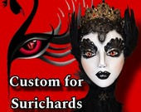
Custom for Surichards, Black Swan, Black Swan Head, Black Swan Mannequin

Sign in with Apple user on Sep 5, 2025
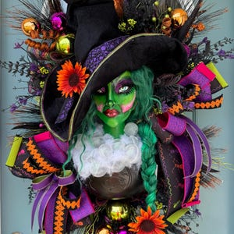
5 out of 5 stars
Amazing artist! Alecia is the best!
Contact buyer
Alicia responded on Sep 6, 2025
Susan you are an incredible artist and designer. It was my pleasure and honor. Thank you so much for your beautiful comments and continued support. You are an angel. All of my love and friendship always

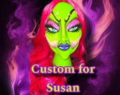
Custom for Susan, Witch Head, Witch Mannequin, Mannequin Head, Mannequin Art, The Witch 2025

- 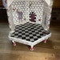
Katherine on Sep 4, 2025
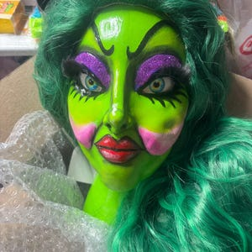
5 out of 5 stars
When I opened her up ( very well wrapped) my mouth dropped, my heart pounded with excitement. She is everything I hoped for !!!
Contact buyer
Alicia responded on Sep 6, 2025
I am so grateful for you and your support my beautiful friend. Thank you so much for your beautiful comments. I truly it and cannot wait to see your beautiful design work. All of my love and friendship


Custom for Kathy, Witch Head, Witch Mannequin, Mannequin Head, Mannequin Art, The Witch 2025

betty on Aug 9, 2025
5 out of 5 stars
As always she always delivers beautiful work. she is my inspiration for me to add ✨🪄 magic to my creativity.
Contact buyer
Alicia responded on Aug 12, 2025
Betty...you are an inspiration for me as well. When I get to create for you, it is always an honor. You are so gifted with your design work and visions. It's truly a privilege. I appreciate your support more than I can express in words. Love you my beautiful friend. THANK YOU


Batty Boop, Bat Mannequin, Bat Head, Mannequin Art, Head Art,

- 
Karen on Aug 8, 2025
5 out of 5 stars
Love, love, love! Love everything about this shop!! HIGH quality and handmade to perfection! Thank you!
Contact buyer
Alicia responded on Aug 12, 2025
Wowwwww. What an honor. Thank you for such a beautiful review. It was a privilege to create for you. I cannot wait to see your magical design my beautiful friend. All of my love and friendship Karen.

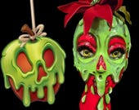
Forbidden Fruit, Mannequin Head, Mannequin Art, Head Art, Forbidden Fruit Head, Fruit Mannequin

betty on Aug 3, 2025
5 out of 5 stars
As always, beautiful master piece.
Contact buyer
Alicia responded on Aug 3, 2025
Thank you as always for your continued support and friendship. Its my pleasure and honor to crrate anything for you. ALWAYS YOUR FAN MY BEAUTIFUL FRIEND


Pumpkin Spice Head, Pumpkin Spice Mannequin, Halloween Head, Mannequin, Head Art, Pumpkin Head

- 
Lori on Aug 2, 2025
5 out of 5 stars
I am so happy with my purchase! Exactly as described and pictured. This girl is phenomenal with her art. Thank you and I will return. ❤️❤️💚💚
Contact buyer
Alicia responded on Aug 3, 2025
Wowwwww Lori. I was so honored to create for you. Thank you for your support and such a beautiful review. My heart is overjoyed. I cannot wait to see what you create. You are so talented. My love and friendship to you always.

Forbidden Fruit, Mannequin Head, Mannequin Art, Head Art, Forbidden Fruit Head, Fruit Mannequin

- 
Christina on Aug 2, 2025
5 out of 5 stars
This piece is absolutely amazing. The photos do it no justice at all. It is so gorgeous in person. Thank you for all of your talents.
Contact buyer
Alicia responded on Aug 3, 2025
Christina.... Wow gorgeous lady! I am so grateful for you and your support. It means everything to me. I was incredibly happy and honored to create for you girl. I cannot wait to see your beautiful design. My love and friendship always.

Forbidden Fruit, Mannequin Head, Mannequin Art, Head Art, Forbidden Fruit Head, Fruit Mannequin

Reviewed by Inactive on Aug 1, 2025
5 out of 5 stars
Love, love this mannequin head!!
Contact buyer
Alicia responded on Aug 3, 2025
Penny, you are such a joy. Thank you with all of my heart my beautiful friend for such a wonderful review. It means everything to me. I cannot see how your design turns out. My heart is so full. My love to you always.

Forbidden Fruit, Mannequin Head, Mannequin Art, Head Art, Forbidden Fruit Head, Fruit Mannequin

Previous page
Average item review

5 out of 5 stars

(119)
Sort by: Most recent
Kristie on Jul 30, 2025
5 out of 5 stars
Amazzzzzzzing thank you for sharing your talent.
Contact buyer
Alicia responded on Aug 3, 2025
I am overjoyed and excited to have created for you. Thank you so much for your beautiful comments and support. My heart is singing. I am looking forward to seeing how you design with it. All of my love and friendship always.

Forbidden Fruit, Mannequin Head, Mannequin Art, Head Art, Forbidden Fruit Head, Fruit Mannequin

- 
Lisa on Jul 28, 2025
5 out of 5 stars
Count Dracula is hauntingly spectacular!!! The photo doesn't capture his presence! He came so carefully packaged that not even a hair was out of place. Soon, he will be showcased in a custom spooky wreath that you won't be able to look away.
Contact buyer
Alicia responded on Jul 28, 2025
I am completely honored and so excited you like him. This made my day. Thank you so much for your kind words and support. It means everything to me. I cannot wait to see what your magic brings to this wreath design. ALL of my love and friendship ALWAYS


Dracula Mannequin, Dracula, Dracula Head, Mannequin

Georgia on Jul 7, 2025
5 out of 5 stars
This is an awesome piece she is really talented. Will purchase from her again
Contact buyer
Alicia responded on Jul 14, 2025
Thank you with all of my heart sweet friend. I am so grateful and honored you trust in me and my art. It was an absolute pleasure. I cannot wait to see your beautiful design. All of my love, friendship and gratitude.

Forbidden Fruit, Mannequin Head, Mannequin Art, Head Art, Forbidden Fruit Head, Fruit Mannequin

Sign in with Apple user on Jun 27, 2025
5 out of 5 stars
Love the fabulous products from Alicia, Super talented! Second purchase and won’t be the last! Can’t wait to design with this😊😁
Contact buyer
Alicia responded on Jun 29, 2025
OMGEEEEE! THANK YOU FOR THE BEAUTIFUL REVIEW! I am over the moon for your continued support and friendship. It means the world to me. You are tge absolute sweetest. This made my day. All of my love beautiful friend.


The Witch 2025, Witch Head, Witch Mannequin, Witch Head Art, Head Art, Mannequin Art

Lisa on Jun 27, 2025
5 out of 5 stars
Unbelievably beautiful & creative! Great detail, vibrant colors & great quality. Shipping was quick & customer service is superior.
Contact buyer
Alicia responded on Jun 29, 2025
I am absolutely honored and grateful for your support and trust in me. You are a treasure. Thank you so much for your kind words. It means everything to me. You are the best my beautiful friend.

Forbidden Fruit, Mannequin Head, Mannequin Art, Head Art, Forbidden Fruit Head, Fruit Mannequin

Betty on Jun 14, 2025
5 out of 5 stars
No words 😳😱 wow. stunning 😍😍. love this girl. her designs are magical.
Contact buyer
Alicia responded on Jun 15, 2025
I am so excited to see what my beautiful friend will design next. Its always so much fun to watch you dream up your magical designs. Thank you always for you continued support and friendship. You are a blessing


Flower Girl, Flower Mannequin, Flower Head, Mannequin

Betty on Jun 14, 2025
5 out of 5 stars
as always master pieces 👏👏👏. packing, quality the designer I have no words to describe her work. I am so glad I found her ❤️.
Contact buyer
Alicia responded on Jun 15, 2025
😍😍😍😍 It is always an honor to be appreciated by another outstanding artist that I admire and respect. I am so grateful for you. Thank you so much for your kind words and belief in my art gorgeous lady.

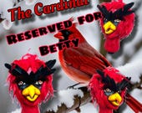
Cardinal Mannequin head, Cardinal head, Cardinal Mannequin, Cardinal Christmas head, Cardinal Christmas

betty on May 23, 2025
5 out of 5 stars
Excellent i will highly recommend
Contact buyer

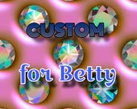
Custom Order for Betty

- 
Marilyn on May 7, 2025
5 out of 5 stars
Wow! This swan wreath attachment is absolutely stunning! The quality and attention to detail that went into this creation is simply outstanding❤️ Thank you so much❤️
Contact buyer

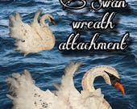
Swan Wreath Attachment, Swan Wall Decor, Swan Display, Swan Centerpiece, Swan Wall Hanger

Betty on May 2, 2025
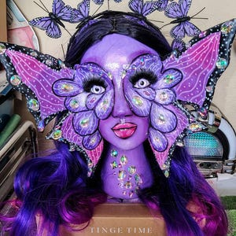
5 out of 5 stars
stunnin beautiful on point every time I get her master pieces my creativity to finish what she startled goes to infinity and beyond thank you Alicia
Contact buyer
Alicia responded on May 8, 2025
Thank you with all of my heart my dear friend. You truly inspire my creativity. Nothing motivates me more to design something outside of the box than a fellow creator that elevates their designs with the same mindset. The possibilities seem endless when you know their are others out there like you! Love u sweet lady. Words cannot express enough my gratitude.

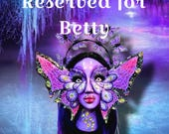
Butterfly Head, Butterfly Mannequin, Flutterby Butterfly, Butterfly Girl

Average item review

5 out of 5 stars

(119)
Sort by: Most recent
Kristie on Jul 30, 2025
5 out of 5 stars
Amazzzzzzzing thank you for sharing your talent.
Contact buyer
Alicia responded on Aug 3, 2025
I am overjoyed and excited to have created for you. Thank you so much for your beautiful comments and support. My heart is singing. I am looking forward to seeing how you design with it. All of my love and friendship always.

Forbidden Fruit, Mannequin Head, Mannequin Art, Head Art, Forbidden Fruit Head, Fruit Mannequin

Lisa on Jul 28, 2025
5 out of 5 stars
Count Dracula is hauntingly spectacular!!! The photo doesn't capture his presence! He came so carefully packaged that not even a hair was out of place. Soon, he will be showcased in a custom spooky wreath that you won't be able to look away.
Contact buyer
Alicia responded on Jul 28, 2025
I am completely honored and so excited you like him. This made my day. Thank you so much for your kind words and support. It means everything to me. I cannot wait to see what your magic brings to this wreath design. ALL of my love and friendship ALWAYS

Dracula Mannequin, Dracula, Dracula Head, Mannequin

Georgia on Jul 7, 2025
5 out of 5 stars
This is an awesome piece she is really talented. Will purchase from her again
Contact buyer
Alicia responded on Jul 14, 2025
Thank you with all of my heart sweet friend. I am so grateful and honored you trust in me and my art. It was an absolute pleasure. I cannot wait to see your beautiful design. All of my love, friendship and gratitude.

Forbidden Fruit, Mannequin Head, Mannequin Art, Head Art, Forbidden Fruit Head, Fruit Mannequin

Sign in with Apple user on Jun 27, 2025
5 out of 5 stars
Love the fabulous products from Alicia, Super talented! Second purchase and won’t be the last! Can’t wait to design with this😊😁
Contact buyer
Alicia responded on Jun 29, 2025
OMGEEEEE! THANK YOU FOR THE BEAUTIFUL REVIEW! I am over the moon for your continued support and friendship. It means the world to me. You are tge absolute sweetest. This made my day. All of my love beautiful friend.

The Witch 2025, Witch Head, Witch Mannequin, Witch Head Art, Head Art, Mannequin Art

Lisa on Jun 27, 2025
5 out of 5 stars
Unbelievably beautiful & creative! Great detail, vibrant colors & great quality. Shipping was quick & customer service is superior.
Contact buyer
Alicia responded on Jun 29, 2025
I am absolutely honored and grateful for your support and trust in me. You are a treasure. Thank you so much for your kind words. It means everything to me. You are the best my beautiful friend.

Forbidden Fruit, Mannequin Head, Mannequin Art, Head Art, Forbidden Fruit Head, Fruit Mannequin

Betty on Jun 14, 2025
5 out of 5 stars
No words 😳😱 wow. stunning 😍😍. love this girl. her designs are magical.
Contact buyer
Alicia responded on Jun 15, 2025
I am so excited to see what my beautiful friend will design next. Its always so much fun to watch you dream up your magical designs. Thank you always for you continued support and friendship. You are a blessing

Flower Girl, Flower Mannequin, Flower Head, Mannequin

Betty on Jun 14, 2025
5 out of 5 stars
as always master pieces 👏👏👏. packing, quality the designer I have no words to describe her work. I am so glad I found her ❤️.
Contact buyer
Alicia responded on Jun 15, 2025
😍😍😍😍 It is always an honor to be appreciated by another outstanding artist that I admire and respect. I am so grateful for you. Thank you so much for your kind words and belief in my art gorgeous lady.

Cardinal Mannequin head, Cardinal head, Cardinal Mannequin, Cardinal Christmas head, Cardinal Christmas

betty on May 23, 2025
5 out of 5 stars
Excellent i will highly recommend
Contact buyer

Custom Order for Betty

Marilyn on May 7, 2025
5 out of 5 stars
Wow! This swan wreath attachment is absolutely stunning! The quality and attention to detail that went into this creation is simply outstanding❤️ Thank you so much❤️
Contact buyer

Swan Wreath Attachment, Swan Wall Decor, Swan Display, Swan Centerpiece, Swan Wall Hanger

Betty on May 2, 2025
5 out of 5 stars
stunnin beautiful on point every time I get her master pieces my creativity to finish what she startled goes to infinity and beyond thank you Alicia
Contact buyer
Alicia responded on May 8, 2025
Thank you with all of my heart my dear friend. You truly inspire my creativity. Nothing motivates me more to design something outside of the box than a fellow creator that elevates their designs with the same mindset. The possibilities seem endless when you know their are others out there like you! Love u sweet lady. Words cannot express enough my gratitude.

Butterfly Head, Butterfly Mannequin, Flutterby Butterfly, Butterfly Girl

Average item review

5 out of 5 stars

(119)
Sort by: Suggested
Betty on Apr 17, 2025
5 out of 5 stars
I am so happy with my mannequin heads her talent and creativity the detail on each piece is absolutely amazing thank you 👍😊 so much.
Contact buyer
Alicia responded on Apr 18, 2025
Wowwwwwwww. I am YOUR fan my gorgeous friend! So to do anything for you is an absolute honor. You truly inspire me with each and every incredible design you create. THANK YOU!......for believing in me and giving me a chance to earn your trust. Each and every time I do anything for you makes my heart sing opera!


Custom for Betty, Colombian Mannequin head, Puerto Rico Mannequin head, Mannequin, Head art, Mannequin head

fabi on Apr 12, 2025
5 out of 5 stars
It’s just beautiful. Even better in person. Another great buying experience from this great and talented artist. Thank you so much 😊
Contact buyer
Alicia responded on Apr 12, 2025
I am completely blown away. Thank you so much for the beautiful review. It's friends like you that inspire me and challenge my abilities with your amazing imaginations and creative ideas. I am so honored for the opportunity to create for you each and every time you trust me. I wish there was a word that could match what I feel in my heart. Love you sweet friend!

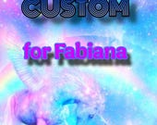
Custom Order for Fabiana, Halloween Unicorn Head, Mannequin Art, Mannequin, Head Art, Unicorn Head Unicorn Mannequin

cindy on Apr 7, 2025
5 out of 5 stars
Swan wreath attachment, perfect for focal point in my wreath. Especially fast shipping and awesome customer service.
Contact buyer
Alicia responded on Apr 7, 2025
Thank you my beautiful friend for your continued support. I am forever grateful and honored. Also thank you so much for taking the time to write a fabulous review. It helps my business so much. I cannot wait to see your design! I know your creation will be a MIC DROP. All of my love and friendship!!!

Swan Wreath Attachment, Swan Wall Decor, Swan Display, Swan Centerpiece, Swan Wall Hanger

Betty on Apr 3, 2025
5 out of 5 stars
It's just stunning, so well done. Everything she makes is amazing 👏 thank you so much.
Contact buyer

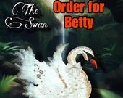
Order for Betty

betty on Mar 30, 2025
5 out of 5 stars
Words can't describe the amazing work Alicia does. She is so talented and I feel honored to put my hands on each piece she creates for me. 💯 will recommend her.
Contact buyer
Alicia responded on Mar 31, 2025
You inspire me everytime you trust me with your designs and your creative vision. Trust me, the pleasure is all mine! You are insanely talented. Thank you for trusting me. It's an honor! Love u my friend.


Custom for Betty, American Indian Princess, American Indian head, American Indian, Mannequin, Head Art

Toni maskunas on Mar 26, 2025
5 out of 5 stars
As I say all the time. She does wonderful work.
Contact buyer
Alicia responded on Mar 26, 2025
Toni, my beautiful friend! It truly speaks volumes and matters more than you know how many times you have returned to support my art! I am truly honored and grateful each time you have ever asked me to fulfill your artistic vision. Thank you ALWAYS for taking the time and publicly sharing your kind words and trusting me. FOREVER GRATEFUL FOR YOU!!!!


Custom for Toni, The Wonder Twins, Mannequin head, Head art

Betty on Mar 11, 2025
5 out of 5 stars
I love it. It's a beautiful piece. Well done, and excellent packaging Thank you
Contact buyer
Alicia responded on Mar 20, 2025
Ohhhhh my gorgeous friend! It is always a complete honor to create for you! With all of my heart and gratitude....A HUGE THANK YOU to you! XOXOXO

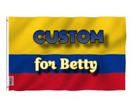
Custom for Betty, Top Hat, Columbia Colors Top Hat, Top Hat Decor, Red, Blue and Yellow Top Hat

Toni maskunas on Mar 7, 2025
5 out of 5 stars
She is so great. She does the best work I have ever scene and makes exactly what you want!
Contact buyer
Alicia responded on Mar 7, 2025
YAYYYYY! YOU GOT IT!!! I am so honored to receive such a beautiful review. It's friends like you who inspire my creativity! You allow my imagination to soar and fulfill my dreams of owning a business. I will forever be grateful and I truly appreciate your trust and belief in me. Thank you with all of my heart for the opportunity. The twins are in the works! Wink wink!......Stayyyyyyy tuned!!!


Custom White Rabbit for Toni, Rabbit Head, Rabbit Mannequin, Mannequin, Head Art

Jennifer on Feb 24, 2025
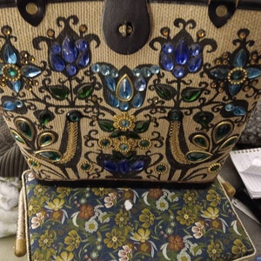
5 out of 5 stars
I love the vintage handbag!! The seller was super quick to ship and packaged very well!!
Contact buyer
Alicia responded on Feb 24, 2025
Awwwww. Thank you so much sweet friend for the kind review. I hope you enjoy your bag. Those are so much fun to collect. All of my best.

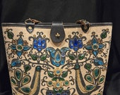
Vintage Enid Collins purse Pavan 2 Pheasant Peacock Blue Jewels

Toni maskunas on Feb 24, 2025
5 out of 5 stars
This is the most beautiful work I have ever seen. Thank you so much!
Contact buyer
Alicia responded on Feb 24, 2025
Ohhhhhhhh wowwwwww! I am so honored and humbled. Thank you with EVERY piece of my heart. I have too much fun creating these heads. I am truly grateful that you appreciate my art. It's truly a dream come true. All of my love and friendship ALWAYS.

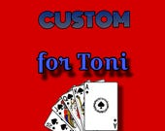
Custom for Toni, Queen of Hearts, Queen of Hearts Mannequin, Queen of Hearts Head, Mannequin, Head Art

Average item review

5 out of 5 stars

(119)
Sort by: Suggested
- 
JoAnn on Feb 21, 2025
5 out of 5 stars
Great customer service made exactly how I requested. This is a beautiful rabbit well crafted. Highly recommend. Haus of Holiday
Contact buyer
Alicia responded on Feb 24, 2025
Thank you with EVERY piece of my heart for such a beautiful review and the opportunity to create for you. It was a complete honor. Thank you for keeping my dream alive. I'm truly grateful. All of my love and friendship!

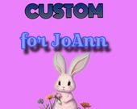
Custom for JoAnn, Elegant White Rabbit, Rabbit Head, Rabbit Mannequin, Mannequin, Head Art

Betty on Feb 14, 2025
5 out of 5 stars
Beautiful master piece. The detail and wonderful finish make this beauty so special. There are no words to describe it. The packing was so carefully done. Just like I was expected. Thank you so much.
Contact buyer
Alicia responded on Feb 14, 2025
WHOOOOHOOOOOO! So happy she made it to you safely. Thank you again for your belief in my art. I am beyond grateful and humbled. You inspire me. I truly appreciate such a beautiful review. Wowwwww! My heart is bursting!! HAPPY VALENTINE'S DAY GORGEOUS!!!

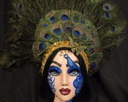
Peacock Woman, Peacock Mannequin, Peacock Head, Peacock, Mannequin, Head Art

- 
The Whimsical Redhead on Feb 6, 2025
5 out of 5 stars
Another great head!! So much talent.
Contact buyer
Alicia responded on Feb 6, 2025
What an honor to create for such a creative and talented designer. Thank you so much for your trust in me with your vision. You truly are a blessing and a dream. My love and friendship to you always. I CANNOT WAIT for you to share your design with the rest of us because I KNOW IT WILL BE EPIC!!!

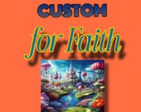
Custom for Faith, White Rabbit, Rabbit Head, Rabbit Mannequin, Mannequin, Head Art

Betty on Feb 5, 2025
5 out of 5 stars
stunning so detailed no words to describe how beautiful these pieces are. thank...you...thank you. ❤️
Contact buyer
Alicia responded on Feb 5, 2025
Wowwwwwwww. Thank you sincerely for such a beautiful review. I am truly honored to create for you. It was a true pleasure. You are a dream. All of my love and friendship ALWAYS!!!!

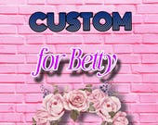
Custom order for Betty, Flora Head, Flower Girl Head, Top hat, Mannequin, Head Art

christine on Dec 10, 2024
5 out of 5 stars
She is so beautiful and the painting is amazing, love her to death, thank you, just ordered the kiss girl, your work is amazing!!
Contact buyer
Alicia responded on Dec 30, 2024
Christine....my heart is so full my gorgeous friend. Thank you so much for such a beautiful review. I truly appreciate your continued friendship and support. I am so grateful for you!

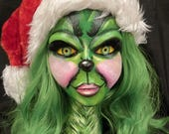
Lady Christmas Green Monster, Lady Green Monster, Christmas Monster, Mannequin, Mannequin Head, Mannequin Art, Head Art

Lynn on Dec 2, 2024
5 out of 5 stars
The Jack Frost mannequin head is a work of art! Absolutely beautiful and well crafted. Alicia communicated often and shipping was quick!
Contact buyer
Alicia responded on Dec 2, 2024
Wowwwww. Be still my heart. Thank you for such a beautiful review. I am so excited you like Mr. Frost. He was definitely one of my faves to do this season. You are an absolute doll. My love, friendship, and gratitude 🙏 always sweet friend!

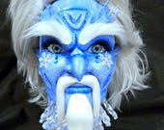
Jack Frost, Jack Frost Head, Jack Frost Mannequin, Mannequin, Head, Head art

Toni maskunas on Nov 27, 2024
5 out of 5 stars
As I have said before she is the best!
Contact buyer
Alicia responded on Dec 2, 2024
Toni I always love doing ANYTHING for you! I truly feel blessed that you appreciate my art. My heart is full of joy and excitement to hear from you! Thank you for taking time out of your day to be so kind to me. My love and friendship ALWAYS to you! Happy Holiday's my beautiful friend!


Custom for Toni

Toni maskunas on Nov 18, 2024
5 out of 5 stars
She is a true artist and her work is always beautiful I have ordered 9 heads from her and would not order from anyone else.
Contact buyer
Alicia responded on Nov 23, 2024
I am blown away by the support you have given me. It's astounding! THANK YOU WITH ALL OF MY HEART! Words cannot express enough my gratitude. I am beyondddddd blessed to have your trust and faith in me and my art. You will ALWAYS have my love and friendship. Thank again for sharing and supporting my dream.

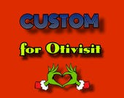
Custom for Otivisit, Christmas Sweetheart head, Mannequin, Head Art, Head

- 
Cynthia on Oct 31, 2024
5 out of 5 stars
Beautiful centerpiece! So much detail and arrived packaged so beautiful. Thank you!
Contact buyer


Clown Centerpiece, Clown Decoration, Mannequin Circus, Mannequin Centerpiece Circus, Party Centerpiece, Halloween decor , Themed Centerpiece

- 
Vicki on Oct 22, 2024
5 out of 5 stars
Absolutely love this seller! Exquisite products!!
Contact buyer
Alicia responded on Oct 22, 2024
Holy Cow Vicki! Thank you soooo much! I'm so excited! I truly appreciate you taking the time and leaving such a beautiful review. I am forever grateful for your support and friendship! You will always have mine!


Custom Order for Vicki, Pirate Dahrrrling Head, Pirate Mannequin, Mannequin, Head, Pirate Head, Pirate Mannequin, Halloween Head
Average item review

5 out of 5 stars

(119)
Sort by: Suggested
- 
Tiffany on Oct 17, 2024
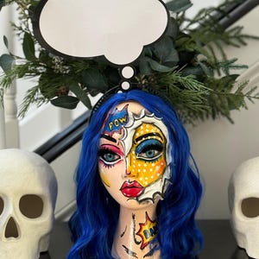
5 out of 5 stars
Simply AMAZING! I’m in love with this! I am blown away by the detail! Can’t wait to design with this beautiful piece!
Contact buyer
Alicia responded on Oct 17, 2024
OMG! You are my kindred spirit. I know your creativity will really bring this to life. I cannot wait to see what you dream up. I am always inspired by your magic sweet friend. Thank you for your loving response and belief in me

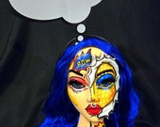
Comic Strip Girl Head, Comic Strip Girl Mannequin, Mannequin, Comic Strip Girl

Tiffany on Oct 17, 2024
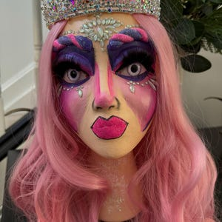
5 out of 5 stars
This piece of art is stunning! Pictures simply do not do it justice! I love it! Thank you Alicia for creating this gorgeous custom piece for me!
Contact buyer
Alicia responded on Oct 17, 2024
If you could only see the smile I am wearing! I am overjoyed for the opportunity to create for such a special person. Thank you for your continued support. It is my great honor! All of my love dear friend

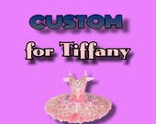
Custom for Tiffany, Sugar Plum Fairy Head, Sugar Plum Fairy, Mannequin, Head, Head Art

- 
Lexie on Oct 16, 2024
5 out of 5 stars
Love this shop. The designs are over the top. Details are well thought out and applied. Shipping is fast!!! Super shop
Contact buyer
Alicia responded on Oct 16, 2024
Gurrrllll. You inspire the heck out of me. I love your creativity and they way you think outside the box. You are a dream and such a beautiful person! Thank you for taking a chance on me. I treasure you 💖

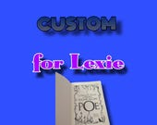
Custom for Lexie, Edgar Allan Poe, Edgar Allen Poe Head, Edgar Allan Poe Mannequin

Betty on Oct 15, 2024
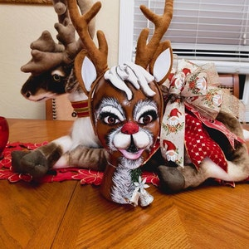
5 out of 5 stars
the most stunning piece. the quality of the packing I have no words. 💕 love it. thank you so much.
Contact buyer
Alicia responded on Oct 15, 2024
Wowwwwww! Thank you Thank you Thank you. I am truly blessed and so thankful. It fills my heart with complete joy that you gave me a chance. It's so kind of you to take the time to leave a beautiful review. Holy Cow!!!! ALL OF MY LOVE and FRIENDSHIP.

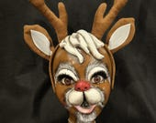
Rudolph Head, Rudolph Mannequin, Rudolph, Head, Mannequin, Head Art, Christmas Head, Christmas Mannequin

Jean on Oct 11, 2024
5 out of 5 stars
The Flapper Girl is amazing. It is even prettier in person. This is my second purchase from this shop and I will purchase again.
Contact buyer
Alicia responded on Oct 14, 2024
Jean my heart is so full! Thank you with all of my heart for such a beautiful review. I truly appreciate it my sweet friend. I cannot wait to see you breathe your magic in her! All of my love and friendship gorgeous!

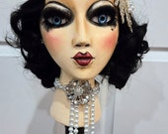
Flapper Girl, Flapper Mannequin, Flapper Head, Gatsby

Tiffany on Oct 8, 2024
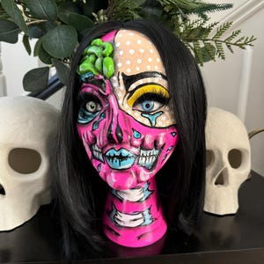
5 out of 5 stars
This is beyond gorgeous! Photos do not do it justice! It’s even more incredible in person. Thanks for another beautiful piece of art, Alicia!
Contact buyer
Alicia responded on Oct 8, 2024
Whattttt???? Wowwwww! Thank you with all of my heart. You are a dream come true. It's always a huge honor and an absolute pleasure to do anything for you. I am beaming with joy! I truly appreciate and value you Tiffany. Thank you for making my day sweet friend 🧡

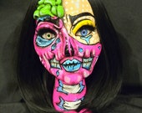
Pop Art Zombie Girl, Pop Art Zombie Head, Pop Art Zombie Girl Mannequin, Mannequin

Tiffany on Oct 8, 2024
5 out of 5 stars
This is absolutely amazing! Truly a work of art! I can’t wait to design with him!
Contact buyer
Alicia responded on Oct 8, 2024
😃😃😃😃😃😍😍😍😍 I am so lucky to know you. What a blessing. Thank you for appreciating my art. It's what dreams are made of. As an artist...there's always risks you take not knowing the outcome. It's such validation and sheer elation when someone gets you. Tiffany I am beyondddddd honored. Thank you Thank you...THANK YOU!

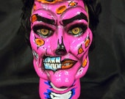
Pop Art Zombie Dude , Pop Art Zombie Head, Pop Art Zombie Dude Mannequin, Mannequin

vickie manthei on Oct 4, 2024
5 out of 5 stars
I’m overwhelmed by the amount of work that has been done on my piece ❤️❤️. Definitely will be ordering again ❤️❤️❤️
Contact buyer


Custom for Vickie. Holiday Heartthrob Head

Toni maskunas on Oct 2, 2024
5 out of 5 stars
This lady is so great and her quality of work always amazes me. She gets the work done as soon as you order it and send it right out.
Contact buyer

Custom for Toni

- 
Pam on Sep 25, 2024
5 out of 5 stars
Excellent quality! Fast shipping. Highly recommended
Contact buyer
Alicia responded on Sep 25, 2024
Wowwwww! I am so honored my emotions are hard to put into words. This is an absolute dream come true to be recognized by such a talented creator. I am truly grateful and blessed beyond measure. Thank you with EVERY piece of my heart Pam! My love and friendship ALWAYS!!

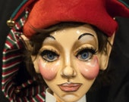
Naughty Elf Head, Elf Head, Elf Mannequin, Mannequin Art, Head Art, Mannequin, Elf
Average item review

5 out of 5 stars

(119)
Sort by: Suggested
fabi on Sep 21, 2024
5 out of 5 stars
Love,love,love. They are awesome. And shipping is super fast
Contact buyer
Alicia responded on Sep 25, 2024
You are the sweetest Fabi! A dream friend and client. I am blessed beyond measure. Thank you with all of my heart gorgeous!😃


Grumpy Orange Halloween Flower, Face Flower, Wonderland Flower, Halloween Flower, Fall Flower

fabi on Sep 21, 2024
5 out of 5 stars
I love my grumpy flowers. They are adorable
Contact buyer


Old Lady Face Flower, Face Flower, Wonderland Flower, Halloween Flower, Fall Flower

fabi on Sep 21, 2024
5 out of 5 stars
Always great . I love her stuff.
Contact buyer


Lady Vampire Face Flower , Face Flower, Wonderland Flower, Halloween Flower, Fall Flower

fabi on Sep 17, 2024
5 out of 5 stars
Always amazing. Can’t wait for Christmas to display this beauty.
Contact buyer


Custom for Fabi, Poinsettia Princess, Poinsettia Head, Poinsettia Mannequin, Mannequin, Head Art, Mannequin Art, Christmas head

The Whimsical Redhead on Aug 25, 2024
5 out of 5 stars
Always love ordering from Haus of Holiday! Such a pleasure every time!
Contact buyer
Alicia responded on Aug 31, 2024
You are such a beautiful person, a treasure, and always so supportive. You truly make my heart sing. Thank you for being a leader of kindness. It's infectious and ALWAYS A PLEASURE to create when I can be inspired by people like you! My love and friendship always!

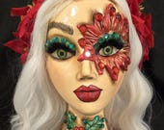
Poinsettia Princess, Poinsettia Head, Poinsettia Mannequin, Mannequin, Head Art, Mannequin Art, Christmas head

Vicki on Aug 23, 2024
5 out of 5 stars
Amazing is all I can say! Unbelievable talent! I can not wait to start my creation! I will definitely reorder rom seller again. I would give 10 stars if I could!
Contact buyer
Alicia responded on Aug 23, 2024
WOWWWWWW! What an honor and a privilege. Thank you so much for taking the time to leave a beautiful review! This absolutely made my day. You are truly a treasure and a beautiful Matey! Arggggghhhhhh! I can't wait to create for you again when you are ready. All of my love and friendship 💕


Custom order for Vicki, Undead Pirate Mannequin, Mannequin, Head, Pirate Head, Pirate Mannequin, Halloween Head

fabi on Aug 19, 2024
5 out of 5 stars
Great as always. And very fast shipping
Contact buyer
Alicia responded on Aug 20, 2024
I LOVEEEEE your vision! Thank you for your kind words and always finding ways to inspire me! You're are a one of a kind special lady! All of my love and friendship always ❤️


Custom for Fabi, Moth Girl, Moth Mannequin, Moth Head, Mannequin

fabi on Aug 12, 2024
5 out of 5 stars
I just love it sooooo much. It’s amazing. The quality, the color everything. Thank you ☺️
Contact buyer

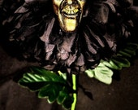
Ghoul Flower, Face Flower, Wonderland Flower, Halloween Flower, Ugly Face Flower

fabi on Aug 9, 2024
5 out of 5 stars
Incredible, spooky, funny and grumpy. Just love it so much
Contact buyer
Alicia responded on Aug 10, 2024
You are the sweetest! Thank you so much my beautiful friend. I appreciate you taking the time to leave a review. More importantly....thank you for believing in my art and allowing me to create for you. It fills my heart with such joy. You have such a unique vision. I cannot wait for future ideas...you are so fun!

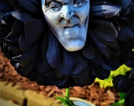
Grouchy Witch Flower , Face Flower, Wonderland Flower, Halloween Flower, Fall Flower

fabi on Aug 9, 2024
5 out of 5 stars
Just love it so much. Deliciously spooky. Love the grumpy little face. I am just obsessed with it. 🥰
Contact buyer
Alicia responded on Aug 10, 2024
YOU ARE THE BEST! LOVE U GURLLLL

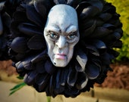
Witch Flower Frown, Face Flower, Wonderland Flower, Halloween Flower, Fall Flower
Average item review

5 out of 5 stars

(119)
Sort by: Suggested
Lexie on Aug 4, 2024
5 out of 5 stars
Quality was outstanding. The detail was amazing. I would definitely techie shop.
Contact buyer
Alicia responded on Aug 4, 2024
OMGEEEEEE! Truly appreciate your beautiful review. My heart is absolutely full! Thank you so much my beautiful friend. It was an absolute pleasure. You are a total sweetheart. All of my love and friendship!!!


Custom Order for Lexie, Undead Pirate Mannequin, Mannequin, Head, Pirate Head, Pirate Mannequin, Halloween Head

Tiffany on Jul 29, 2024
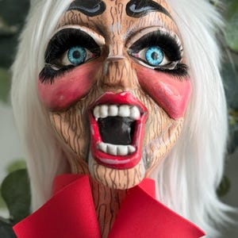
5 out of 5 stars
This piece is gorgeous! Photos do not do it justice! I can’t wait to use this in a wreath! Not only is it a true work of art, but it arrived beautifully packaged and the shipping was incredibly fast! Couldn’t be happier.
Contact buyer

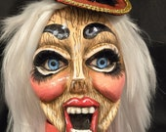
Creepy Puppet Ringmaster Head, Ringmaster Mannequin, Puppet Ringmaster, Ringmaster Mannequin, Mannequin, Head Art, Mannequin art

fabi on Jul 27, 2024
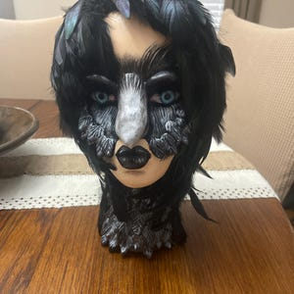
5 out of 5 stars
Amazing piece of art. The details, colors. Just unbelievable. I love my raven girl. Alicia is just amazing and I am in love with her work. A professional from beginning to end and a pleasure to work with. Thank you
Contact buyer

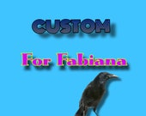
Custom Order for Fabiana, The Raven, The Raven Mannequin, Mannequin, Head, Raven Head

Sign in with Apple user on Jul 19, 2024
5 out of 5 stars
I am beyond excited to design with this fantastic and flipping amazing pirate head! There are not enough words to describe the quality and uniqueness Alicia puts in to her designs! I am so honored and grateful to have purchased this to design with. Thank you my sweet friend!💕
Contact buyer
Alicia responded on Jul 19, 2024
WHATTTTT? THIS ISCONE OFCTHE SWEETEST COMPLIMENTS EVERRRRR! First of all......I cannot thank you enough for giving me the opportunity and trusting and believing in my art enough to design with my creation. I am incredibly honored and excited beyond measure. I am truly grateful for you taking the time and giving me such a beautiful review. This fills my heart and absolutely made my day. ALL OF MY LOVE AND FRIENDSHIP SUSAN. XOXOXO

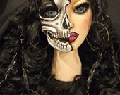
Pirate Dahrrrling Head, Pirate Mannequin, Mannequin, Head, Pirate Head, Pirate Mannequin, Halloween Head

Marilyn on Jun 25, 2024
5 out of 5 stars
I absolutely love my purchase! The handmade masquerade cat is stunning, and coordinates perfectly with my planned arrangement. Thank you so much, Alecia! I highly recommend Haus of Holiday for your unique gift needs❤️
Contact buyer
Alicia responded on Jun 25, 2024
WOWWWWWW... be still my heart. Thank you so much. Can you make my day any better? You are such a teasure and you have a beautiful heart. It has been fun getting to know you better and I hope we always remain friends. Thank you for allowing me to do what I love. All of my love and friendship always my sweet friend.

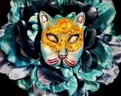
Cat Masquerade Face Flower , Face Flower, Wonderland Flower, Halloween Flower, Fall Flower

sastaple on Jun 23, 2024
5 out of 5 stars
This is a wonderful piece and she did an excellent job.
Contact buyer
Alicia responded on Jun 23, 2024
Ohhhhhh wowwwww. Thank you with all of my heart for the beautiful review. I am completely honored that you believe in my art and have supported my dream. It's hard to express my gratitude with words. My heart is truly fill.

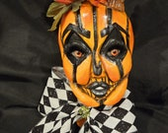
Jackie-O-Lantern Head, Jackie-o-Lantern Mannequin, Mannequin Head, Jack-o-lantern

- 
Debbiann on Jun 22, 2024
5 out of 5 stars
This wreath exceeded my expectations. It is stunning!! The artist’s talent and artwork is outstanding!! I can’t wait to display it! 🎃
Contact buyer
Alicia responded on Jun 22, 2024
I am so incredibly honored and deeply moved and grateful for your belief in my art and trusting me with your business. Thank you so much for such a beautiful review. I cannot thank you enough for keeping my dream alive. I hope you have a beautiful holiday season and look forward to staying in touch with you.


Evil Queen Wreath, Halloween Wreath, Queen Wreath, Halloween Decor, Fruit wreath, Poison Apple Wreath

Toni maskunas on Jun 19, 2024
4 out of 5 stars
As usual this is awesome. I love her items and she is great
Contact buyer

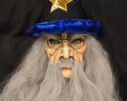
The Wizard, Wizard Head, Wizard Mannequin

Toni maskunas on Jun 16, 2024
5 out of 5 stars
This lady is truly an amazing artist. I have never seen one better. She communicates the entire time she is working on your piece and I will never order from anyone again except her!
Contact buyer
Alicia responded on Jun 16, 2024
OMGEEEEE! What an absolute honor. I am still trying to collect my jaw from off of the floor....lol...WOWWWWWW. Thank you with all of my heart and soul for such a beautiful review. I am so grateful for your friendship and belief in my art. My heart is exploding with excitement and joy. You are what dreams are made of. Pinch me please. What a beautiful person you are. Kindness truly goes a long way. The world needs more amazing humans like you.


Custom for Toni, The 3 Sister Witches, Witch Sister Mannequin Heads

DANIELLE on Jun 13, 2024
5 out of 5 stars
Best seller ever! I absolutely love her work! She is a great artist!!!
Contact buyer
Alicia responded on Jun 13, 2024
Wowwwwww. What an honor. Thank you sooooo much for the beautiful compliment and review. You are a dream client and a treasure of a friend. I truly appreciate your support through the years. I am forever grateful for you. All of my love and friendship always


Corpse Bride Head, Corpse Bride, Mannequin, Corpse Mannequin, Corpse Head

Average item review

5 out of 5 stars

(119)
Sort by: Suggested
DANIELLE on Jun 13, 2024
5 out of 5 stars
Her work is absolutely amazing and top quality! She has the best customer service and is so friendly! I love all of my purchases from her!
Contact buyer

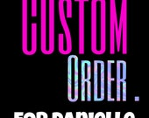
Corpse Groom, Corpse Groom Head, Mannequin, Mannequin Head, Corpse Groom Mannequin

Kitty on Jun 5, 2024
5 out of 5 stars
She is the most wonderful lady to work with so kind listens to your descriptions. Gets the job done on accurate time shipping excellent. I would use her again and again high-quality everything you want you get thank you so much.
Contact buyer
Alicia responded on Jun 5, 2024
Wowwwwww. I am blown away sweet friend. THANK U with all of my heart for such a beautiful and kind review. I am beyond honored you like my art. I truly appreciate you allowing me to do what I love. I look forward to the future as friends.

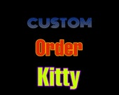
Custom Order Kitty, Pride Head, Pride Mannequin, Mannequin

Toni maskunas on Jun 4, 2024
5 out of 5 stars
Oh my god this is beautiful well made I love her stuff and will buy more. She is great!
Contact buyer
Alicia responded on Jun 5, 2024
You are a dream. Thank you so much beautiful friend for continuing to support me and believing in my art. It means more than you know. I am so grateful for you. I absolutely love creating and you make it worth every minute. All of my love and friendship always

Custom for Toni, Alice Head, Alice Mannequin

Toni maskunas on May 30, 2024
5 out of 5 stars
I love her work this is the 3rd head I have ordered She is absolutely amazing!
Contact buyer
Alicia responded on May 30, 2024
I am beyond honored. You are a complete joy and an absolute sweetheart. Words cannot express my gratitude. My heart is so full it's bursting. It's been an absolute pleasure. Thank you so much my beautiful friend!

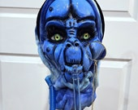
Caterpillar Head, Caterpillar Mannequin, Caterpillar attachment

Toni maskunas on Apr 30, 2024
5 out of 5 stars
Oh my goodness. This is so great I will defiantly buy from the seller again. This looks amazing.
Contact buyer
Alicia responded on Apr 30, 2024
Wowwwww. Thank you so much Toni. I am beyond excited you like it. This absolutely fills my heart. Thank you so much for believing in my art. I am truly honored. I am so grateful for your review. Let's stay in touch!

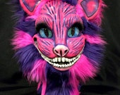
Cheshire Inspired Head, Cat Mannequin, Cheshire Cat Inspired Mannequin Head

- 
Patty on Apr 23, 2024
5 out of 5 stars
Exactly as described. Thank you
Contact buyer
Alicia responded on Apr 30, 2024
Thank you Patty hope you are well my sweet friend. I truly appreciate your kind words.

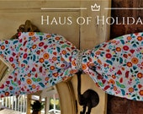
Wreath Attachment, Giant Bow Wreath Attachment, Large bow, Extra large bow, Floral Bow, Spring Bow, Summer Bow

stephen on Apr 14, 2024
5 out of 5 stars
Beautiful purse...great addition to my collection! A very positive buying experience...Thank you!
Contact buyer
Alicia responded on Apr 14, 2024
Thank you sweet friend with all of my heart. Glad you love the purse as much as I did. Enjoy! Hope to stay in touch! All of my best to you always!

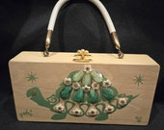
Enid Collins of Texas Poki box bag

cindy on Apr 10, 2024
5 out of 5 stars
I was blown away when I opened my box. Such attention to packaging, and a wonderful hand written card. And then the jewel in the box... my steampunk mannequin head with matching hat!! Absolute perfection. Alicia you are totaling amazing, thank you!!! I opened my box! Such detail to the packaging, a wonderful hand written
Contact buyer
Alicia responded on Apr 14, 2024
I am so honored and grateful you like my art! This made my day sweet friend. My heart is full. I hope to always stay in touch. Wowwwwww! THANK YOU SOOOO MUCH!

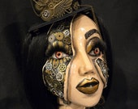
Steampunk Mannequin, Steampunk Head, Steampunk

- 
Yvette on Feb 29, 2024
5 out of 5 stars
OMG! Your craftmanship is AMAZING! I Love it
Contact buyer
Alicia responded on Feb 29, 2024
Thank you so much. I am truly honored and grateful for your support. Thank you so much sweet friend for the kind words. It really keeps me inspired. Thank you for taking the time to leave such kind review.


Disco Diva Mannequin, Disco Diva Head, Black Girl Mannequin, Black Girl Head

- 
Briana on Feb 19, 2024
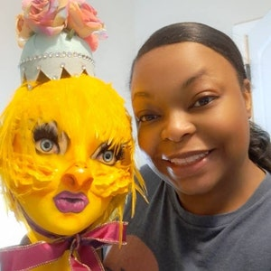
5 out of 5 stars
This is pure ART! I couldn't resist when I saw this magnificent, most unique mannequin head ever! I have never even designed with such an item but I'm going to definitely give it a try! Thank you Alicia for your amazing talent.
Contact buyer

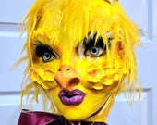
Chic Chick Mannequin, Chick Mannequin, Chicken Mannequin, Easter Mannequin

Average item review

5 out of 5 stars

(119)
Sort by: Suggested
- 
Ashley on Feb 16, 2024
5 out of 5 stars
If I could give 100 stars I would! It’s absolutely gorgeous and the craftsmanship is amazing. Alicia clearly puts her heart into each design. Highly recommend and will purchase from her again.
Contact buyer
Alicia responded on Feb 16, 2024
😱😱😱😱.....WOWWWWWWW. What a beautiful review. Thank you with every bit of my heart. I am always honored beyond measure when a beautiful friend appreciates my art. I have absolute butterflies. All of my love and friendship always. It's friends like you that make me so inspired!! It was an absolute pleasure 🙏

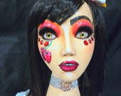
Cherry Cake Girl mannequin, Cherry Girl Mannequin, Cherry Mannequin, Cherry Girl Head, Cherry Cake Girl Head

- 
Sharon on Feb 14, 2024
5 out of 5 stars
FANTASTIC Design! Absolutely gorgeous! I can't wait to put this Diva on a Wreath! May need sunglasses to view it! :)
Contact buyer

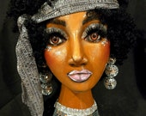
Disco Diva Mannequin, Disco Diva Head, Black Girl Mannequin, Black Girl Head

- 
Michelle on Feb 1, 2024
5 out of 5 stars
WOW It arrived quickly and packaged well. The flower art is crazy cute. Quirky and silly
Contact buyer
Alicia responded on Feb 1, 2024
OMGEEEEEE! THANK YOU SOOO MUCH! That truly makes my heart sing. It's beautiful people like you that inspire me to create. I am grateful for you sweet friend! I look forward to staying in touch with you!


Heart Victorian Woman Face Flower , Face Flower, Wonderland Flower, Halloween Flower, Fall Flower

Sharon on Jan 31, 2024
5 out of 5 stars
BLOWN AWAY! This White Rabbit is Gorgeous and absolutely incredible! 😱😱😱 Alicia’s art is unique and one of a kind! I’m ecstatic I was able to snatch this beauty to create with! I’ll come back and post a photo when it’s finished.
Contact buyer
Alicia responded on Jan 31, 2024
WOWWWWWW. To have a talented creator and visionary like Sharon design with my art is an absolute dream come true. I have been in awe of her talent since I started my biz. I CANNOT WAIT to see what her magic fingers dream up! It is a complete honor and a privilege!.....SHARON CAN I SAY U BLOW ME AWAY RT BACK? SO WHERE DOES THAT LEAVE US MY FRIEND?.....LOL

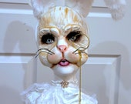
Rabbit Mannequin, Bunny Mannequin, Rabbit Head, Bunny Head, Rabbit Attachment, Bunny Attachment

- 
karen on Jan 16, 2024
5 out of 5 stars
OMG I LOVE her!!!! You are so talented!! Thanks so much!!
Contact buyer

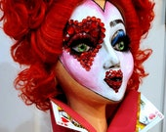
Queen of Hearts head, Queen of Hearts mannequin, Queen of Hearts

DANIELLE on Dec 16, 2023
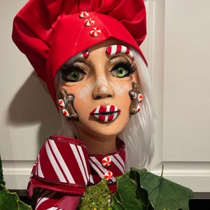
5 out of 5 stars
One of my favorite sellers!!! It is absolutely beautiful
Contact buyer
Alicia responded on Dec 16, 2023
Wowwwww! Thank you so much always for your support and belief in me. friends and customers like you are like pure magic. LOVEEEEE what you did with her! Thank u so much for sharing! My heart is full


Gingerbread Mannequin, Gingerbread Baker head, Baker Mannequin, Gingerbread girl

catinaharden1 on Oct 29, 2023
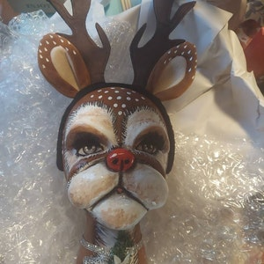
5 out of 5 stars
Awesome experience and I look forward to working with her again
Contact buyer
Alicia responded on Oct 29, 2023
Wowwwwww. Thank you so much sweet friend. It was an absolute pleasure and a joy to create for you. You are so kind and easy to work for. An absolute dream! I truly appreciate you!

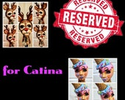
Reserved for Catina, Deer Mannequin and Candy Girl Mannequin

The Whimsical Redhead on Oct 26, 2023
5 out of 5 stars
I LOOOVE my reindeer head. I cannot wait to to add it to something special. I highly recommend HoH shop! Great product, service, and shipping.
Contact buyer


Reindeer Mannequin Head

surichards on Oct 20, 2023
5 out of 5 stars
I love this so much!
Contact buyer
Alicia responded on Oct 20, 2023
Thank you soooo much my sweet friend for the opportunity to make you something special just for you! I truly appreciate your kindness and support!

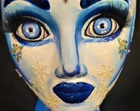
Ice Queen Mannequin, Christmas Mannequin

Jamie on Oct 7, 2023
5 out of 5 stars
Awesome just as pictured very cool
Contact buyer
Alicia responded on Oct 7, 2023
Wowwwww. Thank you so much sweet friend for taking the time and giving such a wonderful review. I truly appreciate your kindness and support. I hope to stay in touch. Have a beautiful Holiday Season. All of my best to you always!

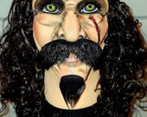
Pirate Pete Mannequin Head, Mannequin Head
Average item review

5 out of 5 stars

(119)
Sort by: Suggested
karen on Oct 2, 2023
5 out of 5 stars
I LOVE it!!! Super fast shipping!! Thanks so much!!
Contact buyer
Alicia responded on Oct 5, 2023
Thank you so much for the beautiful review. I truly appreciate it with all of my heart.

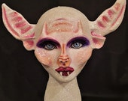
Bat Lady Mannequin Head

- 
Kellie on Aug 18, 2023
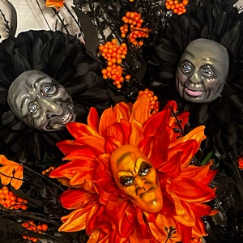
5 out of 5 stars
Gorgeous piece! Deluxe quality flower with an artisan one of a kind face will make a perfect addition to my wreath. Customer service & shipping was excellent. Looking forward to dealing with this seller again!
Contact buyer

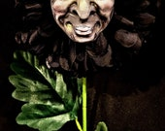
Goofy Ghouly Flower, Face Flower, Wonderland Flower, Halloween Flower, Fall Flower

Kellie on Aug 18, 2023
5 out of 5 stars
Gorgeous piece! Deluxe quality flower with an artisan one of a kind face will make a perfect addition to my wreath. Customer service & shipping was excellent. Looking forward to dealing with this seller again!
Contact buyer

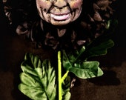
Happy Ghoul Flower, Face Flower, Wonderland Flower, Halloween Flower

Kellie on Aug 18, 2023
5 out of 5 stars
Gorgeous piece! Deluxe quality flower with an artisan one of a kind face will make a perfect addition to my wreath. Customer service & shipping was excellent. Looking forward to dealing with this seller again!
Contact buyer


Angry Orange Witch Flower, Face Flower, Wonderland Flower, Halloween Flower, Fall Flower

Reviewed by Inactive on Jul 26, 2023
5 out of 5 stars
This mannequin head design is absolutely gorgeous with so much attention to detail and I look forward to creating with with!
Contact buyer

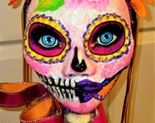
Day of the Dead Mannequin head, Dia de Los Muertos Mannequin head, Diana de Los Muertos Mannequin head

OH Christmas Tree LLC on Feb 9, 2023
5 out of 5 stars
I love everything u do
Contact buyer

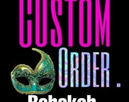
Custom Order Rebekah Mardi Gras Mannequin Heads

DANIELLE on Nov 4, 2022
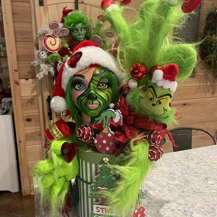
5 out of 5 stars
I am so in love with my green monster girl!!! She is perfect just like the seller! She always goes over and beyond my expectations!!
Contact buyer

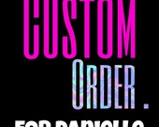
Green Monster Centerpiece for my Buddy

- 
Otivisit on May 9, 2023
5 out of 5 stars
Contact buyer

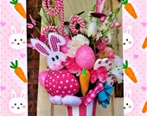
Easter Floral Arrangement, Easter Centerpiece, Spring Centerpiece, Spring Floral Arrangement, Holiday Arrangement

Teddie on Nov 30, 2022
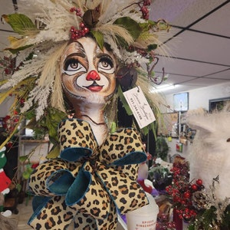
5 out of 5 stars
Contact buyer

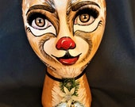
Deer Mannequin, Christmas Mannequin

Mindy on Nov 16, 2022
5 out of 5 stars
Contact buyer

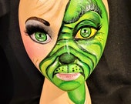
Grinch inspired mannequin, Christmas mannequin
Average item review

5 out of 5 stars

(119)
Sort by: Suggested
DANIELLE on Oct 27, 2022
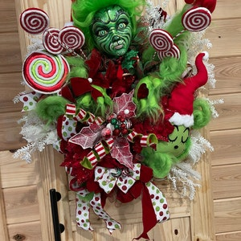
5 out of 5 stars
She is by far one of my favorite sellers on Etsy! Her work is like no others and is willing to make what ever your ideas may be. I am so in love with my wreath and will post pics when I put my Christmas stuff up!
Contact buyer

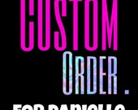
Custom Christmas Monster Wreath for my Buddy!!

Lucy on Oct 19, 2022
5 out of 5 stars
This head is so AWESOME!! I absolutely love the details on it and I can not wait to design with it. Shipping was so fast definitely purchasing more 👏🏼👏🏼
Contact buyer

Grinch inspired mannequin, Christmas mannequin

Teddie on Oct 13, 2022
5 out of 5 stars
Omg love ❤️ love love Amazing 👏
Contact buyer

Deer Mannequin, Christmas Mannequin

DANIELLE on Sep 8, 2022
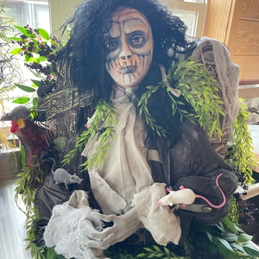
5 out of 5 stars
The best customer service EVER!!! I absolutely am so in love with this wreath and I appreciate all the hard work!! Way beyond what I imagined!!!
Contact buyer

Zombie Guy

DANIELLE on Sep 8, 2022
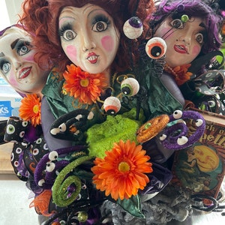
5 out of 5 stars
The best customer service EVER!!! I absolutely am so in love with these and I appreciate all the hard work!! Way beyond what I imagined!!!
Contact buyer

Wicked Witch Gals

codyma on Jul 29, 2022
5 out of 5 stars
So beautiful! The highest quality of materials and the details of the wreath is even better then the picture. The wreath if better then what I expected and I will definitely order more products. I am so glad I have found this shop, Thank you so much!!! This is my favorite for sure!
Contact buyer

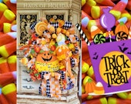
Candy Corn Wreath, Halloween Wreath, Candy Wreath, Candy Corn Decor

Maria Gonzalez on Jul 30, 2022
5 out of 5 stars
Very nice, I was quite impressed with how fast I arrive And customer service
See in original language
Contact buyer

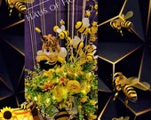
Bee Girl Centerpiece, Gender Reveal, Baby Shower Decor, Table top Centerpiece, Spring decor, Summer decor

Maria Gonzalez on Sep 1, 2022
5 out of 5 stars
Contact buyer

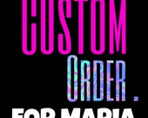
Candycorn Centerpiece for Maria

Maria Gonzalez on Sep 1, 2022
5 out of 5 stars
Contact buyer

Custom order for Maria Wreath

