Column: Return with us now to those thrilling songs of yesteryear in ‘Chicago 1971’
By Rick Kogan | rkogan@chicagotribune.com | Chicago Tribune
Published: March 4, 2026 at 5:00 AM CST
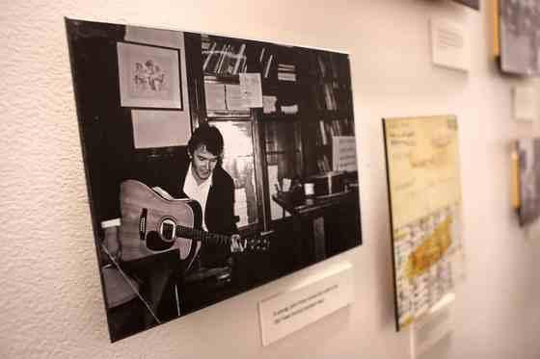
A photograph of a young John Prine honing his skills on the guitar in his Old Town School student days adorns a wall at the Old Town School of Folk Music in Chicago’s Lincoln Square neighborhood on Feb. 26, 2026. (Chris Sweda/Chicago Tribune)
For those of us who keep a foot firmly in the past, how fortunate to find John Ballantyne and Gus Noble, a couple of guys from Scotland, who are in the buoyant business of traveling back more than 50 years to give us a time and place and three guys who changed the face of American music in profound, thrilling ways.
Those guys were Kris Kristofferson, Steve Goodman and John Prine. The time and place form the title of their musical-theatrical show, “Chicago 1971,” and the summer night that these three songwriters met.
Trying not to give up too many details, it was the third night of Kristofferson’s engagement at the Quiet Knight, Richard Harding’s extraordinary music club on Belmont Avenue. Goodman was the opening act and he was determined to get Kristofferson to go see Prine, who was at the Earl of Old Town, the equally extraordinary club on Wells Street. So, late on this Sunday night, Goodman calls and tells Prine not to leave, telling him, “I’m bringing Kris, Paul Anka and Angela Lansbury to see you.”
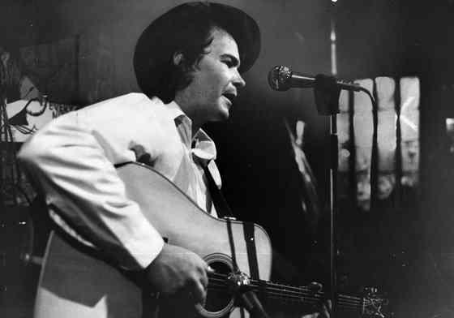
Singer-songwriter John Prine performs at the Earl of Old Town bar on May 7, 1971, in Chicago. (Charles Osgood/Chicago Tribune)
An odd gang to be sure. Anka had performed at a Chicago hotel. Lansbury (or, as some versions have it, actress Samantha Eggar) was in a play in town. The Earl was all but closed, but Prine sings for this audience of four, performing six or seven songs that would make it onto his first album.
As Prine would later recall, “The evening went into the wee hours, and Kris started quoting lyrics from my songs that night. I went home so excited about meeting him and his being so knocked out by my songs. I don’t know if I slept that night. And it was all because of Steve Goodman.”
Kristofferson would help bolster Prine and Goodman in many ways, primarily connecting them with record companies that put them on the road to stardom.
“That is one of the amazing things,” says Ballantyne. “You’d think that Steve would be pushing his own work, but instead, he was more concerned with promoting his pal John. The whole story is, like our show, about the power of kindness.”
Ballantyne then recalls his early introduction to music in his native Scotland.
“The pubs in our town closed at 9 p.m. and my parents used to bring half the crowd back to our house. I was 8 or 9 and sent to bed, but I could still hear. I could hear the music being played, vibrating through the house, and the fun people were having and I thought, ‘I’d like to do that.’”
And so he did, learning and playing guitar and playing in blues bands until the duties of family took over. He came to the United States in the mid-1990s and spent his career in the computer industry. Living in the northwest suburbs, he divorced, retired in 2014 and has three adult children and two grandchildren.
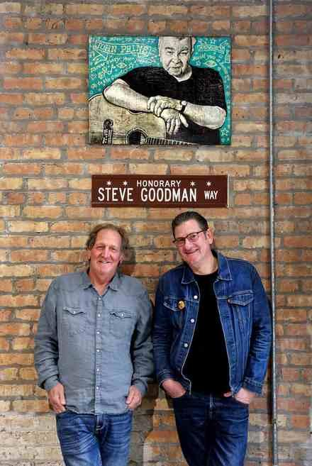
Musicians John Ballantyne, left, and Gus Noble under artwork featuring an image of John Prine and an honorary Steve Goodman Way street sign at the Old Town School of Folk Music in Chicago’s Lincoln Square neighborhood on Feb. 26, 2026. The duo will be playing two shows at Old Town titled “John Ballantyne’s Crazy Heart: Chicago 1971.” (Chris Sweda/Chicago Tribune)
Noble and Ballantyne never met in their native land, though Noble attended university with Ballantyne’s younger brother. “We first met here, in the 1990s, when I came to Chicago to be the president of the Chicago Scots,” says Noble, who plays bass. He has two sons and lives in the Edgewater neighborhood. “We played golf and discovered quickly that we were both no good. But we did find that we shared a reverence for Prine.”
Having started the band Crazyheart in about 2010, they created “Chicago 1971” a few years before Prine’s death at 73 from cancer in 2020. “We had always loved his music and learning about that amazing Goodman, Kristofferson, Prine relationship, we knew we had a story to tell,” says Noble.
The show’s foundation is, of course, the music, a vast catalogue of hundreds of songs that these men wrote. On top of that bonanza, the show incorporates video, photography and many stories told by Ballantyne.
Crazyheart’s slogan is “Honky Tonkin’ wherever they’ll have us!” and it has played local clubs such as Martyrs’, Hey Nonny and FitzGerald’s, and such distant spots as festivals in Scotland. The band recently revisited the charming Mexican town of San Miguel de Allende. At one of their performances, there were two Chicagoans.
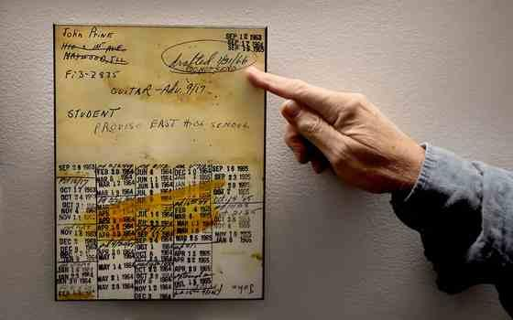
An image of the class registration card of a young John Prine on a wall at the Old Town School of Folk Music in Chicago’s Lincoln Square neighborhood, Feb. 26, 2026. (Chris Sweda/Chicago Tribune)
“It was a great night. The Rain Dog saloon is a bit of a dive, and in every way perfect for Crazyheart,” says Steve Coates, a corporate finance consultant. “Dim lights, thick smoke and loud music, as John’s band treated us to classics by Prine and Goodman, and other country and folk classics.”
His wife, writer and TV producer Sharon Barrett, says, “The Rain Dog was packed with some old Crazyheart pals, and a standing-room-only crowd of new fans. I wasn’t sure what to expect. I’m not a huge fan of either folk or country music, but I have to say this is a good band. John is a joyous and charismatic showman. He has the gift of patter and energy that just draws a crowd in. Gus, with his cool black and white shoes, is so much fun to watch. They, and the rest of the band, put on a great show. Here’s the kicker, these are good people. They invited two aspiring musicians to perform with them.”
Ballantyne enjoyed the visit. And in saying, “We came close to breaking even,” he captured the lack of commercial aspirations. These are mature musicians, their primary aim is to enrich themselves, the audience and not simply inflate their bank accounts. They did cut an album a decade ago but, Ballantyne says, “It wasn’t exactly released. It kind of escaped. It wasn’t the greatest thing.”
They understand and appreciate that interest in Prine remains stronger than ever. “You Got Gold: A Celebration of John Prine,” a tribute film focused on an October 2022 concert at Nashville’s Ryman Auditorium, is currently screening around the country. And there are plans afoot for a large October celebration here marking what would have been Prine’s 80th birthday.
There’s a “Chicago 1971” show at 7:30 p.m. March 13 at Moonlight Theater (moonlighttheatre.com) in St. Charles and an April 26 performance at the Woodstock Opera House (www.woodstockoperahouse.com) in Woodstock. Next weekend is special, with “Chicago 1971” being staged at 3 p.m. and 7 p.m. March 15 at the Old Town School of Folk Music (www.oldtownschool.org), a place that greatly influenced and nurtured Prine and Goodman. Ballantyne and Noble will be joined by Heather Kollmer and Karen Samata (vocals), Leslie Walle-Santos (drums), Mike Fleming (guitar) and Gabriel Stutz (pedal steel).
“We are all so proud to play there,” says Noble.
“This is not some sort of nostalgia trip. We are not a cover band,” says Ballantyne. “These men wrote the best poetry in the world and they connect us to the audience. This is a chance for us to share our love. It’s just the greatest thing. Sometimes I have to pinch myself.”
rkogan@chicagotribune.com

