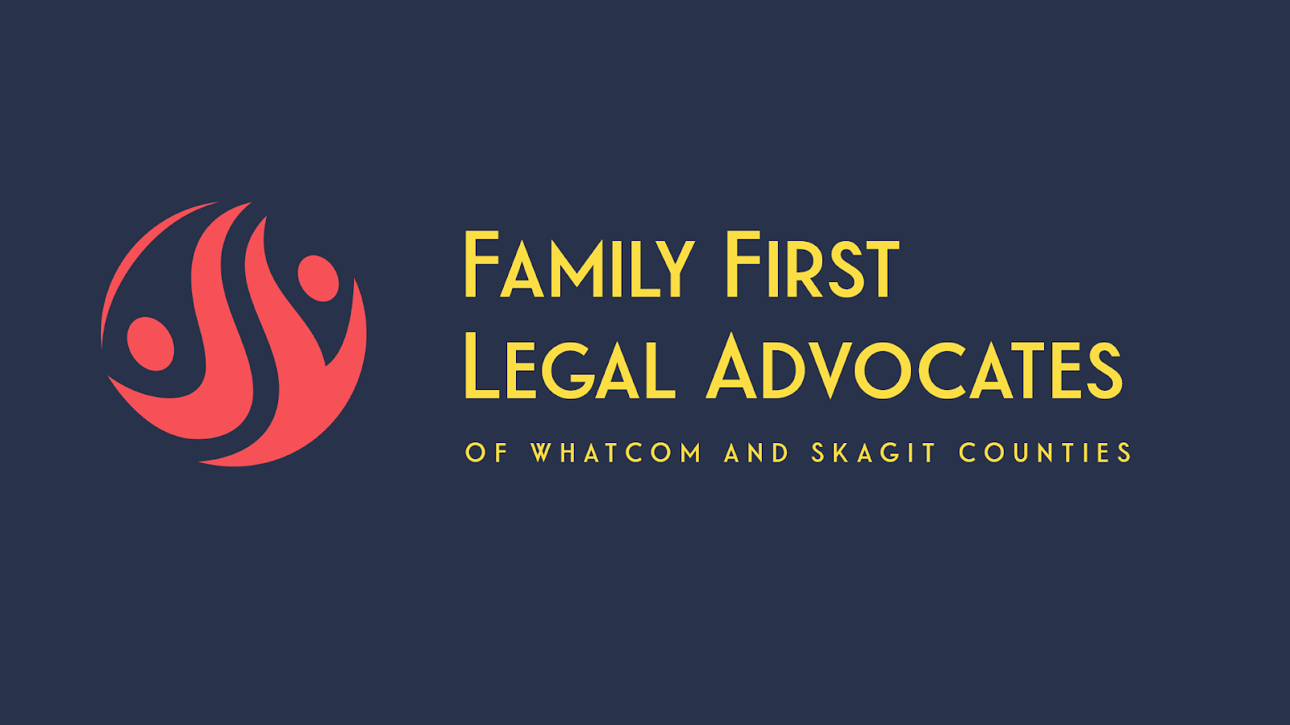  PREGNANT? NEW PARENT? NEED HELP?  Within minutes of calling Family First Legal Advocates we can begin supporting and advocating for you! We provide FREE legal representation to pregnant persons and parents of newborns at risk of CPS intervention and removal. Services include legal consultation and peer advocacy, access to substance abuse treatment, and access to other critical and appropriate services. The goal of Family First Legal Advocates is to help parents make informed decisions, know their legal rights and reduce/prevent the trauma that occurs in families impacted by separation. We have a team of 3 attorneys and a defense social service worker that are ready to help you and your family! We are available in both Whatcom and Skagit County.  FAMILYFIRSTLEGALADVOCATES.COM | preservingfamilies  to  prevent  trauma  cONTACT US  PHONE  253-507-2550  EMAIL  JAMIEPAGEPRP@GMAIL.COM  scan me  

