UTSA First Women’s Leadership Academy

By Cynthia Rocha, CEO, L3-Life Long Legacies

The University of Texas San Antonio College of Engineering kicked off it’s First Women’s Leadership Academy presented this past spring by L3-Life Long Legacies, Inc with a graduating class of 25 female engineering students. This program was a vision of Dr. JoAnn Browning, Dean of the College of Engineering. Her goal was to bring a leadership development program that would address the needs of women in engineering and break down the stereotypes that many women face in male dominated industries. Each of these 25 young ladies was hand picked by the Dean.

This leadership workshop was designed to prepare female engineering students for the competitive global marketplace and encourage them to take on leadership roles as they enter into the future workforce. The focus was on leadership development, communication skills, generational and cultural nuances and career planning. .They will gain self-awareness about how their own cultural values and beliefs can be leveraged in today’s global business environment and gain confidence on how to optimize these values for their future business advancement and during their tenure at UTSA.

Cynthia Rocha is the CEO of L3-Life Long Legacies, a consulting company that focuses on leadership development, diversity and empowering people to find their true potential.

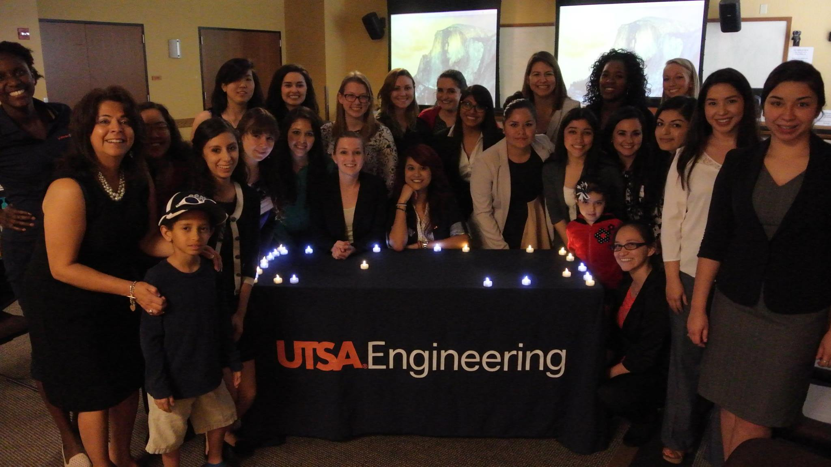

Testimony by Melissa Escobar- Sophomore-Mechanical Engineering

“I believe that this program is different from other programs because they started educating us from the heart. We all understand academics, yes, we struggled but it is not as hard as your struggles in life. Some of us had rougher childhoods than others and those experiences sometime keep us from moving forward. We need to use those nightmares, mistakes or regrets from the past as knowledge to guide and protect us for what is to come in the future. Other programs teach us the fundamentals like the dress code for interviews and how to act professional, but they don’t teach you how to act professional while being yourself and feeling good about yourself.

This program has helped me to step out of my comfort zone and get to the next level by following my heart and believing in myself. “