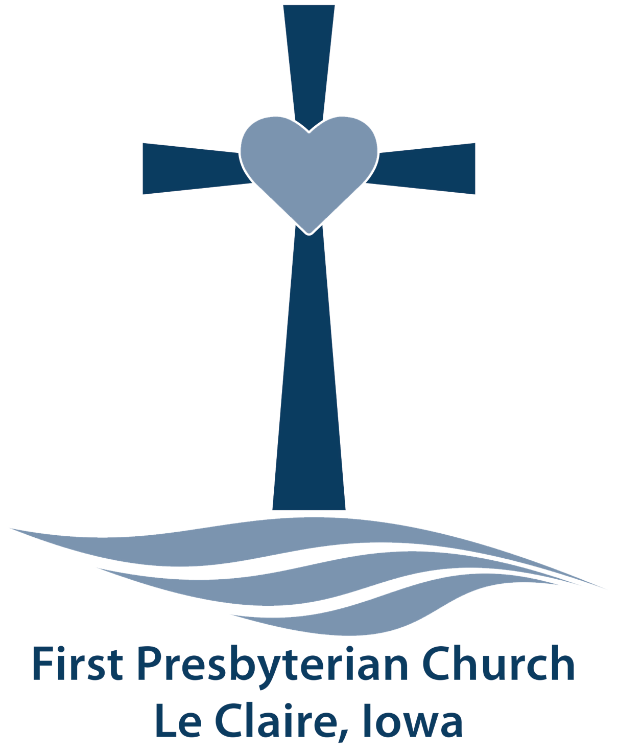
Child Protection Policy Summary

First Presbyterian Church
Le Claire, IA

First Presbyterian Church — Le Claire, IA
Child Protection Policy Summary

Jesus clearly affirmed the great importance of children when he took a little child in his arms and said in Mark 9:37, “Whoever welcomes one of these children in my name welcomes me; and whoever welcomes me isn't actually welcoming me but rather the one who sent me.” And again when he said in Mark 10:14, “Allow the children to come to me. Don't forbid them, because God's kingdom belongs to people like these children.”

THE SCREENING PROCESS
All those who volunteer to work with children and/or youth must complete the Volunteer Application and give permission to the Child Protection Committee to do a background check. The background check will include a check of the appropriate state sex offender registries. The screening process is the responsibility of the Child Protection Committee.

As part of the screening process, any volunteer who provides automobile transportation as part of an event must be an adult and must have completed the Volunteer and Vehicle Operator Application. Drivers must have a valid driver’s license and automobile liability insurance.

Drivers need not follow the Two-Adult-Rule (see below) if there are always at least two children in the car and the car is proceeding either directly to a church event or directly back to the church from an event. All occupants of the vehicle must wear a seatbelt.

TWO-ADULT RULE
A minimum of two screened adults must be present to supervise each church activity involving children and/or youth. It is the intent of this policy that an event will be cancelled if it is known prior to an event that two adults will not be present to supervise. An exception will be made if the illness of a child or teacher occurs during an event and makes following the Two-Adult-Rule impossible.

Exceptions will also be made during pastoral counseling and/or individual music lessons. During these sessions, either the room door must be kept open or a glass panel in the door must allow the pastor or staff member to be visible at all times.

SIX-MONTH RULE
Volunteers must be members or actively affiliated with the church for at least six months before being permitted to work with children and/or youth.

YOUNGER HELPERS
Children and youth are permitted to help with children/or youth activities, but the Two-Adult-Rule still applies. Children and youth do not have to go through the same clearance procedure as adults.

REPORTING ABUSE
All volunteers are to report any incident of apparent or suspected child abuse that they observe to the Associate Pastor in charge of the event or program where the incident took place, or to the Pastor or Head of Staff. When an investigation of an incident confirms that the incident is consistent with requirements for mandatory reporting, the church will make such a report. This will normally be to the local police department and/or the Iowa Department of Human Services.

Notification of parents/guardians of involved minors (victims and/or alleged perpetrator) will happen during the initial response to an allegation.

FURTHER QUESTIONS ABOUT CHILD PROTECTION
The forgoing is a summary. The complete Child Protection Policy is available to anyone who requests a copy. Questions about the Child Protection Policy should be directed to the Child Protection Committee.

CODE OF CONDUCT FOR VOLUNTEERS AND PAID STAFF
Working with Children or Youth

I consider this a vow before God, and a covenant between me and (fill in the name of the church) the children and youth with whom I will be working, and their families.

- While working with children and youth, I will conduct myself as a Christian called to service in God’s Kingdom.
- I understand that I have been entrusted with the safety and welfare of all children and youth assigned to me. At all times, I will guard their physical safety and mental, emotional, and bodily health.
- I understand that I have been entrusted with the spiritual health of all the children and youth assigned to me.
- I will take care of my own physical and spiritual health.
- I understand that I must be careful of questionable or “suggestive” situations. I will abide by the two-adult rule. If a child or youth requests time alone with me, I will inform the other adult supervisor and will meet with the child or youth in sight of others, but not necessarily where others can hear us.
- I will never touch a child or youth in anger.
- I will use appropriate signs of affection and Christian caring. I will respect the feelings of those who do not enjoy even the slightest casual touch.
- I will guard my language. I will not swear or use inappropriate language in the presence of children and youth.
- I will set a good example by respecting the property of the church, any off-site location of a church event, and of others and will be a good steward of God’s earth.
- I will immediately report any behavior toward a child or youth that seems to be abusive or otherwise inappropriate.

I have read and understand the above Code of Conduct and agree to abide by its provisions.

Signature Date
CONTACT INFORMATION FOR
REPORTING OF ALLEGATIONS

IF A CHILD IS IN EMMINENT DANGER,
CALL 911!!!

Department of Human Services:
Phone Number for Oral Report: (800) 362-2178
Email for Written Report: csiu@dhs.state.ia.us
Fax Number for Written Report: (515) 564-4011

Ministers and Congregations Commission Moderator:
Name: Kristine Ward
Phone: (563) 370-1564
Email: kristinew@me.com

