# Japanese Salmon Furikake

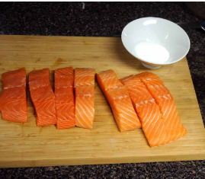

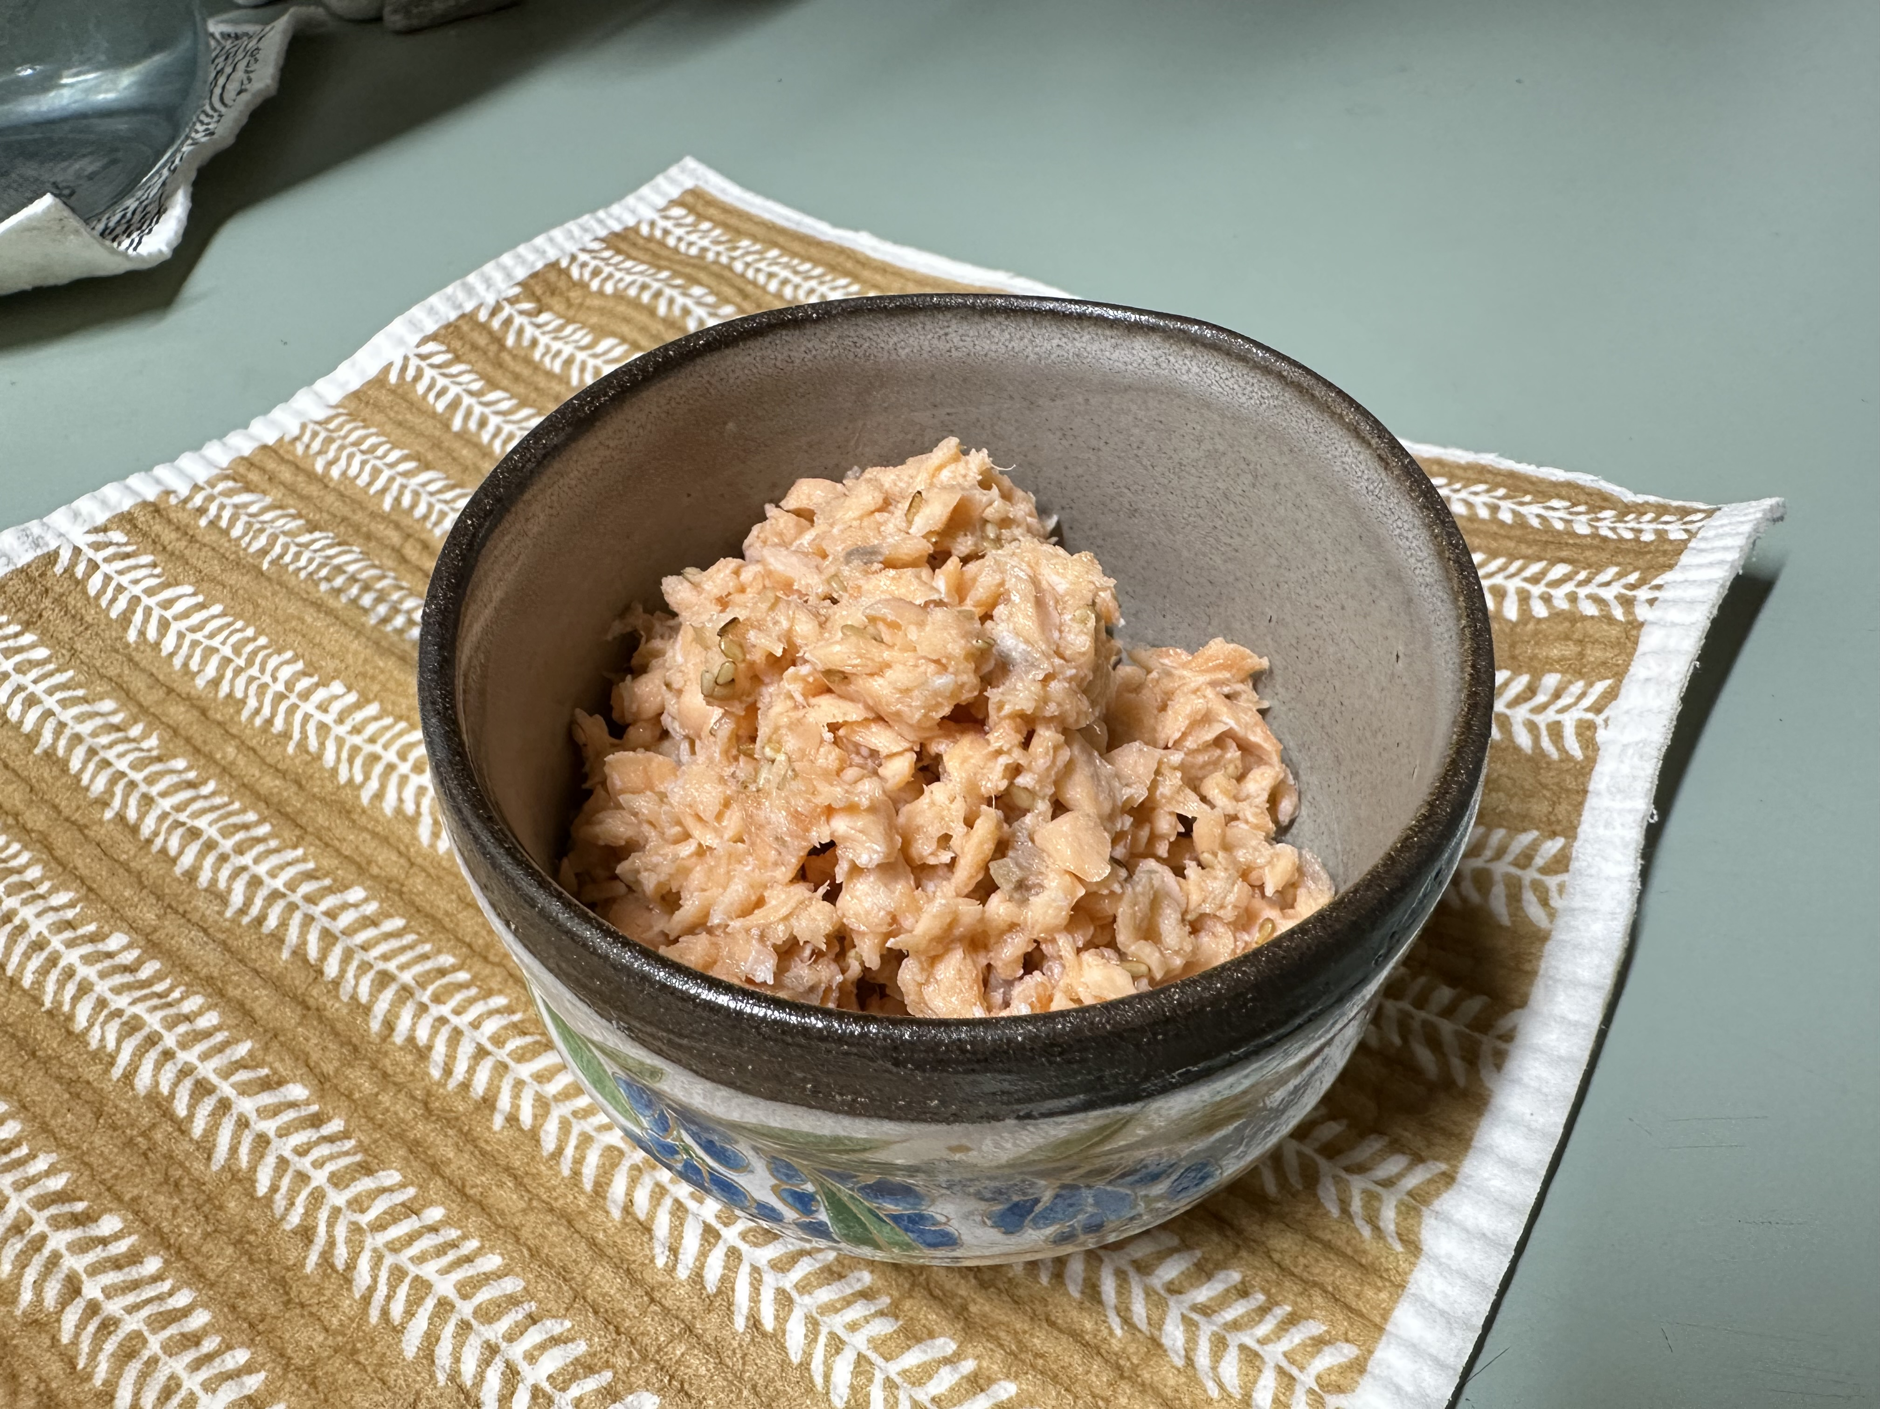

Photo By Yu*me

## Ingredients

* 2 small salmon fillets
* Important: Use **Japanese-style cuts “Kirimi”** -smaller portions about 2 inches wide. Remove **all bones and skin before cooking**. The size matters for texture and even breakdown (see photo for reference).
* 3 Tbsp sake
* 3 Tbsp mirin
* ½ tsp salt
* ½ Tbsp sesame oil

## Instructions

1. Cook the salmon: Place salmon in a skillet, add sake and mirin. Simmer over **medium** heat. As the salmon cooks, use chopsticks or a spatula to break it into small flakes (this is key).
2. Season and reduce moisture (simmer uncovered): Add salt. Keep stirring and breaking it up until most of the moisture evaporates.
3. Add sesame oil: Toss in sesame oil and stir gently. Keep heat on low and continue mixing until the texture is dry but still a bit soft — not crunchy.
4. Cool and store: Let the flakes cool fully before storing. Use an airtight jar or container. Keeps in the fridge up to one week.

## Optional Additions

* Toasted sesame seeds
* Crushed nori
* Bonito flakes
* Chili flakes or ground shiso for a twist