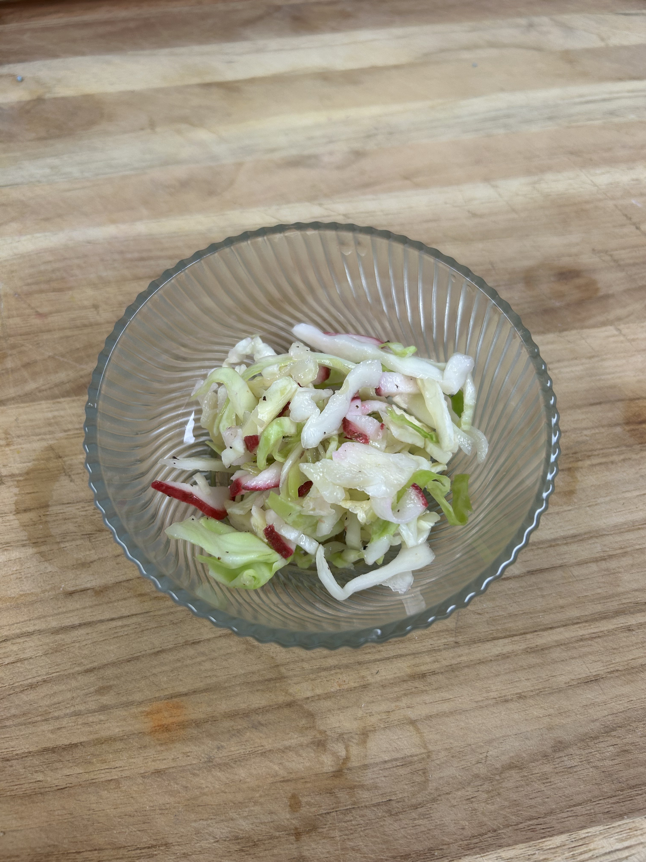
Quick Pickle Slaw with Red Radish

Ingredients
• 1 cup shredded green cabbage
• 4–5 red radishes, thinly sliced into matchsticks
• 1 tablespoon rice vinegar (or apple cider vinegar)
• 1 teaspoon sugar
• 1/2 teaspoon salt
• 1 teaspoon sesame oil (optional for flavor boost)
• 1 tablespoon chopped green onion (optional)

Instructions
• In a mixing bowl, combine the cabbage and radish.
• In a separate small bowl, whisk together the rice vinegar, sugar, and salt until dissolved.
• If using sesame oil, whisk it in as well.
• Pour the dressing over the cabbage and radish, tossing well to coat evenly.
• Let the slaw sit for at least 10 minutes before serving to allow flavors to meld.
• Garnish with green onion if desired.

Variations & Substitutes
• Replace red radish with daikon radish for a milder flavor.
• Swap shredded green cabbage with Napa cabbage for a softer texture.
• Add thinly sliced cucumber or carrot for extra crunch and color.
• Use lemon juice instead of vinegar for a citrusy twist.
• Sprinkle with toasted sesame seeds for added nutty flavor.

