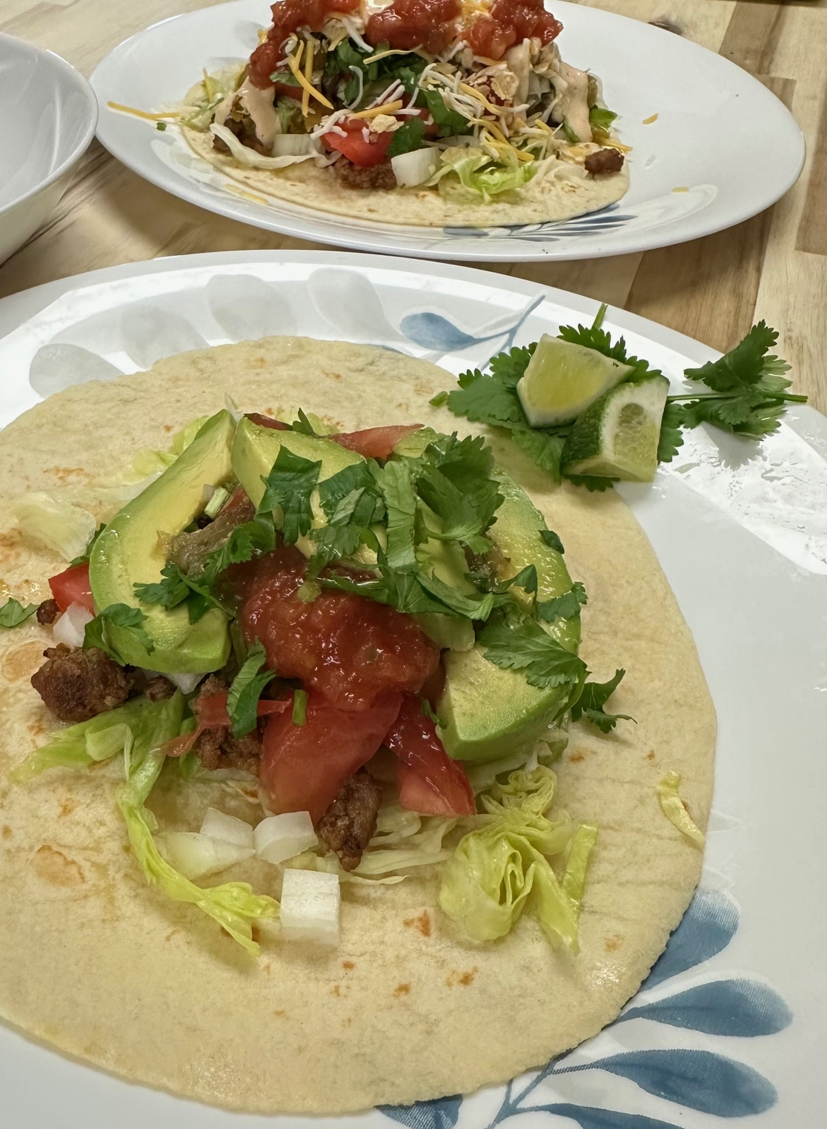
Fairbanks Crunchwrap – Taco Burrito Hybrid

Total Time:
30 minutes

Servings:
2-4 depending on appetite

Ingredients:
• 2-4 large burrito-size flour tortillas
• 1 lb ground beef, chicken, or pork
• Small handful of crushed tortilla chips or tostada shells (per wrap)
• 1/2 small onion, finely chopped
• 1/2 cup fresh cilantro, chopped
• 1/2 cup shredded Mexican blend cheese (optional)
• Salsa, hot sauce, or creamy dressing (for drizzling)
• 1-2 limes, cut into wedges

Quick Taco Seasoning Blend:
• 1 tsp cumin
• 1 tsp chili powder
• 1/2 tsp garlic powder
• 1/2 tsp onion powder
• 1/2 tsp smoked paprika (optional)
• Pinch of oregano (optional)
• Salt to taste

Instructions:
- 1. Warm the tortillas slightly so they are soft and pliable.
- 2. In a skillet over medium heat, brown the ground meat. Halfway through cooking, sprinkle over the seasoning blend. Add a splash of water or broth, stir, and cook until liquid evaporates and meat is fully cooked.
- 3. Lay out a tortilla. Spoon a layer of seasoned meat in the center.
- 4. Add a layer of crushed tortilla chips or a whole tostada shell on top of the meat for internal crunch.
- 5. Sprinkle chopped onion and cilantro over the crunch layer. Drizzle with salsa, hot sauce, or creamy dressing if desired.
- 6. Add cheese if using.
- 7. Fold the tortilla tightly around the filling. (Optional: light fry folded side down in a dry pan to crisp it slightly.)
- 8. Serve hot with lime wedges on the side.

Notes:
-

