Japanese Buta no Kakuni (Braised Pork Belly)

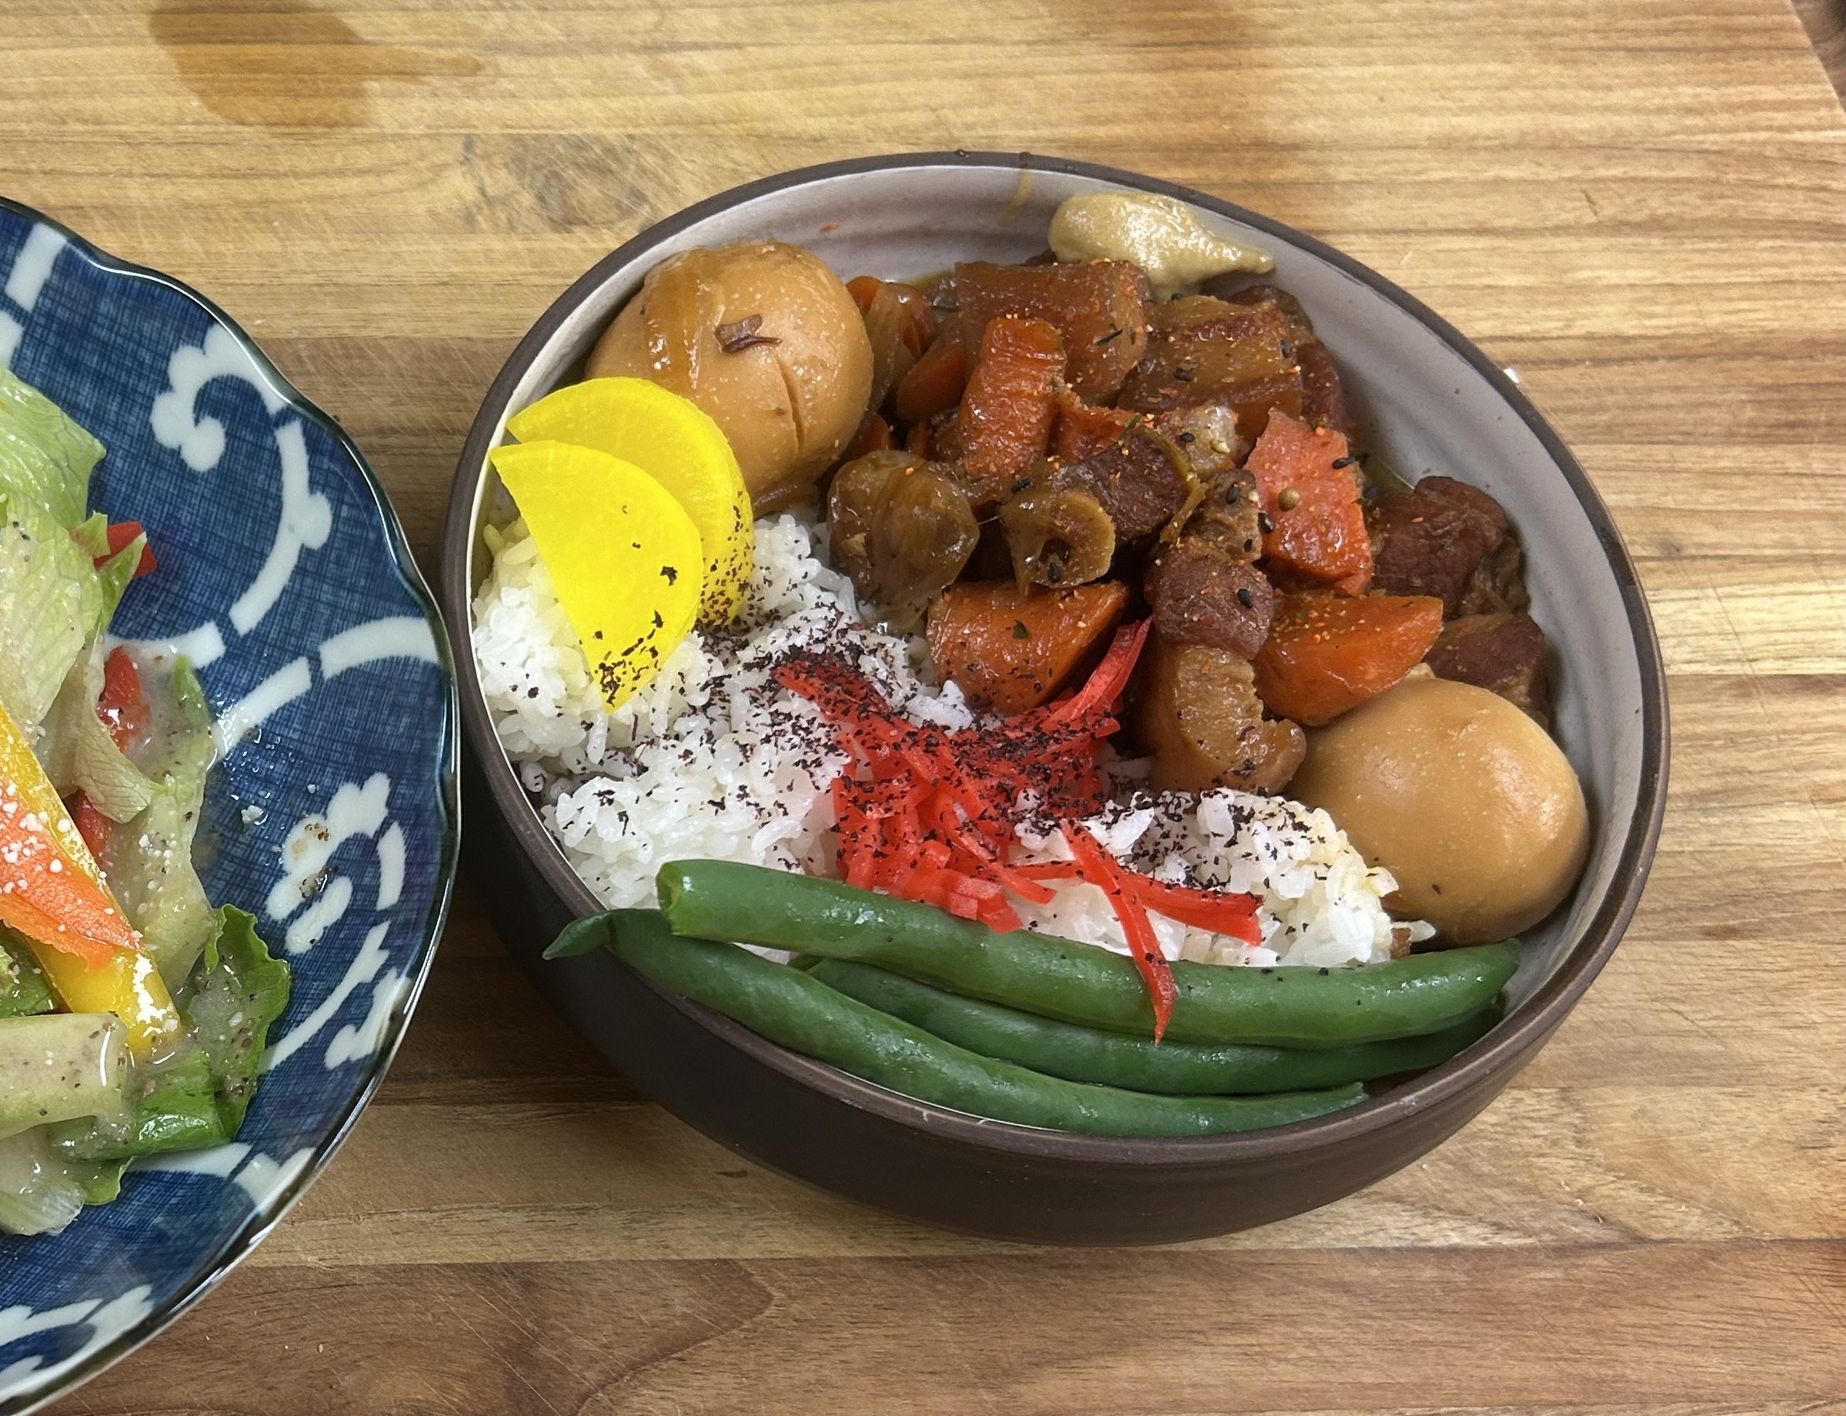
Ingredients:
• 2 lbs pork belly, cut into 2-inch cubes
• 2 tbsp vegetable oil
• 1 knob ginger, sliced
• 3 cloves garlic, smashed
• 1 cup sake (or dry white wine if needed)
• ½ cup soy sauce
• ½ cup mirin
• 3 tbsp sugar (rock sugar if available)
• 3 cups dashi or chicken broth
• 4 boiled eggs (optional, peeled)
• 2 green onions, chopped (for garnish)

Steps:
1. Blanch pork belly cubes in boiling water for 5 minutes to remove impurities. Drain and pat dry.
2. In a heavy pot, heat oil and brown pork belly on all sides.
3. Add ginger and garlic, sauté briefly until fragrant.
4. Pour in sake, soy sauce, mirin, sugar, and broth. Bring to a boil, then reduce to a gentle simmer.
5. Cover and braise on low heat for 1.5–2 hours, skimming fat occasionally, until pork is tender.
6. In the last 30 minutes, add boiled eggs to soak in the sauce (optional).
7. Remove from heat and let rest for 10 minutes. Garnish with chopped green onions before serving.

Chef Tip:
For extra depth, sear the pork belly in batches so it browns well. If the sauce reduces too much, add a splash more broth. This dish tastes even better the next day after resting in the fridge and reheating gently.

