NQP Recipe Card: Mirepoix Beef Skillet
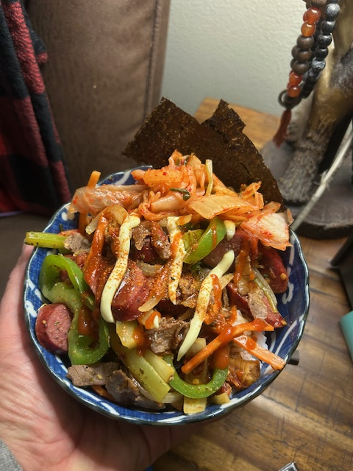

Ingredients

• Beef Sausages – 1–2, sliced into coins
• Thin-Sliced Beef Steak – 1 lb, cut into strips
• Onion – 2 cups, diced
• Celery – 1 cup, diced
• Carrot – 1 cup, diced
• Bell Pepper – 1, sliced
• Zucchini – 1, sliced
• Cauliflower – 1 cup florets
• Garlic – 3–4 cloves, smashed/minced
• Tomato Paste – 1 tbsp
• Smoked Paprika – 1 tsp
• Thyme or Italian Seasoning – 1 tsp
• Crushed Red Pepper – optional
• Beef Broth or Water – 1/2 to 1 cup
• Lemon – zest + juice
• Salt & Black Pepper
• Oil for cooking

Instructions
• Brown the Beef Sausage: Sear sliced sausage until browned, then remove.
• Sear the Thin-Sliced Steak: Quick sear, 1–2 minutes, then remove.
• Build the Mirepoix: Add onion, celery, carrot; cook 6–8 min. Add garlic.
• Season: Add tomato paste, smoked paprika, thyme; toast 1–2 min.
• Add Veg: Bell pepper, zucchini, cauliflower; cook 3–5 min.
• Deglaze: Add broth, scrape bottom. Add lemon zest + half the juice.
• Return Meat: Add sausage & steak back in; simmer 5–8 min on low.
• Finish: Adjust salt, pepper, and lemon.

Serve With
• Rice
• Potatoes
• Flatbread
• Or enjoy as a skillet bowl

