Fluffy Dumplings (Cooked Separately, Then Added to Soup)
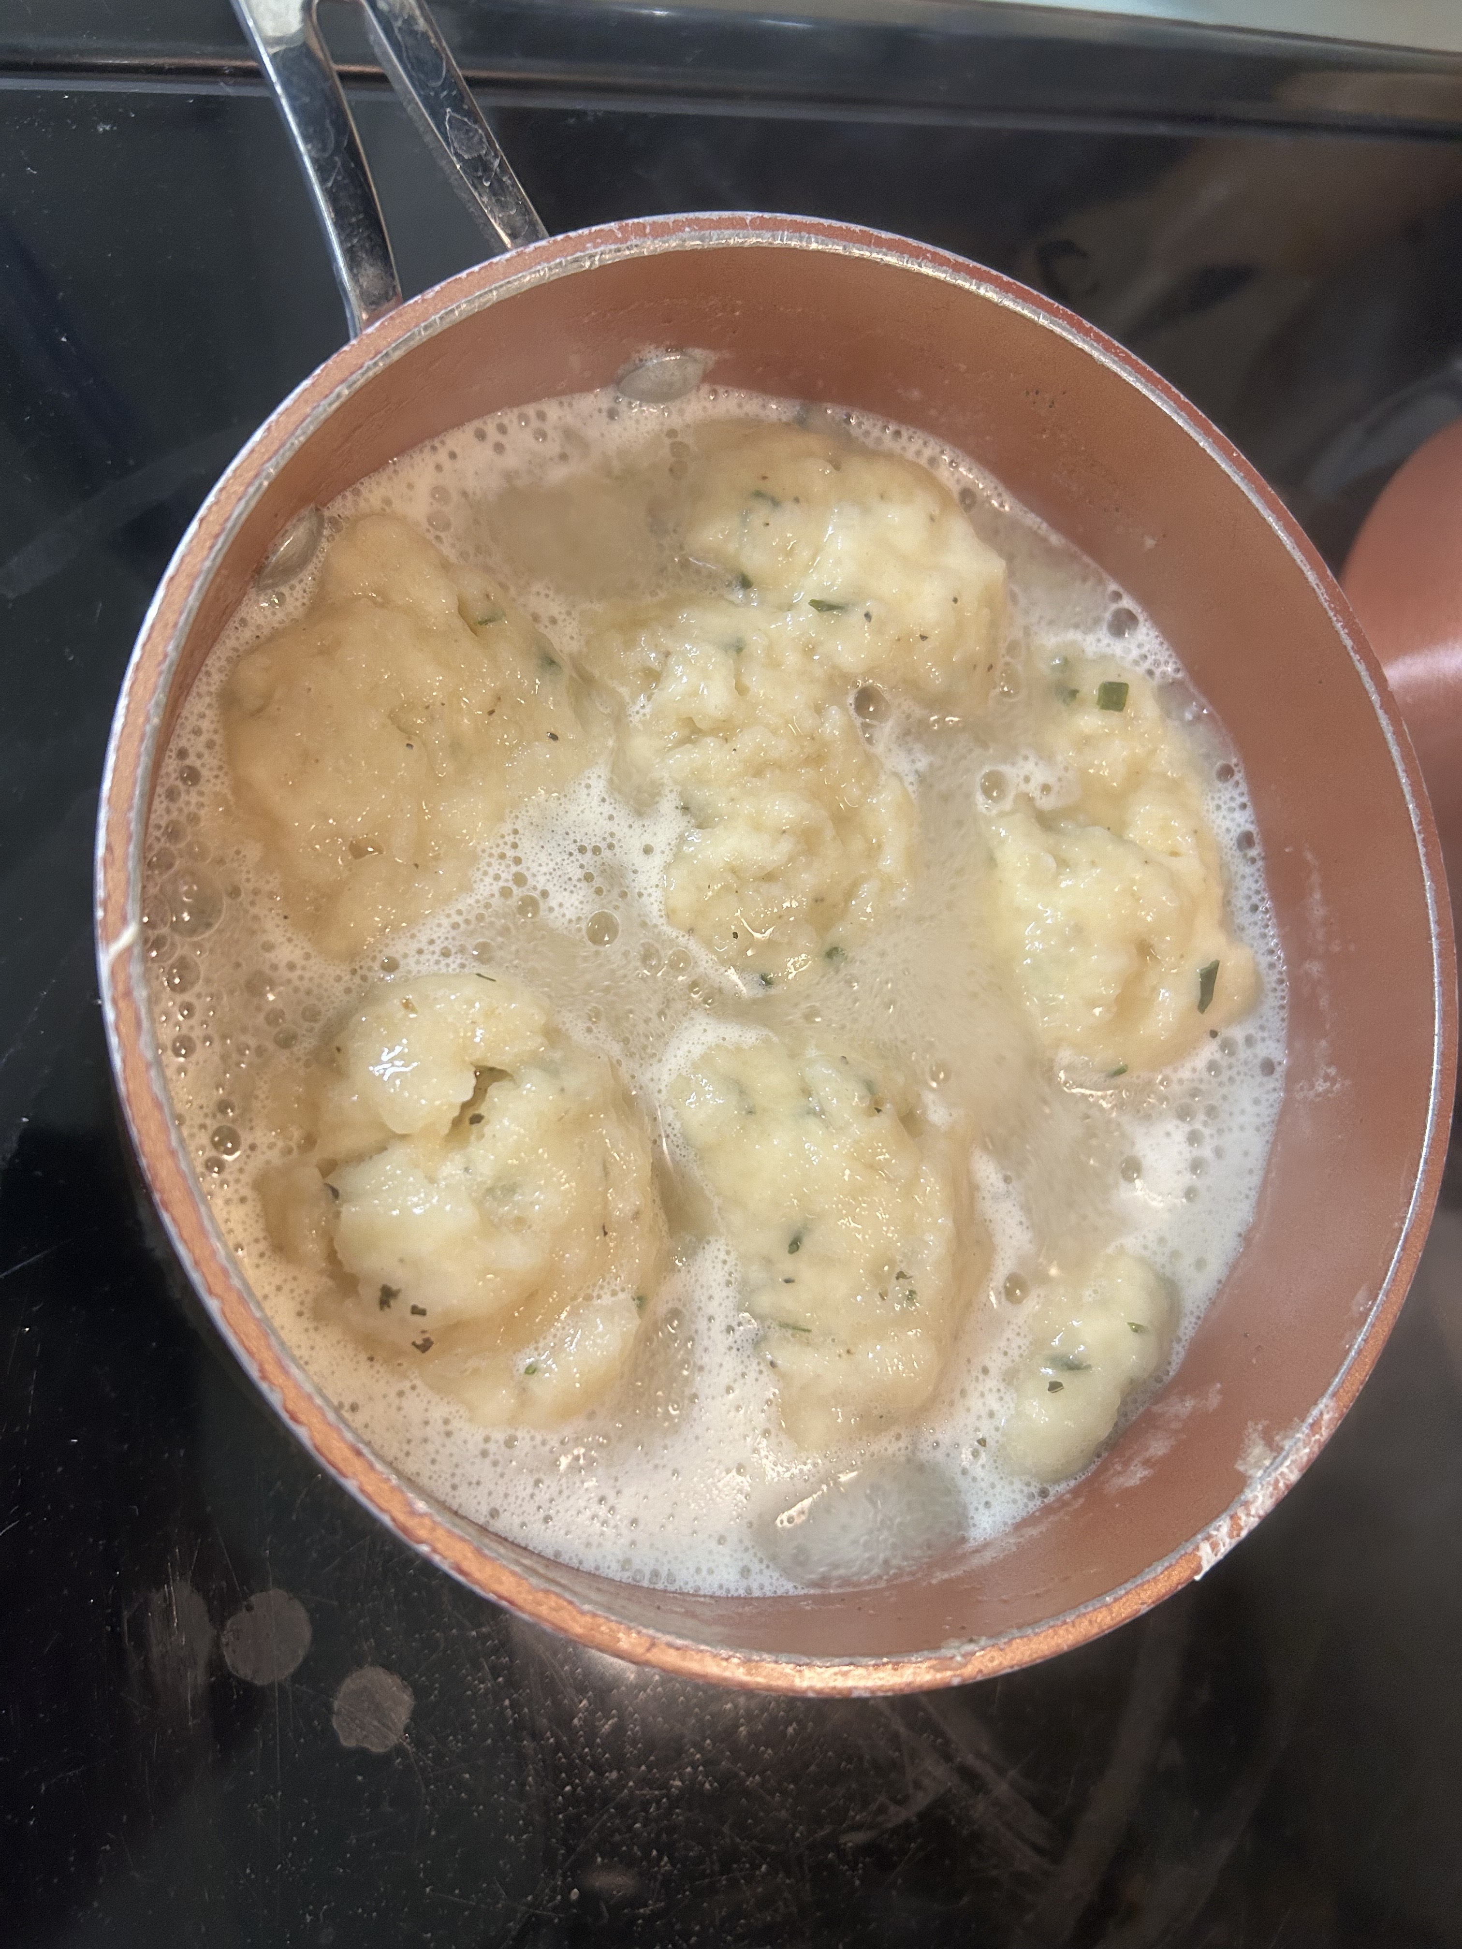

Ingredients (makes ~10–12 dumplings):
• 1 cup all-purpose flour
• 2 tsp baking powder
• ½ tsp salt
• 2 tbsp butter (cold, cut into small cubes)
• ½ cup milk (or soy milk works fine)
• Optional: 1 tbsp fresh parsley or chives, finely chopped

Steps:
1. In a bowl, whisk together flour, baking powder, and salt.
2. Work the butter into the flour with your fingers or a fork until crumbly.
3. Stir in milk gently until you have a sticky dough (don’t overmix).
4. In a saucepan, bring salted chicken broth or water to a gentle simmer (not a rolling boil).
5. Using a spoon, drop golf-ball-sized portions of dough into the simmering liquid.
6. Put on a tight lid and let them cook undisturbed for 12–15 minutes. They’ll puff up and cook through.
7. Lift dumplings out with a slotted spoon and transfer them straight into your finished soup. Ladle some of the cooking broth in too—it’ll deepen the flavor.

Chef Tip:
Add ½ tsp garlic powder or a pinch of black pepper into the flour for extra punch. If you skimmed any chicken fat from your soup, swap that for the butter for rich, savory dumplings.

