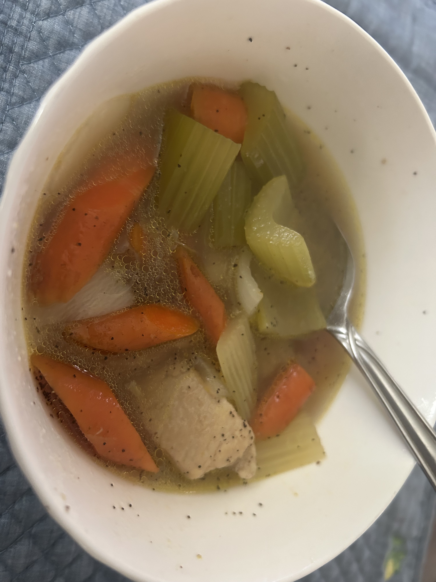
Bob’s Weekend Chicken Soup

For the Stock:
- 4 bone-in, skin-on chicken thighs
- 3 onions (2 chopped with skin on for stock, 1 fresh for soup)
- 5 medium carrots (3–5 chopped in 1” pieces for stock)
- 2 heads of celery (1 whole head for stock)
- 1 box of vegetable stock
- Seasonings: Small Punch each
- - Onion powder
- - Garlic powder
- - Salt & pepper
- -Celery Salt (Secret Weapon)
- -Nutmeg
- - Soy sauce (splash)
- - Sake (splash)
- - Chinese Five Spice –optional- (dash if you want a little different)
- - 2 chicken bouillon cubes
- - 2 beef bouillon cubes (optional, taste as you go)

Instructions:
- Debone the chicken thighs. Set the meat aside in the fridge.
- Add skins and bones to a stock pot with chopped onions (skins on), celery, and carrots.
- Pour in veggie stock and fill with water until 1" above the veggies.
- Bring to a boil, add spices and bouillon then simmer 30–60 minutes. Add water as needed to maintain level.
- Once veggies are broken down, strain the stock through a basket or mesh insert. Let it fully drain—don’t waste the flavor.

For the Soup:
Vegetables (All cut into 1” cubes):
- Fresh celery
- Fresh carrots
- 1 onion
- 1 potato (or substitute/alternate with turnips or parsnips)

Prep:
- Soak raw chopped veggies in a saltwater bath while making the stock and cooking chicken.
- After soaking, strain and rinse well to remove excess salt.

Chicken:
- Season reserved thigh meat with salt, pepper, and basil.
- Pan-fry until fully cooked and slightly browned.
- Let rest, then slice into bite-sized chunks.

Final Assembly:
- Add the rinsed raw vegetables and sliced chicken to the strained stock.
- Bring to a boil, then reduce heat and simmer for 20 minutes.
- Begin testing vegetables with a fork for doneness.
- Adjust seasoning if needed—but if your stock is dialed in, it should be nearly perfect.

