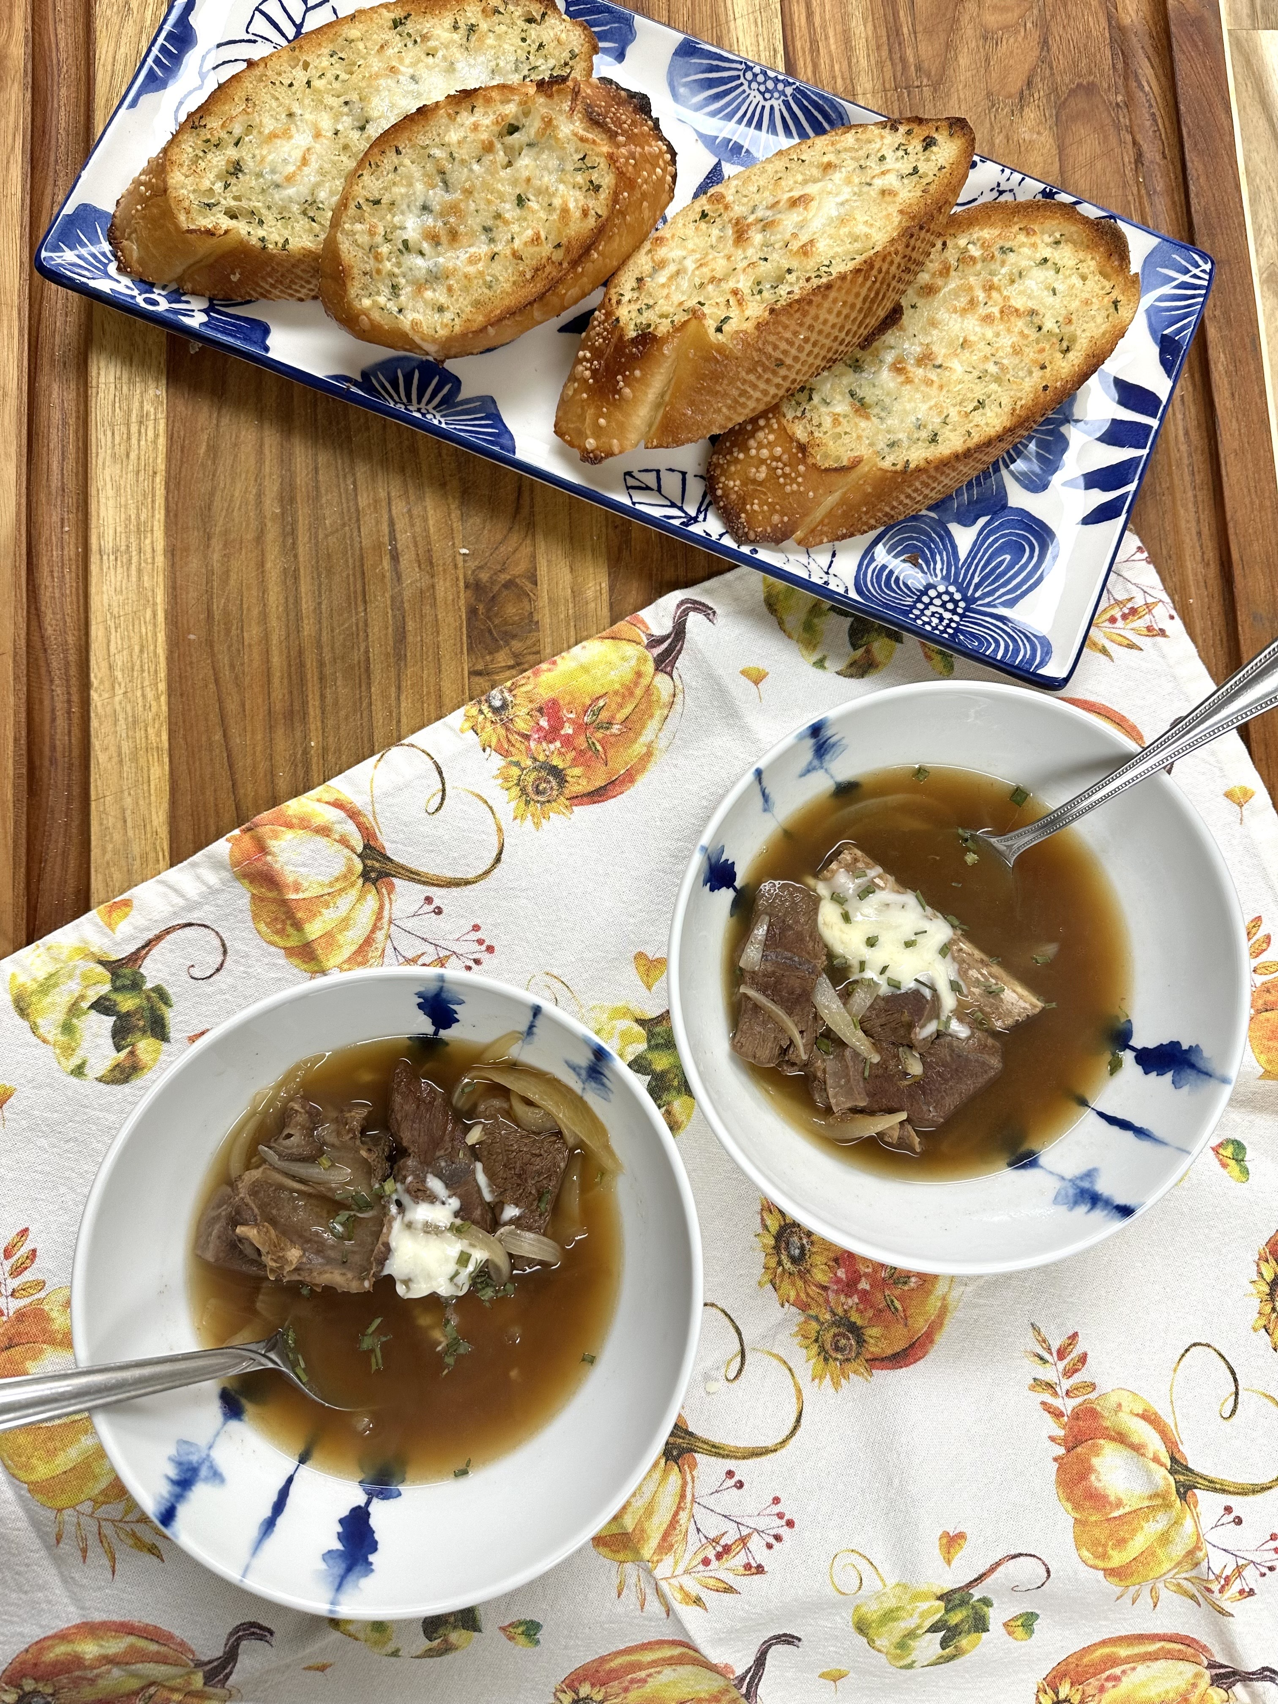
French Onion Short Rib Soup Recipes

Ingredients
- 2 lbs bone-in beef short ribs
- olive oil
- 3 large yellow onions, thinly sliced
- 4 cloves garlic, minced
- 6 cups beef broth
- 3 Tbsp balsamic vinegar
- 3 tsp Worcestershire sauce
- Salt & pepper, to taste
- Fresh thyme

For the Gruyère Toast
- 1 baguette, sliced
- 4 Tbsp butter, softened
- 1 tsp Minced Garlic
- Sprinkle of Parsley
- Garlic Salt
- Garlic Powder

Instructions
- Brown the short ribs: In a large heavy pot, heat olive oil over medium-high. Season ribs with salt & pepper and sear on all sides until browned. Remove and set aside.
- Caramelize onions: In the same pot, add sliced onions and cook slowly over medium-low until deep golden brown (about 30–40 min). Add garlic in the last few minutes.
- Deglaze: Stir in balsamic vinegar and Worcestershire. Scrape the bottom of the pot.
- Build the soup: Return ribs to pot, pour in beef broth, bring to boil, then reduce heat and simmer covered for 2–3 hours, until ribs are tender and falling off the bone.
- Finish: Remove ribs, shred meat, discard bones, and return beef to the pot. Adjust seasoning.
- Make toast: Butter baguette slices, top with Gruyère, and broil until bubbly and golden.
- Serve: Ladle soup into bowls, top with cheese toast, and garnish with fresh thyme.

Beef Rib & Onion Soup (using separated bones + top blade)
- Broth base with bones:
  - Take the rib bones, season lightly with salt & pepper, and roast them in a hot oven (425°F) for 20–25 min until browned.
  - Transfer to a stockpot, cover with water (or part water + beef broth), add an onion half, a carrot, celery stick, and a bay leaf.
  - Simmer gently for 2–3 hours. Strain and reserve the broth.
- Soup build:
  - Use the recipe you uploaded
French_Onion_Short_Rib_Soup
: caramelize your onions low and slow, add garlic, then deglaze with balsamic + Worcestershire.
  - Add your homemade rib broth.
- Meat step:
  - Brown the top blade steak chunks separately, then add them into the soup to braise until tender (about 1.5–2 hours).
  - Option: near the end, pull out the meat, slice/shred, and return it.
- Finish:
  - Gruyère toast on baguette slices under the broiler, then float them on the soup.
  - Garnish with thyme if you want the classic touch.

