Stick To Your Ribs Fried Rice

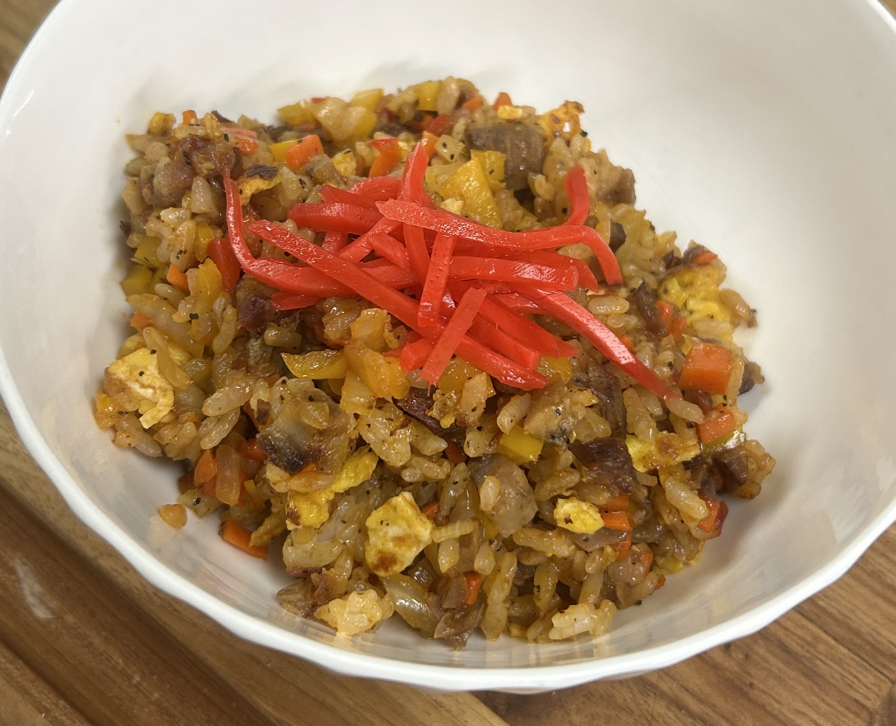
Ingredients
- • Leftover ribs (chopped into bite-size pieces)
- • 2 eggs (scrambled)
- • Cold, day-old rice (declumped)
- • 1–2 cloves garlic (minced)
- • 2–3 green onions (sliced)
- • ½ cup shredded carrots
- • ½ yellow onion (diced)
- • 1 small bell pepper or mini peppers (diced)
- • 1–2 tsp soy sauce
- • 2-3 shots (round turns in the pan) of ketchup
- • 1 shot BBQ sauce
- • Optional: dash of sesame oil, splash of rice vinegar
- • Garnish: sliced scallions, kimchi, or pickled ginger (beni shoga)

Instructions
- Prep:
- Chop rib meat into small, bite-size pieces.
- Dice all vegetables and set aside.
- Scramble eggs in a hot pan with a touch of oil. Remove and set aside.
- Sauté (High Heat):
- In the same pan, sear rib meat until slightly crispy.
- Add garlic, green onion, carrots, onion, and bell peppers. Sauté until vegetables begin to soften and caramelize.
- Rice Time:
- Toss in cold, declumped rice. Stir-fry everything together, flipping the rice several times to combine and crisp.
- Add soy sauce, drizzle ketchup around the pan, and hit it with one shot of BBQ sauce.
- Optional: Add a touch of sesame oil for depth, or a splash of rice vinegar for brightness.
- Finish:
- Return scrambled eggs to the pan and mix well.
- Taste and adjust seasoning if needed.
- Serve:
- Plate hot and top with scallions, kimchi, or pickled ginger.

Pro Tip – Let It Stick Before You Flip
Keep the heat high and resist the urge to stir constantly. Let the ketchup and BBQ sauce caramelize on the bottom of the pan—you want that sticky, smoky layer. Then flip the rice, let it hit again, and repeat a few times. That’s where the deep, bold flavor comes from. The little crispy bits? That’s the gold. Learned this in Japan!!!

Notes
- Use day-old rice for ideal texture—fresh rice will get mushy.
- Great on a Camp Chef, cast iron skillet, or standard nonstick.
- Swap in what veggies you have—this dish is all about resourceful flavor.

