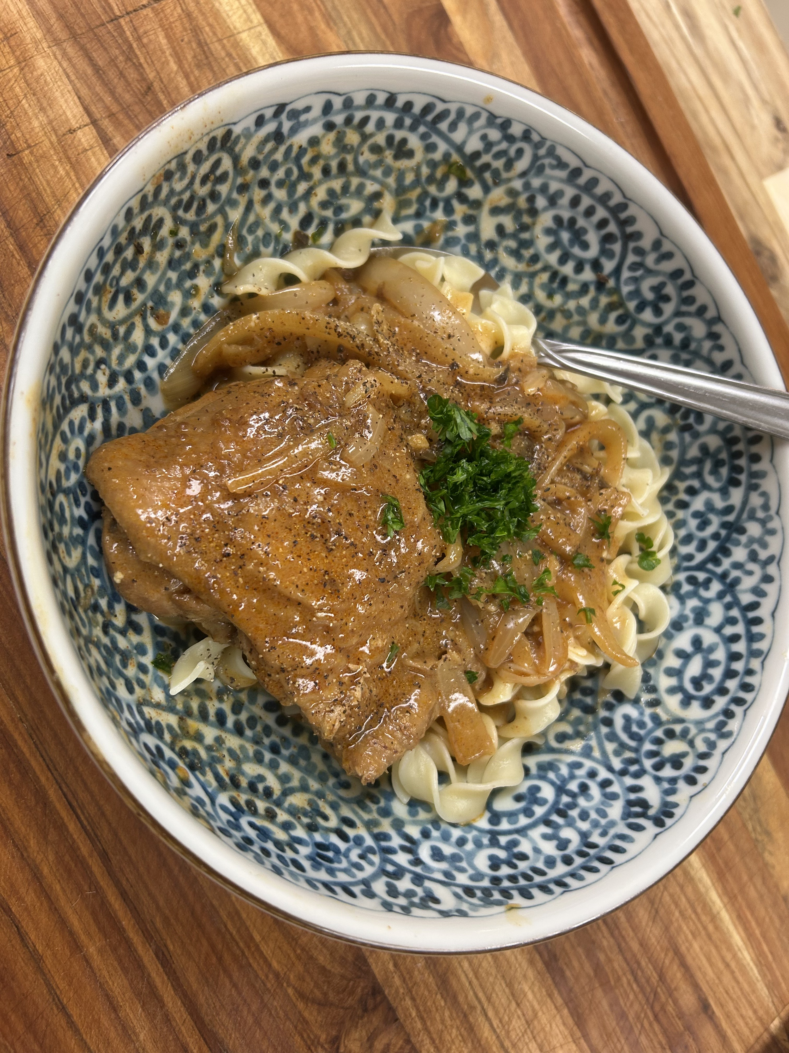
Hungarian Chicken Paprikash

Ingredients:
• 2 lbs chicken thighs or drumsticks
• 2 tbsp vegetable oil or butter
• 2 large onions, thinly sliced
• 2 cloves garlic, minced
• 2 tbsp Hungarian sweet paprika
• 1 tsp hot paprika or cayenne
• 2 tbsp flour
• 2 cups chicken broth
• 1 cup sour cream (or soy milk + 1 tbsp lemon juice for lighter version)
• Salt and pepper to taste
• Fresh parsley, chopped
• Egg noodles or dumplings, for serving

Steps:
1. Season chicken with salt and pepper. In a large pot or Dutch oven, heat oil/butter and brown chicken on all sides. Remove and set aside.
2. In the same pot, sauté onions until golden and soft (10–12 minutes). Add garlic and cook 1 more minute.
3. Stir in paprika(s) and flour, coating the onions well. Cook 1–2 minutes to toast the spices.
4. Slowly add chicken broth while stirring to avoid lumps. Bring to a simmer.
5. Return chicken to the pot, cover, and simmer gently for 30–40 minutes until chicken is tender and cooked through.
6. Remove pot from heat. Stir in sour cream (or soy milk + lemon). Do not boil after adding sour cream—it can curdle.
7. Taste and adjust seasoning with salt and pepper.
8. Serve hot over egg noodles or dumplings, garnished with fresh parsley.

Chef Tip:
For richer flavor, render out a little chicken fat at the start and use it in place of oil. Use authentic Hungarian sweet paprika if you can find it—it makes the dish. If making ahead, keep the sour cream out until reheating and add just before serving.

