Authentic UP Miner's Pasty (with Game Option)

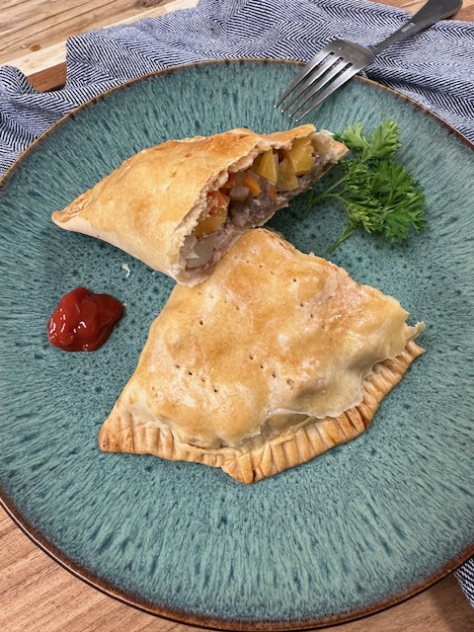
Ingredients (makes 6 pasties)

For the crust:
- 2 cups all-purpose flour
- 2 cups bread flour
- 1 ½ tsp salt
- 1 cup unsalted butter (room temperature)
- ¾–1 cup ice water

For the filling:
- 1 lb beef chuck or venison (cut into small ½" cubes)
- 2 medium russet potatoes, peeled & diced small
- 1 medium rutabaga, peeled & diced small (about 1 ½ cups)
- 1 medium onion, finely chopped
- 1 medium carrot, diced
- 3 sticks of celery
- 1 ½ tsp salt
- 1 tsp black pepper
- 2 tbsp butter, cut into small pieces

For finishing:
- 1 egg, beaten (egg wash)

Instructions
- Make the crust: Mix flour and salt in a bowl. Cut in butter (or lard) until it looks like coarse crumbs. Slowly add ice water until dough just comes together. Divide into 6 balls, wrap, and chill 30 min.
- Prep the filling: In a large bowl, mix meat, potatoes, rutabaga, onion, carrot, salt, and pepper season to taste.
- Assemble pasties: Roll out each dough ball into an 8–9" circle. Spoon filling onto half, leaving ½" edge. Dot filling with butter. Fold dough over into half-moon. Crimp edges tightly with fingers.
- Bake: Place on parchment-lined baking sheet. Brush with egg wash. Bake at 375°F (190°C) for 45–55 minutes, until golden brown and filling is tender.
- Serve: Traditional miner’s style → eat by hand, no condiments. Plated style → serve with ketchup or brown gravy if desired.

Variation
Use venison, elk, or moose instead of beef for a true game pasty. The vegetables balance out lean meat perfectly.

