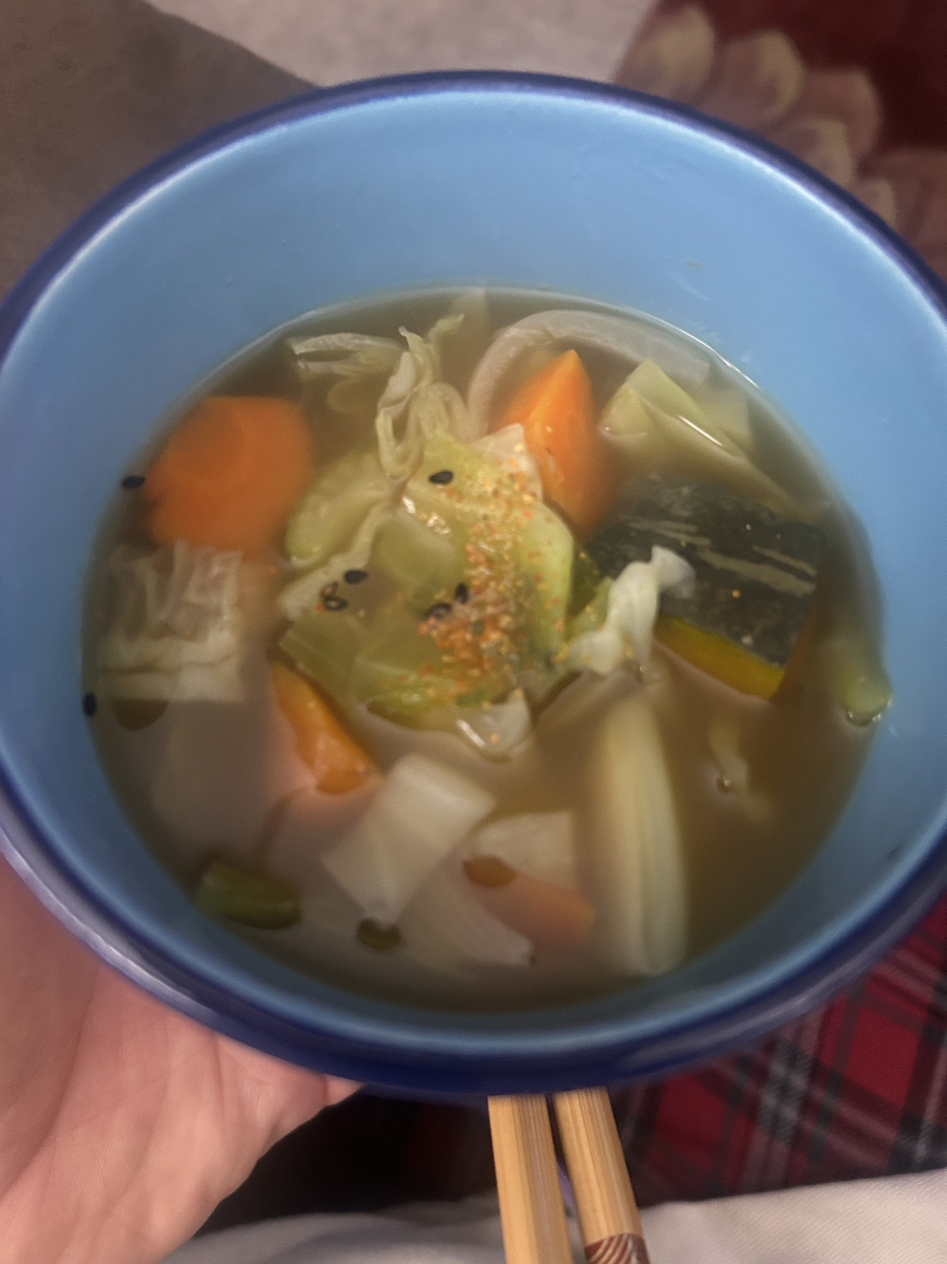
Bob's Gudakusan Soup

Broth Base
- 1 quart water
- Splash of sake
- 4 Tbsp soy sauce
- ¼ tsp fish sauce
- A few dashes Maggi seasoning
- 1 heaping tsp chicken base
- 1 heaping tsp beef base
- 1 large clove garlic
- 1 knob ginger (sliced or crushed)

Vegetables
- ½ large onion, sliced
- ¼ butternut squash, cubed ½" (skin on)
- 2 medium carrots, sliced
- 2 stalks celery, chopped
- ¼ small cabbage, cut into ½" squares (added late)

Instructions
- In a stockpot, combine water, sake, soy sauce, fish sauce, Maggi, chicken base, beef base, garlic, and ginger. Bring to a simmer to build the broth.
- Add onion, butternut squash, carrots, and celery. Simmer until vegetables are just tender.
- Add cabbage last, cooking only until slightly softened but still vibrant.
- Adjust seasoning if needed.
- Serve hot. Optional: garnish with sesame seeds or shichimi togarashi.

Notes
- This broth blends Japanese influence (sake, soy, dashi style) with depth from chicken and beef base — hearty but still clean.
- Squash skin softens during cooking, adding texture and nutrients.
- Add heat with shichimi or chili oil if desired.

