Soy–Miso Rib Finger Marinade (Balanced & Controlled)
This version preserves the bold, umami-forward flavor of the original marinade while adjusting sesame oil and sugar balance to prevent bitterness or scorching during cooking. Designed specifically for beef rib fingers.

Marinade Recipe
Ingredients:
- 6 tbsp soy sauce
- 3 tbsp sake
- 3 tbsp white or yellow miso
- 2 tsp canola or vegetable oil
- 1–1½ tsp toasted sesame oil (reduced for balance)
- 1 tbsp cane sugar
- 1 tbsp honey
- 1 thumb fresh ginger, grated
- ¼ tsp minced garlic
- ½ tsp black pepper
- ¼ tsp togarashi
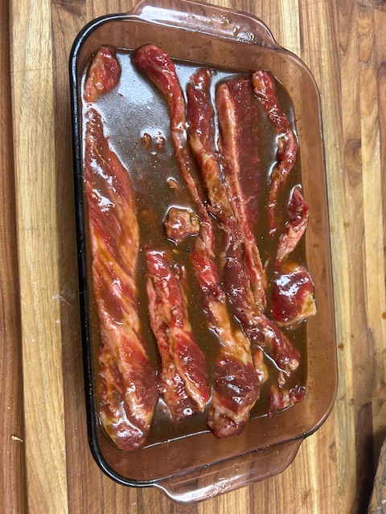

Method
- Whisk soy sauce and miso until smooth.
2. Whisk in sake.
3. Add canola oil and blend.
4. Add sesame oil last, keeping it restrained.
5. Stir in remaining ingredients until fully combined.
- This will be a thicker consistency

Marinating Guidelines
- Marinate refrigerated.
- Minimum: 4 hours
- Ideal: 6–12 hours
- Maximum: ~18 hours **longer risks excess salt dominance**.

Cooking Guidance (Important)
- Remove meat from marinade and pat dry before cooking.
- Best methods: braise, oven roast, or indirect grilling.
- If searing, wipe off excess marinade to prevent burning.
- Use medium to medium-low heat to allow sugars to caramelize slowly.

Finishing Tips
- Adjust salt only after cooking.
- Add a small splash of rice vinegar or stock at the end if richness needs lift.
- Optional: a few drops of sesame oil or fresh togarashi as a finishing accent.

Notes
This marinade delivers deep umami and a glossy finish when handled with restraint. Heat control is the key to success.

