# Bob’s Slaw Mediterranean-Inspired

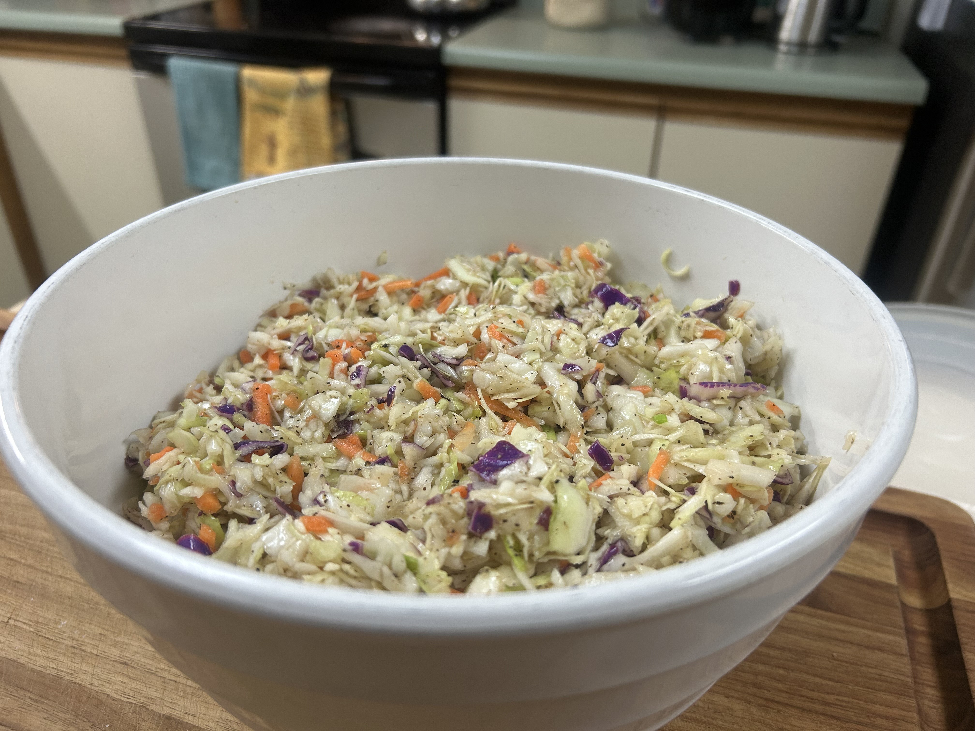A light, zesty slaw with a Mediterranean flair—perfect for potlucks, picnics, and everyday meals.

## Ingredients

* 3 packages tricolor coleslaw mix
* ½ cup apple cider vinegar
* ¼ cup brown sugar
* 2 tbsp granulated garlic
* 2 tbsp granulated onion
* 2 tbsp coarse black pepper
* 1 tsp Himalayan pink salt (adjust to taste)
* Drizzle of extra virgin olive oil (to coat evenly)

## Instructions

1. Prep the Slaw Base: Empty all three coleslaw packages into a large mixing bowl. Chop down the mix slightly for uniform texture.
2. Rinse: Light rinse under cold water helps freshen the mix. Drain well before continuing.
3. Make the Dressing: In a separate bowl, whisk together apple cider vinegar, brown sugar, garlic, onion, pepper, and salt. Drizzle in olive oil until emulsified and smooth.
4. Combine: Pour the dressing over the slaw and toss thoroughly by hand to coat evenly.
5. Chill: For best Flavor, cover and refrigerate overnight. Stir once before serving to redistribute dressing.

## Optional Toppings

Serve toppings on the side or mix them in right before serving:

* Shredded chicken or sliced Salami
* Toasted almonds
* Sunflower seeds
* Pumpkin seeds
* Balsamic glaze drizzle

## Notes

* Mayo-free: Safer for outdoor events
* Budget-friendly, big-batch crowd pleaser
* Kid-friendly flavor & crunch
* Lasts well in the fridge for 3–5 days