Japanese Salmon Furikake
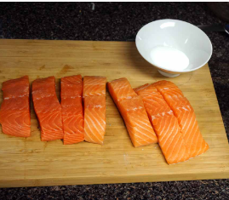
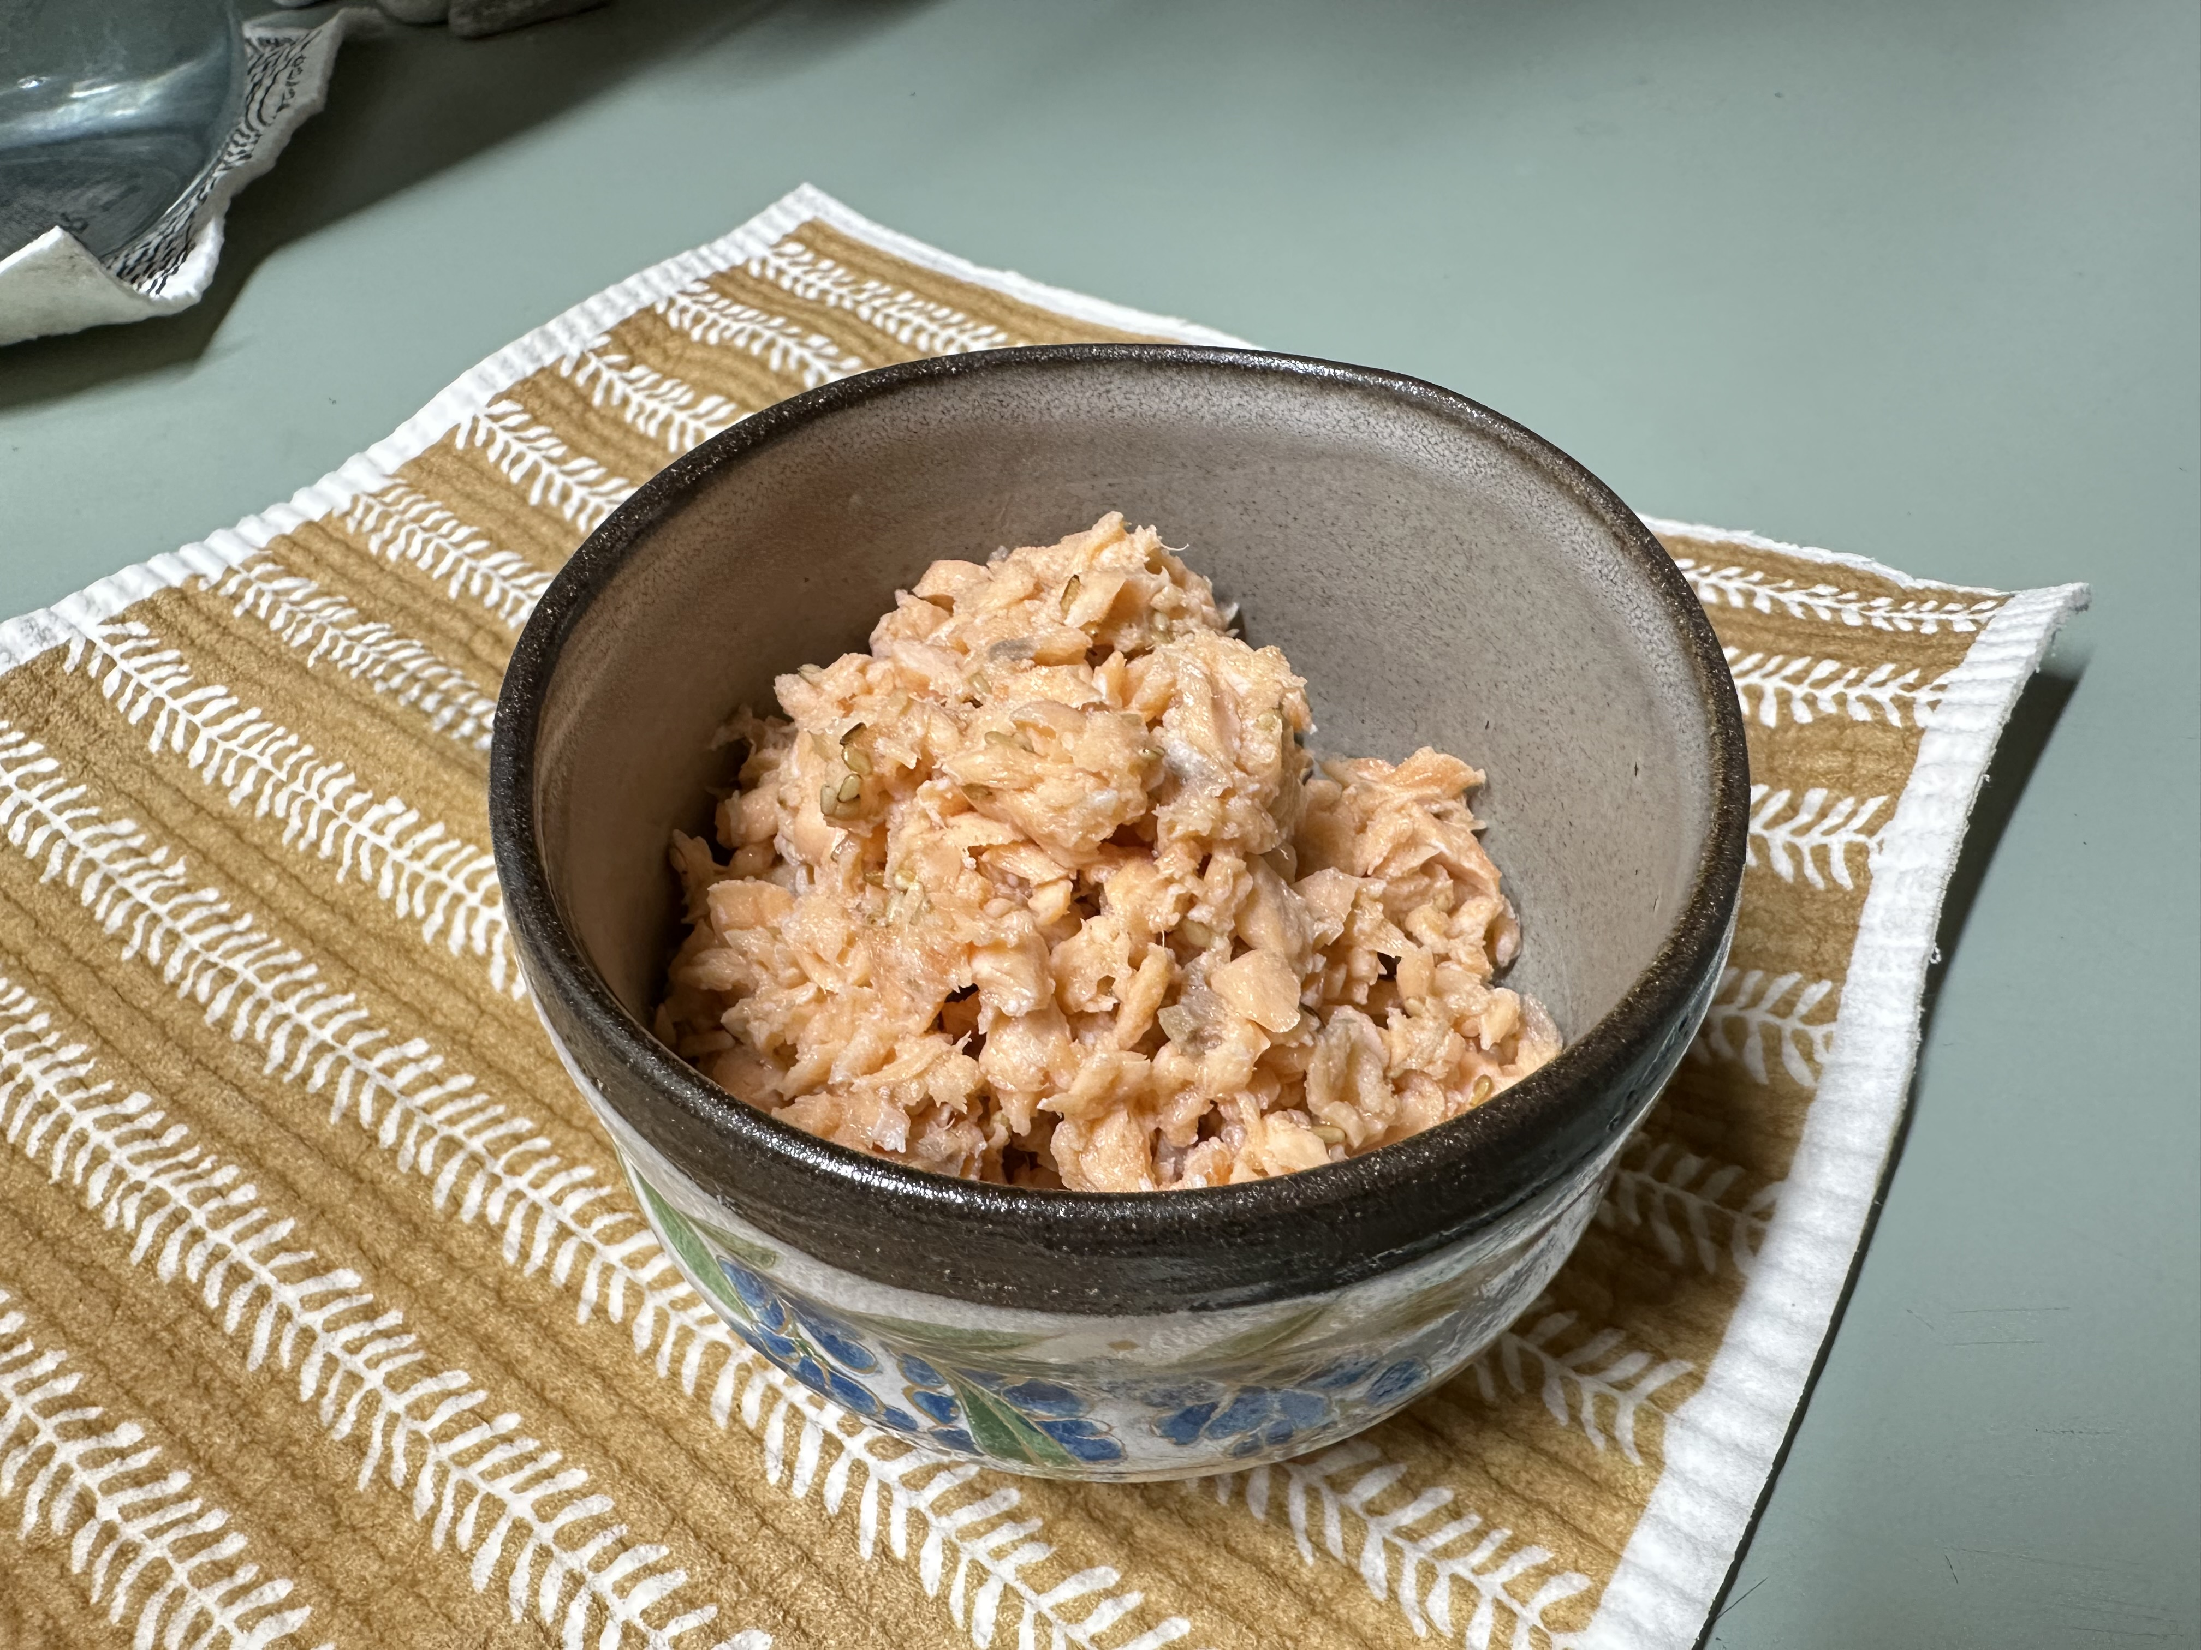

Photo By Yu*me

Ingredients
- 2 small salmon fillets
- Important: Use Japanese-style cuts “Kirimi” -smaller portions about 2 inches wide. Remove all bones and skin before cooking. The size matters for texture and even breakdown (see photo for reference).
- 3 Tbsp sake
- 3 Tbsp mirin
- ½ tsp salt
- ½ tsp Low sodium Soy Sauce
- ½ Tbsp sesame oil

Instructions
- Cook the salmon: Place salmon in a skillet, add sake and mirin. Simmer over medium heat. As the salmon cooks, use chopsticks or a spatula to break it into small flakes (this is key).
- Season and reduce moisture (simmer uncovered): Add salt. Keep stirring and breaking it up until most of the moisture evaporates.
- Add sesame oil: Toss in sesame oil and stir gently. Keep heat on low and continue mixing until the texture is dry but still a bit soft — not crunchy.
- Cool and store: Let the flakes cool fully before storing. Use an airtight jar or container. Keeps in the fridge up to one week.

Optional Additions
- Toasted sesame seeds
- Crushed nori
- Bonito flakes
- Chili flakes or ground shiso for a twist

