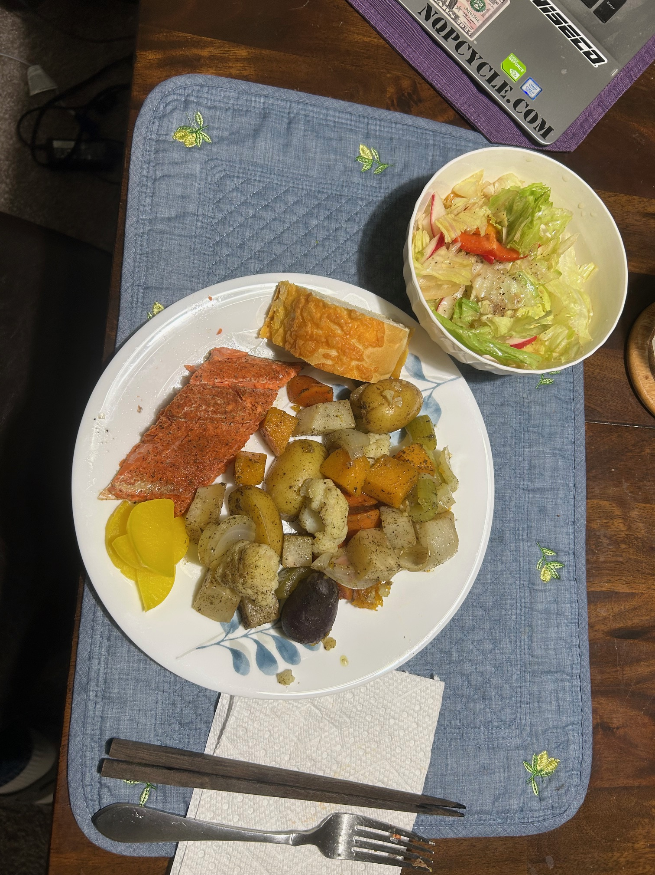
Salmon & Roasted Veggie Bake
A hearty one-pan feast of roasted root vegetables topped with lemon-pepper salmon. Perfect for a balanced dinner with minimal cleanup!

Ingredients:
- 1 salmon fillet (1–1.5 lbs), patted dry
- 2–3 cups mixed potatoes (gold, red, or purple), halved
- 1 cup butternut squash, cubed
- 2 carrots, chopped
- 1 cup cauliflower florets

- 2 celery stalks, chopped
- 1 onion, chopped
- 2–3 tbsp olive oil
- 1–2 tsp salt & black pepper
- 1–2 tsp lemon pepper seasoning salt (for salmon)
- Optional: pickled vegetables, salad, and bread for serving

Method:
1. Preheat oven to 375°F (190°C).
2. On a large sheet pan, spread the potatoes, squash, carrots, cauliflower, celery, and onion. Drizzle with olive oil, season with salt and pepper, and toss well to coat.
3. Roast vegetables for 30–40 minutes, stirring halfway through, until edges are golden and potatoes are tender.
4. While vegetables roast, bring salmon to room temperature. Pat dry and season generously with lemon pepper seasoning salt.
5. After veggies have roasted 30–40 minutes, place salmon fillet on top. Return to oven and roast another 18–22 minutes, or until salmon flakes easily with a fork.
6. Serve hot with a crisp side salad, crusty bread, and pickled vegetables for contrast.

Notes:
- You can substitute salmon with another firm fish (snapper, cod, halibut).
- Add rosemary, thyme, or garlic for extra depth.
- Leftovers make a great next-day lunch bowl with rice or greens.

