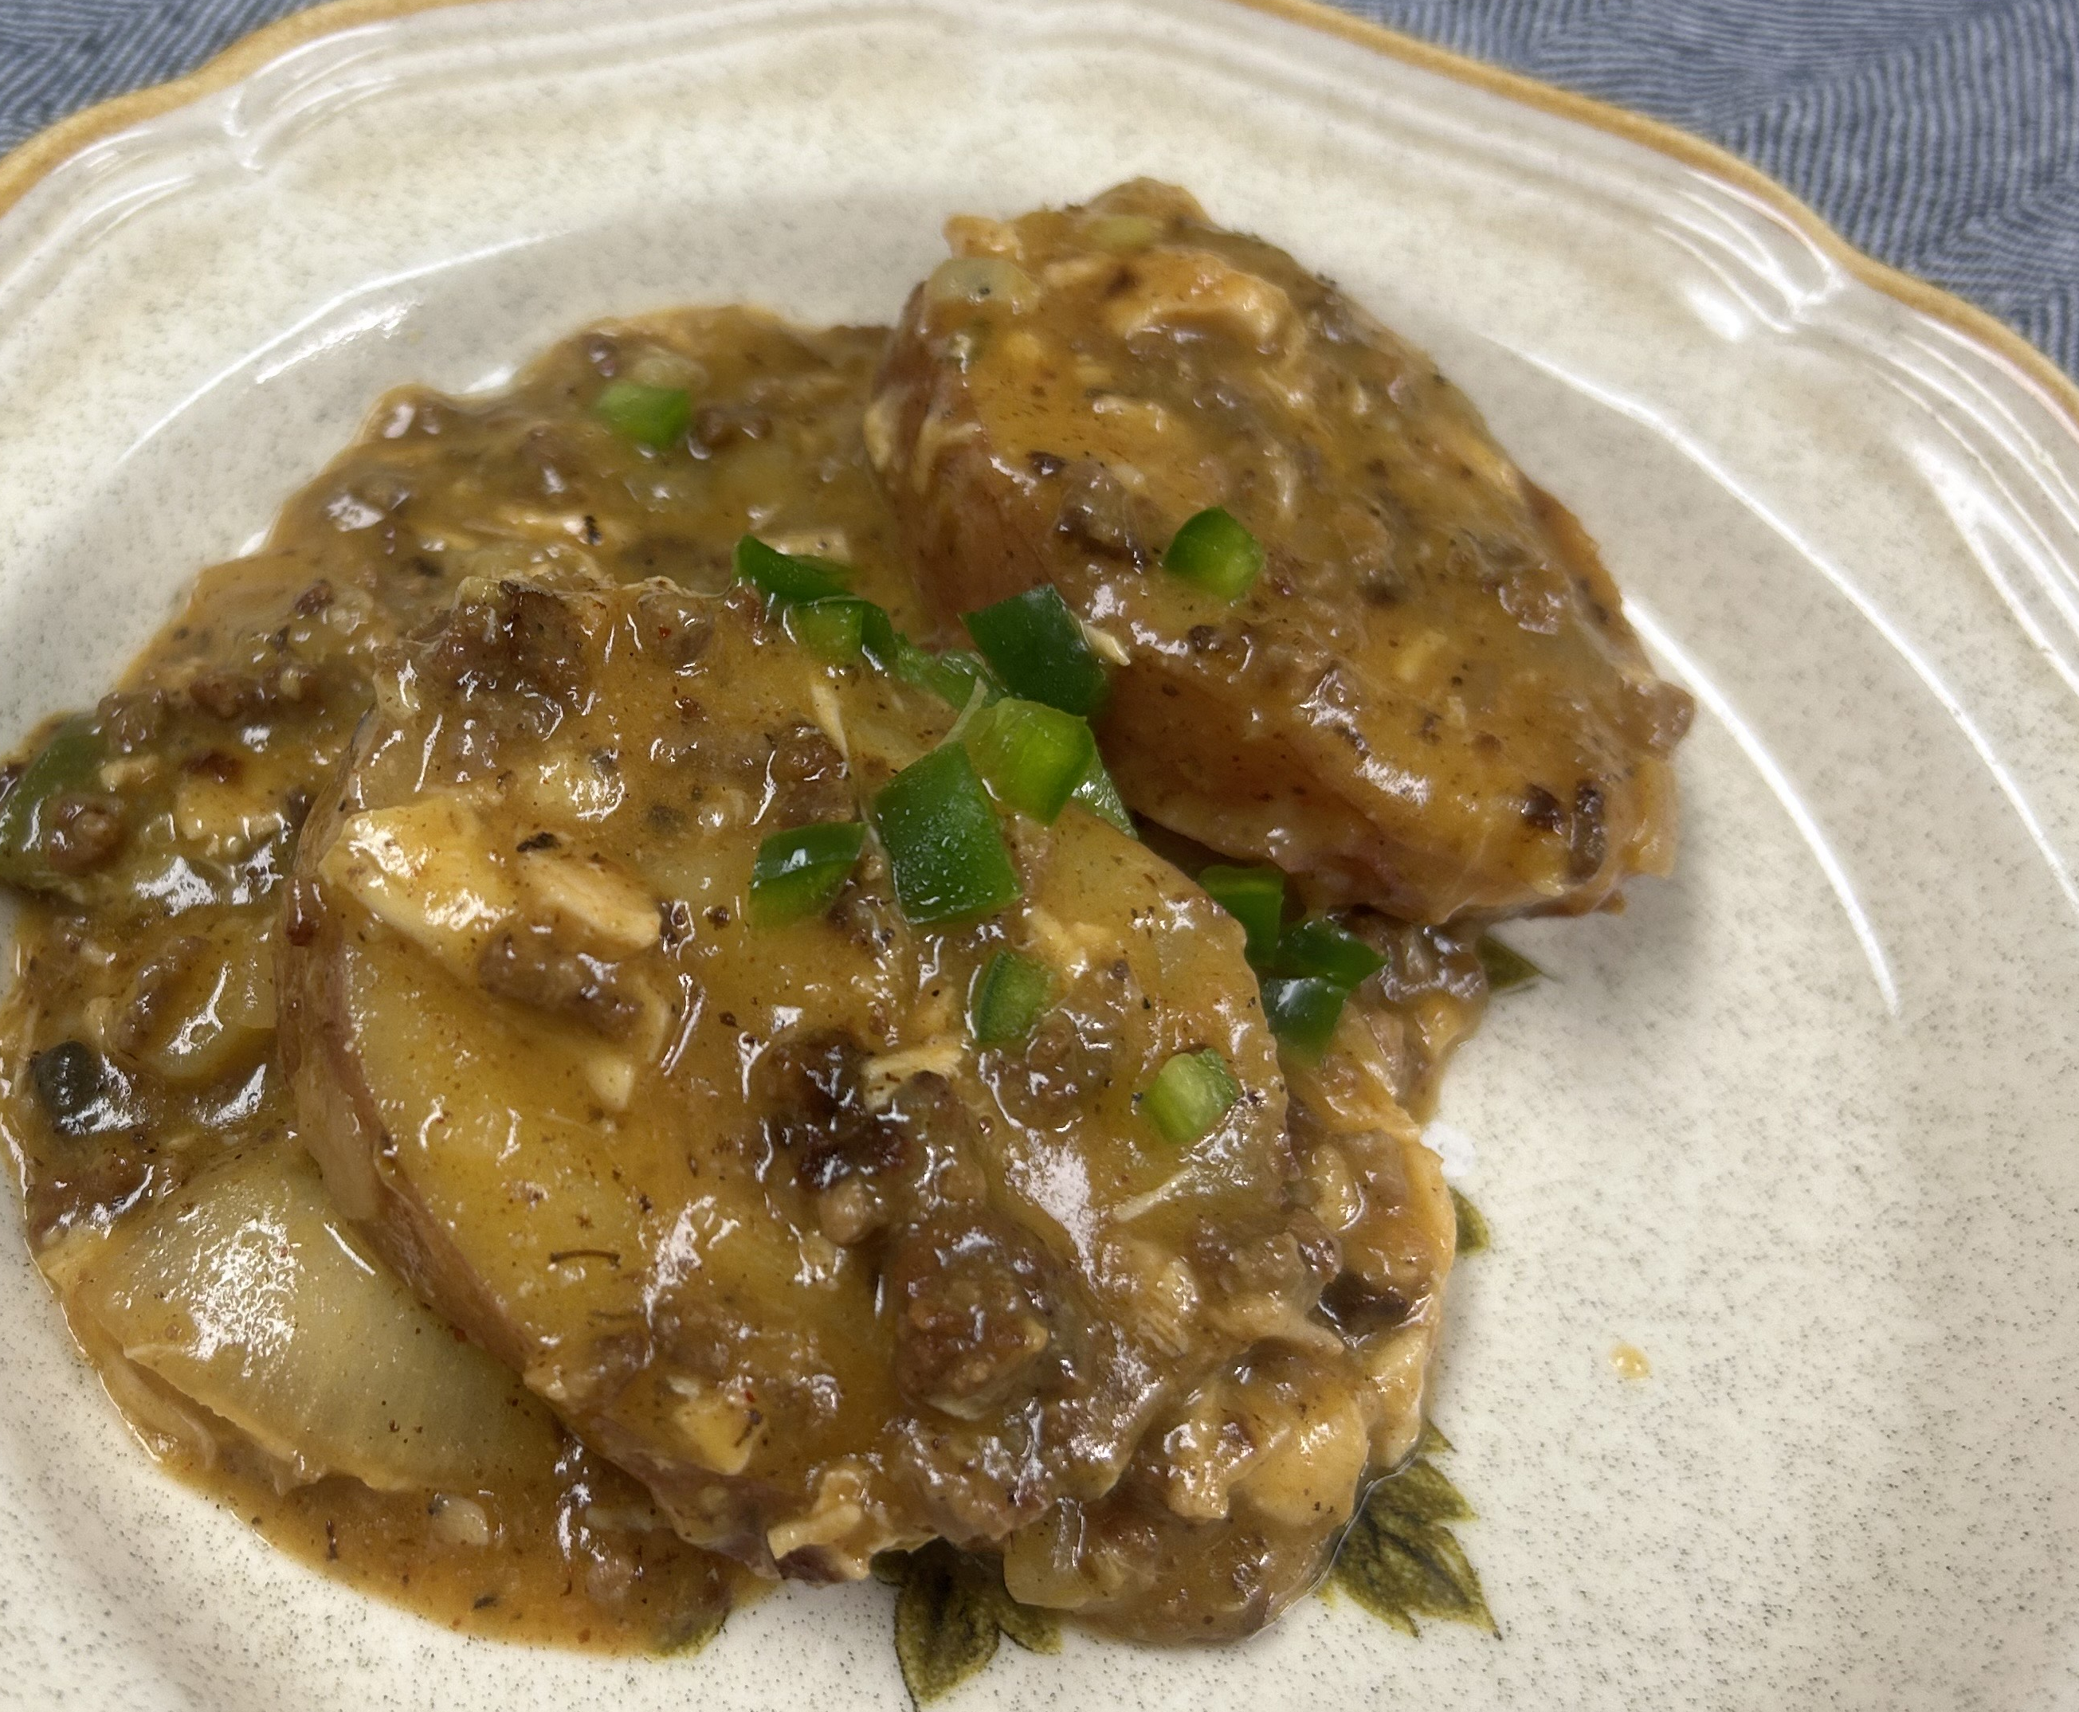
Double Cheesy Potatoes
Pressure Cooker Recipe
Yield: 6–8 servings
Cook Time: ~30 minutes
Method: Pressure Cooker (Instant Pot–style)

Ingredients

Base

- 2–2½ lb potatoes, sliced ¼"
- 1 large onion, sliced
- 1–2 jalapeños, sliced (seeded for mild)
- 4–5 cloves garlic, minced
- 1½–2 lb chicken (thighs preferred; breasts ok)
- Optional: ½–1 lb ground beef

Flavor Profile

- Juice of 2 limes
- Juice of 1 orange
- 1½ tsp ground cumin
- 1 tsp chili powder
- ½ tsp smoked paprika
- ½ tsp Mexican oregano
- ½ tsp chipotle powder (or cayenne)
- Salt and black pepper, to taste
- 1 tbsp olive oil

Creamy Binder

- 1 can Campbell’s Cream of Chicken soup
- 1 can Campbell’s Cheddar Cheese soup
- ½ cup chicken broth
- 1–1½ cups shredded cheese (Monterey Jack, Mexican blend, or cheddar-jack)

Instructions
- Optional Beef Step: If using ground beef, set pressure cooker to Sauté, brown beef with a pinch of salt, cumin, and chili powder. Remove and set aside.
- Build the Pot: Layer potatoes, onion/jalapeño/garlic, chicken, and beef (if using). Sprinkle spices evenly. Drizzle olive oil and pour citrus juices over the top. Do not stir.
- Add Creamy Base: Whisk soups and chicken broth together. Pour evenly over contents. Do not stir.
- Pressure Cook: Seal lid and cook on High Pressure for 12 minutes. Natural release 10 minutes, then quick release.
- Shred & Finish: Remove chicken and shred. Return to pot, stir everything together, add shredded cheese, and rest on Keep Warm for 5–10 minutes to thicken.

Serve
Finish with fresh lime juice. Optional toppings include cilantro, hot sauce, or pickled jalapeños. Serve in bowls, over tortillas, or straight up.

Notes & Variations
- Chicken thighs provide richer flavor and better texture.
- Add poblano or Anaheim chiles for deeper heat.
- Leftovers make excellent enchilada or burrito filling.
- Dish thickens as it cools.

