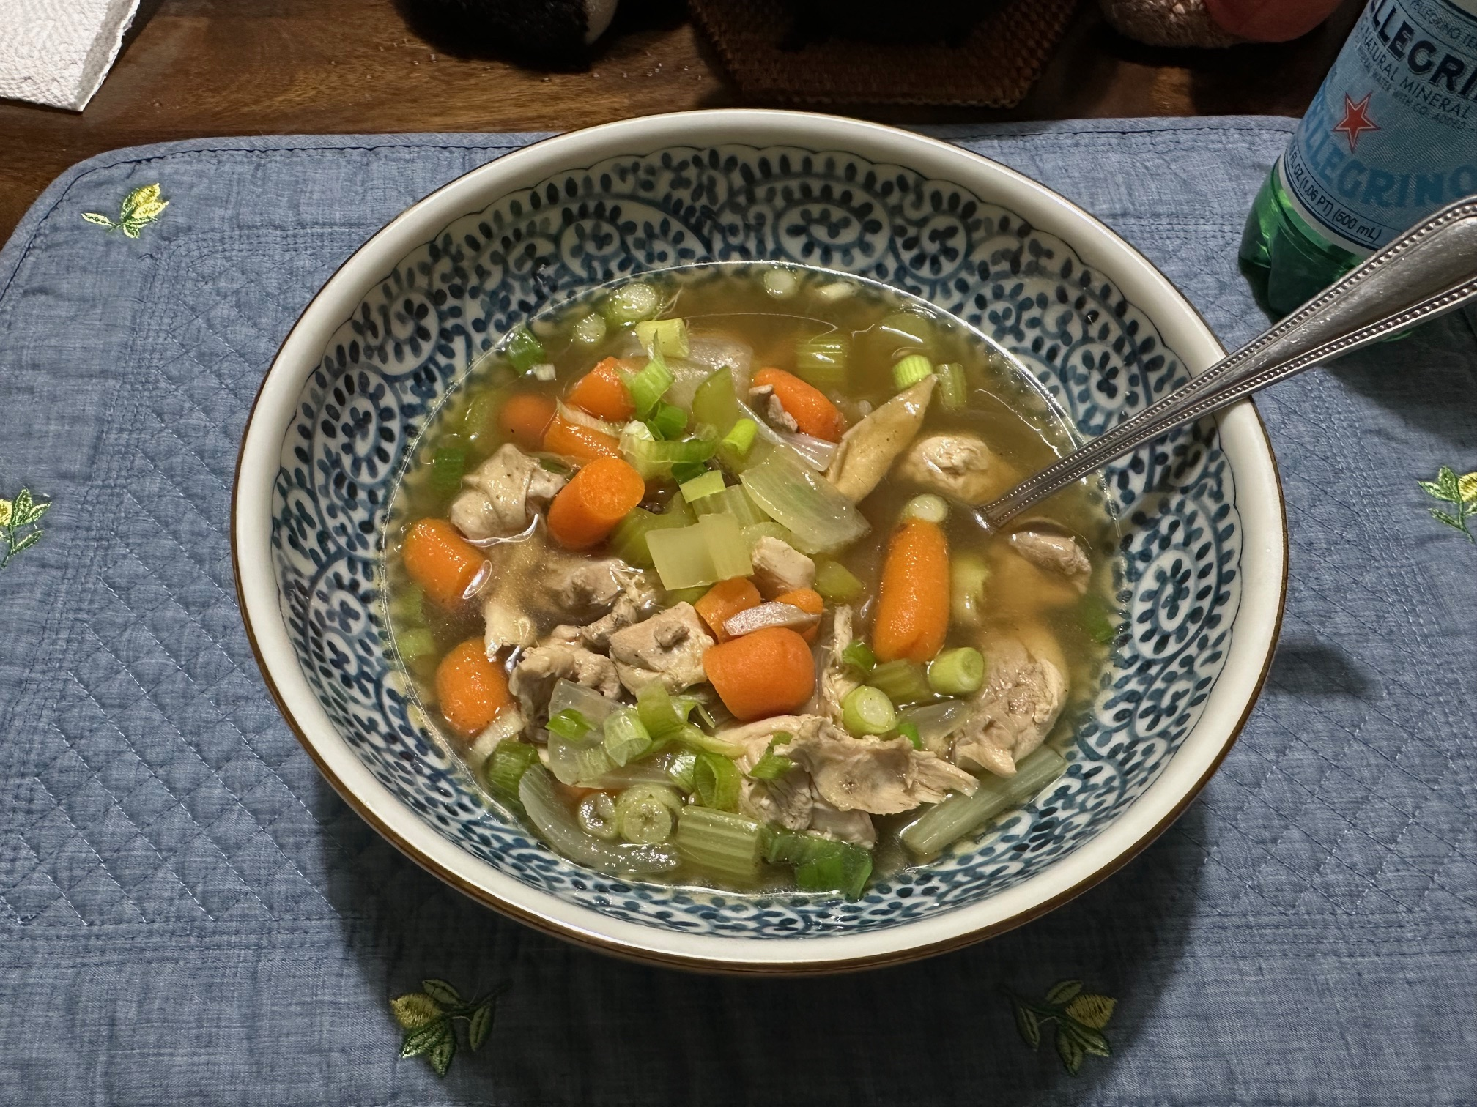
Bob’s Famous Chicken Soup

Perfect for Chicken, Beef, Pork and Wild Game
Just adjust the seasoning accordingly

Ingredients:
• 1 whole chicken, broken down (breasts reserved for another meal, wings left meaty, thighs/legs/tenderloin cubed)
• 2 large onion (skin on, cut in half)
• 4 carrots (rough chopped, plus extra fresh for later)
• 6 celery stalks (rough chopped, plus extra fresh for later)
• 1–2 cups mushrooms (rough chopped, plus extra fresh for later)
• 2 garlic cloves
• 1 Thumb-sized piece of fresh ginger, peeled and choped

• 1 tsp salt
• 1 tsp black pepper
• 1 tsp onion powder
• 1 tsp garlic powder
• 1 tsp Chinese 5 spice
• 1 tbsp soy sauce
• 1 shot sake
• 1 tsp Worcestershire sauce
• Celery salt to taste (key finishing seasoning)
• 1–2 tsp chicken & beef bouillon (sparingly, near the end)

Method

Stage 1 – The Base (30 minutes)
Place the chicken carcass, 1 onion (skin on), half of the carrots, celery, mushrooms. Add the garlic cloves, and ginger into a large pot. Add salt, pepper, onion powder, garlic powder, and Chinese 5 spice. A Splash in soy sauce, sake, and Worcestershire. Add enough water to cover and boil hard for 30 minutes. Strain out the bones and vegetables, leaving a rich clear broth. You can boil lower and slower if you have time and this will deepen the flavor.

Stage 2 – The Body (20–30 minutes)
Add fresh chopped onion, celery, carrots, mushrooms, and the cubed raw chicken & wings, to the broth. Simmer 20–30 minutes until chicken is cooked and vegetables are tender but not mushy. 1” cubed Potatoes can be added here or cooked egg noodles separately when soup is complete if desired. Adding noodles in while cooking brings in the starch and affects the flavor.

Stage 3 – The Secret Finish
Near the end of cooking, stir in a small amount of chicken and beef bouillon. Use sparingly to enhance flavor without overpowering the natural broth. Adjust seasoning with celery salt, salt, and pepper as needed. We make a slurry with some of the hot broth and add small amounts at a time.

