Bob’s Sesame Slaw

# Ingredients **Total (Whole Batch): ~310 calories** **Per Serving (if 4 servings): ~78 calories**

## Base:

• 1 bag store-bought coleslaw veggie mix (rinsed, drained, patted dry)

• 2–3 small English cucumbers (sliced on a sharp angle, then into matchsticks)

## Dry Seasoning (light sprinkle):

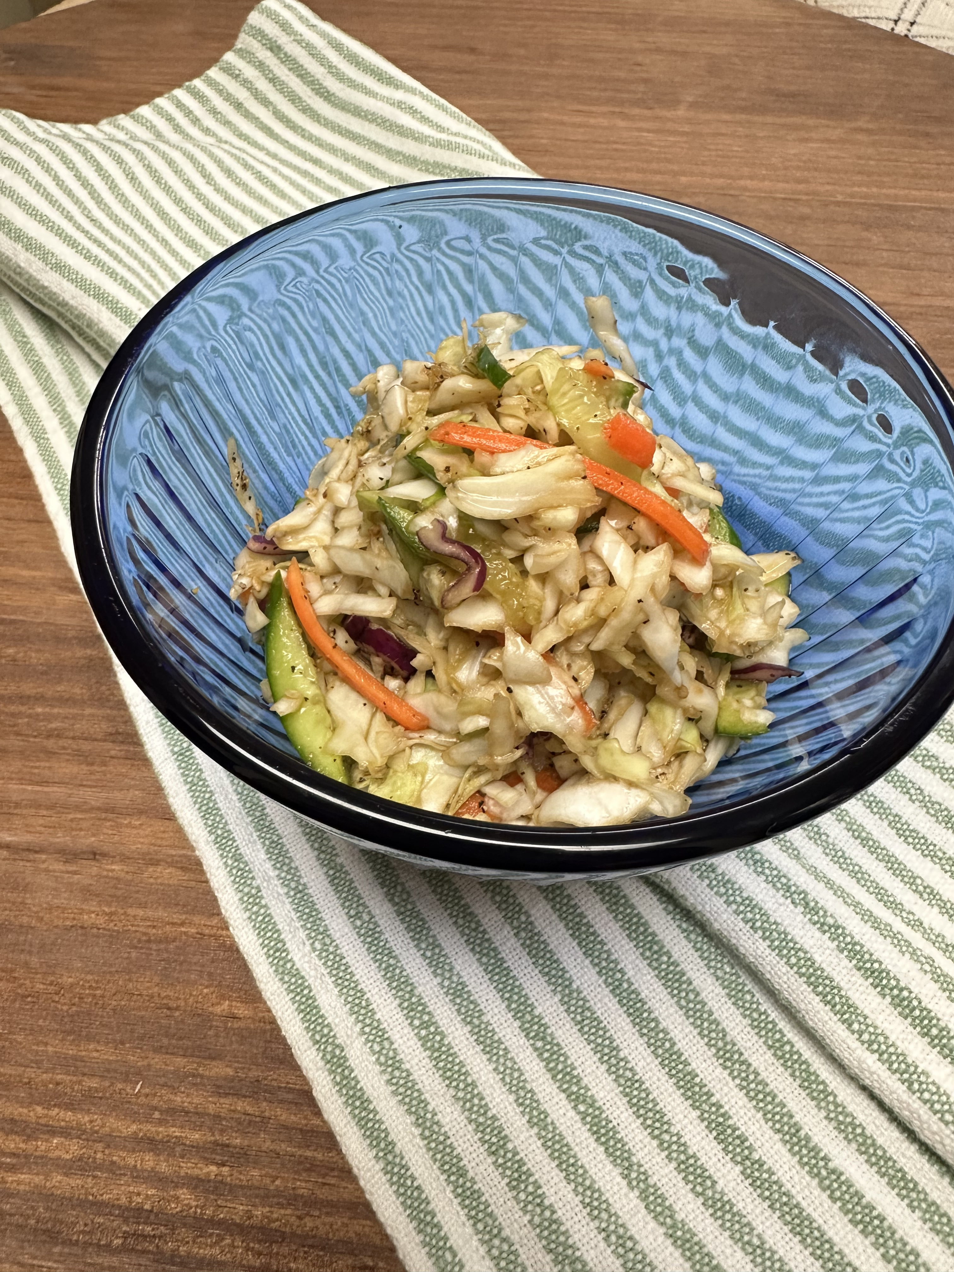• Black pepper

• Himalayan pink salt

• Onion powder

• Garlic powder

## Dressing (subtle umami blend):

• 1 tbsp soy sauce

• 1 tbsp fish sauce

• 1 tbsp sake

• 1 tbsp mirin

• 2 tbsp rice wine vinegar

• 1 tsp sesame oil (goma abura)

• 1 tbsp toasted sesame seeds (irigoma)

# Instructions

1. Wash and drain the coleslaw mix. Pat dry thoroughly.

2. Julienne the cucumbers by slicing on a diagonal, then cutting those slices into thin matchsticks.

3. Combine coleslaw and cucumber in a large mixing bowl.

4. Lightly sprinkle in black pepper, Himalayan salt, onion powder, and garlic powder. Toss gently.

5. In a separate bowl, whisk together all dressing ingredients until well blended.

6. Pour dressing over the salad and toss thoroughly to coat.

7. Let rest for 10–15 minutes to absorb flavor without overpowering.

8. Serve chilled or at room temperature for a clean, light bite.